Lively Fruity & Lemon
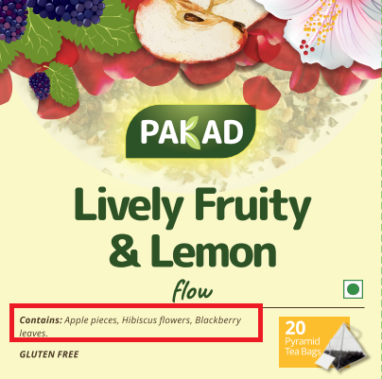 | Contains – All words will start with upper case (like below)  Contains: Apple Pieces, Hibiscus Flowers, Blackberry Leaves.
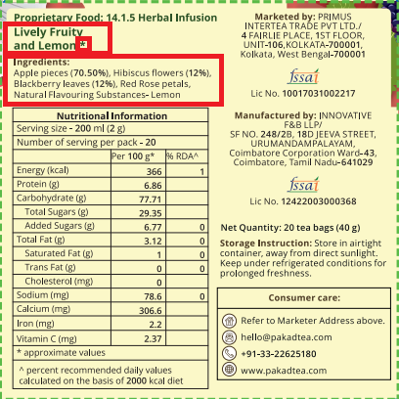 | 1. Ingredients – All words will start with upper case (like below)  Ingredients:  Apple Pieces (70.50%), Hibiscus Flowers (12%), Blackberry Leaves (12%), Red Rose Petals, Natural Flavouring Substances- Lemon  2. Remove the star mark (*)  3. Lively Fruity & Lemon- name to come in one line, replace the word ‘and’ with ‘&’

