Strawberry Sweet- delighted
- Follow the same changes done to Beautea. Also see the below.
- Font size should be minimum 2mm for alphabets and 3mm for numericals.
- Ingredients: (Face 2)
Hibiscus Flowers (28%), Rosehips (23%), Orange peel (18%), Apple pomace (13%), Blackberry leaves (8%), Strawberry fruit Granules, Safflower petals, Natural Flavouring Substances- Strawberry.
- On Face 1 and 3 where ingredients are mentioned put as below:
Contains: Hibiscus Flowers, Rosehips, Orange peel, Apple pomace, Blackberry leaves.
GLUTEN FREE (as footnote)
- This is just a trade name and does not represent the true nature of the product- This Declaration will NOT come on this Blend
- Net Quantity: 20 tea bags (40 g)
- Please insert- Proprietary Food: 14.1.5 Herbal Infusion instead of 'Herbal Infusion on Face 2
- Face 4-
- under brewing instruction for hot cup in No. 2 Pour (P will be capital)
- under brewing instruction for hot cup in No. 3 correct the spelling of minutes
- Nutritional Table for this blend – Strawberry Sweet
Nutritional Information
Serving size - 200 ml (2 g)
Number of serving per pack - 20
 | Per 100 g* | % RDA^
Energy (kcal) | 349 | 1
Protein (g) | 7.12
Carbohydrate (g) | 75.45
Total Sugars (g) | 16.86
Added Sugars (g) | 6.46 | 0
Total Fat (g) | 2.13 | 0
Saturated Fat (g) | 1 | 0
Trans Fat (g) | 0 | 0
Cholesterol (mg) | 0
Sodium (mg) | 22.3 | 0
Calcium (mg) | 331.4
Iron (mg) | 0
Vitamin C (mg) | 2.33
* approximate values
^ percent recommended daily values calculated on the basis of 2000 kcal diet

Barcode_Strawberry Sweet_8908022942020   | QR_Strawberry Sweet_8908022942020  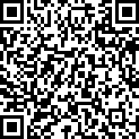

Strawberry Sweet – DELIGHTED

Allow your senses to dance with delight as you sip our Strawberry Sweet Tisane, conjuring up an emotion of sheer joy and contentment. The infusion reveals a mesmerizing ruby-red hue as the first sip graces your lips, imparting a gentle tartness along with a sweetness thereby creating a symphony of taste that is both refreshing and comforting, like a warm embrace from a dear friend!
Logos:
Gluten Free  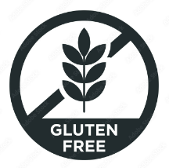 | Swachh Bharat  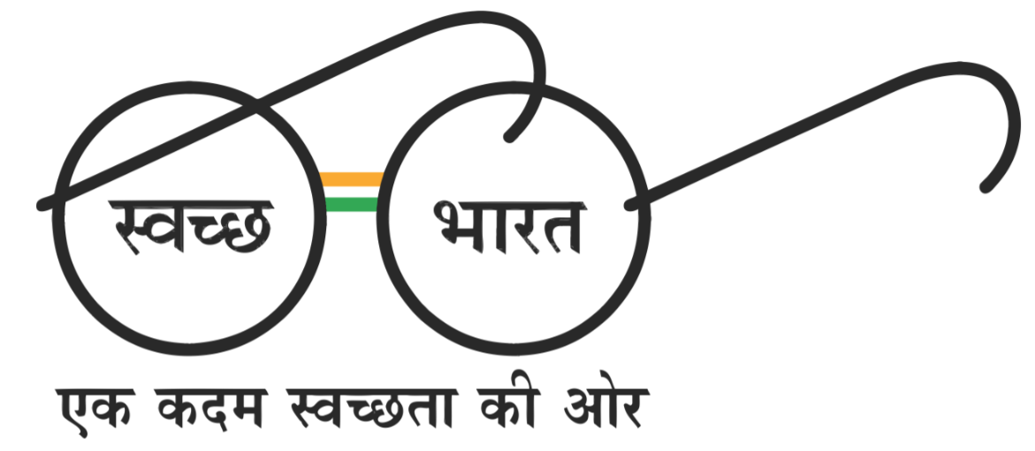
Ingredients List : Strawberry Sweet
Ingredients:
Hibiscus Flowers (28%), Rosehips (23%), Orange peel (18%), Apple pomace (13%), Blackberry leaves (8%), Strawberry fruit Granules, Safflower petals, Natural Flavouring Substances- Strawberry.

