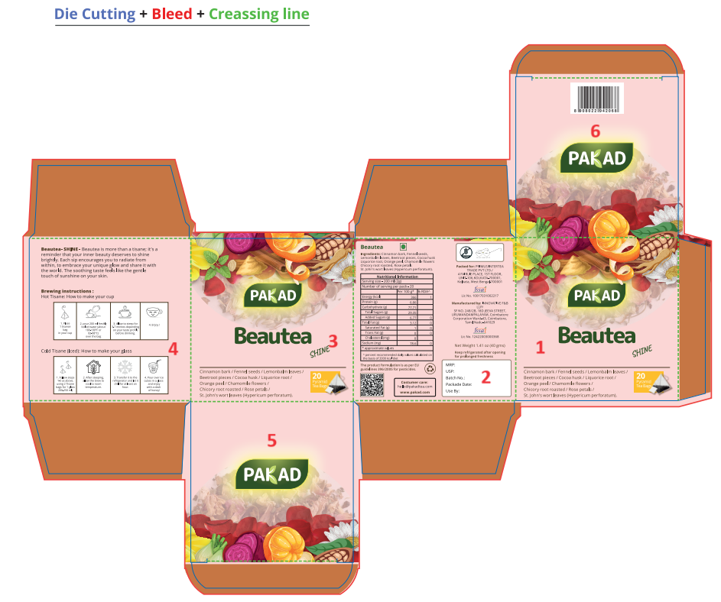
- Please move the barcode to Face 5 . Due to typing error I had mentioned Face 6 in the last draft. Sorry.
- For the brewing instructions please use uniform clipart images . My images were just for reference purposes. Some are dark some are light. It is not looking good.
- The Emotion word Shine to be put under the word Beautea in a straight line. The angle is not looking good on all the boxes hence we want to keep it in a straingt line.Put this word in lower case(shine). The font is okay.
- Remove the ingredients from Face 2 and just mention the words GLUTEN FREE under the Tea name. Also remove the veg logo from this face.
- We need a declaration – This is just a trade name and does not represent the true nature of the product.
This declaration to be put on Face 2 along with a star mark(*) . And also add the star mark to the name of the tea Beautea (*) on the same panel.
- Veg logo – Please shift it back on Face 1 and 3 . The logo should have white background.
- Face 1and 3 in the ingredients list replace ‘/’ (slash symbols) with ‘,’(comma symbol)

- Consumer Care – make the following changes
 hello@pakadtea.com
 +91-33-22625180
 www.pakadtea.com

- Instead of Net Weight on Face 2 mention:
Net Quantity: 20 tea bags (30 g)

- Remove the EU Regulations line from Face 2
- Storage Instruction: Keep refrigerated after opening for prolonged freshness. Avoid direct sunlight.
- Logo- Put the recycle logo also with the other two in the same box in a line.
- Nutritional Table for this blend - Beautea
Nutritional Information
Serving size - 200 ml (1.5 g)
Number of serving per pack - 20
 | Per 100 g* | % RDA^
Energy (kcal) | 351 | 1
Protein (g) | 9.87
Carbohydrate (g) | 72.49
Total Sugars (g) | 11.13
Added Sugars (g) | 3.07 | 0
Total Fat (g) | 2.41 | 0
Saturated Fat (g) | 1 | 0
Trans Fat (g) | 0 | 0
Cholesterol (mg) | 0
Sodium (mg) | 104.6 | 0
Calcium | 298.8
* approximate values
^ percent recommended daily values calculated on the basis of 2000 kcal diet

Barcode_Beautea_8908022942068   | QR_Beautea_8908022942068  

Beautea- SHINE

Beautea is more than a tisane; it’s a reminder that your inner beauty deserves to shine brightly. Each sip encourages you to radiate from within, to embrace your unique glow and share it with the world. The soothing taste feels like the gentle touch of sunshine on your skin.
Logos:
Gluten Free   | Swachh Bharat  
Ingredients List for all: Please check this while making the design for all
Ingredients:
Cinnamon bark, Fennel seeds, Lemonbalm leaves, Beetroot pieces, Cocoa husk, Liquorice root, Orange peel, Chamomile flowers, Chicory root roasted, Rose petals, St. John's wort leaves (Hypericum perforatum)

