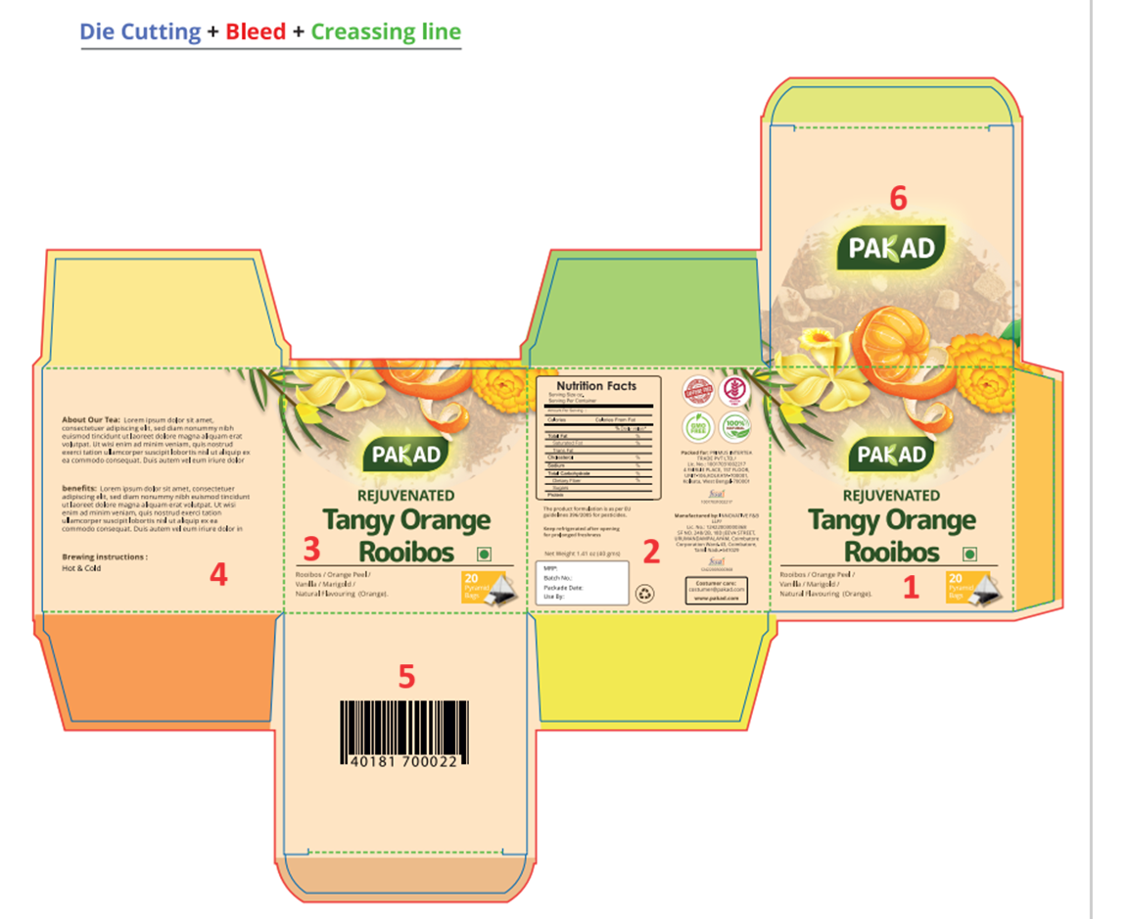
- All the inward flaps to be of one colour different from the box colour . Choose this different colour from any of the ingredients colour.
- We will need the PAKAD logo Separately.
- The emotion word – Change the font. Use an informal font and write in lower case. Can be put at an angle if that looks good. The emotion word is written below with each type. Please follow that.
- Veg Logo – Remove from face 1 and 3 and put it on Face 2. Include the name of Tea on Face 2 along with the veg logo
- Change the customer care email to – hello@pakadtea.com
- Bar Codes – I have pasted the Actual barcodes beneath with the names to be put on Face 6.
- QR Code- Include the respective QR Code in the design where it looks good.
- For Tea description and Brewing instruction see below. Put this on Face 4.
- Logos – We only keep Gluten Free and Swachh Bharat ( Attached below). Remove all others
- Nutritional table to come in the order as per the PPT slide(DRAFT LABEL) uploaded. Please refer to that and make the table on all the designs we will put the values later. Same as it is in the PPT slide.
- Once done please upload both the flat and the box view of all the designs
- Face 2- In the MRP box include one more row – USP ( put this under MRP)
Barcode_Strawberry Sweet_8908022942020   | QR_Strawberry Sweet_8908022942020  
BArcode_Lively fruity&Lemon-8908022942013   | QR_Lively fruity&Lemon_8908022942013  
Barcode_Chocolate Truffle8908022942037   | QR_Chocolate Truffle_8908022942037  
Barcode_Tangy Orange Rooibos_8908022942006   | QR_Tangy orange_8908022942006_QR Code  
Barcode_Forest Fruit_8908022942044   | QR_Forest Fruits_8908022942044  
BArcode_Fuelup_8908022942051   | QR)Fuelup_8908022942051  
Barcode_Beautea_8908022942068   | QR_Beautea_8908022942068  

Brewing Instruction: To be put on Face 4
Hot Tisane: How to make your cup
  1. Place 1 tisane bag in your cup | 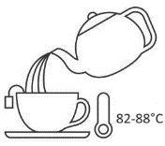  2. Pour 200 ml freshly boiled water (about 180-190°F or 82-88°C) over the bag. |   3. Allow to steep for 3-7 minutes depending on your taste profile before drinking. |   4. Enjoy !
Cold Tisane (Iced): How to make your glass
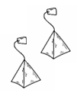  1. Follow steps 1-3 as above, using 2 Tisane bags for 1 glass (200 -250 ml) |   2. After steeping, allow the brew to cool to room temperature. |   3. Transfer it to the refrigerator and let it chill for at least an hour. | 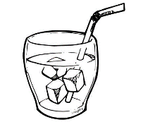  4. Pour over ice cubes in a glass and enjoy with a dash of honey!

Tea Description: To be put on Face 4

- Strawberry Sweet – DELIGHTED

Allow your senses to dance with delight as you sip our Strawberry Sweet Tisane, conjuring up an emotion of sheer joy and contentment. The infusion reveals a mesmerizing ruby-red hue as the first sip graces your lips, imparting a gentle tartness along with a sweetness thereby
creating a symphony of taste that is both refreshing and comforting, like a warm embrace from a dear friend!

- Lively Fruity and Lemon - FLOW

Indulge in a tantalizing symphony of flavors with our Lively Fruity and Lemon Tisane. The vibrant infusion brings out a subtle sweetness along with the pronounced zesty lemon which lets you flow into the day with ease acting as a mood lifter inviting you to embrace life's rhythm and vitality.

- Chocolate Truffle – MOVE ON

With the first sip our light red Chocolate Truffle Tisane emanates unique taste of chocolate and truffle combined with a subtle sweetness. The smooth velvety texture caresses your palate as the sensation lingers with every sip. It is an invitation to shred the past and move on in life.

- Tangy Orange Rooibos- TALK TO ME

Experience our Tangy Orange Rooibos Tisane that beckons you to indulge in a flavorful conversation with your senses. The robust earthiness of Rooibos with zesty brightness of orange adds a creamy sweetness to the cup. It’s a comforting friend encouraging you to share your thoughts and embrace the moment.

- Forest Fruits- RISE

Emerge from the depths of tranquility with our Forest Fruit Tisane, a vivid elixir that bathes your cup in a deep red hue, evoking the stirring emotion of Rise. The sensation is like a morning sunbeam dispelling the night`s darkness with its burst of fruity energy and floral complexity.

- Fuel Up – REJUVENATE

Experience a rejuvenating journey with our Fuel Up Tisane, a radiant brew that illuminates your cup with a gentle yellow glow. This elixir whispers to your spirit, inviting you to pause, replenish and give you fresh perspective and boundless energy.

- Beautea- SHINE

Beautea is more than a tisane; it’s a reminder that your inner beauty deserves to shine brightly. Each sip encourages you to radiate from within, to embrace your unique glow and share it with the world. The soothing taste feels like the gentle touch of sunshine on your skin.
Logos:
Gluten Free   | Swachh Bharat  
Ingredients List for all: Please check this while making the design for all
- Strawberry Sweet  Hibiscus Flowers  Rosehips  Orange peel  Apple pomace  Blackberry leaves,  Strawberry fruit Granules  Safflower petals  Natural Flavouring Substances- Strawberry | - Lively Fruity and Lemon  Apple pieces  Hibiscus flowers  Blackberry leaves  Red Rose petals  Natural Flavouring Substances- Lemon
- Chocolate Truffle  Apple Pieces  Cocoa  Hibiscus Flowers  Rosehip  Blackberry leaves,  Carob-Fruit Pods  White Chocolate Pieces  Dehydrated Yoghurt granules  Strawberry fruit pieces  Natural Flavouring Substances- Chocolate | - Tangy Orange Rooibos  Rooibos  Orange Peel  Vanilla Pods (Dried Fruit)  Marigold Flowers  Natural Flavouring Substances- Orange
- Forest Fruit  Hibiscus Flowers  Rosehip  Blackberry Leaves  Natural Flavouring Substances- Black Currant | - Fuel Up  Ginger pieces  Peppermint leaves  Lime Peels  Lemongrass leaves  Nettle leaves  Parsley leaves  Gojiberries- Pieces  Carrot pieces  Dandelion root  Pepper pieces  Liquorice root
- Beautea
Cinnamon bark
Fennel seeds
Lemonbalm leaves
Beetroot pieces
Cocoa husk
Liquorice root
Orange peel
Chamomile flowers
Chicory root roasted
Rose petals
St. John's wort leaves (Hypericum perforatum)

