Strawberry Sweet
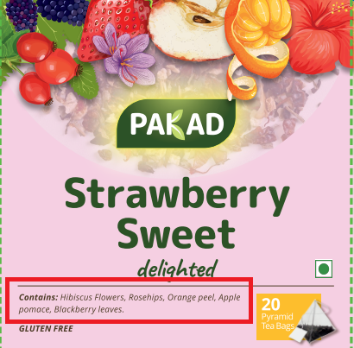 | Contains – All words will start with upper case (like below)  Contains: Hibiscus Flowers, Rosehips, Orange Peel, Apple Pomace, Blackberry Leaves.
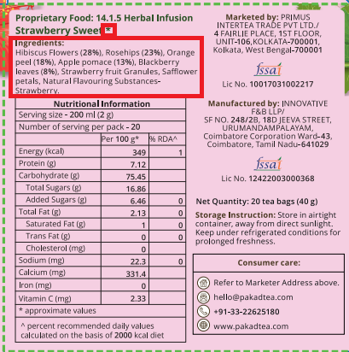 | 1. Ingredients – All words will start with upper case (like below)  Ingredients:  Hibiscus Flowers (28%), Rosehips (23%), Orange Peel (18%), Apple Pomace (13%), Blackberry Leaves (8%), Strawberry Fruit Granules, Safflower Petals, Natural Flavouring Substances- Strawberry.  2. Remove the star mark (*)

