Forest Fruits
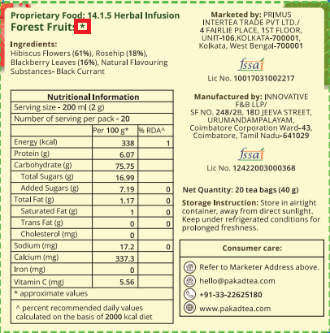 | Remove the star mark (*)

