Chocolate Truffle
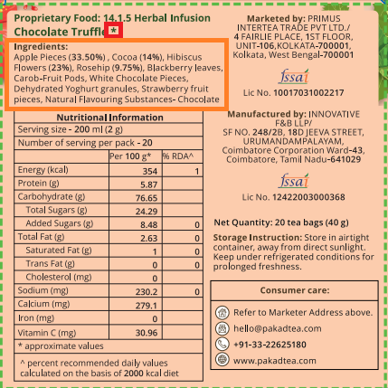 | 1 Remove the star mark.  2. Ingredients – All words will start with upper case like below  Ingredients:  Apple Pieces (33.50%), Cocoa (14%), Hibiscus Flowers (23%), Rosehip (9.75%), Blackberry Leaves, Carob-Fruit Pods, White Chocolate Pieces, Dehydrated Yoghurt Granules, Strawberry Fruit Pieces, Natural Flavouring Substances- Chocolate
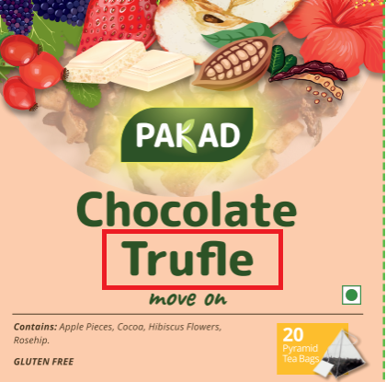 | Spelling Truffle
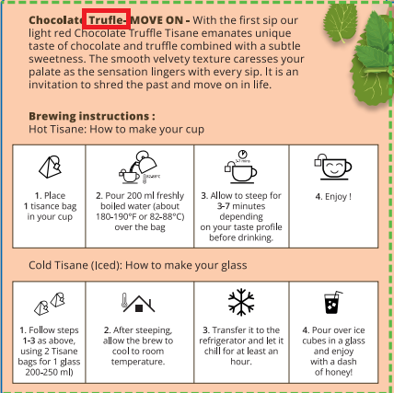 | Spelling Truffle

