Tangy Orange Rooibos
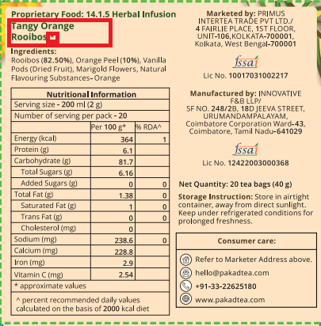 | - Remove the star mark (*)  - Tangy Orange Rooibos to come in one line

