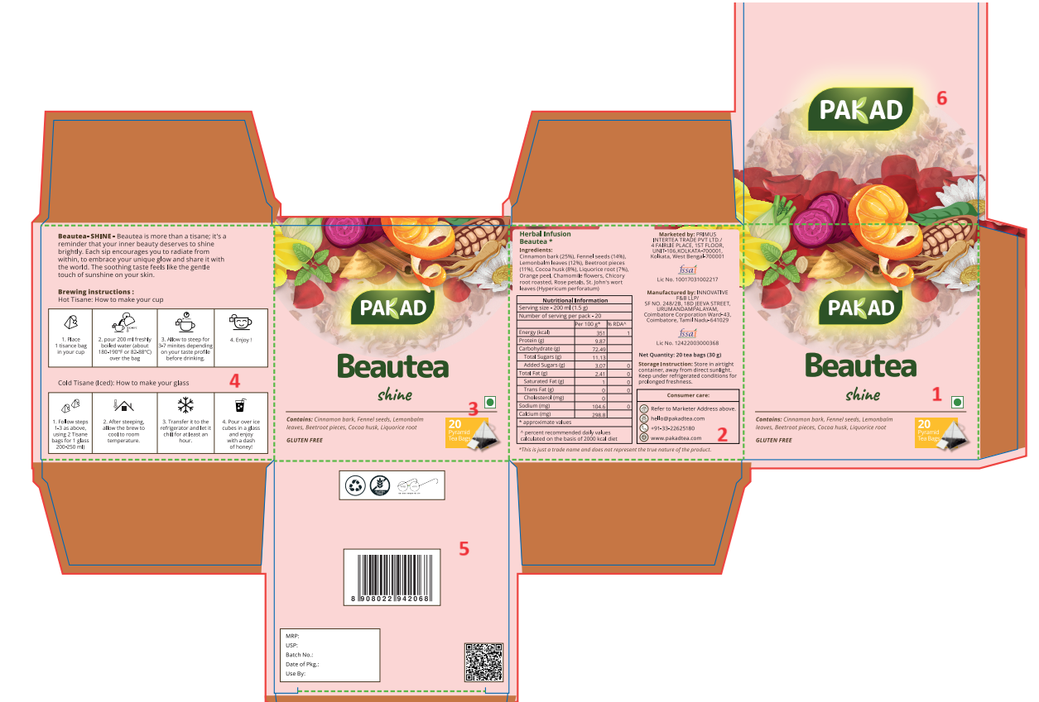
- Ensure the font size is min. 2mm for text and 3mm for numericals.
- Please insert- Proprietary Food: 14.1.5 Herbal Infusion instead of 'Herbal Infusion on Face 2
- Face 4-
- under brewing instruction for hot cup in No. 2 Pour (P will be capital)
- under brewing instruction for hot cup in No. 3 correct the spelling of minutes

- Nutritional Table for this blend – Beautea
Nutritional Information
Serving size - 200 ml (1.5 g)
Number of serving per pack - 20
 | Per 100 g* | % RDA^
Energy (kcal) | 351 | 1
Protein (g) | 9.87
Carbohydrate (g) | 72.49
Total Sugars (g) | 11.13
Added Sugars (g) | 3.07 | 0
Total Fat (g) | 2.41 | 0
Saturated Fat (g) | 1 | 0
Trans Fat (g) | 0 | 0
Cholesterol (mg) | 0
Sodium (mg) | 104.6 | 0
Calcium (mg) | 298.8
* approximate values
^ percent recommended daily values calculated on the basis of 2000 kcal diet

Barcode_Beautea_8908022942068   | QR_Beautea_8908022942068  

Beautea- SHINE

Beautea is more than a tisane; it’s a reminder that your inner beauty deserves to shine brightly. Each sip encourages you to radiate from within, to embrace your unique glow and share it with the world. The soothing taste feels like the gentle touch of sunshine on your skin.
Logos:
Gluten Free   | Swachh Bharat  
Ingredients List: Beautea
Ingredients:
Cinnamon bark (25%), Fennel seeds (14%), Lemonbalm leaves (12%), Beetroot pieces (11%), Cocoa husk (8%), Liquorice root (7%), Orange peel, Chamomile flowers, Chicory root roasted, Rose petals, St. John's wort leaves (Hypericum perforatum)

