Tangy Orange Rooibos- talk to me
- Follow the same changes done to Beautea. Also see the below.
- Font size should be minimum 2mm for alphabets and 3mm for numericals.
- Ingredients: (Face 2)
Rooibos (82.50%), Orange Peel (10%), Vanilla Pods (Dried Fruit), Marigold Flowers, Natural Flavouring Substances- Orange
- On Face 1 and 3 where ingredients are mentioned put as below:
Contains: Rooibos, Orange Peel.
GLUTEN FREE (as footnote)
- This is just a trade name and does not represent the true nature of the product- This Declaration will NOT come on this Blend
- Net Quantity: 20 tea bags (40 g)
- Please insert- Proprietary Food: 14.1.5 Herbal Infusion instead of 'Herbal Infusion on Face 2
- Face 4-
- under brewing instruction for hot cup in No. 2 Pour (P will be capital)
- under brewing instruction for hot cup in No. 3 correct the spelling of minutes
- Nutritional Table for this blend – Tangy Orange Rooibos
Nutritional Information
Serving size - 200 ml (2 g)
Number of serving per pack - 20
 | Per 100 g* | % RDA^
Energy (kcal) | 364 | 1
Protein (g) | 6.1
Carbohydrate (g) | 81.7
Total Sugars (g) | 6.16
Added Sugars (g) | 0 | 0
Total Fat (g) | 1.38 | 0
Saturated Fat (g) | 1 | 0
Trans Fat (g) | 0 | 0
Cholesterol (mg) | 0
Sodium (mg) | 238.6 | 0
Calcium (mg) | 228.8
Iron (mg) | 2.9
Vitamin C (mg) | 2.54
* approximate values
^ percent recommended daily values calculated on the basis of 2000 kcal diet

Barcode_Tangy Orange Rooibos_8908022942006   | QR_Tangy orange_8908022942006_QR Code  

Tangy Orange Rooibos- TALK TO ME

Experience our Tangy Orange Rooibos Tisane that beckons you to indulge in a flavorful conversation with your senses. The robust earthiness of Rooibos with zesty brightness of orange adds a creamy sweetness to the cup. It’s a comforting friend encouraging you to share your thoughts and embrace the moment.
Logos:
Gluten Free  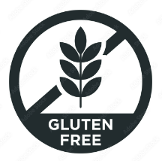 | Swachh Bharat  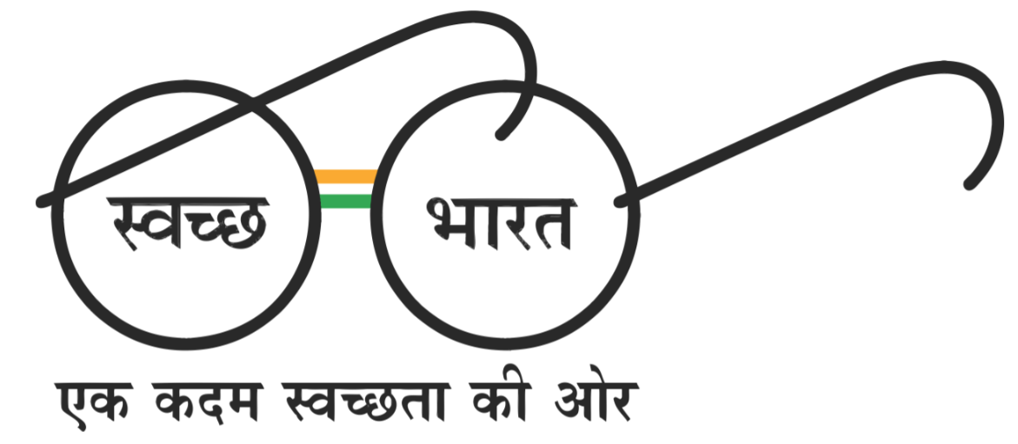
Ingredients List : Tangy Orange Rooibos
Ingredients:
Rooibos (82.50%), Orange Peel (10%), Vanilla Pods (Dried Fruit), Marigold Flowers, Natural Flavouring Substances- Orange.

