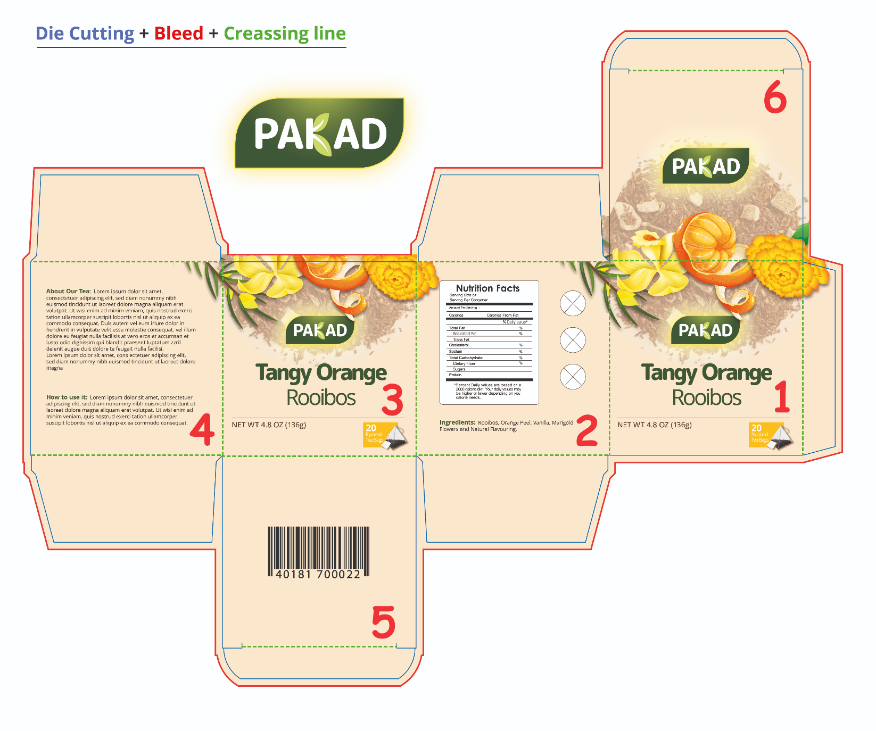
Face 1
- Move the ingredients to face 1.
- Add (Orange) after Natural Flavouring
- Only put Marigold. Remove Flowers.
- Tangy Orange Rooibos – Full name in bold
- Include a Veg Logo near the Name
- Mention 20 Pyramid Bags (Remove the word Tea)
Face 2
- FSSAI Logo to be places – 2 nos.
- Add licence no. under each logo
- Manufactured by: INNOVATIVE F&B LLP/ Lic. No.: 12422003000368
SF NO. 248/2B, 18D JEEVA STREET, URUMANDAMPALAYAM, Coimbatore Corporation Ward-43, Coimbatore, Tamil Nadu-641029
- Packed for: PRIMUS INTERTEA TRADE PVT LTD./ Lic. No.: 10017031002217
4 FAIRLIE PLACE, 1ST FLOOR, UNIT-106,KOLKATA-700001, Kolkata, West Bengal-700001
- Insert a separate panel to give the following details- Batch No., Packed date, Use By
- Net Weight 1.41 OZ (40 gms)
- MRP-
- Nutritional table- To Insert , we will give the parameters and values later.
- Mention below the Nutritional table – The product formulation is as per EU guidelines 396/2005 for pesticides.
- Add Recycle Logo
- In the 3 circles include 3 logos
- GMO free
- 100% Natural
- 100% Caffeine Free
- Gluten Free
- Add: Keep refrigerated after opening for prolonged freshness
- Customer care: email id ( make provision we will give the id)
- Website: www. Pakad.com
Face 3
Same as Face 1
Face 4
- About the tea, taste ,benefits etc.
- Brewing instructions – Hot & Cold
Face 5
Barcode only
Face 6
okay
Make all the inward folding flaps of different colours- Choose the colours from the ingredients colours itself

 | 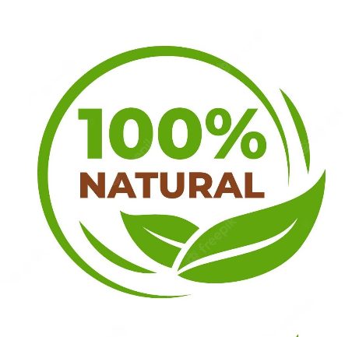
 | 
 | 

