Ethical Dilemma: Challenging Family Dynamics in an Emergency Setting (This section needs to be up the top under the heading – it explains the case study that the four principles will be referring to)
Responding to a distress call from a patient stating a drug overdose. Upon arriving, the patient's mother greets you at the door, concerned and anxious. The patient emerges from the house, looking distressed and is guided to the ambulance for initial observations. During the conversation, she admits to feeling suicidal and reveals that, at times, her parents have locked her in the garden shed. Concerned for her well-being, you impress the need to present to the hospital.
The patient agrees to seek further help and returns to the hospital to collect some personal belongings. As she reappears, her mother by her side, there is a noticeable change in the atmosphere. Her mother appears tense and denies any issues. The patient's demeanour has also shifted, echoing her mother and denying thoughts of suicide and the apparent overdose. Her mother has now called the police. It is very clear that the family has tension and disagreement regarding their daughter's condition and the appropriate course of action for her medical needs.


Application of Bioethical Principles: This is the theory of the 4 principles applied to this case study – each of these areas will have 100-150 words and might include table or graph please.
Autonomy:

While the patient initially expressed her desire for medical help, her subsequent change of heart raises concerns. Her independence should be respected, but a careful assessment of her decision-making capacity is crucial, given the potential for external influence or mental health issues.
Beneficence:

Given her history of suicidal thoughts and the conflicting messages, your primary responsibility is her well-being. Acting in her best interest is paramount if you suspect she's being coerced or manipulated.
Non-Maleficence:

Your role is to ensure that her actions are not compromised by undue pressure or emotional manipulation from her mother. If you sense harm could come to her due to the situation, steps must be taken to protect her.
Justice:
While considering the patient's mother's perspective, your ultimate priority remains the patient's welfare and safety. Balance her mother's role with your duty to safeguard the patient from harm.
Conclusion: This section at the bottom please to summarise all the 4 different discussion points
The situation is complex, involving potential coercion, mental health concerns, and disagreement within the family. Collaboration with medical professionals and possibly involving the police might be necessary to ensure her safety and well-being. Although you should strive to honour the patient's autonomy, you have a duty to intervene if her current stance is influenced by factors that put her at risk. Ultimately, your actions should align with the principles of protecting her from harm and prioritising her overall welfare.

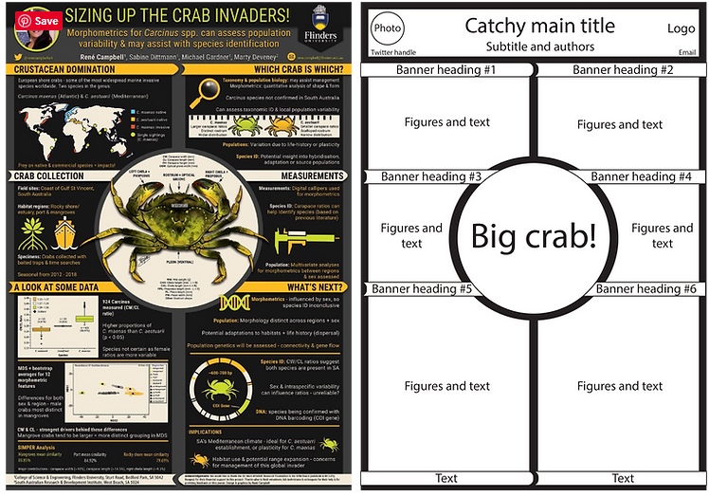
Examples of layout (not colour):

