Business Details are as follows:

Contact: Michelle Mackenzie
Phone: 0437 772 974
Email: info@betterlifeyoga.com.au
Website: www.betterlifeyoga.com.au
ABN: 63 603 452 522
Location: Cockatoo, Victoria Australia 3781
Facebook: BetterLife Yoga | Facebook
Instagram: betterlifeyoga4kids
------------------------------------------------------------------------------------------------------------------------------------
Home Page

Welcome to BetterLife Yoga…
BetterLife Yoga believe that you are never too young to benefit from and fall in love with yoga.
My aim is to EMPOWER kids and teens to thrive by teaching life skills in Yoga, Mindfulness and Breathing techniques to deal with daily challenges and big emotions.

BetterLife Yoga gives kids an opportunity to enjoy and experience yoga for themselves and primarily focuses on programs for Schools, Pre Schools and Early Learning Centres, Private Classes, Sporting Clubs, Martial Arts Schools, Scout Groups and Occupational Therapy Centres just to name a few.
All classes are age appropriate and encourage children’s natural drive to learn, move, and be creative.

Benefits of Yoga…
The benefits of yoga can last a lifetime. It is my aim & passion to introduce yoga to kids of all ages and backgrounds so that they can not only experience the benefits of yoga but fall in love with the practice.

Yoga benefits include:

Healthy bodies:
• Develops strong, flexible and healthy bodies
• Promotes spinal alignment and good posture
• Builds energy and stamina
• Improves internal physical function - organs, digestion, elimination, circulation, and blood flow.
• Helps breathing and lung capacity
• Teaches the enjoyment of movement
• Works the ‘whole’ body

Healthy minds
• Cultivates confidence and self-esteem
• Develops concentration and attention
• Clears the mind for better clarity and decision making
• Helps relax and sleep better
• Calms the nervous system
• Learns to cope with stressful situations
• Balances emotions

Healthy spirits
• Fosters creativity, expression and imagination
• Cultivates kindness to themselves and others
• Cultivates respect for self and others
• Builds balance and inner quiet
• Builds inner strength and resilience
• Teaches self-awareness
• Focuses on positive self-talk

BetterLife Yoga combines all the benefits of traditional yoga and a lot of fun!
We play games and practice engaging flows which get our bodies moving, then we take a quiet moment to be still and calm as we focus on our breathing.
​
BetterLife Yoga Kids will learn that relaxation is just as important as moving their bodies, and the exercises which they learn in class can easily be repeated at any time in their busy day to feel calm and grounded.

About Page

Hi and welcome to BetterLife Yoga!
My name is Michelle, and I am the creator & facilitator of BetterLife Yoga.

With the increasing numbers of youth mental health, I have started BetterLife Yoga wanting to assist children and teens with their mental health for life, with the magic of yoga.

I had always wanted to teach children, but had never found the right platform to do so… That was until I found yoga!

I genuinely believe the practice of yoga and mindfulness especially at a young age can offer life-long tools to kids and teens such as dealing with their emotions, developing resilience, self-awareness, respect and confidence in a positive and fun environment.

I decided to combine my passion for mental health, wanting to make a difference in today's youth, with giving back to the community and my love for yoga. This led to me completing my teacher's training in children’s Yoga through Zenergy Yoga 4 Kids.

I am proud and excited to have created BetterLife Yoga, and I love to share my knowledge of yoga with family and friends and now with kids and teens so that they have the tools they need to feel calm, courageous and compassionate.

Heartfelt Intention…

BetterLife Yoga’s vision is to influence our youth’s mental health and wellbeing, so they grow into happy and balanced adults who impact their world with positivity.

Classes Page

BetterLife Kids Yoga Classes…

Does your child or teen get anxious? Would they benefit from activities that help to build resilience, without competition or pressure?

BetterLife Yoga offers a range of options of classes for kids and teens:
- after school classes (Day and Location)
- day care/ early learning (age 2- preschool)
- school (as part of the curriculum)
- private sessions (in person at Location)
​
Classes are a perfect blend of fun + calm and include:
- mindful movements
- stretches to improve flexibility
- exercises to help build strength, co-ordination & good posture
- fun group activities and games to enhance teamwork; social skills; playfulness & conscious communication
- calm breathing techniques
- mindfulness activities
- guided relaxation to reduce anxiety
​
Classes are tailored to meet the unique needs of the group to be age appropriate and suitable for their capability.

Yoga in Early Learning …

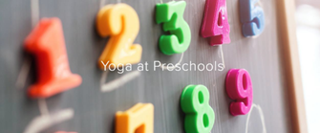

Offer BetterLife Yoga at your childcare centre or Kindergarten!

Give little ones a way to let out their energy in a healthy and mindful environment. BetterLife Yoga’s experienced kids and teens yoga teacher teach children to have fun with yoga, build strength, focus, balance and coordination in a kind and nurturing way.

Yoga sessions can be tailored for the different ages of children, group size, curriculum strand / themes in the centre, weekly program, or one-off class. We bring yoga to you and ​Catering for the whole centre:
- 15 min classes with ages 2-3
- 20 min class with ages 3-4
- 30 min class with ages 4-5

Costs: from $90- $180 depending on location, duration, mats, class sizes

Yoga in Schools…

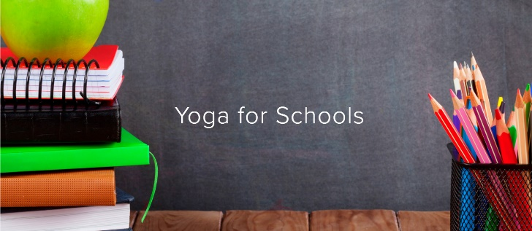
Offer BetterLife Yoga at your school!
Classes are tailored by the age of students, group size, curriculum strand / made relevant to a subject, term program or one-off class for both Primary and High Schools. We bring yoga to you…options include after school yoga club, yoga as a PE unit, yoga in health class, and more.
Experienced kids and teens yoga teacher that engage kids with thoughtful yoga classes that develop strength, focus, confidence and more. Balanced with time to breathe and reset.
Online Classes are also available
​​Costs: from $120- $200 depending on location, duration, mats, and class size.

Yoga for Tweens (aged 7-11)…

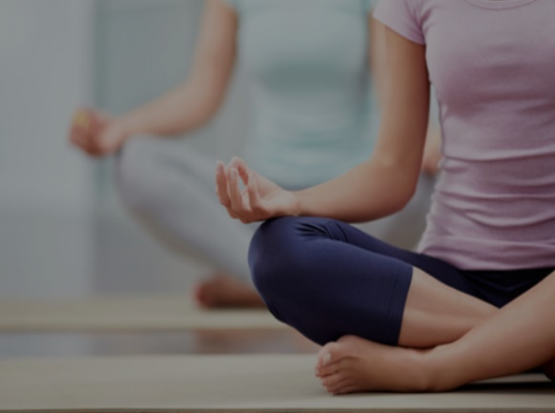

An interactive 60-minute class for children aged 7-11 to enjoy yoga poses; games; partner yoga and learning life skills in a fun way. Each class ends with quiet time to breathe and relax.
​
When:
Day & Time
Term: e.g.: July 20- Sept 7
​
Where:
TBC
​
Cost:
$55 4 class pass
$110 term pass
$170 term pass for 2 siblings
No credits for missed classes

Book Now Link
​

Yoga for Teen Girls…

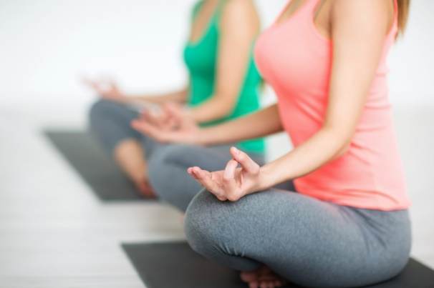

A beautiful class for teen girls to learn life skills and build self-confidence through yoga poses and empowering affirmations and partner yoga. Each class ends with quiet time to breathe and relax.
​
If your daughter is not yet a teen, but is in high school, she can join.
​
When:
Thursday, 5-6pm
Term 3: July 20- Sept 7

Where:
TBC

​
Cost:
$60 4 class pass
$120 term pass
$190 term pass for 2 siblings
No credits for missed classes

Book Now Link

Private Sessions…
​
If a group class is not suitable for your child, or if they would benefit from an individualised program to suit their needs, then you can consider a private lesson. ​

​As a Kids Yoga Teacher, I have a Working with Children's Check card, first aid certificate, insurance, and relevant qualifications.

One on one, private sessions are the most effective way to ensure the student receives exactly what is right for them in the moment.
​
Enquire Now Link
​

Kids Yoga Online

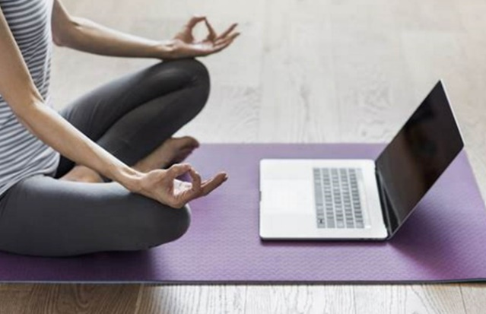

"Online" is the new world we live in... and whilst it is not my favourite way to connect, it is better than no connection at all…..So, if face to face sessions with me aren't possible, check out these options.

Online private sessions for kids

​Online private sessions on zoom are designed for kids who physically cannot make it to a yoga class, either due to distance, anxiety, or medical reasons. I will tailor the activities and duration (30-60 mins) to suit their individual needs.

Yes! I want my child to learn calm tools in a tailored, online private session Enquire Now Link

Online sessions for schools
Home learning during lockdown takes its toll on everyone- kids, parents & teachers. If you want to schedule in a little chill out time between lessons, or at the end of a structured day of learning, I will teach a class that is tailored to your group's age & needs. They don't even need to look at the screen the whole time!

Options for:
- Preschool & Prep
- Primary School
- High School

​Yes! Our kids would benefit from some chill out time Enquire Now Link

Blog Page

To be able to add Blogs moving forward

Contact Page
Find Out More…
If you would like any further information or simply need clarification, please send me an email and I will happily answer your questions either via email or over the phone if you prefer.
Form to contact via email
Name*
Email*
Subject*
Message*

Alternatively, please call Michelle 0437 772 974

Website Footer…
To include:
- Logo
- Facebook Icon
- Instagram Icon
- Email address
- Copyright 2023 BetterLife Yoga

