

Existing site: www.sploj.com
The concept:
Be easily found by displaying a code
If you visit the site and select ‘A1’ and company then you get an idea.


The code is displayed on a car, caravan/holiday home or company vehicle.

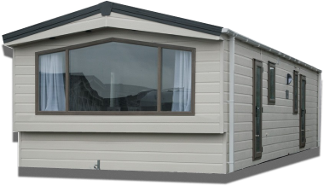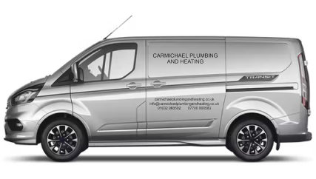
Existing images:
The background image is a mix of the 3 images.
It is NOT compulsory to use these images. We want to use real images in the future of a car, van, caravan with a real ‘code’ but use the existing images if needed or find real images of a real van, real car, real caravan to use in the meantime which can be replaced at a later date
Possible Text:
Simple – create your advert and display your code
Unique – customers find you by an easy-to-remember code
Effective – customers are directed to you and not a list of your competitors
This is taken from a previous version (please ignore the design)

If this can be improved on then please do so.

The Brief:
There’s nothing about the current design that absolutely needs to be kept. You can start with a blank canvas.
The website should be simple, crisp, clear and modern. At the minute though the website is too simple. It needs to look more professional and interesting.
I don’t particularly like black, white, grey and yellow as colours for a website but unfortunately I think it has to be this way to match the dark grey and yellow vinyl graphics that are displayed on company vehicles and caravans.

