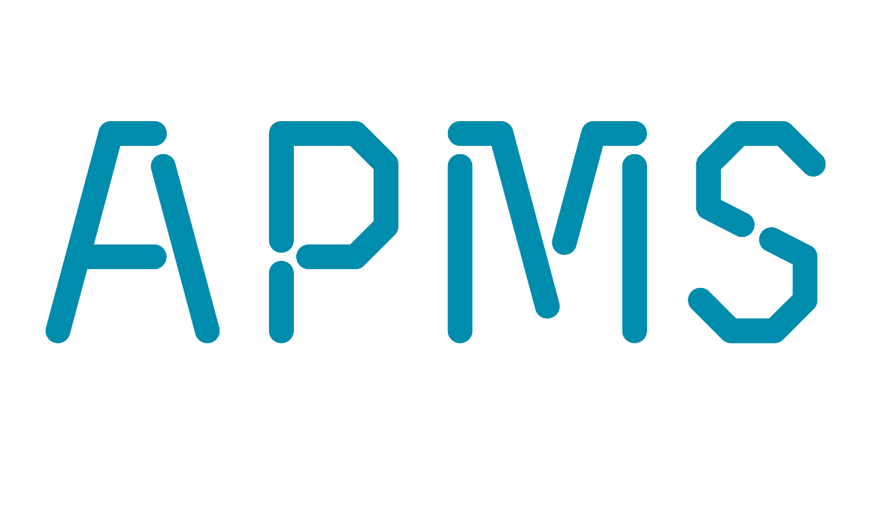


ADELAIDE PIPELINE MAINTENANCE SERVICES
Proudly South Australian owned and operated since 1952 and still the pioneers in the industry.
Our wide range of state of the art, specialist equipment is operated by the most experienced technicians in the country and will enable us to find solutions to all of your sewer, stormwater and hydraulic problems.
An expansion into pipe patching and relining using the very latest technology allows us to offer an affordable solution to a range of common problems.
Availability in all areas of South Australia including regional.

Services include:
- Water Recycling Combination Jetvac and Hydrojet Drain cleaning
- CCTV inspections of new and existing stormwater and sewer
- Hydro-excavation (non destructive digging) of drains and services
- Location of underground services
- Confined Space entry
- Patching and relining of damaged pipework.

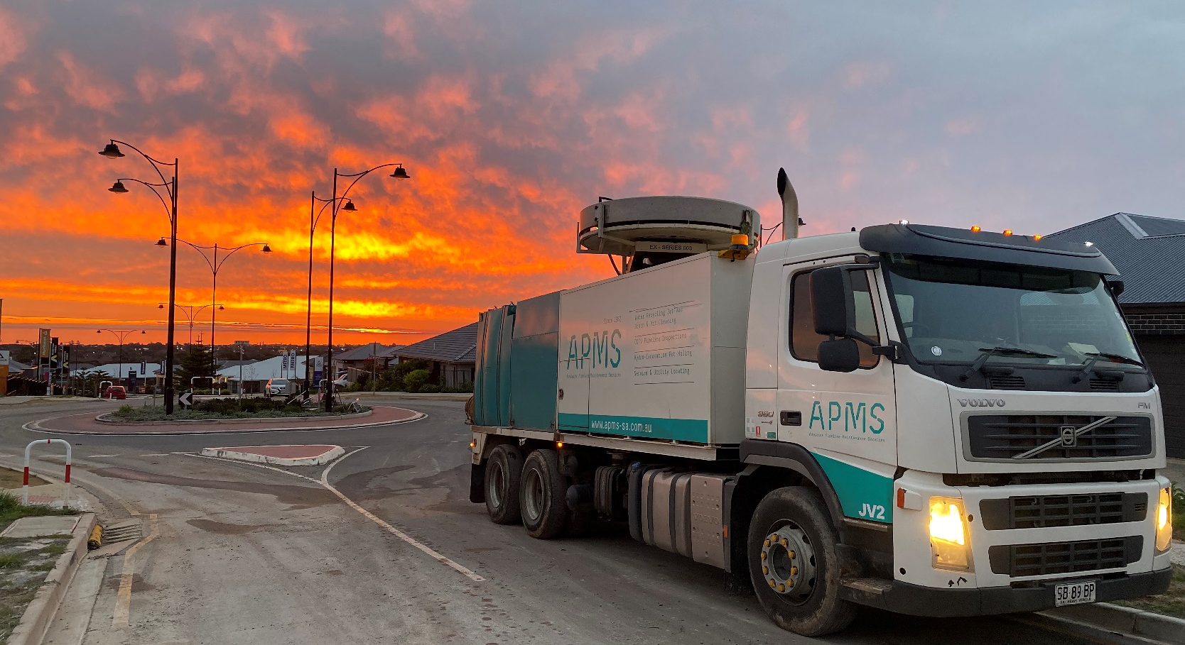
93-99 Mooringe Ave, Camden Park SA 5038 8427 2525 www.apms-sa.com.au service@apms-sa.com.au

