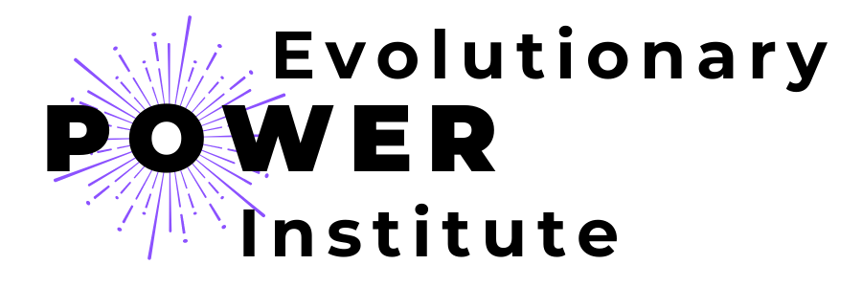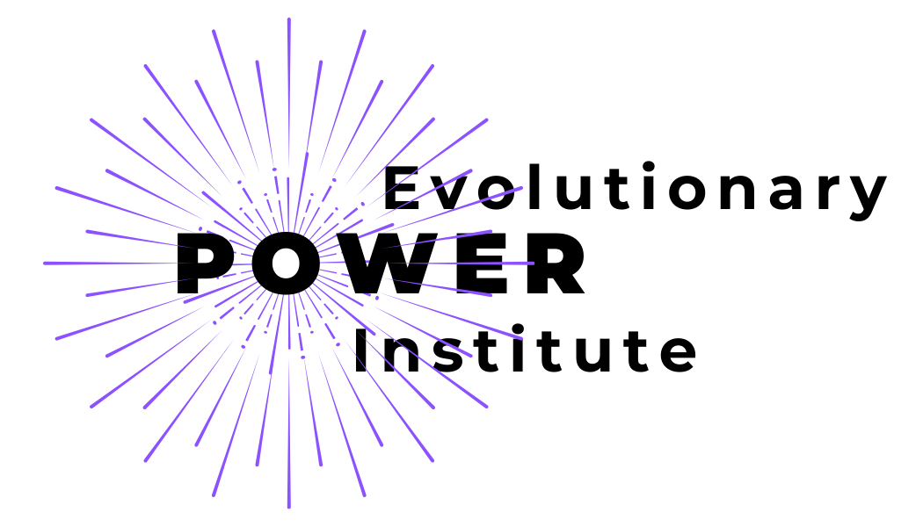

EPI Style Guide
#cba7ef | #6d03de | #b681ef | #0b3fbc | #0787e9 | #41b8e9 | #06bee1 | #fbf9f9 | #ffcb47 | #ffe300

#e0c9f8 | #7e7e7e

Circular social media icons | Style elements
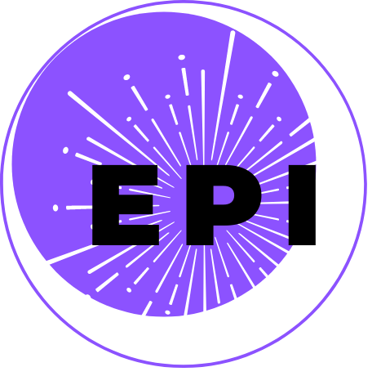 | 


Montserrat Semi -bold (50)

Montserrat (25)

Hind Madurai (Canva- Hind Guntur) (19)

Didact Gothic

