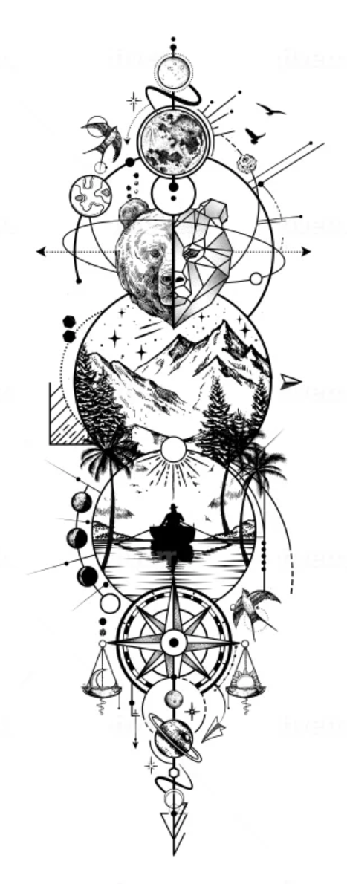
Like the animal head half and half, mountains and pines. Compass is a nice touch to needing direction.
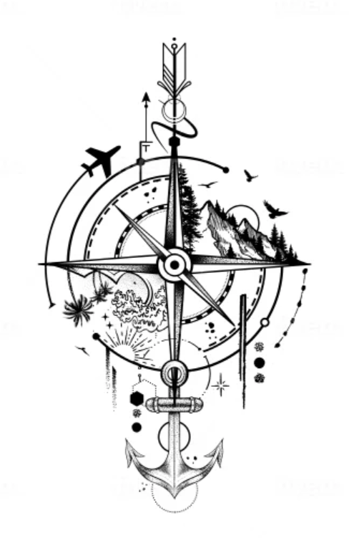
Compass with pines/mountains on one side and beach/palms on the other. Make plane a B-29. On the outside ring put Nash and Charlotte birthdates. Place to add Hebrew letters at the end, maybe Paul’s name in Hebrew?
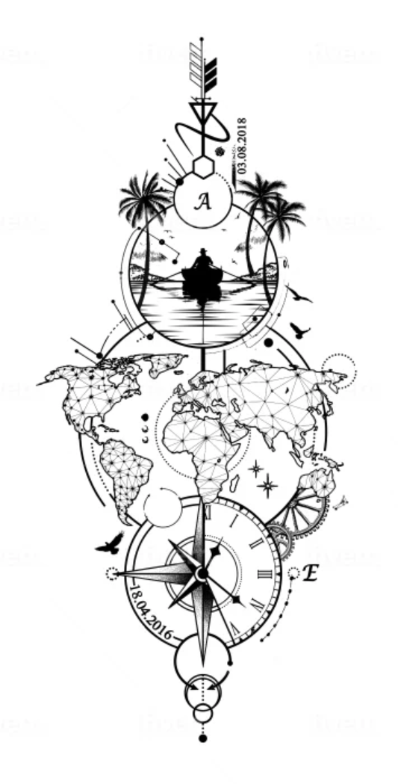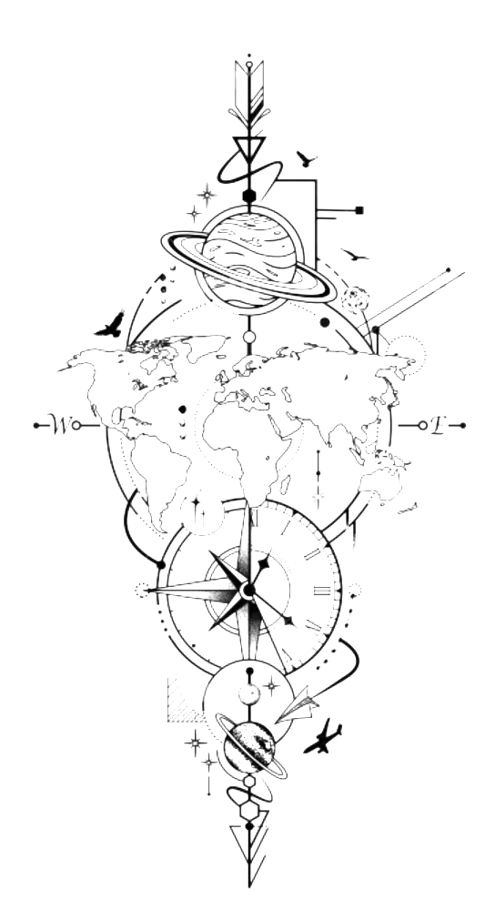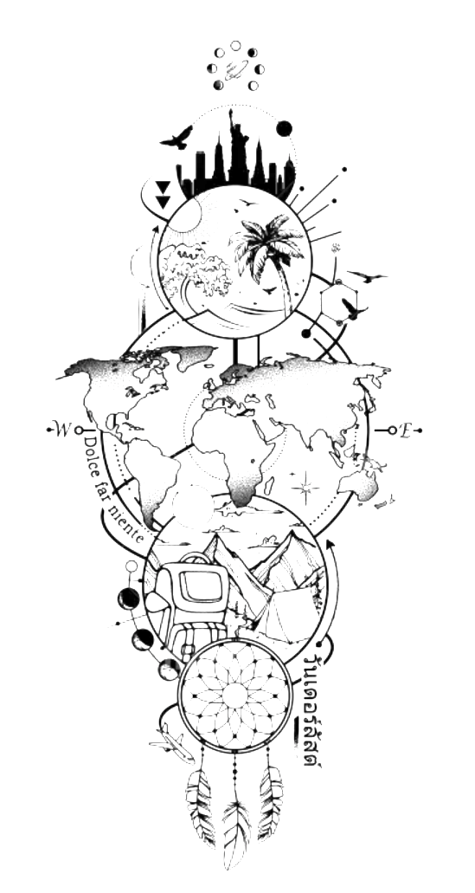
The geometric global map is really nice, but this might be better for a thigh tattoo I am looking to get as well.
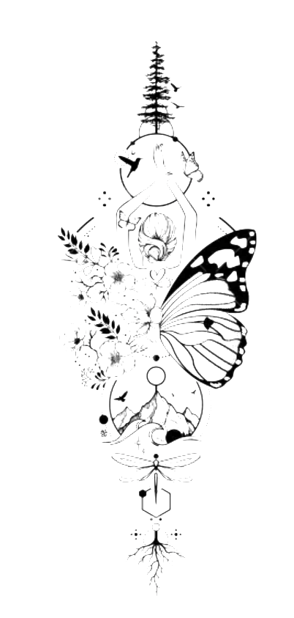
Like the less circles and more just artwork in a row.
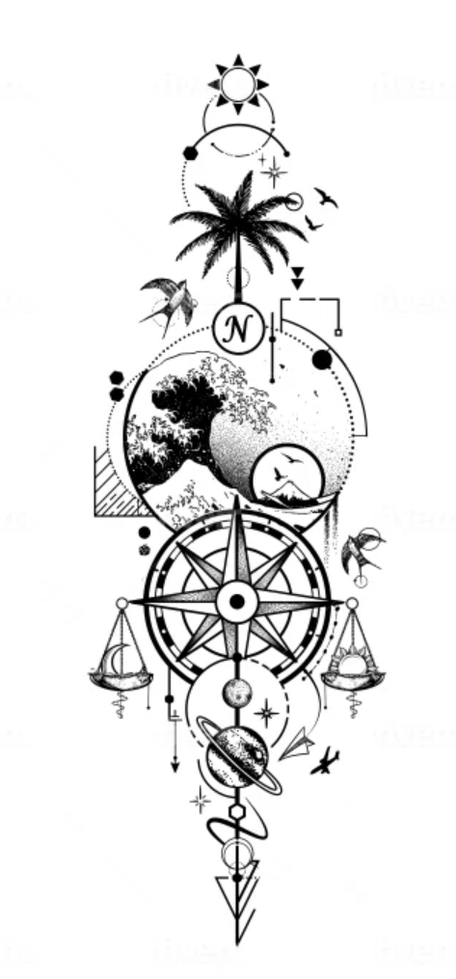
Scale on the compass is nice, finding balance.
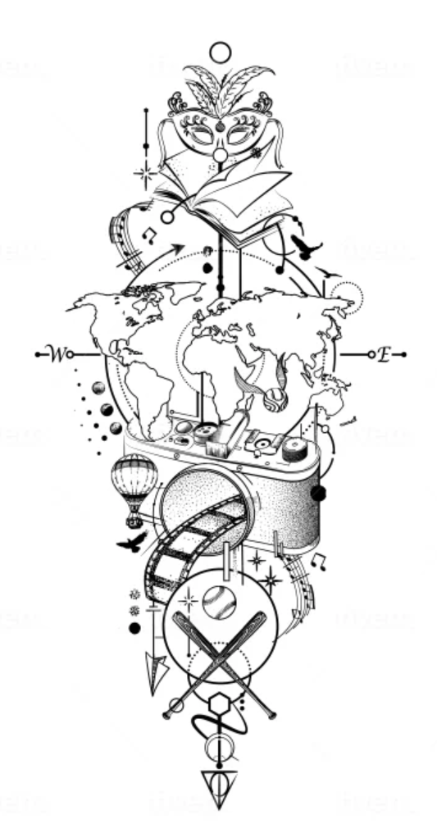Another of examples of more art less in circles.
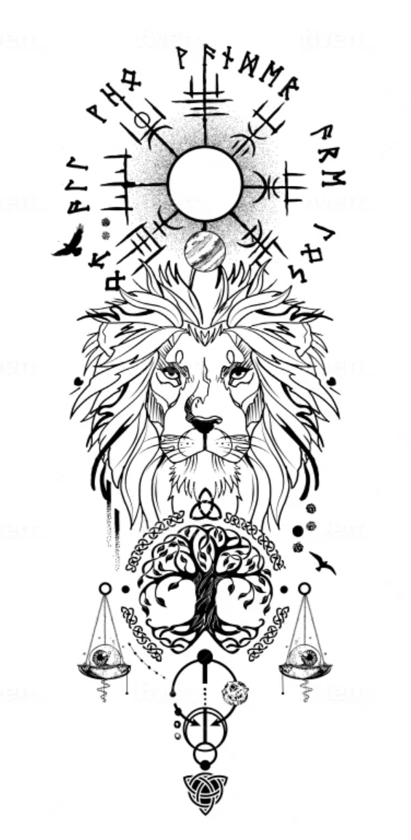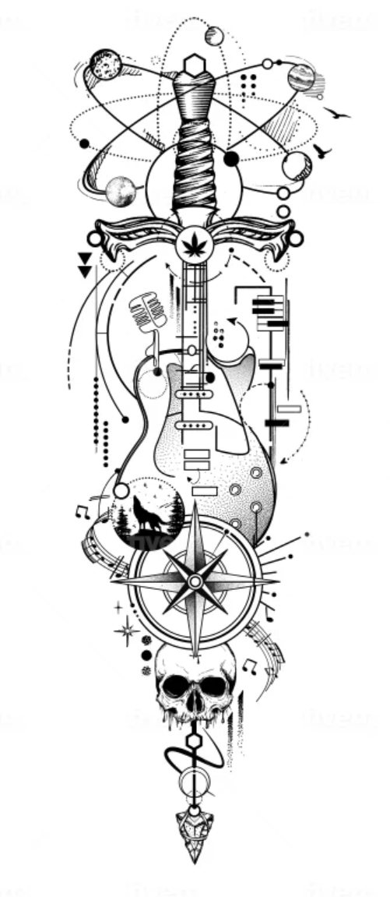
Thicker from one end, inner elbow, to wrist.
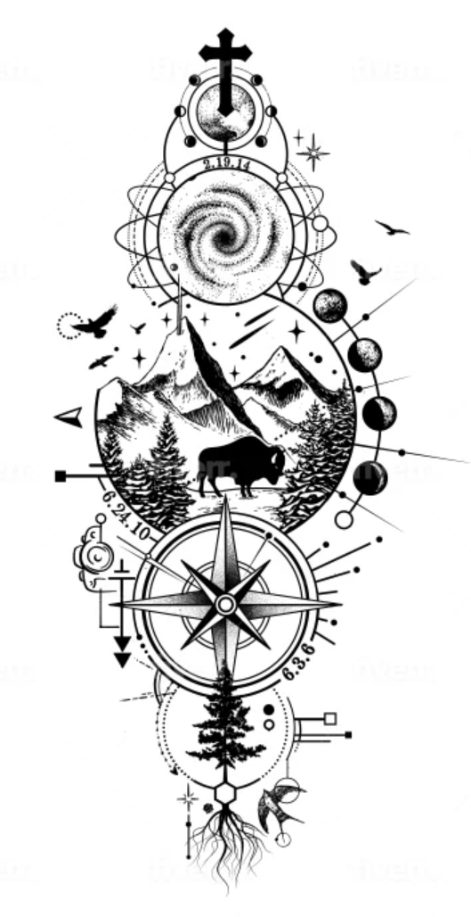
Kinda like the roots at the bottom.
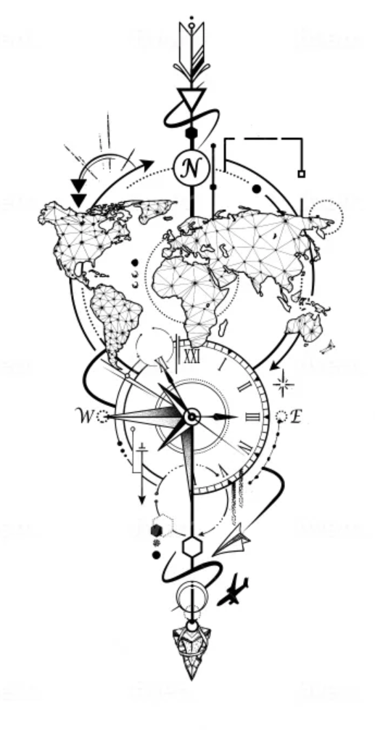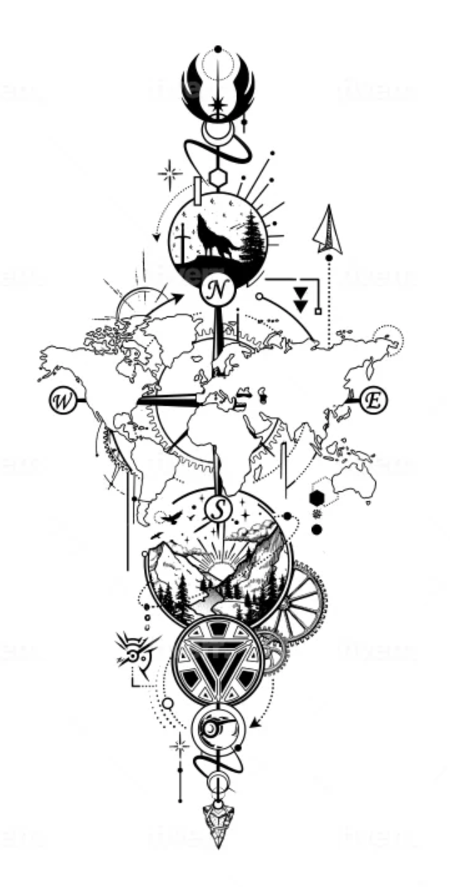
Like having “N” being towards the wrist. And the “E” and “W” on the compass. Or at least the “N” to always be moving forward, or never lost.
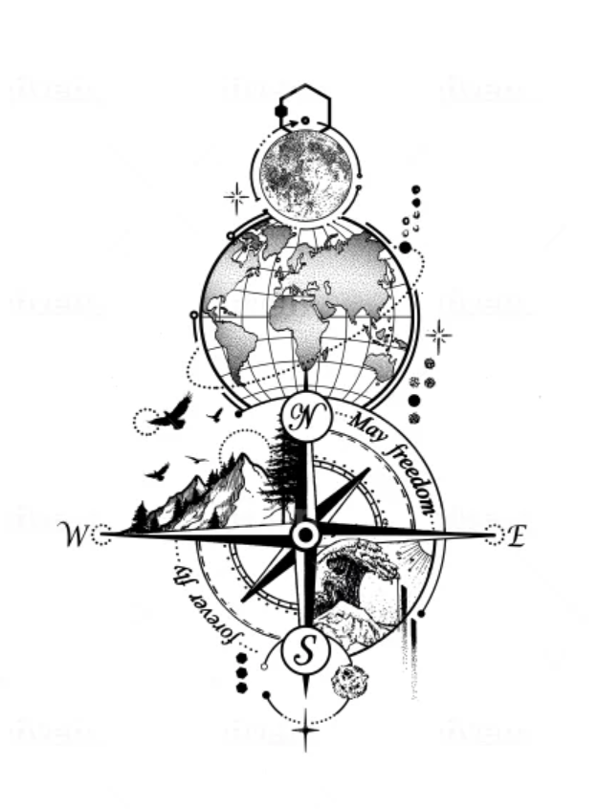
Another take on the mountains and ocean on the compass.
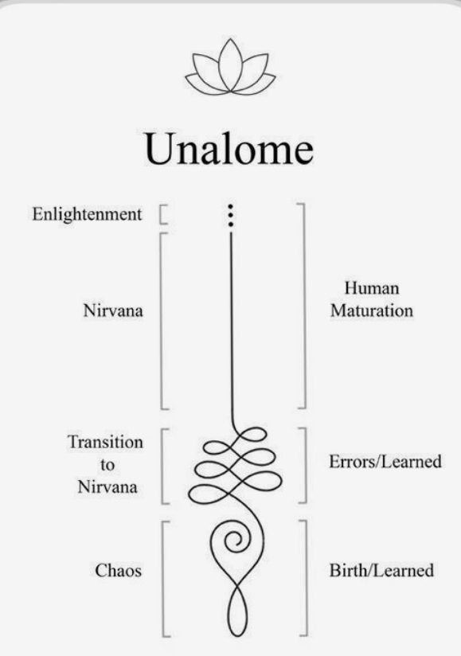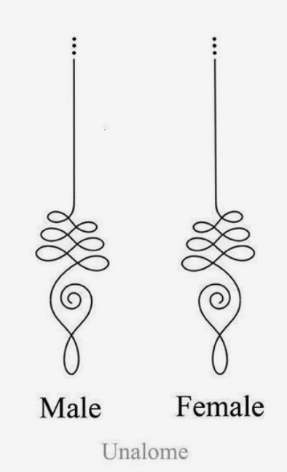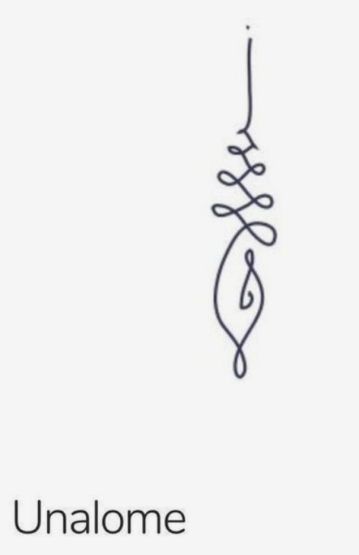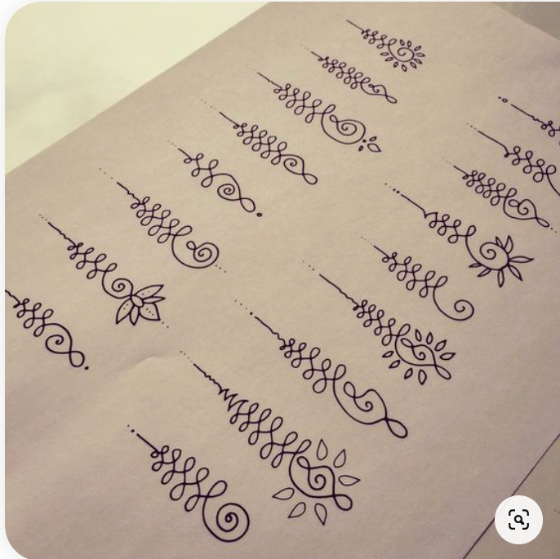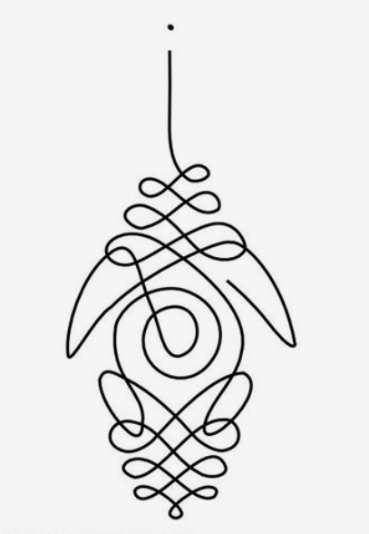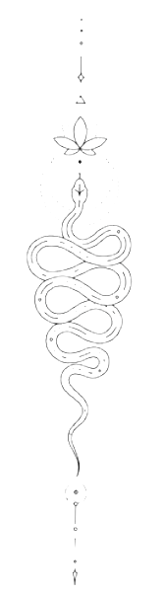
Ideas for customizing the Chaos and Transition sections of the Unalone

