CC Media Training

Slide 1 (Title):

Media Training

[Space to insert info about participant, location, etc.]

Logo

******
Add a static bar at the top that will remain throughout all content slides showing the section title with the logo on the far right

Section 1: Introduction to Media Training

Slide 2:

What is media training?

- It’s not natural.
- It requires practice.
- It’s about developing a mindset.

Slide 3:
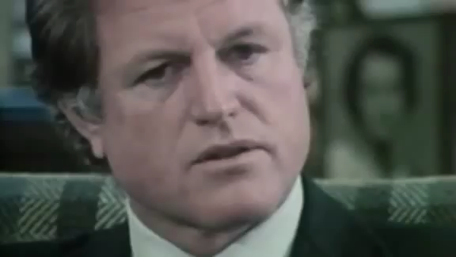
Training and preparation are the difference between success and failure.

Slide 4:

Goals:
- Learn how to prepare
- Develop a strategy
- Clarify message
- Build a practice approach

****
Section 2: Preparation

Slide 5:

What to negotiate?

- Timing and location
- Rules of recording/broadcast
- Rules of translation
- Questions
- Recording (for accuracy)



Slide 6:

Create your story.

Slide 7:

On the record:

- Everything for print
- Your name for attribution
- Always assume everything is on the record

Slide 8:

Off the record:

- Not for print
- Not for attribution
- Doesn’t mean it won’t be used/printed

Slide 9:

On Background:

- Education
- Context for print
- Can be used with attribution
- Attribution to be negotiated

Slide 10:

Preparation Matters!
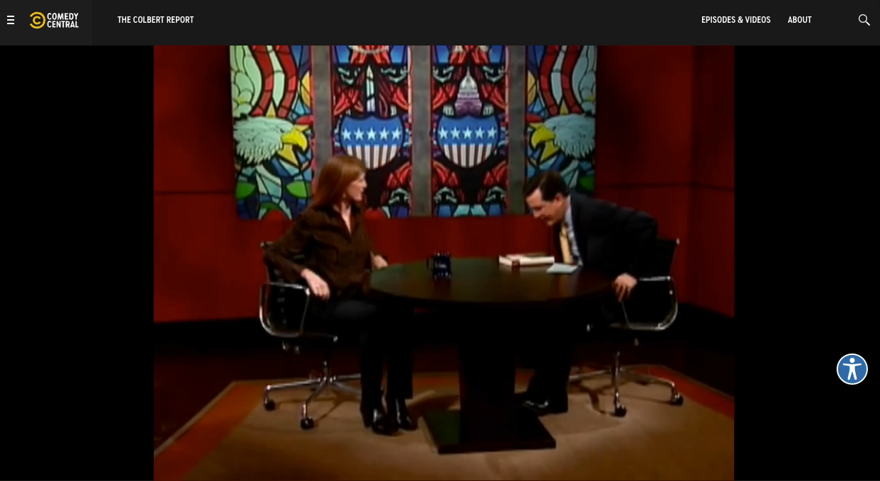

Slide 11:

Schedule

- Develop Q/A
- Write answers but also vocalize
- Practice: table
- Practice: mock

Slide 12:
Go Wider

- Know recent news
- Know your footprint
- Know upcoming events
Slide 13:
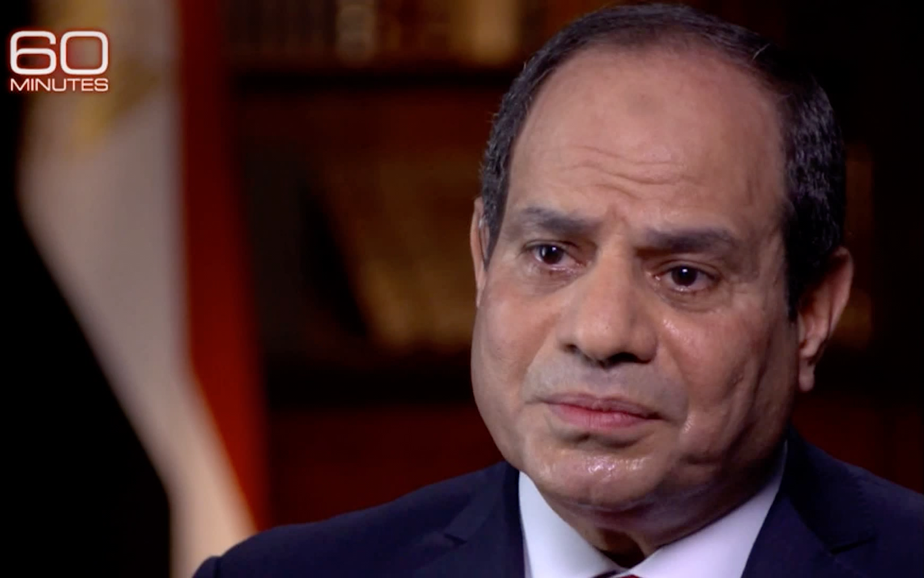
Media Approach

- Advance use of social media
- Control content – cut and distribute
- Damage control – surrogates and channels
- Follow up, one off has limited value

Slide 14:

Case Study – Without Preparation

Slide 15:

Case Study – With Preparation



*****
Section 3: Message

Slide 16:

The Elevator Pitch:

One Main Message

Slide 17:

Good messaging:

- Forward looking
- Positive
- Common language
- Connect

Slide 18:

Bad Messaging:

- Complicated
- Negative, accusatory
- Buzz words, jargon
- Uninteresting

Slide 19:

The Message Diamond
1
2
3
- Main Message
- Enhance (story, anecdote, example or fact)
- Repeat

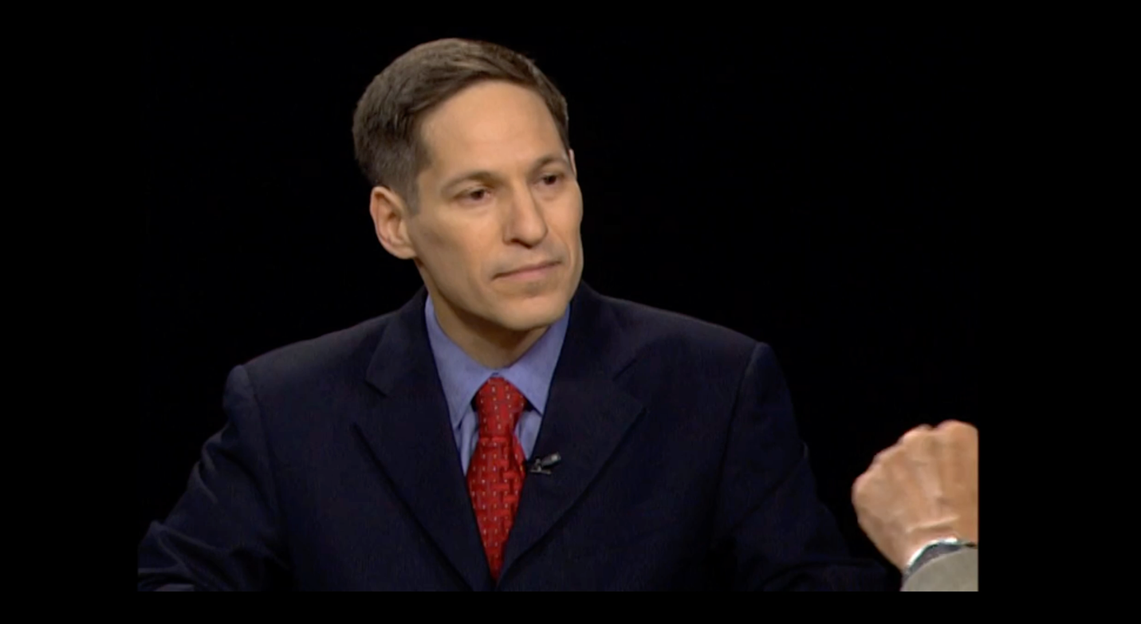
Slide 20:

Message Diamond in Action

Slide 21:

Repetition
- Same message, different versions
- Attention span
- Rule of Seven

Slide 22:

Decade of Consistency:

Obama at the 2004 and 2016 Democratic Conventions



Slide 23:

Know Your Audience

Who are you talking to?
- Peer group
- Financial community
- Specific decision makers
- General population

Slide 24:

Storytelling vs. Data
- Relatable
- Trust and transparency
- Personal
- Remember stories, not numbers

Slide 25:

Make News

- Reason for interview
- What is your headline?
- Surprise/take-a-way

Slide 26:
Make news or be the news.
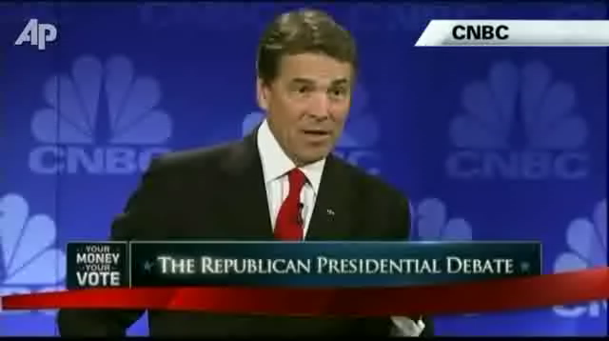

Slide 27:

Owning the Interview
- You’re in control
- Your answers are more important than the questions.
- Message is more important than the story.

Slide 28:

Owning the Interview
- Reporters are a tool
- Reporters access your audience
- Reporters are not friends and not enemies

Slide 29:

Anticipation
- Predict questions
- Research journalist
- Know bias and intent
- Get ahead of questions

Slide 30:

Handling Challenging Questions

What to do:
- Welcome chance to clarify
- Acknowledge
- Address directly

Slide 31:

Handling Challenging Questions

What not to do:
- Don’t ignore
- Don’t use “no comment”
- Don’t get defensive
- Don’t ramble

Slide 32:

Handling Challenging Questions

The Bridge
- Acknowledge
- Pivot
- Message

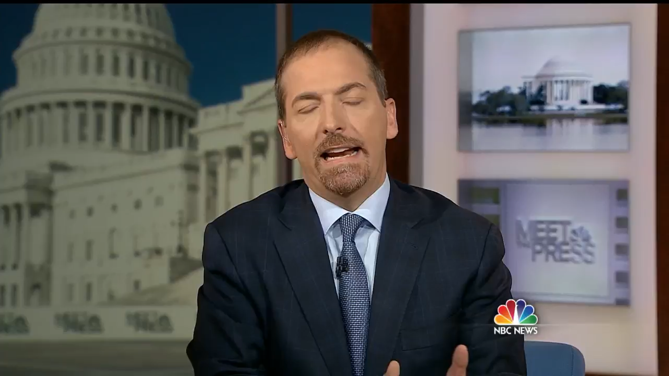
Slide 33:
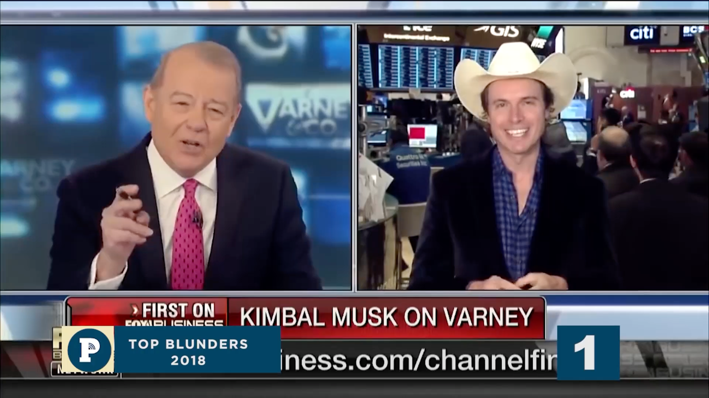
Bridge Failure

Slide 34:
Bridge Success

Slide 35:

Handling Challenging Questions

Use language like this:

- “I’ll get back to you, but…”
- “We’re still gathering information on that, but…”
- “I’m not fully familiar with that, but….”
- “I can refer you to X on that, but….”
- “That’s important, but…”
- “What I can tell you is….”

Slide 36:

Nonverbals

Body Language

- Eyes
- Expression
- Hands
- Legs
- Posture

Slide 37:

Nonverbals

What to wear
- Send a message
- Casual vs. business
- Business vs. traditional
- Nothing distracting
- Event branding

Slide 38:

Control the Space
- Setting
- Sit/Stand/Walk
- Timing/Length

Slide 39:

Zoom World

- Background
- Lighting/Windows
- Interruptions
- Eye contact
- Know the platform

Slide 40
Zoom Problems

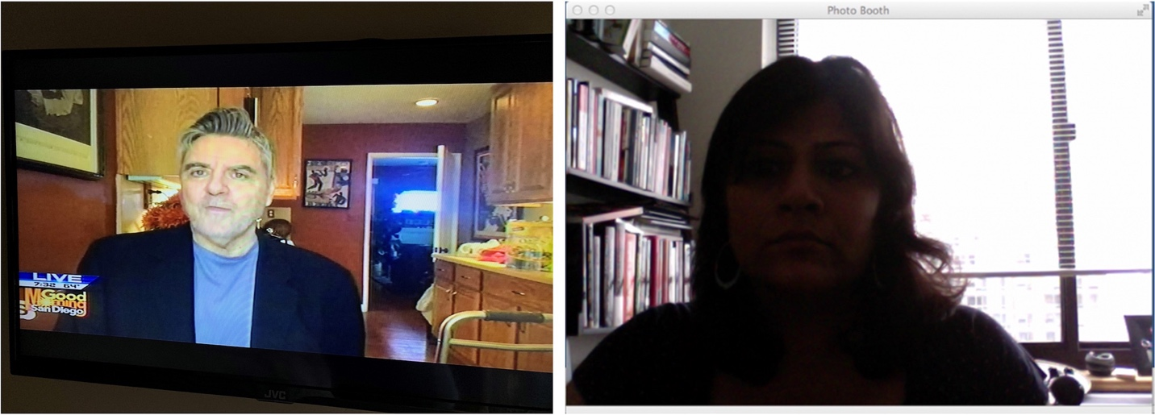

Slide 41
Zoom Problems

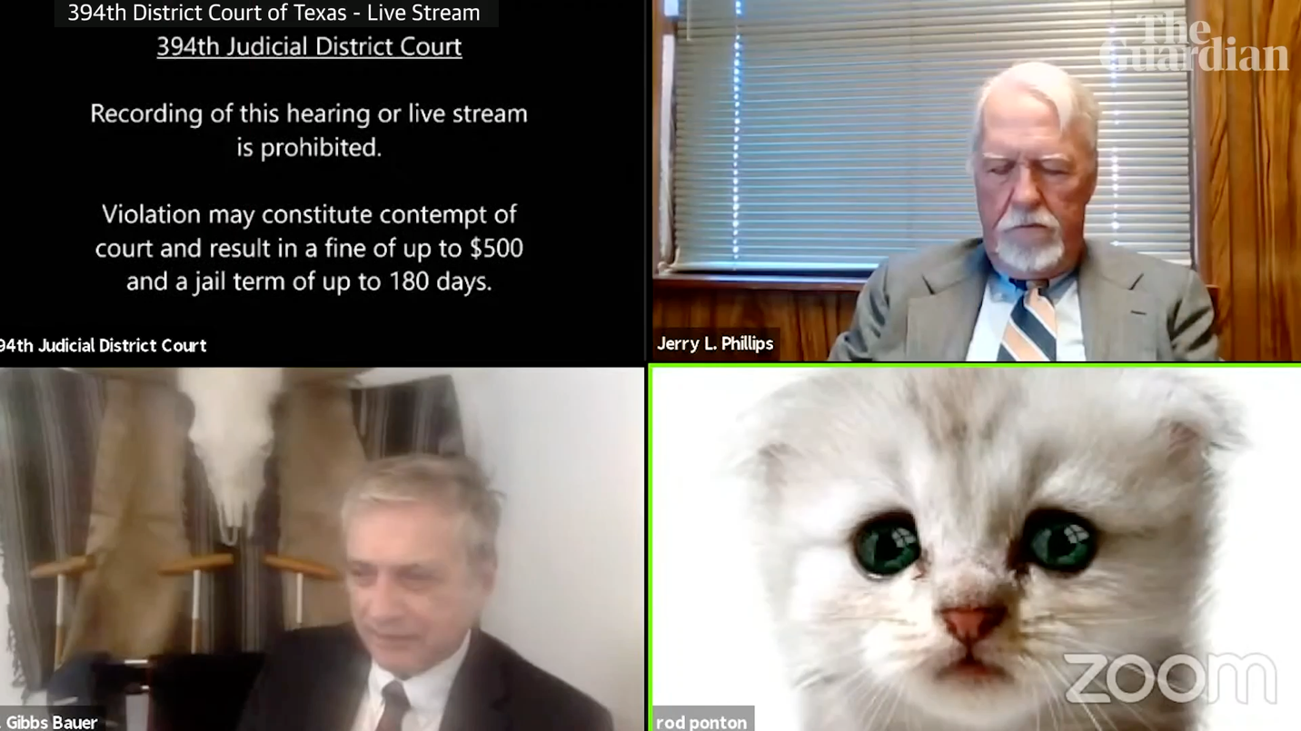
Slide 42

Zoom Problems

Slide 43:

Mistakes to Avoid

- Mic always hot
- Never guess or speculate
- Never over answer
- Never fill empty space
- Journalists are everywhere

Slide 44:

Interview – Keys to Messaging

- What do people need to know
- What needs correction
- What is your story
- What is the unexpected question

Slide 45:

Interview – Keys to Success

- Message repetition
- Write the headline
- Set the tone
- Control after

Slide 46:

Next Steps

- Work with Messaging
- Know misconceptions
- Regular practice
- Always full prep before interview

Slide 47:

Scenario – Rapid Fire Interview

Focus on Message Brevity


Slide 48:

Scenario – Print Interview

Focus on Message Consistency



Slide 49:
Scenario – Television Interview
Focus on Message Delivery

