P.O.S Box design. Tower

All Bar codes to be placed in their proper place.
Inventory control bar codes on back.
Design should be eye catching, the use of bright colors.
Both sides of the box must have a simple 3 step process use of the product.
A pencil sketch of the process.
Image; Hand shaking the condiment packet contents to the bottom.
Step 1) Should say. Shake the contents to the bottom.
Image; Hands using the piercer to pierce the packet empty end.
Step 2) Should say. Pierce the packet 3 to 4 times.
Image; Hands squeezing out the contents out.
Step .3) Should say. Slowly squeeze the contents out.
Text on front box.
So simple to use even a child can do it.
Don’t put the condiment packet in your mouth to open it.
That’s just gross.
Use our Condiment Packet Piercer.
Great for people on the go.
Not a child’s toy, keep away from small children.

Made in China Dishwasher safe.
Count 24

The condiment packet piercer.
Whatever other text you think will help make sales or that are required by law.

Point of Sale bar code.
To be placed on the top front left of Box.
U.S.A & Canada
U.S.A & Canada
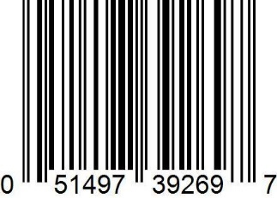

Point of sale bar code.
To be placed on the top right of Box.
Text above bar code.
European
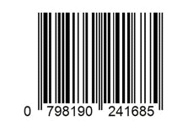

Inventory control Bar codes.
To be printed on the back of Point-of-Sale box with text.

USA and Canada Inventory bar code

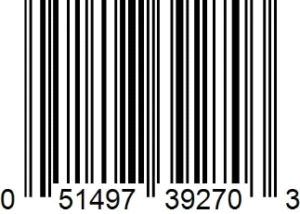

European Inventory bar code
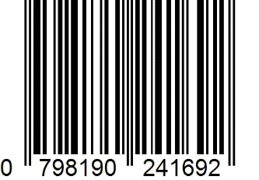
Tower = Product # 1002
Product of CPPI Inc
www.cppinyc.com
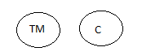

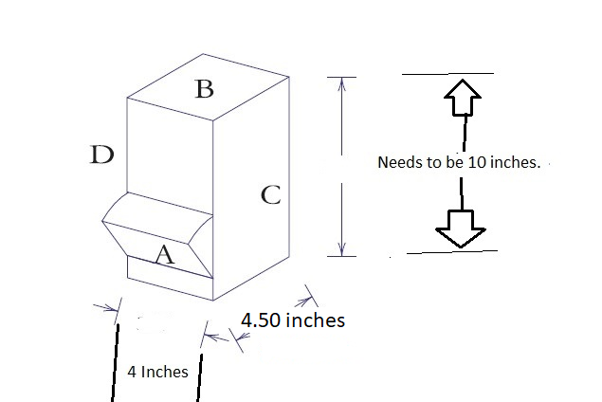

The templet is all in metric, convert to US standard and make sure the measurements meet my needs in the drawing on this page.

