P.O.S Box design. Slope Box

All Bar codes to be placed in their proper place.
Inventory control bar codes on back and count.
Design should be eye catching, the use of bright colors.
Both sides of the box must have a simple 3 step process use of the product.
A pencil sketch of the process.
Hand shaking the condiment packet contents to the bottom.
Step 1) Should say. Shake the contents to the bottom.
Hands using the piercer to pierce the packet.
Step 2) Should say. Pierce the packet 3 to 4 times.
Hands squeeze the contents out.
Step .3) Should say. Slowly squeeze the contents out.
Text on front box.
So simple to use even a child can do it.
Don’t put the condiment packet in your mouth to open it.
That’s just gross.
Use our Condiment Packet Piercer.
For people on the go.
Made in China
Dishwasher safe.
The condiment packet piercer.
Whatever other text you think will help make sales,
A blank circle for retailor to mark their price point on retail sales.
Not a child’s toy, keep away from small children.

Point of sale bar code for USA and Canada
To be placed on the top left of Box.
Text to be placed above bar code
U.S.A & Canada
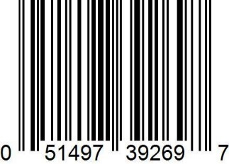
Point of sale bar code for outside the U.S.A and Canada
To be placed on the top right of Box.
Text above bar code.
European

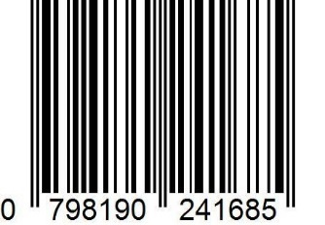

Inventory Control Bar codes to be placed on the back of box with text.

Inventory Control Bar Codes
U.S & Canada

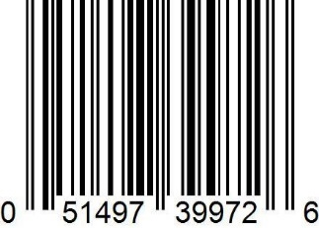

European
Printed on back
Product of CPPI Inc
www.cppinyc.com
Product # 1001
Count 24
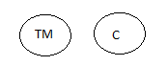

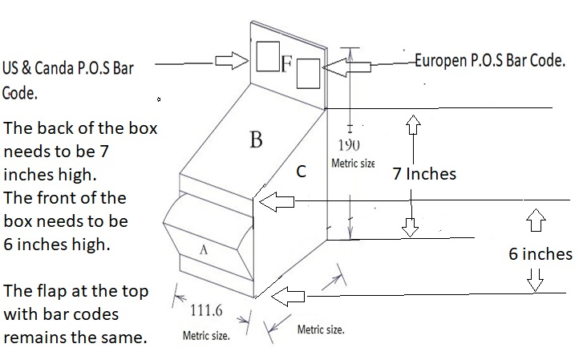
The templet is all in metric, convert to US standard and make sure the measurements meet my needs in the drawing on this page.

