Hanger
I’m thinking NYC taxi cab yellow background with black text.
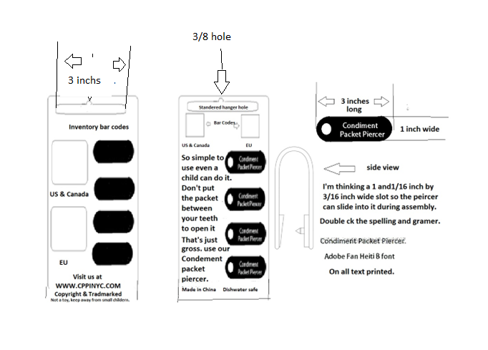
All Bar codes to be placed in their proper place.
Inventory control bar codes on back.
Design should be eye catching, the use of bright colors.
Text on front see drawing.
So simple to use even a child can do it.
Don’t put the condiment packet in your mouth to open it.
That’s just gross.
Use our Condiment Packet Piercer.
Whatever other text you think will help make sales or that are required by law.

Made in China
Dishwasher safe.
Not a child’s toy, keep away from small children.
The condiment packet piercer.

Point of sale bar code for USA and Canada
To be placed on the top left of hanger
Text to be placed above bar code.
U.S.A & Canada
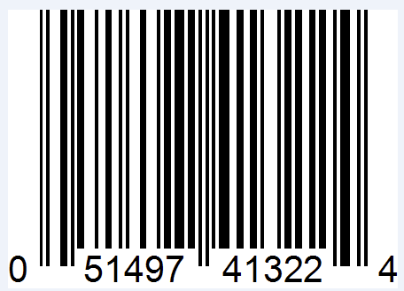

To be placed on the top right of hanger with text
European Point of sale bar code
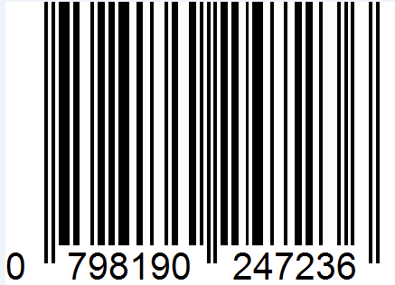

Inventory control Bar codes.
To be printed on the back of Point-of-Sale hanger with text.

European Inventory bar code
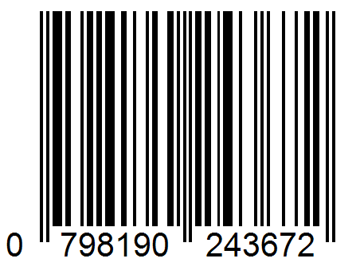

US and Canada Inventory Bar code

Count 4
Product of CPPI Inc
Product # 1004

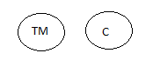

www.cppinyc.com
Not a child’s toy, keep away from small children.

