Transformation Delivered.

We do more for our customers than implement software. We listen. We work to understand where they are in their transformation journey and where they want to go. We partner with them to clear the roadblocks that stand in their way, ensuring they reach their destination. At Ascendex, we:

Focus on business value, with an emphasis on delivering value quickly.

Meet our customers where they are without backing them up to the beginning of their journey.

Provide a wide range of services, from strategy to product support.

Commit to our customer’s long-term success.

Ascendex is business transformation, delivered.

Transformation Supported by Technology
During our early years, Ascendex focused only on business transformation. We came to realize that successful transformation often depended on quality software implementations, and often more than one. Now we focus on five things, the five things most businesses need to reach their goals.
Business Transformation | ERP Implementations | CRM  Implementations | BI and Data | Building the Right Team of People
 |  | 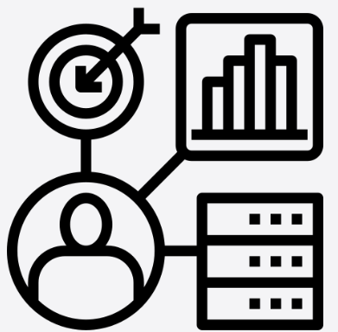 | 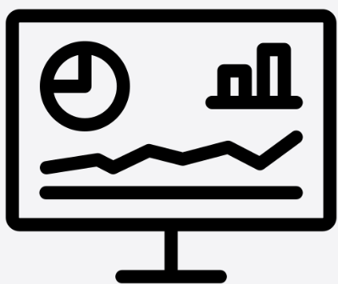 | Amplify  By Ascendex
Define and execute your strategy. | Assess, upgrade, and implement ERP solutions to meet your needs. | Take your relationships to the next level. | Discover, connect, and trust your data. | Hire resources for your transformation journey.
Find out how Ascendex can help you put all the pieces together and get them done.

It’s the People
The world has changed in the past twenty years. The people you need might not all work for one company. Our clients want the best resources, available quickly. That’s why, in addition to our team of experts, we partner with:
- A large network of expert consultants who are the best at what they do,
- Service providers all over the world to provide the resources and value that are right for you, available 24 x 7.
People are invariably at the center of our customer’s success. Find out how we can add our experts to yours.

