Questions – do I need a separate mobile site?
Either delete or needs update
http://mobile.muse2muse.com/index.php

Browser favicon

Want APP on HP that UPDATES DAILY DATE

FYI logo & branding used in past:
muse2muse
productions llc

site and branding logos


muse2muse p r o d u c t i o n s llc

Logo Font:
https://fontsgeek.com/vag-rounded-font

Also text font used
https://www.myfonts.com/collections/glypha-font-linotype

Should have my photo somewhere on homepage and perhaps WORK page – either one can be used anywhere. I can resize as needed:



Nav bar

HOME – global contact @ bottom of pages/?
ABOUT
WHAT WE DO
PORTFOLIO
CONTACT
Homepage copy

Tag line
We produce digital and print custom content and strategy that builds your brand and business.

Large type blurb HP Text copy

The power of a story is its emotional bond with the reader. And the power of a brand is the trust it inspires in customers. Marry those magnets and you understand the creative reach of Muse2Muse Productions, custom content provider.

Footer
Muse2Muse Productions LLC is Woman-Owned and Small Business certified (WOB, SMB).

ABOUT

Entrepreneur, author, online architect and widely published multimedia journalist, JOANNA L. KROTZ founded Muse2Muse Productions to provide customized content for print, digital and social media brands, businesses and nonprofits.

She is especially attuned to the brand-building needs of startups and growing businesses, having fine-tuned the art of reaching consumers and multitasking professionals at prestigious global marketers and national magazines.

As a top-rated editor at national publications, Krotz helped launch a journalistic transformation in home furnishings and interior design coverage. Directing coverage for 2 million affluent readers, she pioneered women's financial news and advice, with groundbreaking stories like "Women Are Smarter Than Men About Money." Later, Krotz oversaw coverage for more than a million entrepreneurs and as a featured small business columnist for MSN and Microsoft.

Often featured in national media, Krotz has been an adjunct professor at the NYU Center for Publishing and is a frequent keynote speaker and conference presenter at business leadership, entrepreneurship and philanthropy events.

Sidebar or box
Krotz is the author of:

- Being Equal Doesn’t Mean Being the Same: Why Behaving Like a Girl Can Change Your Life and Grow Your Business
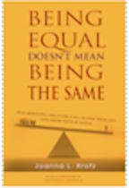

- The Guide to Intelligent Giving: Make a Difference in the World and in Your Own Life
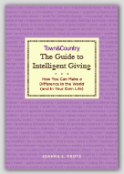

- Contributor, Leading Women: 20 Influential Women Share Their Secrets to Leadership, Business, and Life
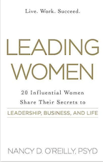

- Coauthor, The Microsoft Small Business Kit, a 500-page guide to launching a startup
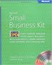

Text copy for WHAT WE DO PAGE

WHAT WE DO
We create must-read print, digital and social media communications. We have developed multimedia marketing solutions for some of the world's best-known brands, including Samsung, Microsoft, The Women’s Philanthropy Institute, Guardian Insurance, Hyundai, The Olympic Committee, LOTTE, The US Department of State and more.
The goal of every one of our communications is to attract and deepen relationships with your customers, stakeholders, investors and staff.
Every M2M product engages and inspires the reader to action. Every M2M publication entertains and delights. Every M2M electronic communication invites the user to discover and respond.
That's how you build loyalty and long-lasting, profitable relationships with customers.
Muse2Muse Productions
- EVALUATES your brand and marketing strategy, including your competition and most valued customers
- CREATES must-have digital or print features, newsletters, brochures and social media communications that build your brand's values and benefits
- LAUNCHES relevant online solutions to educate, acquire and retain customers
- DELIVERS value by sharing information and services that customers need

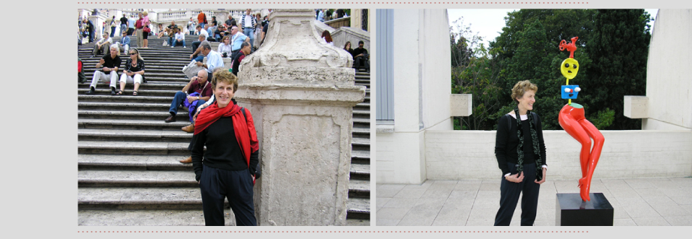

Text and images for PORTFOLIO
PORTFOLIO
Corporate
Muse2Muse Productions creates original digital and print branded content to promote and build brand messaging, products and services. M2M also produces e-news, custom publications and multimedia platforms, including e-books, brochures, point-of-sale posters, event and conference materials and online journals. Here are examples of recent work.

GENUONE SCIENCES


Created English-language text for website launch of this international provider of pharmaceutical manufacturing services and medicines based in South Korea.
http://www.genuonesciences.com/

HANWHA INTERNATIONAL



Created English-language text for Hanwha’s sustainability initiatives at The World Economic Forum in Davis, Switzerland (top) and for the 2023 Profile of all Hanwha international businesses (bottom).

https://www.hanwha.com/en/news_and_media/stories/sustainability/stepping-into-sustainability-in-2023-hanwhas-continued-partnership-with-davos.html

https://www.hanwha.com/content/dam/hanwha/download/Hanwha-Profile-2023-en.pdf

WOMEN’S PHILANTHROPY INSTITUTE
The Center on Philanthropy at Indiana University
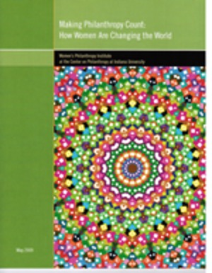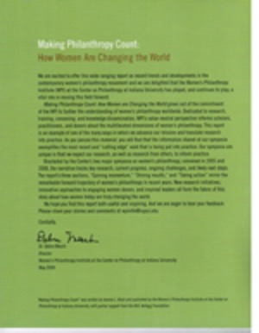
Commissioned to research, create and write a report on the contemporary women's philanthropy movement, "Making Philanthropy Count: How Women Are Changing the World."

https://www.wpi.edu/

PYEONGCHANG 2018 WINTER OLYMPICS

Created content for “New Horizons,” Korea’s winning bid pitch to the International Olympics Committee

Journalism & Profiles

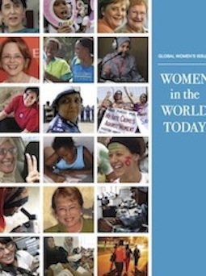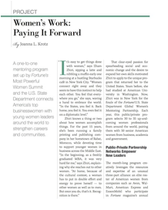
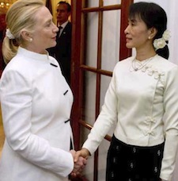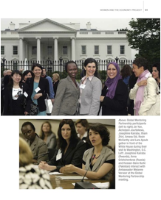
US Department of State Women in the World Today: Global Women’s Issues,
Focus on Hillary Clinton

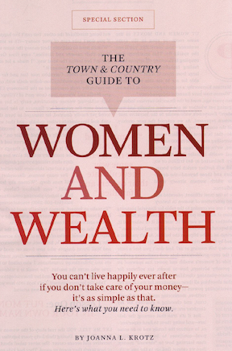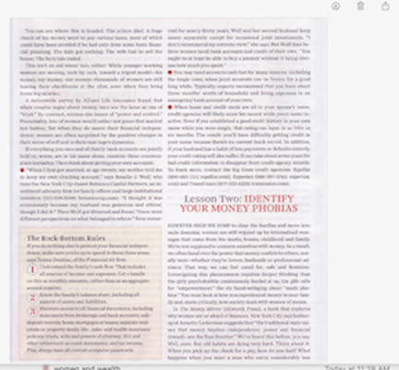
Town&Country:
Special section examining women’s financial decisions and relationships.

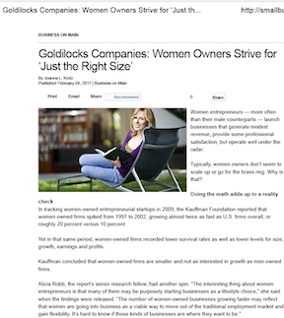

Fox Small Business News:
Women small business owners grow with smarts and balance.

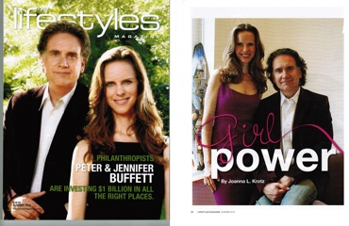

Peter and Jennifer Buffett are giving away a billion dollars —with care and consideration.

