- Windows Size is 2 x windows 2350mm high x 2930mm wide.
- Windows printing size is 2 x 1260mm High x 2930 Wide.
- Door size is 890mm wide 1040 High.

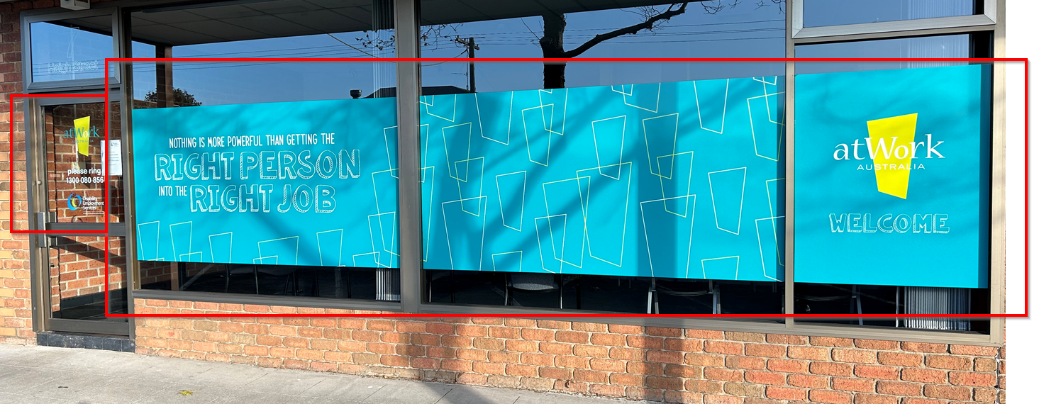

- This Sign: Size: 7800 mm x 1000 mm

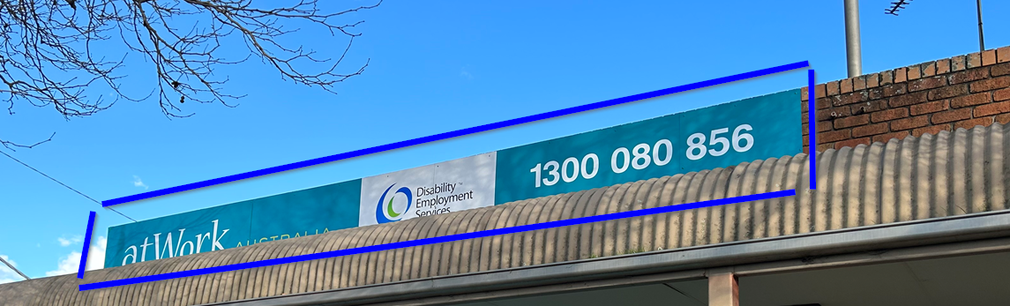

- This Sign: Size is: 340mm x 1800mm.

- Cars: Back Window and passenger and driver size
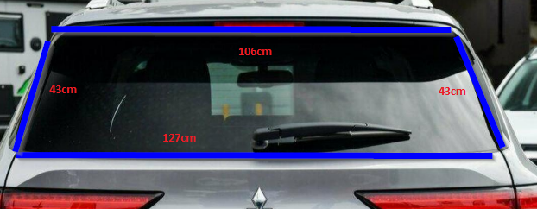
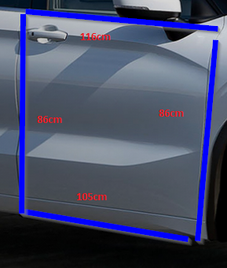
Current



- Business Cards.

