This is our Mood board for colours and vibe in terms of the office refresh update. We are actually getting the green, pink/ red circle couches in the middle and similar colour ottomats etc.
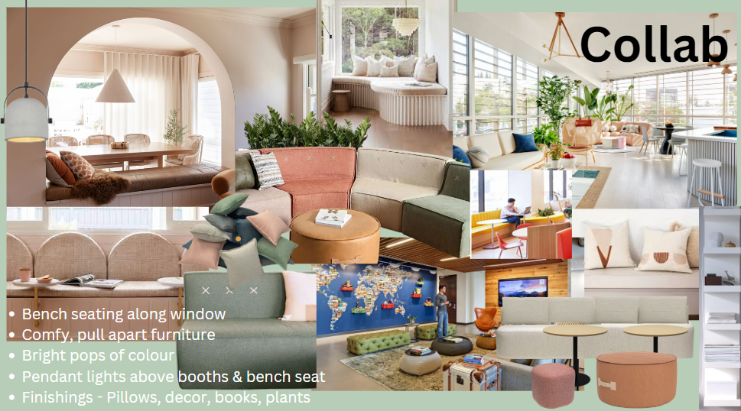
Below is some samples of styles and colours we like. We were thinking perhaps in the 4 x offices it could be more colourful and fun and then in the 2 x meeting rooms a bit more basic neutral, but it would be based around the meeting room names; e.g. Meeting room name: Spotify have the word obvious and then have music notes, maybe some with binoculars (play on words.. and some other random picture for. Each office connecting so its not all completely different, but individual.
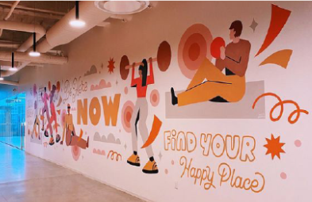
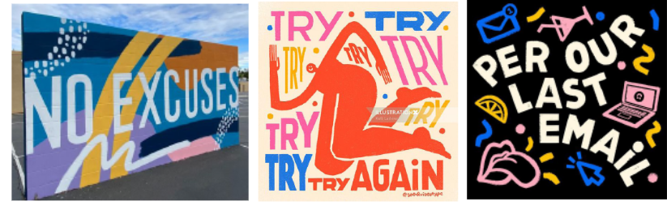
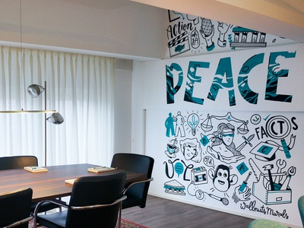
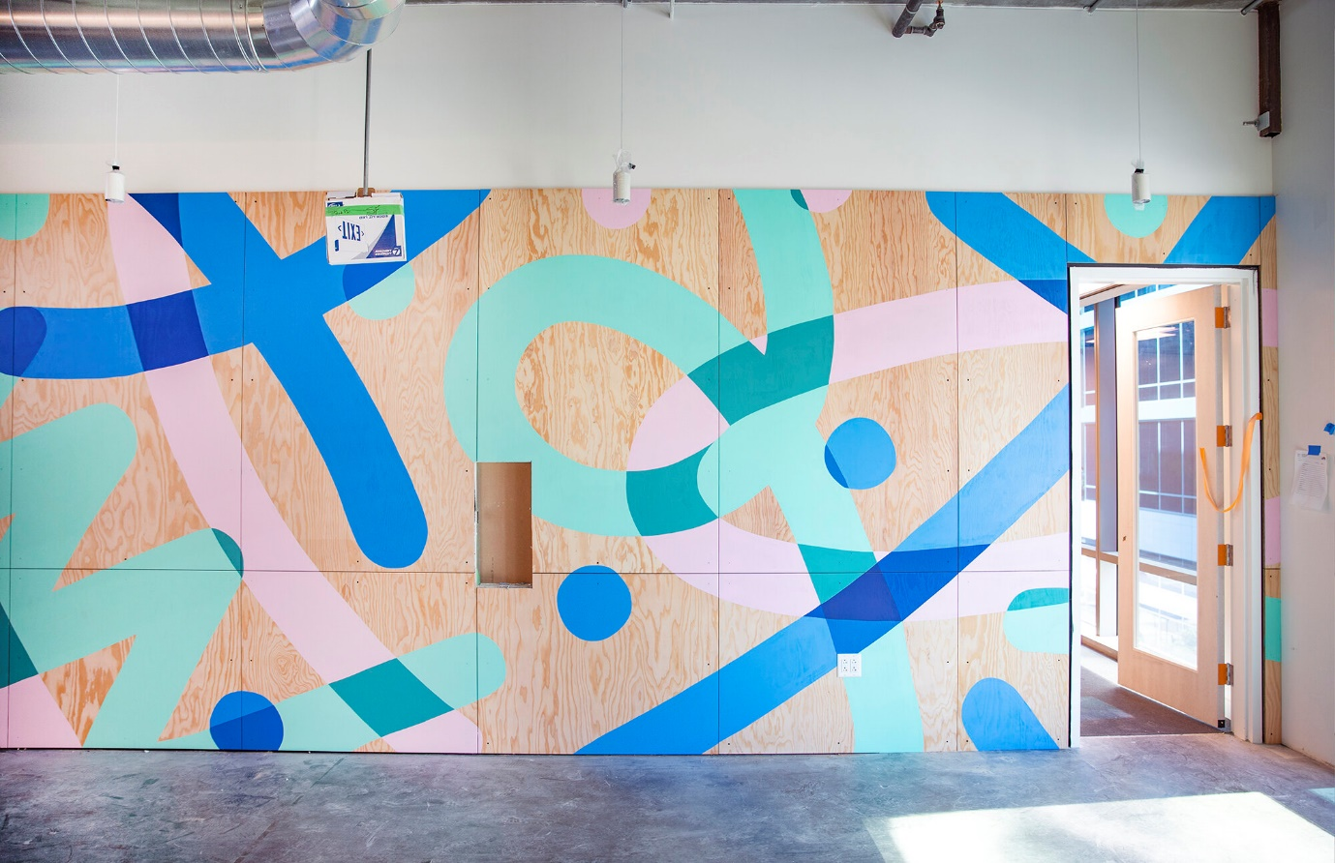
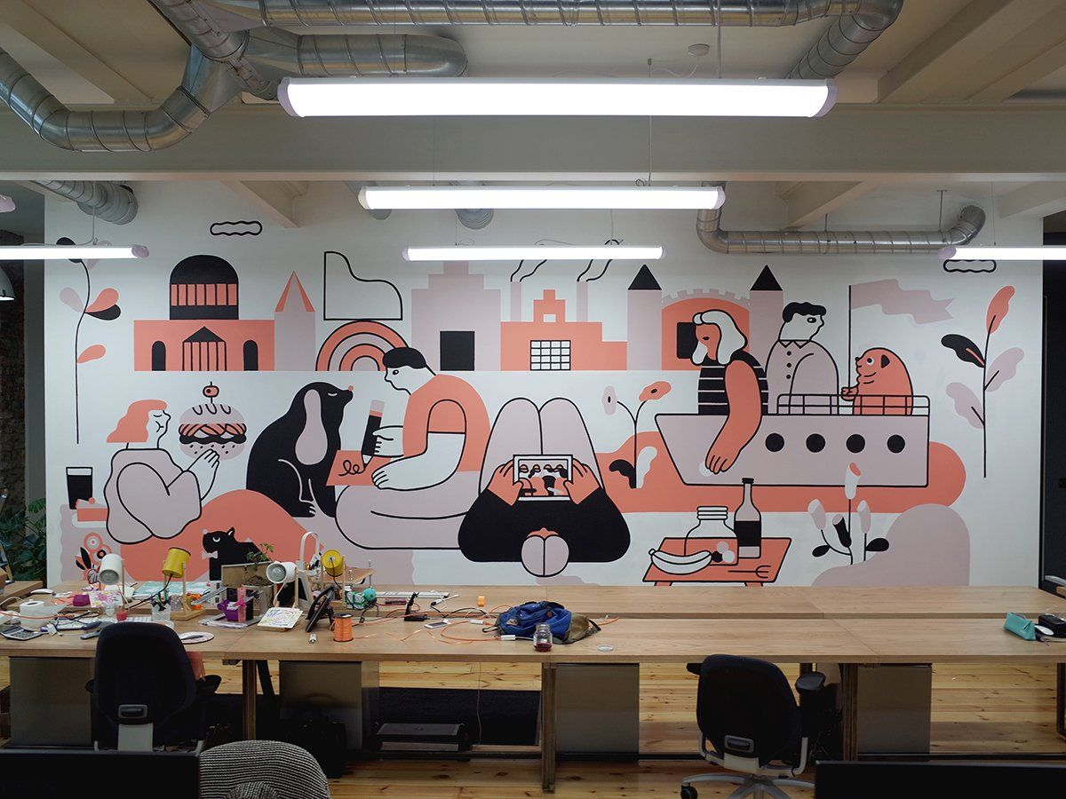
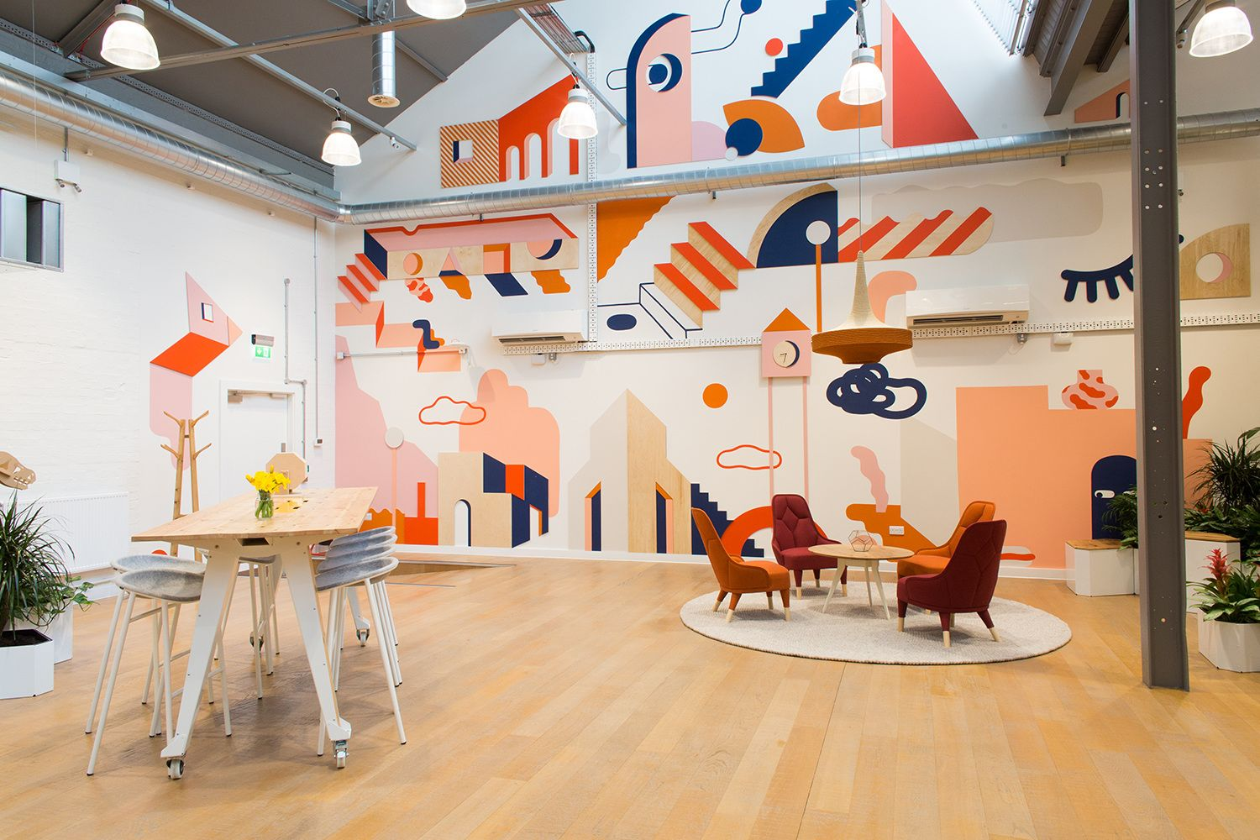
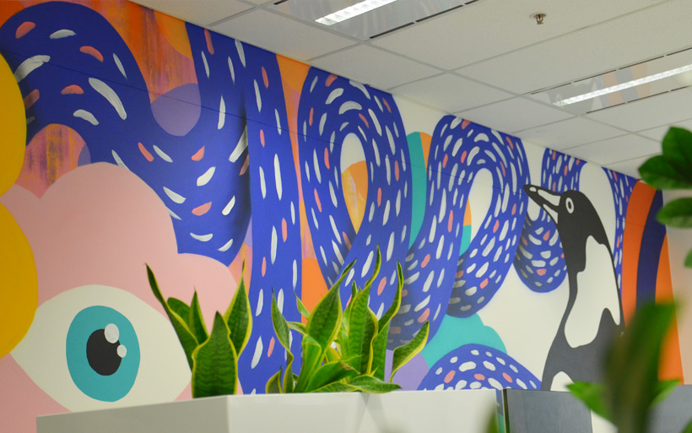
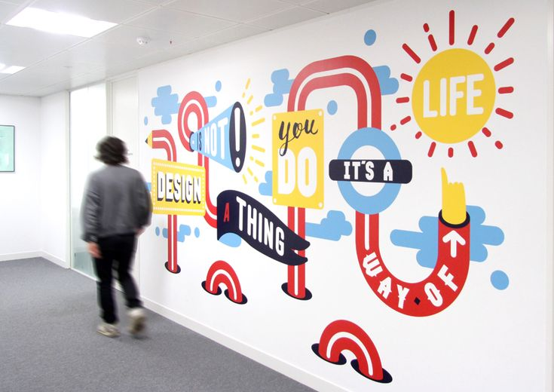
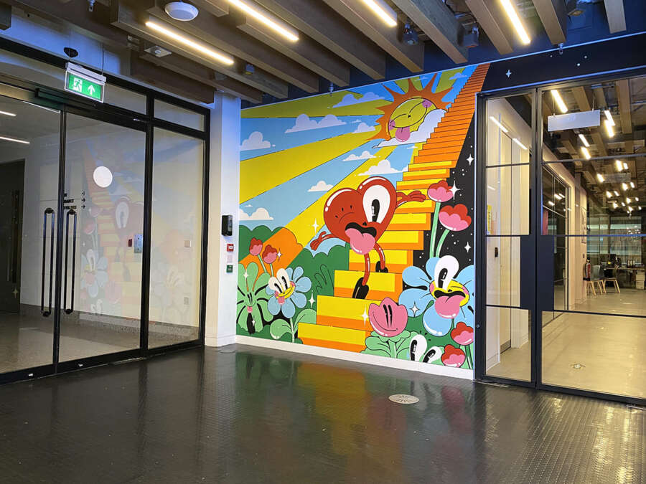
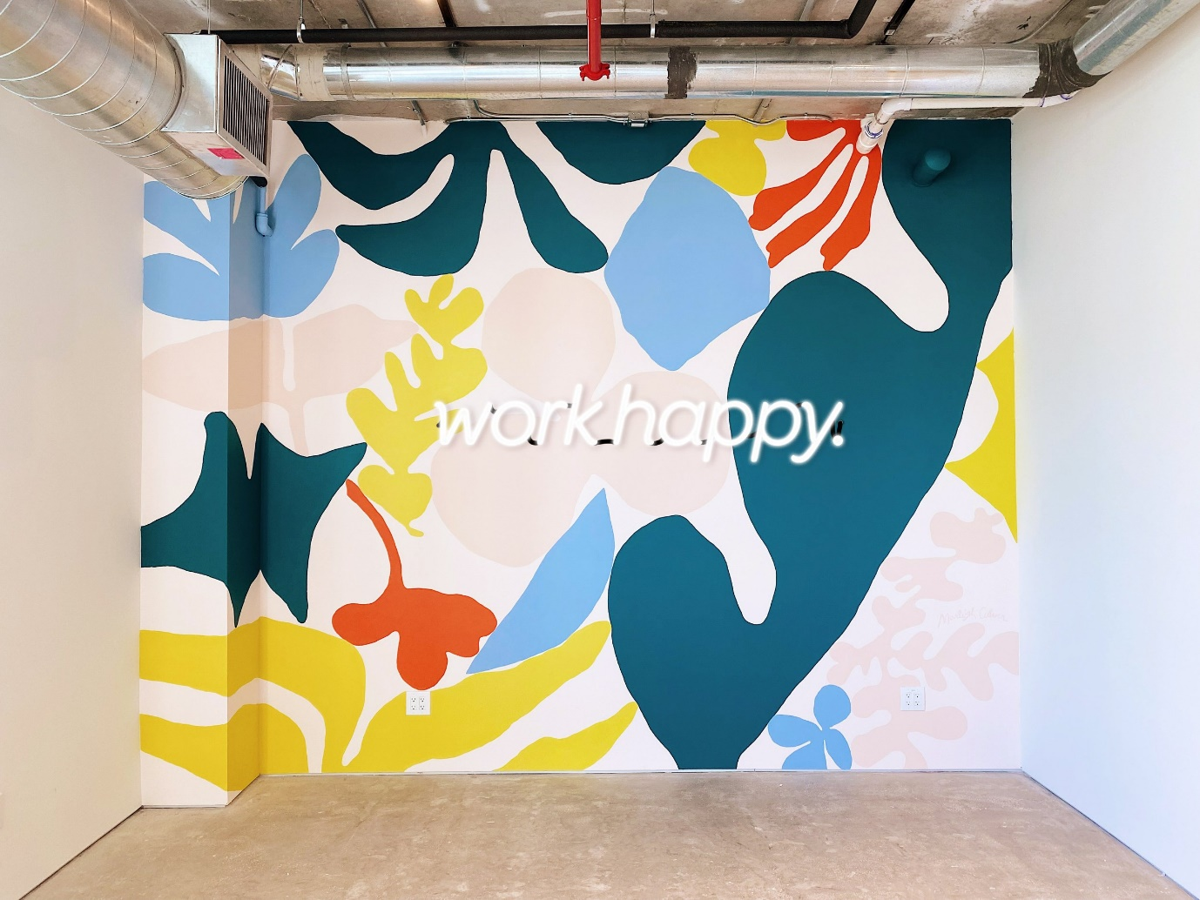

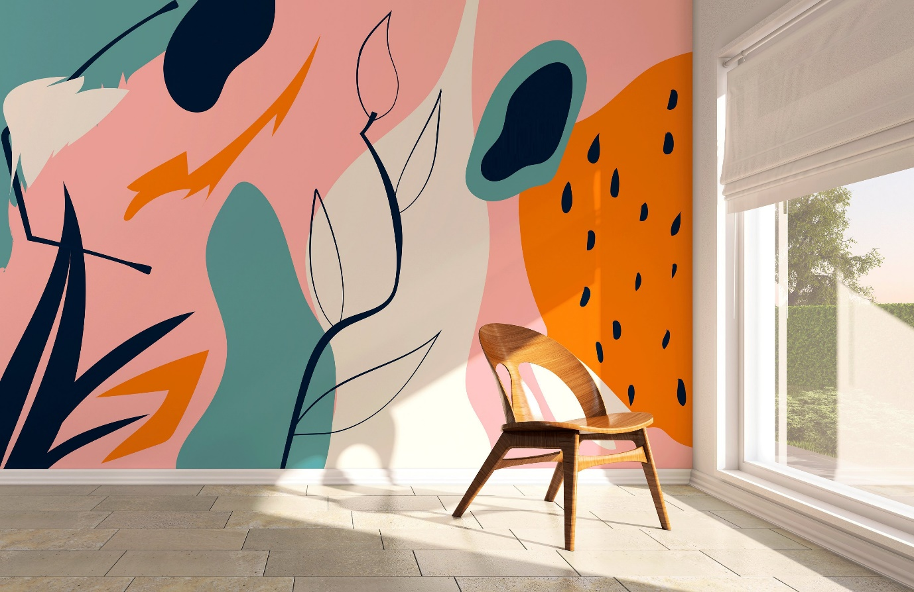
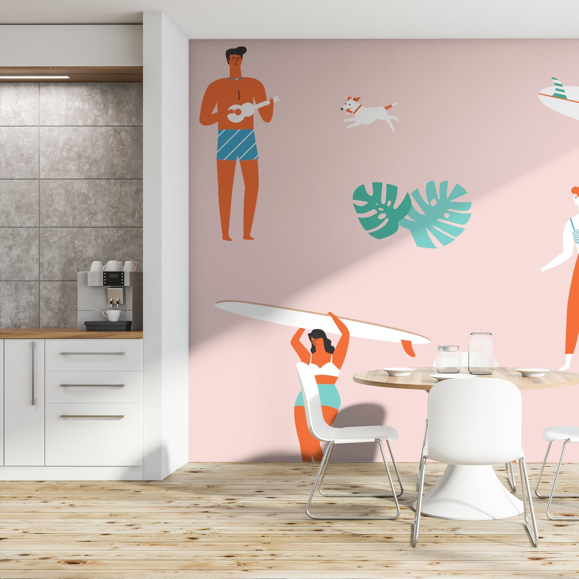
https://www.google.com/imgres?imgurl=https%3A%2F%2Fi.etsystatic.com%2F21896250%2Fr%2Fil%2F96af58%2F2828922050%2Fil_fullxfull.2828922050_n0w3.jpg&tbnid=JZ2RwaM5Las7zM&vet=12ahUKEwjGt4C20_n-AhVo33MBHdxMC5AQMyhWegQIARB0..i&imgrefurl=https%3A%2F%2Fwww.etsy.com%2Flisting%2F937586724%2Fpink-hawaiian-surf-theme-koa-wallpaper&docid=idBPJCcP0WUxnM&w=1666&h=1666&itg=1&hl=en&ved=2ahUKEwjGt4C20_n-AhVo33MBHdxMC5AQMyhWegQIARB0
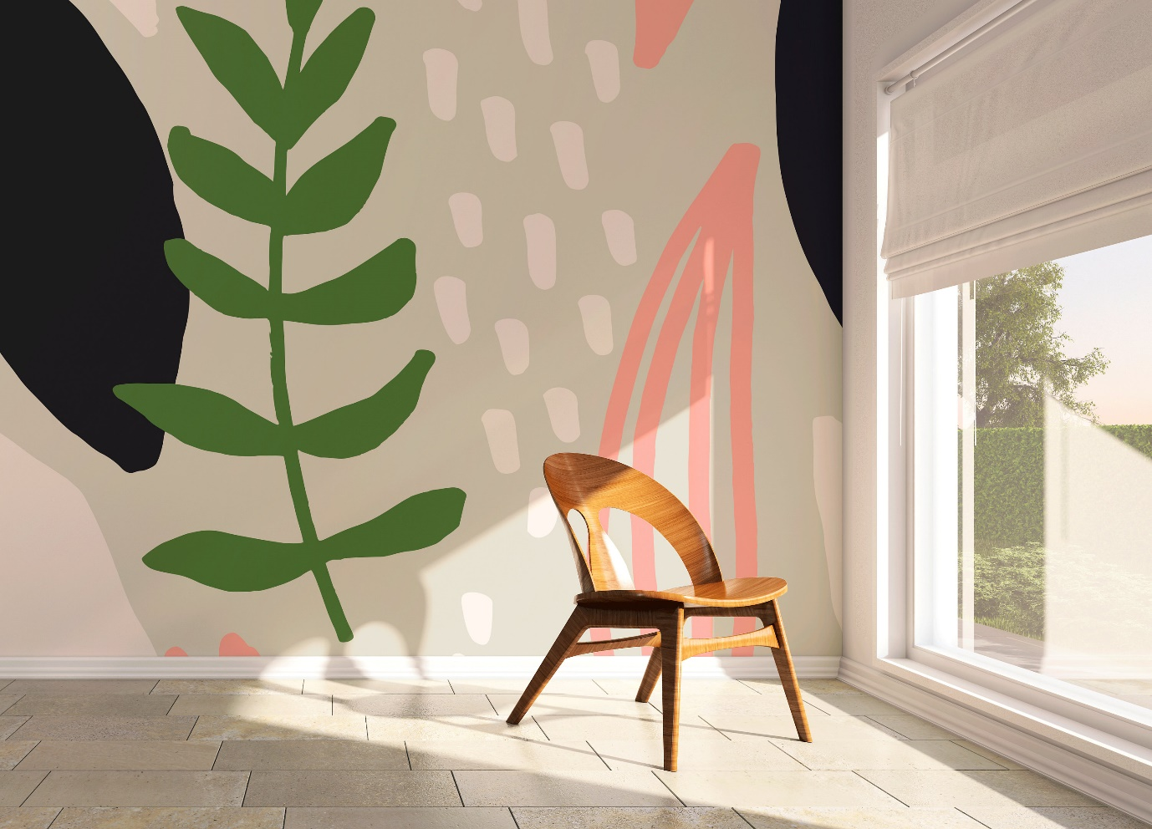
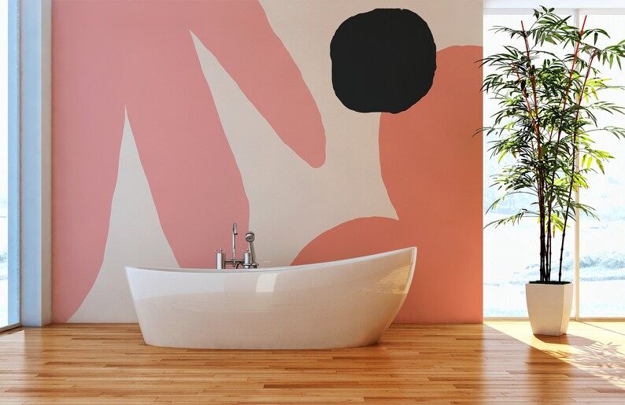
https://www.google.com/imgres?imgurl=https%3A%2F%2Fi.etsystatic.com%2F15423336%2Fr%2Fil%2F7a8234%2F2925867059%2Fil_fullxfull.2925867059_fepf.jpg&tbnid=k2KrTGRcaLo1yM&vet=10CBEQxiAoCGoXChMI2OzLwNT5_gIVAAAAAB0AAAAAEAo..i&imgrefurl=https%3A%2F%2Fwww.etsy.com%2Fin-en%2Flisting%2F950442594%2Ftemporary-wallpaper-nursery-decor&docid=W6eaX_HTwivzAM&w=3000&h=2160&itg=1&hl=en&ved=0CBEQxiAoCGoXChMI2OzLwNT5_gIVAAAAAB0AAAAAEAo

