RIACT AFRICA

WEBSITE DESIGN BRIEF

Introduction

ABOUT RIACT

RIACT is a premier consulting firm that specialises in aiding global corporations and emerging businesses to enter and scale within Africa's dynamic markets. Through swift, actionable insights and innovative strategies, RIACT empowers clients to capitalise on Africa's untapped potential, thereby catering specifically to forward-thinking entities poised for exponential growth.

TASK DESCRIPTION

Develop a 5-page website for RIACT.

The primary goal is to present a clear and concise picture of our consulting firm, its Africa-centric experience, and its offerings to multinational clients looking for a professional partner to penetrate African markets or reclaim lost market share.

Website Framework

Page Architecture:

Home

A powerful landing page that instantly communicates who RIACT is and what solutions it provides. Incorporate impactful visuals and calls-to-action.

About

A compelling narrative that illustrates RIACT's unique approach to consulting, dedication to Africa, and experience assisting multinational firms.

Services

A showcase of RIACT's successful projects and client testimonials. This page should build trust and credibility, demonstrating RIACT's ability to deliver exceptional results.

Team

Introduce up to 8 key team members, with each profile featuring a professional photo, name, title, and a brief bio showcasing the individual's skills, experiences, and contributions to RIACT's mission.

Contact

Clear and easy ways for visitors to contact RIACT for more information or to initiate a partnership.

Footer

Links to RIACT's social media profiles on Instagram and LinkedIn, along with a privacy policy.

Social links

Instagram: https://www.instagram.com/riactafrica/

LinkedIn: https://www.linkedin.com/company/riactafrica/

Privacy Policy

Insert placeholder "lorem ipsum" text.

Text will be provided with the revision round or RIACT will update text on site handover.

Design Inspiration

The website's design should evoke professionalism and elegance, with simple and clean lines inspired by site pages like:

https://prophet.com/

https://prophet.com/services/

One aspect we particularly appreciate is how visitors can easily navigate by scrolling down to find what they're looking for and see everything they need to in an intuitive way on the home page

What we don’t like about this site is how they navigate from the home page to other random pages – we like about to take you to the about page, and so on.

Branding Guidelines:

See logo on Design Crowd: Design #: 30444308

We like the idea of the logo being black or white and have uploaded these options as well.

Monochrome themes, with spots or splash of colour to highlight something is a style we appreciate.

Website Objectives and Goals:

Our website's primary goal is to create a strong online presence, acting as a hub for potential clients to discover our credibility, reliability, and our ability to deliver exceptional results. It's essential that our website portrays professionalism, instils trustworthiness, and showcases our sincere dedication to Africa.

Target audience:

RIACT's audience consists of businesses in mobile money, gaming, FMCG, beverage, and alcohol sectors, primarily Business Development Managers or Operations Managers who are seeking insight into their respective marketplaces.

Company Overview:

RIACT stands out from the crowd as a consulting firm with a difference. Our dynamic team is fully dedicated to one mission: brand development within Africa.

Unlike other companies that focus solely on online connectivity, we recognize the tremendous value in embracing the vibrant street culture that makes Africa so unique. Community engagement, empowerment, and expansion are at the forefront of everything we do.

we recognize that unlocking business growth starts with a deep understanding of consumer behavior. It is this understanding that bridges the gap between companies and the communities that drive the cash economy. Our purpose is to reconnect businesses with the vibrant pulse of these essential local markets, injecting fresh vitality into their brands and propelling them towards resounding success in Africa.

Development to include:

Basic SEO Setup:

The website should be optimized for search engines, incorporating keywords, meta tags, and alt tags for images.

Google Analytics Setup.

To track website traffic and user behaviour for ongoing optimization.

Google Crawling Setup

The website needs to be easily indexed by Google, allowing it to appear in search results, and updated information effectively crawled by Google SEO and AHREFS scores.

Page Content:

Home Page

Background

Option #1

4K video on home page, running on loop

Bold Statement Text over Video

Option #2

Still Image

Animated text making bold statement (e.g. our motto)

Sections

Contrast colour blocks or a way of making it clear that the next topic is a new topic.

5 sections

Home Main - Video + bold statement text

About - A paragraph and visual about us (lorem ipsum) that has a click through to our About Page (ignore how prophet.com navigate, we think this is too complicated for our needs)

Services – communicated in some simple and powerful ways (we leave this open to you) – but keeping in mind it needs to be concise and professional.

Other - Something about our process that makes us unique (lorem ipsum text) and a placeholder image/animation.

Contact – a call-to-action button that takes you to our contact, but showcases a mobile number and email address.

Footer – as described in the previous section – placeholder for Instagram and LinkedIn only.

About Page

Don’t reference prophet.com for this page.

Main Section

Bold statements and images

History Section

A story about us and our past

Final Section

Some of our comments and final thoughts

Services Page

How https://prophet.com/services/ is laid out is great – we prefer a light theme.

6 - 8 x icons with headings and a brief description text box, and a read more drop down – all as placeholders to be edited later.

For ease of direction for this page, look to the link shared above.
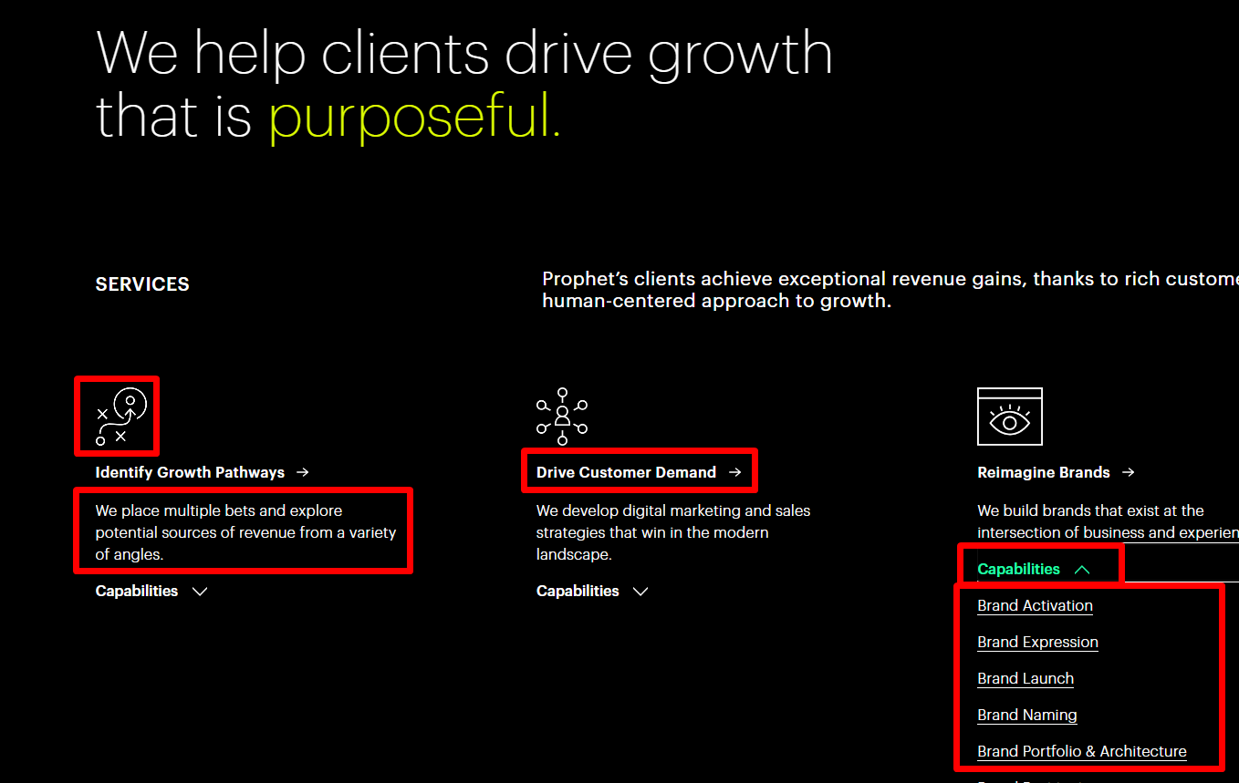

Team

Add Placeholders for up to 8 team members (we only have 4 now):

Image placeholder

Name placeholder

Title placeholder

Short Bio (lorem ipsum)

Contact

Clear and easy ways for visitors to contact RIACT for more information or to initiate a partnership.

Insert placeholder "lorem ipsum" text, we will provide the text with our revision round.

Ideally an easy form process that gives the user some options or dropdowns to complete before submission – up to 3 would be sufficient.

Require their name and contact details.

