FRONT COVER:
Photo (copy below, file attached in separate jpeg file, purchased from Shutterstock)
Title words for cover: There will only ever be one you! – Martha Graham

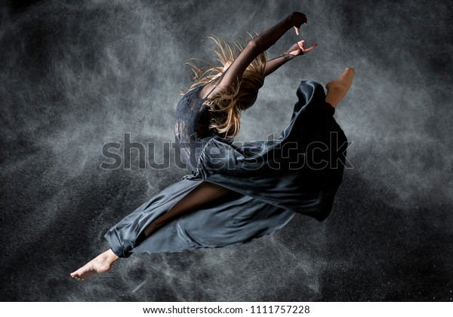

INSIDE COPY:
In the rural Ohio village where I grew up, one of the highlights of Sunday morning church service -- in between congregational hymn-singing and the preacher’s sermon -- was the “special selection,” a musical performance by a parishioner. Typically, it was a vocalist or instrumental on piano, organ or violin. One Sunday, we were surprised by an unusual performance. A plump, buxom farm wife approached the pulpit, puckered up her lips and unexpectedly began to whistle the hymn “The Old Rugged Cross.” As a 10-year-old, I found this hilarious as I tried to choke back my wide-eyed amazement and giggles.
Despite the irreverence of my pre-adolescent reaction, this memory has stayed with me for decades as an iconic example of the wonderment of individual differences. Of the delight I find in witnessing someone express herself in sometimes surprising and even courageous ways. Of the marvel of beholding a person be truly authentic and uniquely original.
Someone who personified the irrepressible impulse to express her individuality was the early 20th century dancer and choreographer Martha Graham. A pioneer of modern dance, she threw tradition overboard and was inspired to dance in a way that was a radical departure from the formalized style and rigidly dictated forms of classical ballet. Graham felt compelled to express the rawness and emotion of human experience in her dancing -- not just present a form of pretty entertainment. Iconoclastically brilliant, she created a new language of dance, a revolutionary vocabulary of movement that electrified the stage, often creating a visceral response in the audience.
In her biography of Graham, her friend and equally talented choreographer Agnes de Mille recalled that despite sensational reviews for her own innovative work in the Broadway musical Oklahoma!, de Mille had a gnawing feeling that her work was only mediocre. De Mille confessed her anxieties to Graham who listened quietly and then responded, “There will only ever be one you!” Continuing, she added:
“There is a vitality, a life-force, an energy, a quickening that is translated through you into action. And because there is only one of you in all of time, this expression is unique. And if you block it, the world will not have it. It is not your business to determine how good it is nor how valuable nor how it compares with other expressions. It is your business to keep it yours clearly and directly, to keep the channel open. You have to keep open and aware directly to the urges that motivate you. Above all else, keep the channel open!”
Graham’s wisdom reminds us that we must not hold back or judge our gifts. Although there may be moments when we doubt ourselves or when we worry that we’re not good enough, our job is to be fearless and to “keep the channel open.”
Guard the precious miracle of your own uniqueness. Find that home-sweet-home feeling where you feel you are your most authentic self. There will only ever be one you! And importantly, respect the differences of others. Our world would be a drab, boring place if we all only whistled one tune.

BACK COVER
(thumbnail reduction of cover photograph here)
There Will Only Ever Be One You is the 16th in a series of Labor Day essays inviting a moment of reflection on living a more meaningful, more mindful life
Lois Sekerak Hogan, Ph.D.
Crane Neck House
74 Main Street
West Newbury, Massachusetts 01985

Mobile: 978-764-7650
Email: Lshogan@comcast.net

©2023

(reduce photo below (jpeg attached) to about 2x2 and incorporate it with the copy below titled “About Martha Graham”)
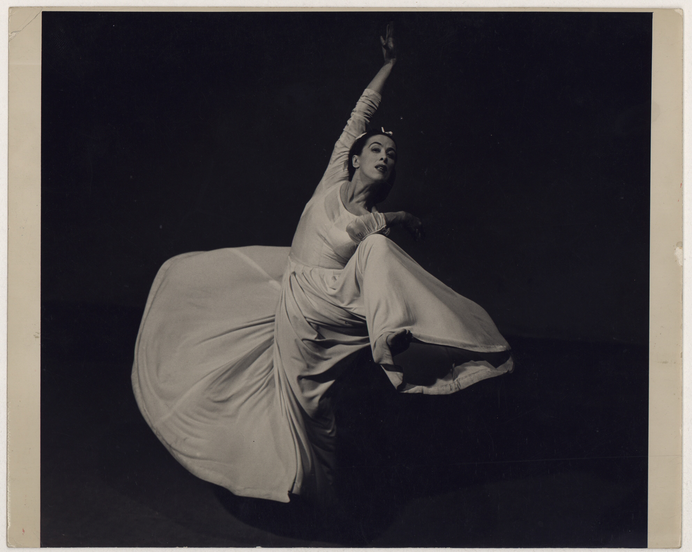

“Martha Graham in Letter to the World, No. 1” © The Barbara Morgan Archive

About Martha Graham: Born in 1894, Martha Graham danced and taught for over 70 years. She is recognized as a primal artistic force of the 20th century, whose influence on modernity has been compared to Picasso, James Joyce, Stravinsky, and Frank Lloyd Wright. Her themes dealt with the lives and conflicts of ordinary people, and she brought serious issues to the stage like war, poverty, intolerance and the injustices of slavery and treatment of Native Americans. Rebelling against conventions of the past, her dancing and choreography exposed the depths of human emotion through intense movements that were forceful, stark, angular, jagged, and percussive – startlingly unlike the formality of classical ballet, which she saw as antiquated.

About Photographer Barbara Morgan: In 1935 Barbara Morgan saw a performance by modern dancer and choreographer Martha Graham. Morgan was so inspired by the dance performance that she introduced herself to Graham, and the two artists began an artistic collaboration that lasted more than 60 years. Morgan often photographed dancers in action, to capture the emotion behind their movement. Her artistic style was in line with Graham’s philosophy of dance. This photo from the dance, “Letter to the World,” is one of Morgan’s most famous photographs. The title of this work comes from an Emily Dickinson poem, which inspired Graham to create a dance performance based on Dickinson’s life.

