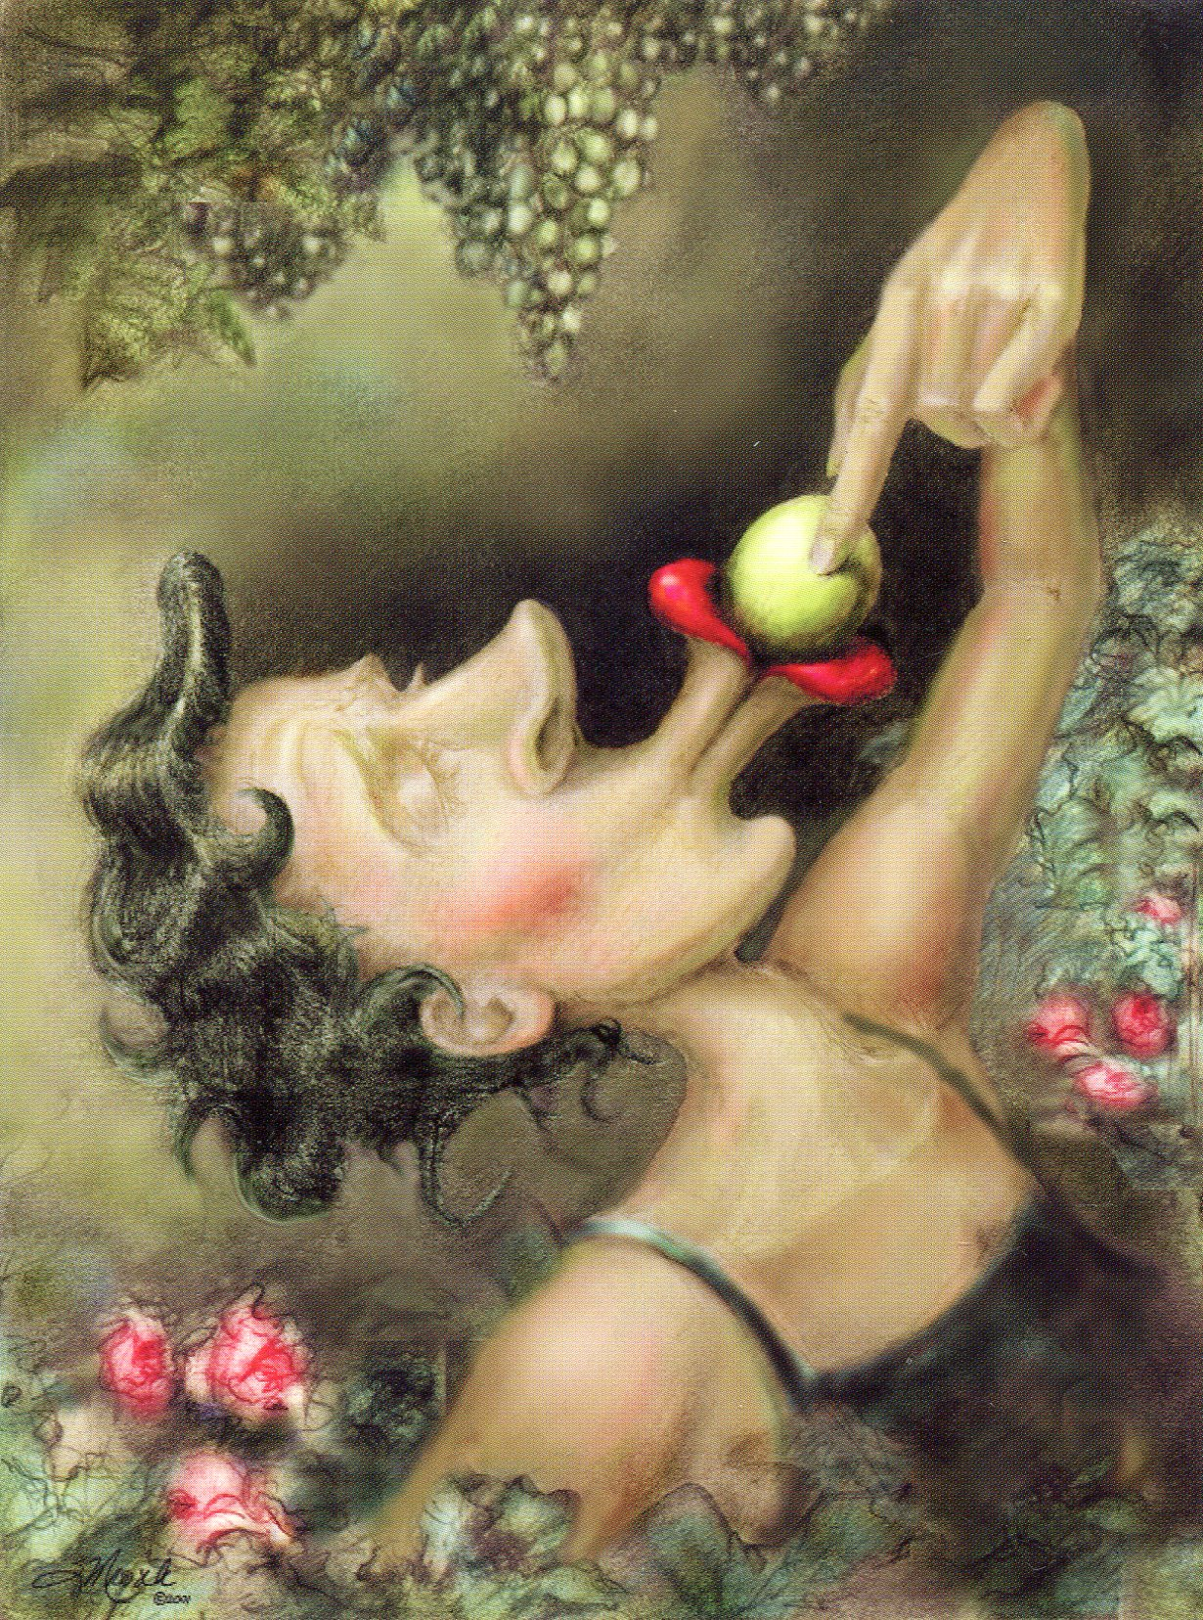
For today,
the grapes are green, sweet, and plenty

It is August, and I am reveling in the tastes, sights and sounds of late summer. Like the sated, reclining guests of some Roman banquet, I have feasted on corn-on-the-cob, husked on the way from the garden to the kettle, dripping with butter down my chin. Roadside farm stands tempt with shiny eggplants, piles of zucchini and my favorite -- ripe, knobby heirloom tomatoes in myriad colors (even a green zebra stripe!). We harvested golden peaches and fat blackberries sweetened in the summer sun, then baked them in a cobbler bathed in a puddle of melting ice cream. Can there be a juicier, more delicious time of year? The earth is bursting with bounty, and I am an unabashed hedonist, relishing it all.
Enjoying a latte on my patio, my eyes drink in the colors and textures of my perennial garden. The vibrant purple, honey-scented blooms of my buddleia bush, heavy with nectar, are like some Odyssian siren beckoning bumble bees and butterflies that flitter about like women at a Neiman-Marcus 50% off-sale. A fairy-sized toad, no bigger than the tip of my finger, stands sentry near my begonias. A dragonfly alights on my arm, its intricate, lacy wing pulsing with life and strange bulbous eyes taking in the world. Then there are the sounds. It is the time of year when my windows, flung open to the night, admit a choir of cicadas and crickets to sing me to sleep, while birdsong wakens me in the morning.
These kinds of experiences urge us to savor life and the joy and pleasure that are possible when we pay attention. Mindfulness can change our mood. It can enrich ordinary moments with enchantment and wonder. As the Vietnamese Zen monk Thich Nhat Hanh says, “The miracle is not to walk on water. The miracle is to walk on the green earth, dwelling deeply in the present moment and feeling truly alive.”
Wait, you may say. Not all of life is beautiful and wonderful. What about all those not-so-nice things that happen? Are we just supposed to ignore those and play “The Glad Game” like some glass-is-always-half-full Pollyanna? My longer response to that is an essay for another year, but the short answer is about choice. Quite simply, we get more of what we think about. At any given moment, we can focus our attention on a thousand things, but we choose – sometimes unconsciously -- what to notice and be absorbed by. What’s magical is that the more we expect to experience good things, the more we will rendezvous with them.
Here’s good news for anyone who is not a born optimist: contemporary neuroscience is demonstrating that the way we focus our attention and direct the flow of energy and information through our neural circuits can actually change our brain. We can (drum roll) rewire negative default patterns of thought to develop new, healthier predispositions. We can cultivate a more habitually optimistic mindset. This ultimately means more satisfaction, more joy, more happiness – and if we could start a little contagion of that around us, imagine the possibilities!
There are times when I feel such appreciation for the sweetness of life that my heart melts into a quiet prayer of gratitude. Hamza el Din describes this as a “sweet benediction flowing through everything existing.” I am blessed, you are blessed. We just need to open our hearts and feel it.
My wish for you this year is a parcel of clichés: seize more moments. Stop and smell the roses. Look for things that make you happy. Smile more, expect to laugh. Anticipate kindness and generosity. Make lemonade out of lemons. Play the Glad Game! Count your blessings before drifting off to sleep. Follow your bliss. Be in love with life. For today the grapes are green, sweet and plenty.

The world shines about me,
luminous as the moon, smiling like a rose,
and a sweet benediction
flows through everything existing.
How beautiful life is.
I marvel at people who are not in love with life.
- Hamza El Din

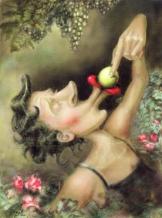
“Grapes” is the 11th in a series of Labor Day essays inviting reflection on living a more meaningful, more mindful work and personal life

Lois Sekerak Hogan, Ph.D.
Crane Neck House
74 Main Street
West Newbury, Massachusetts 01985

Mobile: 978-764-7650
Email: Lshogan@comcast.net
©2013
About the artist: “Grapes” cover illustration, ©2001, used with permission. Tucson, Arizona artist Susan Mrosek’s work takes us on a whimsical journey into wisdom, truth and laughter. Her style is described as “lusciously twisted and profoundly humorous.” Susan has followed her passion for painting and writing to create a line of greeting cards and posters available on her website The Pondering Pool. Says Susan, "At the heart of the Pool are its sweet characters, quite imperfect, funny, relentlessly honest, and in various stages of struggle and healing. They were born kind of sideways, as a byproduct of the way my sister and I used humor to deal with our challenges. I can’t thank them enough for coming forth to show us that playing is essential, and that being different is in no way a flaw, but a blessing." To see more of her imaginative work, go to: http://ponderingpool.com

About the poetry: Hamza El Din was a legendary figure in world-music who had an influential hand in the careers of Bob Dylan and the Grateful Dead. Born in southern Egypt and inspired by his Sufi faith, Hamza El Din performed on the oud, the Arabic precursor of the lute. He has collaborated with Joan Baez, Charles Lloyd and the Kronos Quartet and was first heard in the U.S. at the Newport Folk Festival and Woodstock. His music has been described as “mesmerizing,” “hypnotic,” and “trance-like.” This poem was attributed to him, but I’m not sure if he actually wrote it or if it was written by another person and he set it to music.

