IMAGOnation.com

دعوة للفرد لكي يكون انسان ويكون نفسه
Unleash Your True Self

The Why

Life challenges in UAE

The paradox between the quality of life in the UAE and the prevalence of mental health problems is a significant concern. On one hand, the UAE is known for its luxurious lifestyle, economic prosperity, and modern infrastructure, contributing to a high overall standard of living. However, local studies have revealed notable rise in mental health disorders within the population where the prevalence rate for anxiety was the highest at 56%, followed by depression, post-traumatic disorders,
Factors contributing to this paradox include the fast-paced and competitive nature of the society, high work demands, increased stress levels, and social isolation. The pressure to succeed, maintain a certain image, and meet societal expectations can take a toll on individuals' mental well-being, despite the outward appearance of prosperity.
Addressing this paradox requires a comprehensive approach that focuses on Encouraging individuals living in UAE to cultivate their humanity and be true to themselves.
By recognizing the importance of Authentic Self, Human Essence and True Identity, the UAE can work towards bridging the gap between its high quality of life and the prevalence of mental health disorders.

Our Human needs

At the core of human existence are fundamental needs for identity, belonging, purpose, and impact. These needs shape our perceptions, motivations, and overall well-being, playing a significant role in our journey towards personal fulfilment.
- Identity is the complex fabric that shapes our individuality, comprising our values, beliefs, culture, and personal experiences. A strong sense of identity allows us to embrace our uniqueness, navigate confidently, and form meaningful connections with others.
- Belonging is a deep human need to connect with others and be part of something greater. Through belonging, we form deep connections, and build enriching relationships that offer acceptance, understanding, and a shared sense of purpose.
- Purpose is the beacon that gives meaning to our actions and drives us towards fulfilment. It stems from understanding our goals, values, and passions, propelling us with direction and a sense of purpose. When our actions align with our purpose, we experience profound fulfilment.
- Impact is the intrinsic longing to create a significant and positive impact on others and society as a whole. Through our actions, words, and contributions, we have the power to influence, inspire, and leave a lasting legacy for future generations. By embracing our capacity for impact, we tap into our inherent potential and understand the profound ripple effect our choices can have on the world.
By acknowledging and nurturing these fundamental needs of identity, belonging, purpose, and impact, we embark on a transformative journey towards personal growth and fulfilment.

The What

IMAGOnation Vision and Mission
Vision Statement: Our vision is to provide a community platform that embraces the fundamental needs of identity, belonging, purpose, and impact, empowering individuals to discover their true identities, forge deep connections, and create a meaningful impact in the world.
Mission Statement: Our mission is to cultivate a community services platform that fosters self-discovery, authentic connections, and purpose-driven actions. Through our platform, we aim to facilitate meaningful interactions, provide resources for personal growth, and encourage individuals to make a positive impact in their own lives and the lives of others. By fostering a sense of belonging, promoting personal development, and celebrating diverse perspectives, we aspire to create a community where everyone's unique identity is valued and nurtured. Together, we can unleash our full potential and collectively create a brighter future for individuals and society as a whole.
Brand themes ( for branding purpose only )
- Unleash: Unleashing human true self is a breakthrough comparable to the Big Bang effect. It involves tapping into untapped capabilities, pushing boundaries, and experiencing transformative growth, expanding our true identity.
- Journey: The inward journey of change unravels the circles and layers of the human being, revealing the true core circle. It is a quest to discover our authentic essence, untouched by external influences, and embrace the depth of our being.
- Stained glass: The stained glass mirrors the complexities of our existence, with its fragments and imperfections. Through the light, it forms a captivating mosaic, reminding us that we are not defined by our past. Even in brokenness, beauty and meaning can be found.
- Chisel: The chisel symbolizes embracing our potential to become our true selves. In the hands of the sculptor chipping away at excess stone, we shed wrong beliefs , fears, and limitations Through this process, we uncover our authentic selves and live in alignment with our true purpose.

The How

IMAGOnation services

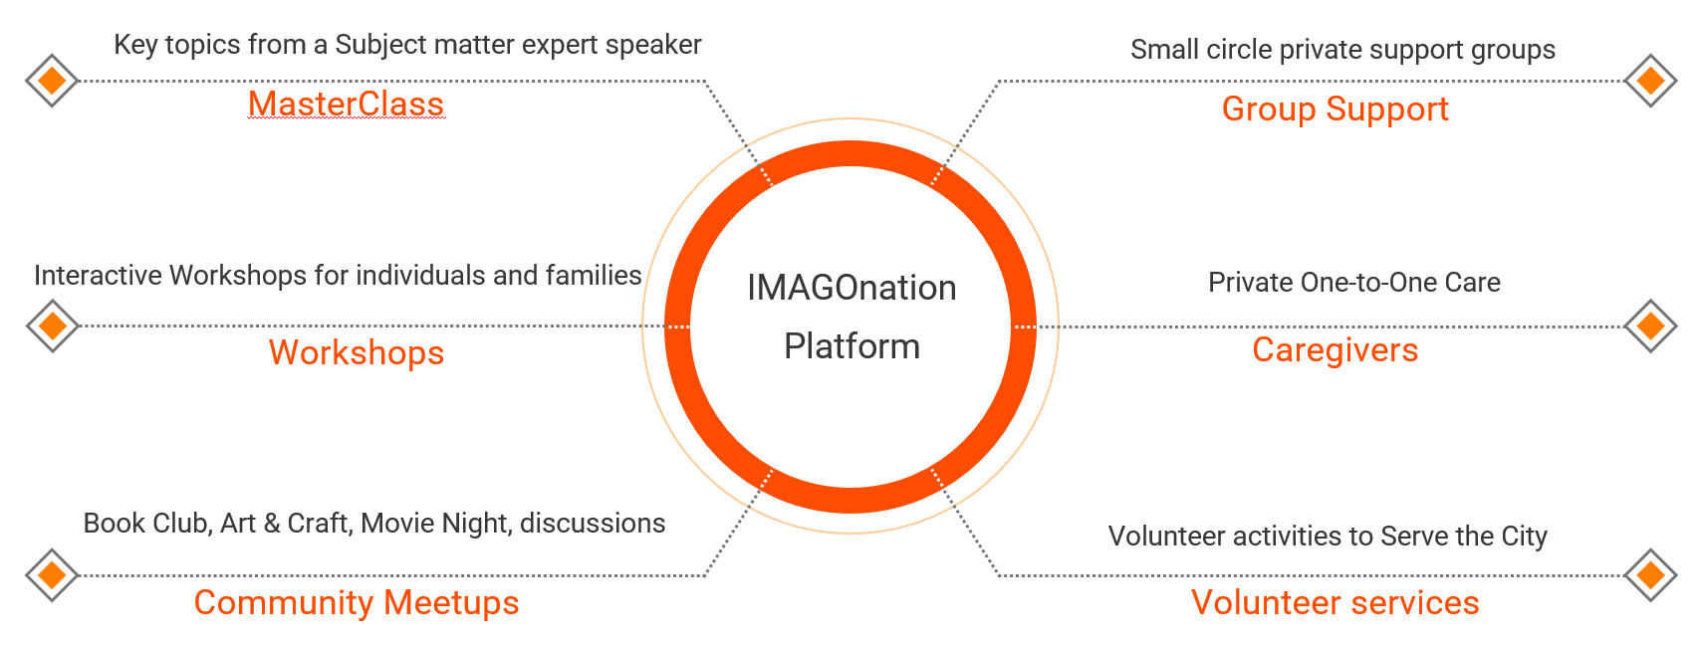

Masterclass
IMAGOnation will offer masterclass events where experts in a specific field from around the world will share their knowledge and skills through in person event. Learners will gain access to high-quality instruction from accomplished professionals, gaining valuable insights and practical guidance to enhance their own abilities.
Example of Topics:
Leadership, Humanity , Manhood , Emotional Intelligence , How to think about what we think, Gender Identity & Sexual orientations , Free Will , Psychology of Money, Human’s need , Purpose Driven Life, Redefining our key life measurements ( Joy vs Happiness , Success vs Significance ,

Workshops
IMAGOnation will offer hands-on workshops in an interactive learning experience where participants actively engage in practical activities to gain practical skills and knowledge in a specific subject. It emphasizes experiential learning and provides a dynamic environment for participants to apply theory in practice.

Example of Topics:
Addictions, Anxiety, Depression, Trauma, Loneliness & feeling disconnected, dealing with Pornography, Shame, Guilt & Insecurity, Healthy Relationships & Boundaries, smoking, being a Workaholic, addiction to shopping, how to deal with Forgiveness , Human Identity in Consumer world, Why we Lie? What’s the Neuroscience behind Lying, Meaningful relationships vs. Toxic relationships, Coping with Grief and Loss, what is Freedom.

Community Meetups
Encouraging individuals in the UAE to cultivate their humanity and authenticity through community meetups and gatherings where like-minded individuals can connect, learn and engage in activities aligned with their life goals and passions. By fostering such environments, individuals are empowered to embrace their true selves, nurture their unique interests, and cultivate a sense of belonging and fulfilment.
Example of Meetups:
- Book club: it uses collective reading and discussion to support personal growth and emotional well-being. By exploring diverse books and engaging in thoughtful conversations, individuals gain insights, empathy, and self-reflection.
- Arts & crafts: it uses creative activities to support healing and self-expression. Through painting, sculpture, and other crafts, individuals can process emotions, reduce stress, and enhance self-esteem.
- Drumming & Rhythm Therapy: it uses drumming and rhythmic activities to promote healing and well-being. It reduces stress, allows for emotional expression, enhances coordination and mindfulness, and fosters social interaction..
- Movie screenings: It combines the enjoyment of films with meaningful conversations to explore emotions and personal growth. By watching selected movies and engaging in facilitated discussions, individuals reflect on the film's themes, characters, and their own experiences

Support Groups
Through our certified counsellors, IMAGOnation support groups provide a safe space for individuals facing similar challenges to come together, share experiences, and get mutual support. The group setting provides a sense of belonging and validation, reducing feelings of isolation and loneliness often associated with challenging circumstances.
Examples of support groups moderated by certified counsellors:
- Mental health support groups: Groups that focus on various mental health conditions such as depression, anxiety, bipolar disorder, or schizophrenia.
- Grief support groups: Gatherings for individuals who have experienced the loss of a loved one, providing a space to share their feelings and find solace.
- Parenting support groups: Groups where parents come together to discuss common challenges, share parenting strategies, and seek advice.
- Divorce or separation support groups: Supportive environments for individuals navigating the challenges of divorce or separation, providing emotional support and guidance.

Caregivers
Experience the power of effective listening with our highly trained caregivers.
Our dedicated caregivers are equipped with the skills and compassion to guide you through your concerns. They will actively listen to your thoughts, feelings, and challenges, providing a safe space for you to express yourself without judgment.
Through our one-on-one sessions, you will have the opportunity to work towards finding pathways to emotional well-being, building resilience, and fostering personal growth. We pair men with men and women with women to ensure a sense of understanding and relatability.
Our goal is to support you on your journey towards emotional wellness, offering you a dedicated and empathetic companion who will walk alongside you. We understand that everyone's experiences are unique, and our caregivers are trained to tailor their approach to suit your individual circumstances.

Volunteer Services
Serve the City is a global movement of volunteers dedicated to demonstrating kindness and compassion towards those in need in UAE.
In Partnership with “Serve the City” , IMAGOnation will tap into local social services in UAE to connect volunteers with a diverse range of activities, to support individuals in need. Our vision is to engage everyone in caring for the well-being of others. We believe that EVERYONE can volunteer to make a meaningful difference.
We are committed to creating positive change in UAE by harnessing the collective power of volunteerism and compassion.

