https://www.designcrowd.com/magazine-design/contests

MaRHE Center
Annual Report 2022

MaRHE Center:
resilience, agility and creativity to drive an acceleration in the knowledge of research marine field

Box Simone&Davide
Research collaboration with the Bar-Ilan University of Tel Aviv and the Design-Tech Lab of Technion Institute to advance technologies in coral reef restoration through 3D printed structures.
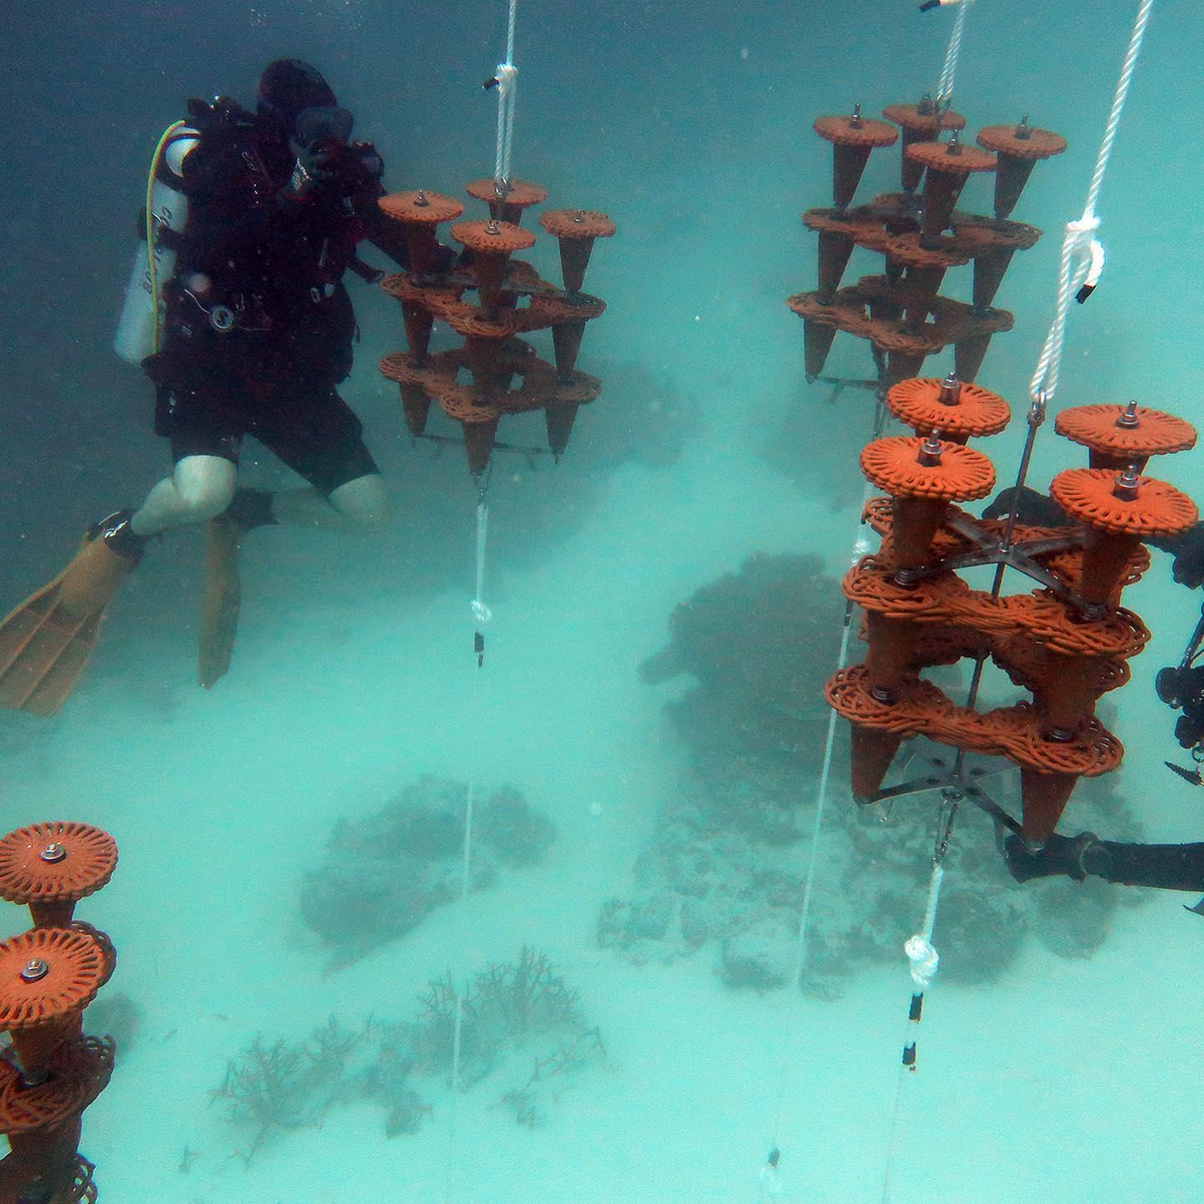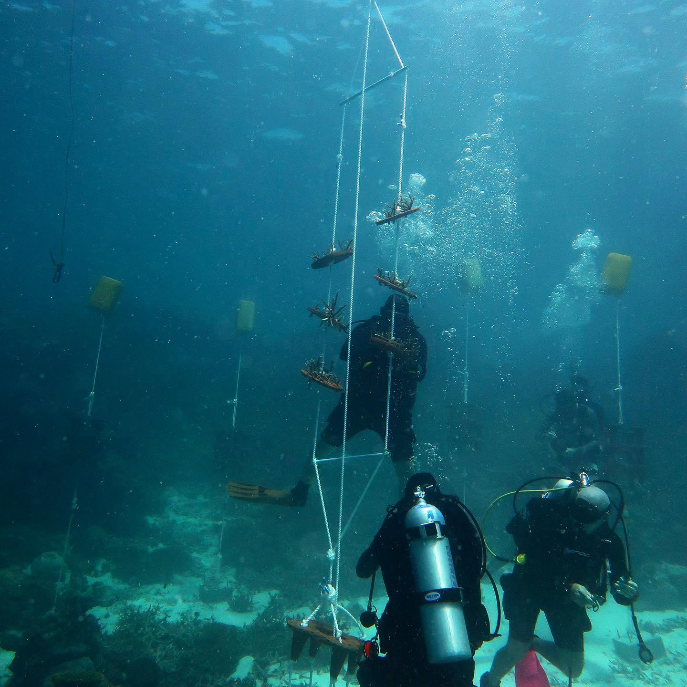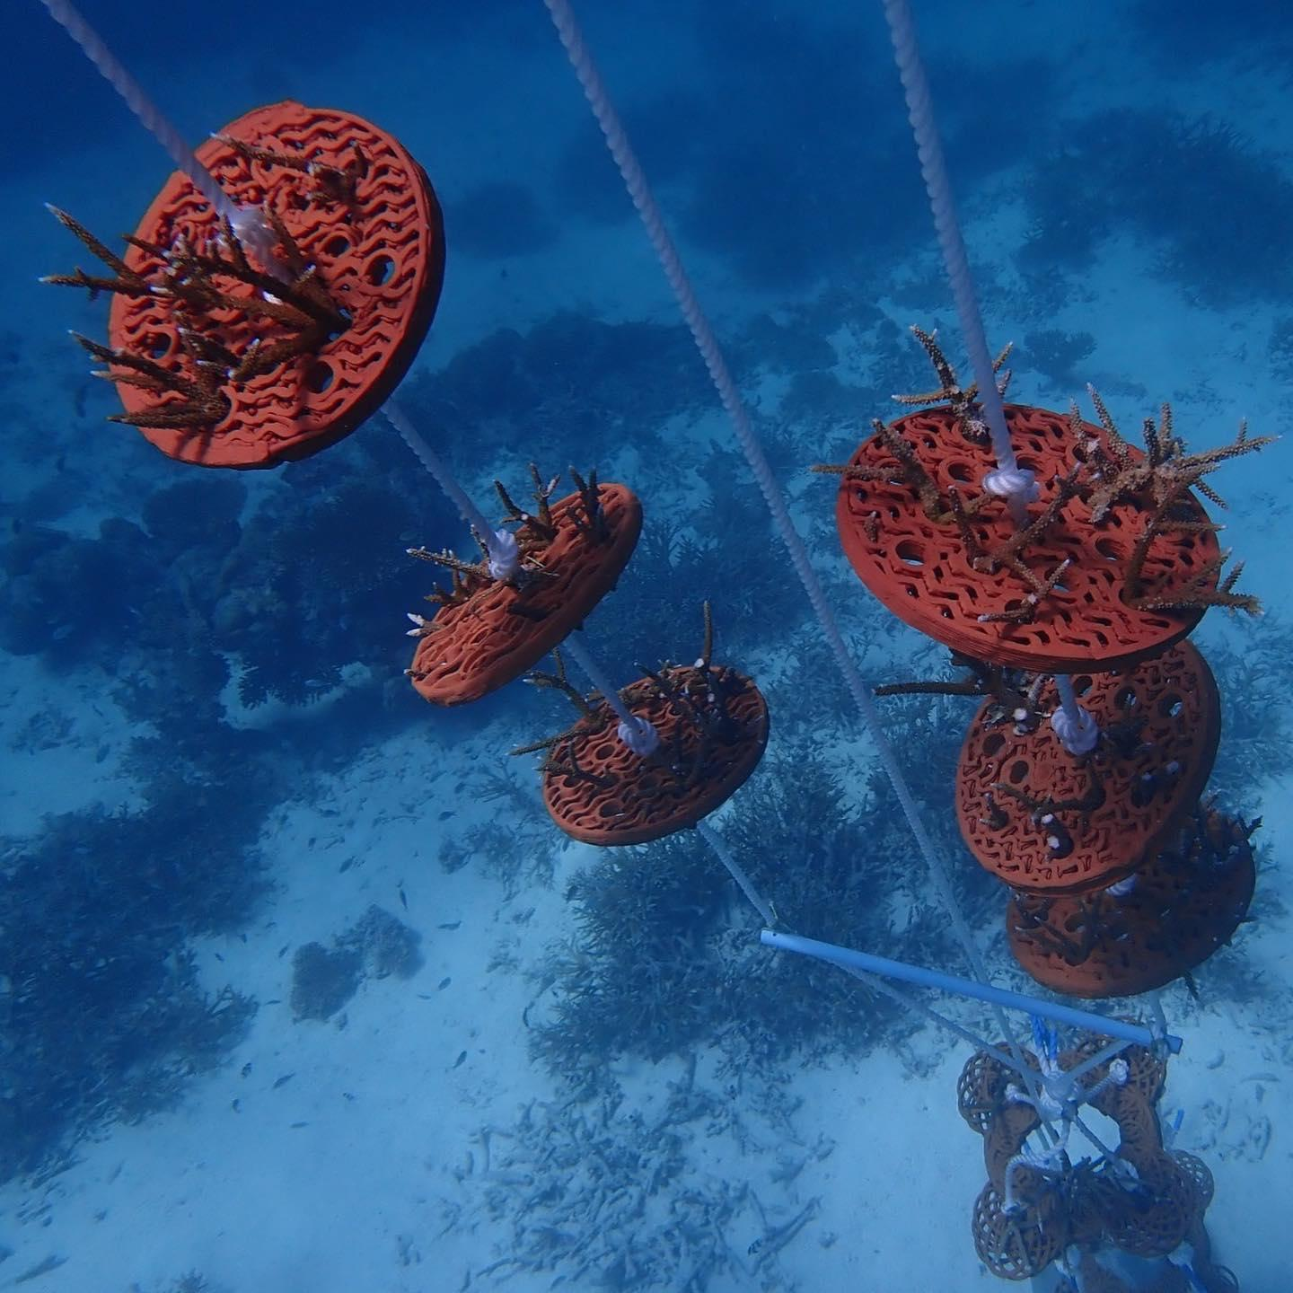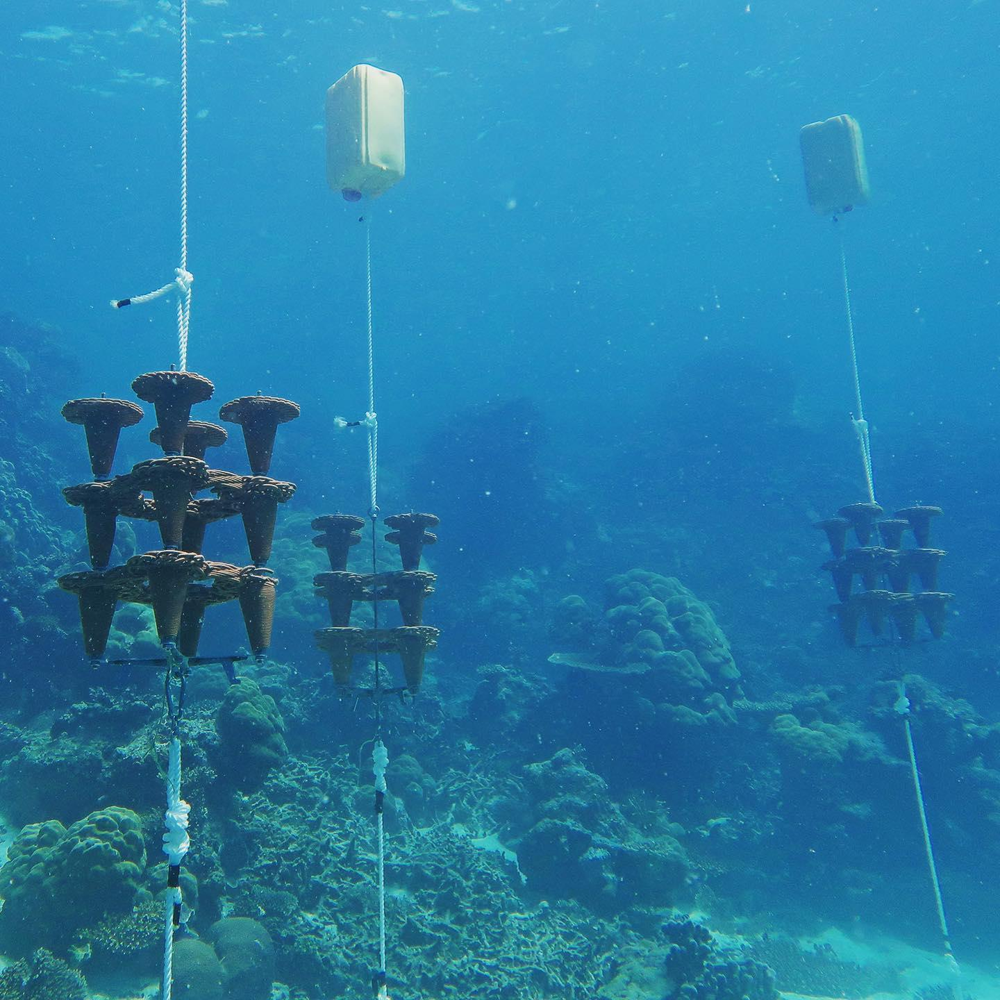

Many people living on coral islands in the Maldives are reliant on surrounding coral reefs for food, coastal protection, and livelihoods. These reefs are suffering from species loss and coral cover due to stressors from environmental and human impacts such as climate change, poor water quality, and overfishing, urgently requiring intervention and restoration. The mass mortality of corals coincides with the widespread loss of architectural complexity upon which many species depend to hide, feed and reproduce. The flattening of coral reefs will likely have serious consequences for the maintenance of reef biodiversity beyond the most conspicuous species as well as for ecosystem functioning and their associated environmental services. This scientific collaboration in the coral reef restoration sector aims to analyse and develop different strategies, techniques and structure to enhance the coral settlement and recruitment aimed at restoring degraded and non functional coral reefs and to monitor the coral growth progression and the effectiveness of the used techniques at spèecific time intervals.
Structural restoration using artificial reefs (ARs) is one of the most commonly used strategies for ecosystem recovery. It most commonly involves placing existing structures that have become obsolete for other uses such as shipwrecks, construction materials and used tires on the seafloor to provide the three dimensional habitat complexity that was lost in severely impacted areas. However, the existing types of ARs often poorly mimic the 3D complexity of natural coral reef habitat and they are difficult to scale-up to larger areas by virtue of their design. New technologies are needed for more sustainable and effective coral reef restoration efforts that can be readily scaled-up. In this project, we will leverage the latest 3D printing technologies to design fit-for-purpose, eco-friendly artificial reef ecosystems that mimic natural coral reefs, to support the recovery process for degraded reefs and exploited fisheries. We plan to monitor the restoration process using a combination of genomics approaches to measure impacts on reef diversity and photogrammetry methods, involving 3D photomosaics, to evaluate the project's success.

Box Luca Donazione Droni
Ocean Unmanned (USA-based NGO) donates two water-landing fixed-wing drones to MaRHE Center for conservation and monitoring activities

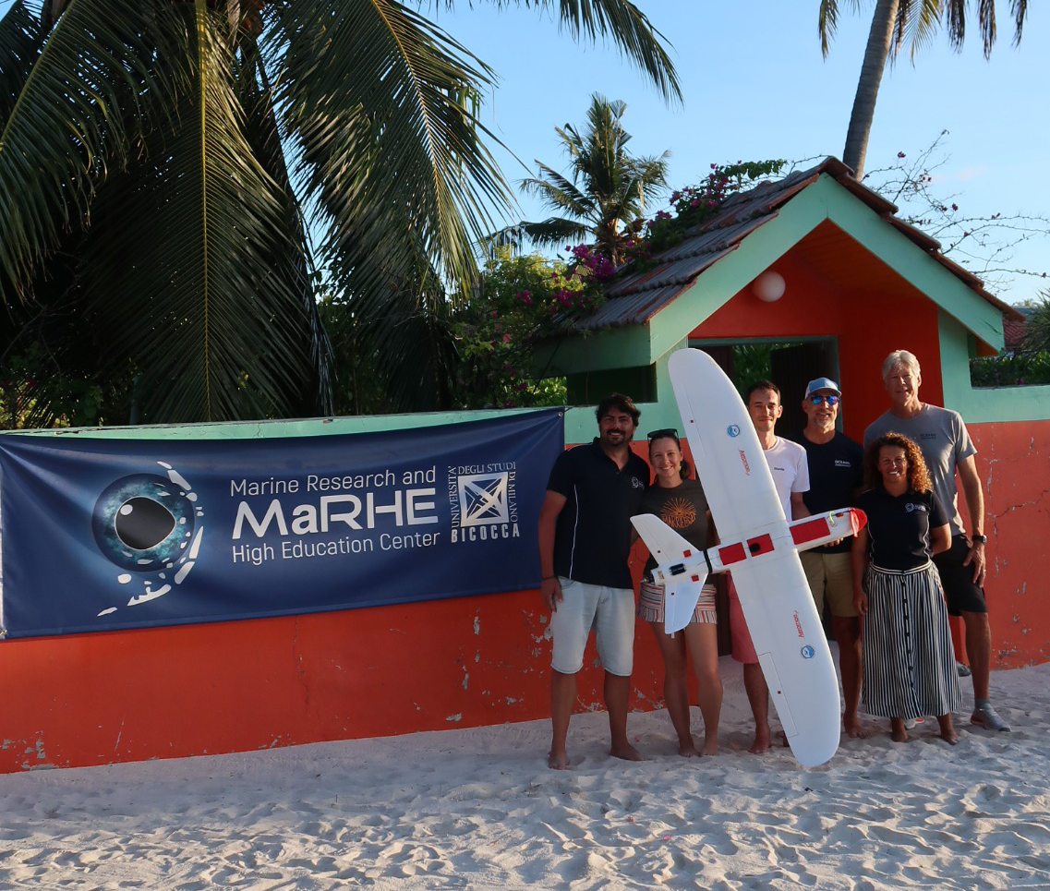

Ocean Unmanned, a non-profit organization dedicated to protecting marine resources through the use of unmanned technologies and promoting safe and environmentally conscious operations, has donated two fixed-wing Tallon drones to the MaRHE Center. The drones were delivered to the Maldives by two NOAA aeroplane pilots (now retired), CDR Matthew Pickett and Captain Brian Taggart, who are now involved in running the organization.
The Tallon drones are equipped with high-resolution cameras and sensors that will allow the MaRHE Center to collect data on a variety of marine ecosystems. The data will be used to track changes in the environment, monitor populations of marine life, and identify areas that need conservation attention. Moreover, the drones will allow the Center to collect data on a larger scale and in more remote areas.
The drones will also be used to conduct outreach activities. The MaRHE Center will use drones to educate the students in future workshops about marine conservation technology and the importance of monitoring the ocean.

The donation of the Tallon drones is a significant contribution to the MaRHE Center's conservation efforts. The drones will allow the Center to collect data and conduct outreach activities that would not be possible without them.

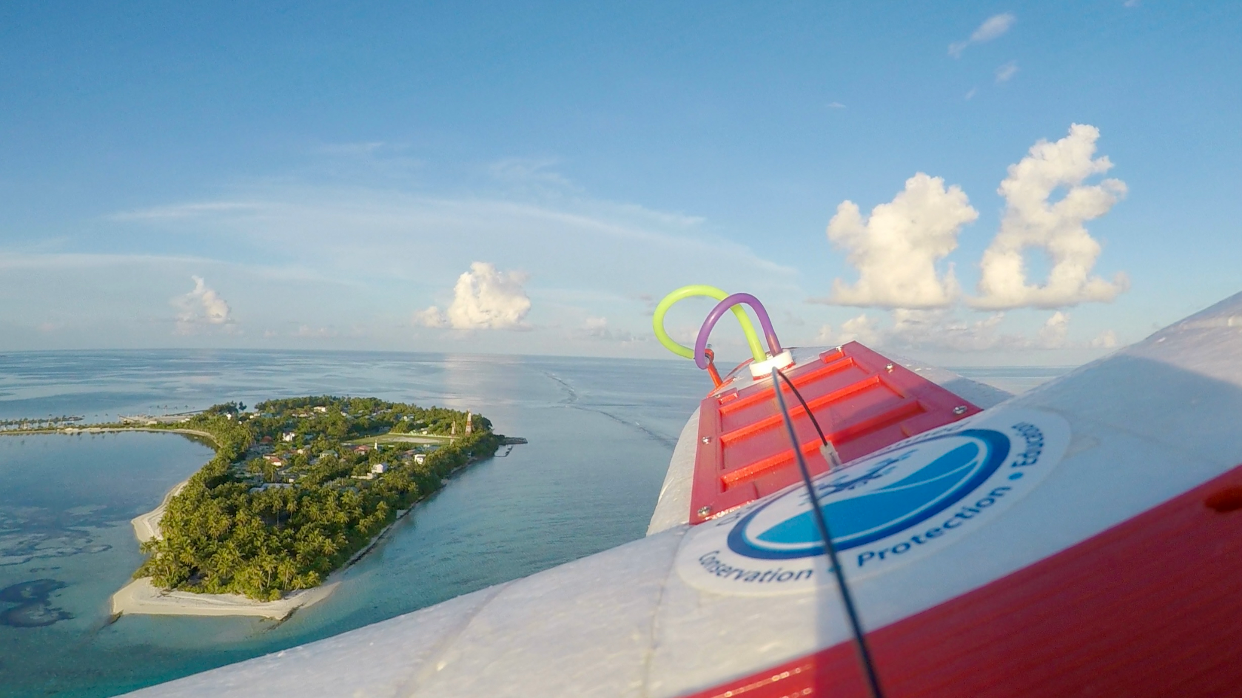
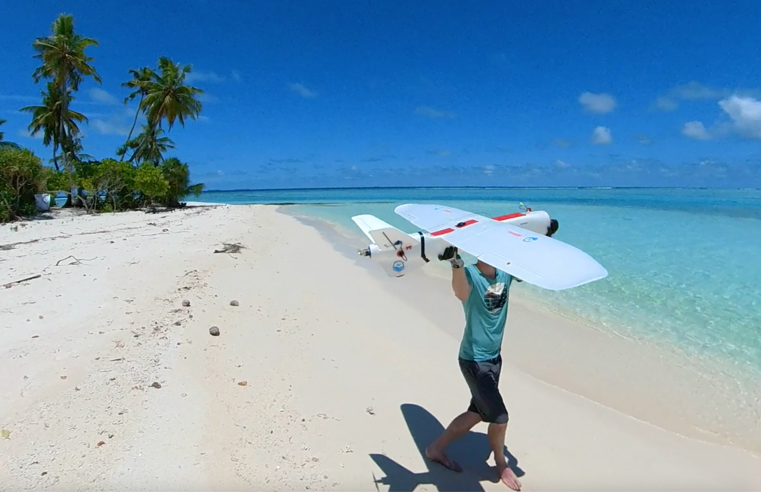

BOX (ale) Marhe Center will Welcome Erasmus Students from 6 European universities for the EU Erasmus+ BridgEt project a Summer School on submarine and coastal geohazards in the Maldives
We are proud to announce the involvement of the MaRHE center in the groundbreaking EU Erasmus+ "Bridget" project, started in 2022 and led by the University of Milano Bicocca. BridgET (bridget.unimib.it) has been designed to develop innovative and inclusive teaching methods, providing a unique and immersive learning experience, to upgrade key skills and scientific expertise in the field of 3D environmental and geological mapping in coastal regions, in order to unlock new horizons in geohazard research, and to renew the way in which marine geosciences are thought, contributing to the sustainable development of vulnerable areas. The MaRHE Center was selected by BridgET as a perfect location where a summer school on marine and coastal geohazard will be organized in 2024 for 24 MSc students, selected from the 6 European universities that join the Eurpean BridgET partnership (University of Milano-Bicocca, Arctic University of Norway, National and Kapodistrian University of Athens, University of Kiel, University of Liege, University of Malta) in collaboration with the National Institute of Geophysics and Volcanology (INGV), the National Institute of Astrophysics (INAF) and the small-sized enterprise OrthoDrone, based in Kiel, Germany. The entire BridgET partnership will be therefore involved at the MaRHE Center for the last project summer school, as part of a pioneering initiative that combines education, research, and sustainable development to address the geohazard challenges in the climatically sensitive atolls of the Maldives.
The Marhe Center, known for its expertise and commitment to advancing scientific knowledge, will have a critical role in the BridgET project. Erasmus students will have access to world-class research facilities and laboratories at the Marhe Center, equipped with state-of-the-art technology and resources. They will be guided by a distinguished team of European researchers and experts, who will mentor and inspire the students through a combination of lectures, fieldwork, and practical exercises. Participants will gain invaluable insights into the complexities of geohazard analysis, risk assessment, and management strategies. MaRHE Center will offer Erasmus students an exceptional opportunity to gain hands-on experience on the use of cutting-edge technologies to explore marine and coastal environments, as well as to broad their understanding on marine geohazard from a socio-cultural perspective. At the MaRHE Center students will have indeed the opportunity to engage with local communities, fostering cross-cultural exchange and gaining a deeper understanding of the social and economic implications of geohazards in the Maldivian archipelago, improving their awareness of the significance of sustainable development in vulnerable coastal communities.
By empowering students with the knowledge and skills to address geohazard challenges, the project strives to make a tangible difference in the preservation of climatically sensitive and vulnerable areas like the Maldives, while simultaneously fostering international cooperation and understanding, in line with the sustainable development goals.

Contents
Index

FOREWORD BY THE MaRHE DIRECTOR

Message from the Director
Prof. Paolo Galli

It is an honour and a pleasure to introduce the 2022 annual report of the Marine Research and High Education Center. Established in 2009 in Magoodhoo, Faafu Atoll, in partnership with the Government of Maldives, the MaRHE Center has grown to be one of the most important research organisations in the Maldives. Our goal is to conduct world-class, cutting-edge research on many aspects of marine ecosystems and the human communities that depend on them. Our research is multi-faceted and inter-disciplinary, reflecting the complex problems faced by the world's oceans. We train students at the undergraduate, master's and doctoral levels. We emphasise small groups, intensive research experiences, immersion in field work. We encourage all our students to become engaged citizens who will strive to make the world a better place. MaRHE Center helps educate students at the bachelor's, master's and doctoral levels. We are keenly aware of the challenges facing the world's oceans and our faculty are strong advocates for conservation of Maldivian marine ecosystems and Maldivian maritime communities.
We are proud to be part of the MaRHE Center and we accept to be part of a large research university. We invite anyone to join us here for a unique educational and research experience in the Maldives.
I am deeply grateful for the priceless support of our University and our esteemed Rector Giovanna Iannantuoni, as well as the Bicocca General Directorate, Dr. Cristiano Nicoletti, and all the University administrative staff that have contributed to the success of our work. I would like to take this opportunity to express my gratitude to the Government of the Maldives as well. In particular, H. E. Aminath Shauna, Maldives' minister of environment, climate change and technology. My sincere gratitude also goes to the esteemed Italian Ambassador for the Maldives and Sri Lanka, Mrs. Rita Giuliana Mannella, and to the Consul of the Maldives, Mrs. Giorgia Marazzi. A special thanks also goes to our partners, in particular to Sara Rosso of Planhotel and Alberto Gherli of White Wave Maldives. Last but not least, my heartfelt gratitude goes to all the members of the MaRHE team, who wake up every morning believing in our mission and putting their enthusiasm and skills at the service of this great project. To them all my gratitude, with the hope of a lasting and fruitful collaboration in the years ahead.

Team

Paolo Galli, Director
Professor of Ecology, Department of Environmental Sciences of University of Milano-Bicocca
Marcella Schmidt di Friedberg, Vice-director
Professor of Cultural Geography, Department of Human Sciences for Education, University of Milano BIcocca
Davide Seveso, Vice-director
Professor of Marine Ecology, Department of Environmental Sciences of University of Milano-Bicocca
Simone Montano, Vice-director
Professor of Marine Ecology, Department of Environmental Sciences of University of Milano-Bicocca
Elena dell’Agnese,
Professor of Geography at the Department of Sociology and Social Research, University of Milano-Bicocca
Stefano Malatesta,
Professor of Geography, Department of Human Sciences for Education, University of Milano BIcocca
Alessandra Savini,
Professor of Marine Geology, Department of Environmental Sciences of University of Milano-Bicocca
Maria Grazia Strepparava,
Professor of Clinical Psychologist, Department of Medicine and Surgery of University of Milano-Bicocca
Maria Carla Gilardi,
Professor of Department electronic bioengineering and informatics of Medicine and Surgery of University of Milano-Bicocca
Ilaria Tani,
Professor of international law, Department of Law, University of Milano Bicocca
Roberto Danovaro,
Professor in Marine Biology and Ecology at the Polytechnic University of Marche
Silvia Lavorano,
Genoa Aquarium, Curator of the Marine Tropical Department- Aquarium of Genoa- Costa Edutainment SpA
Davide Maggioni
Professor of Zoology, Department of Biotechnology and Biosciences
University of Milano Bicocca
Elena Valsecchi,
Professor of Zoology, Department of Environmental Sciences of University of Milano-Bicocca
Luca Fallati,
Professor of Marine Geology, Department of Environmental Sciences of University of Milano-Bicocca
Marco Contardi,
Professor of Materials Science And Technology, Department of Environmental Sciences of University of Milano-Bicocca
Enrico Montalbetti,
PhD Student, Department of Environmental Sciences of University of Milano-Bicocca
Jacopo Gobbato,
PhD Student, Department of Environmental Sciences of University of Milano-Bicocca
Mohamed Shifah,
Local Project coordinator, University of MIlano Bicocca
Louis Yohan Didier,
Professor of Zoology, Department of Environmental Sciences of University of Milano-Bicocca
Federica Siena,
PhD Student, Department of Environmental Sciences of University of Milano-Bicocca
Claudio Melli,
PhD Student, Department of Sociology and Social Research, University of Milano-Bicocca
Valerio Isa,
PhD Student, Department of Environmental Sciences of University of Milano-Bicocca
Federico Cerri
PhD Student, Department of Environmental Sciences of University of Milano-Bicocca

EDUCATIONAL ACTIVITIES CONDUCTED BY MaRHE CENTER

WORKSHOP “SUSTAINABLE TOURISM” ACS (FIRST SESSION: 15th – 21st MARCH 2022)
TOTAL PARTICIPANTS: 22 Workers + 3 Faculty
Professors and assistants of the University of Milano-Bicocca: 3
-Claudio Melli, DSRS, University Milano-Bicocca
-Valerio Isa, DISAT, University Milano-Bicocca
-Stefano Malatesta, DISUF, University Milano-Bicocca

WORKSHOP “SUSTAINABLE TOURISM” (FIRST SESSION: 22nd – 30th MARCH 2022)
TOTAL PARTICIPANTS: 20 Students + 6 Faculty
Professors and assistants of the University of Milano-Bicocca: 6
- Claudio Melli, DSRS, University Milano-Bicocca
- Valerio Isa, DISAT, University Milano-Bicocca
-Stefano Malatesta, DISUF, University Milano-Bicocca
- Marcella Schmidt di Friedberg, DISUF, University Milano-Bicocca
- Elena dell'Agnese, DSRS, University Milano-Bicocca
-Giovanni Modaffari, DSRS, University Milano-Bicocca

WORKSHOP “SUSTAINABLE TOURISM” (SECOND SESSION: 1st – 9th APRIL 2022)
TOTAL PARTICIPANTS: 21 Students + 6 Faculty
Professors and assistants of the University of Milano-Bicocca: 6
-Claudio Melli, DSRS, University Milano-Bicocca
-Valerio Isa, DISAT, University Milano-Bicocca
- Marcella Schmidt di Friedberg, DISUF, University Milano-Bicocca
- Elena dell'Agnese, DSRS, University Milano-Bicocca
-Giovanni Modaffari, DSRS, University Milano-Bicocca
-Valeria Pecorelli, IULM University

WORKSHOP “TROPICAL MARINE ECOLOGY” (FIRST SESSION: 24th APRIL - 2nd MAY 2022)
TOTAL PARTICIPANTS: 28 Students
Professors and assistants of the University of Milano-Bicocca: 4
- Luca Fallati, DISAT, University Milano-Bicocca
- Davide Maggioni, DISAT, University of Milano-Bicocca
- Federica Siena, DISAT, University of Milano-Bicocca
- Jacopo Gobbato, DISAT, University of Milano-Bicocca
- Federica Siena, DISAT, University Milano-Bicocca
Researchers from foreign University/NGO:
- Melissa Schiele, University of Loughborough
- Steve Lloyd, University of Loughborough
- CDR Matt Pickett, NOAA (ret)- OCEAN UNMANNED
- CAPT Brian Taggart, NOAA (ret)- OCEAN UNMANNED

WORKSHOP “TROPICAL MARINE ECOLOGY” (SECOND SESSION: 3rd MAY - 11th MAY 2022)
TOTAL PARTICIPANTS: 27 Students
Professors and assistants of the University of Milano-Bicocca: 4
- Luca Fallati, DISAT, University Milano-Bicocca
- Davide MaggionI, DISAT, University of Milano-Bicocca
- Federica Siena, DISAT, University of Milano-Bicocca
- Jacopo Gobbato, DISAT, University of Milano-Bicocca

WORKSHOP “TROPICAL MARINE FISHES: IDENTIFICATION AND ECOLOGY” (12th - 20th MAY)
TOTAL PARTICIPANTS: 18 Students
Professors and assistants of the University of Milano-Bicocca: 6
- Davide Seveso, DISAT, University Milano-Bicocca
- Massimo Boyer, Kudalaut
- Giovanni Strona, Professor University of Helsinki (Finland)
- Simone Montano, DISAT, University Milano-Bicocca
- Jacopo Gobbato, DISAT, University Milano-Bicocca
- Federica Siena, DISAT, University Milano-Bicocca

WORKSHOP FOR HIGH SCHOOL STUDENTS “CLIMATE CHANGE, VULNERABILITIES, MANAGEMENT OF PLASTIC WASTE AND STRATEGIES FOR ADAPTATION AND MITIGATION” (12th -19th JUNE)
Total participants 20 (students)
Professors and assistants: 5
Paolo Galli - Department of Earth and Environmental Sciences
Silvia Lavorano - Genoa Aquarium
Federica Siena - Department of Earth and Environmental Sciences
Valerio Isa - Department of Earth and Environmental Sciences
Elena Cotugno - University of Milano-Bicocca

WORKSHOP for Maldivian National University “MARINE AND LAND SURVEY” (25th- 29th OCTOBER)
TOTAL PARTICIPANTS: 16 Students from the BMS in Marine Sciences and BMS in Environmental Management
Professors and assistants of the University of Milano-Bicocca: 2
- Luca Fallati, DISAT, University Milano-Bicocca
- Federica Siena, DISAT, University Milano-Bicocca
Researchers from foreign University:
- Melissa Schiele, University of Loughborough

WORKSHOP: TROPICAL MARINE ECOLOGY (FIRST SESSION: 30th OCTOBER – 7th NOVEMBER)
TOTAL PARTICIPANTS: 28 Students +3 Faculty
Professors and assistants of the University of Milano-Bicocca:
- Luca Fallati, DISAT, University Milano-Bicocca
- Davide Maggioni, DISAT, University of Milano-Bicocca
- Federica Siena, DISAT, University of Milano-Bicocca
Researchers from foreign University:
- Melissa Schiele, University of Loughborough

WORKSHOP: TROPICAL MARINE ECOLOGY (SECOND SESSION: 9th – 17th NOVEMBER 2022)
TOTAL PARTICIPANTS: 27 Students + 3 Faculty
Professors and assistants of the University of Milano-Bicocca:
- Davide Maggioni, DISAT, University of Milano-Bicocca
- Federica Siena, DISAT, University of Milano-Bicocca
- Jacopo Gobbato, DISAT, University of Milano-Bicocca

VISITING PROFESSORS AND RESEARCHERS

Dr. Eva-Maria Knoll, Institute For Social Anthropology (Isa), Austrian Academy Of Sciences, Vienna, Austria. 22- 29 October

Prof. Oren Levy, The Mina and Everard Goodman Faculty of Life Sciences, Bar Ilan University, Ramat Gan 52900, Israel. 12-22 December

Dr. Inbal Ayalon, The Mina and Everard Goodman Faculty of Life Sciences, Bar Ilan University, Ramat Gan 52900, Israel. 12-22 December

Prof. Ezri Tarazi, The Mina and Everard Goodman Faculty of Life Sciences, Bar Ilan University, Ramat Gan 52900, Israel. 12-22 December

Dr. Ofer Bermann, Technion, Israel Institute of Technology, Haifa, Israel. 12-22 December

Dr. Gert Worheide and 3 Faculty members, Ludwig Maximilian University of Munich. 24 March - 2 April

Dr. Imogen Napper, Dr. Francesco Saliu, Dr. Valerio Isa, Claudio Melli. 22 November - 5 December. “Delivering workshops and guidance in environmental chemistry to female children living in small Maldivian islands to inspire future scientific careers”. The goal of the project was to engage primary school students, to grow their interest in future scientific careers by offering lessons concerning the basic concepts of chemistry linked to real world scenarios and involving practical aspects of marine chemistry and hot topics such as climate change, plastic pollution and sustainable development. The project reached a total of 57 students between grade 2 and grade 3.

UNIVERSITÀ STRANIERE CHE HANNO SOGGIORNATO AL CENTRO

University of Exeter: 12th - 23rd April
TOTAL PARTICIPANTS: 25 students + 4 faculty members
Assistants from University of Milano Bicocca: 4

SPECIAL EVENTS

Lisbon, 28 June 2022 – at the United Nations Ocean Conference, MaRHE Center presents VERTICAL OCEAN

“Vertical Ocean” project, which revolutionizes the approach to ocean protection through consideration of all three marine dimensions regulated by the law of the sea: the seabed and subsoil, the water column, and the airspace above the marine surface.

On the second day of the United Nations Ocean Conference, the Government of the Maldives (Ministry of Environment, Climate Change and Technology) and University of Milano-Bicocca (Milan, Italy) signed a Memorandum of Understanding (MoU) aimed at providing an innovation tool for coordination and cooperation in protecting one among the most emblematic marine and coastal sites of the world for what concerns the current global environmental threats deriving from climate change, including sea-level rise and ocean acidification: the central Maldivian atolls of Meemu, Faafu, Dhaalu and Thaa, in the earth of the Indian Ocean.

The objective of the MoU is pursued through the implementation of the “Vertical Ocean” project, which revolutionizes the approach to ocean protection through consideration of all three marine dimensions regulated by the law of the sea: the seabed and subsoil, the water column, and the airspace above the marine surface.

“Vertical Ocean” moves from the premise that the relationship between man and the ocean has been long since influenced by the viewpoint of a subject that walks on land. Inherently, man does not dive, nor fly. His point of view has always been the one of a man that becomes seaman and, as such, crosses the ocean horizontally, sailing all over the world. Ocean depth exploration is only for a few, and the sky is mostly looked at as a separate part of the ecosystem. “Vertical Ocean” aims, instead, at recognizing the low-lying Maldivian land features and the surrounding natural elements – namely, the marine waters and the atmosphere – as a single unit of the same ecosystem.

Accordingly, each of the three marine dimensions, regulated by a specific legal regime in the context of the jurisdictional divisions established by international law, must be included in any consideration aiming at pursuing an ecosystem approach to environmental preservation and protection of marine and coastal areas. A “vertical” approach is thus needed, as the rise of ocean level has somehow changed our original perspective.

The fact that the International Law Commission has elected ‘Sea-level Rise in Relation to International Law’ as a topic that deserves in-depth study is emblematic of the urgency of the matter also for what concerns the certainty of international relations, since the rules on the measurement of maritime baselines are destined to be challenged by a changing coastal environment. “Vertical Ocean” would offer a privileged point of view in assessing the potential changes of the maritime inner limits.

Besides the legal issues raised by sea-level rise, environmental preservation of pristine sites proves particularly challenging in the era of climate change, as the physical and ecological conditions of the same ecosystem are being subject to abrupt transformations. A “vertical” approach is deemed more appropriate with a view not to forget the degree of the reciprocal influences of the three different elements of the ocean space, as well as their associated species, in relation to climate change. Sea-level rise can be better understood in the context of a “vertical” approach to the measurements of such reciprocal influences. Last but not least, the ‘human’ element of the oceans, i.e. the population of islanders profoundly impacted by these increasing pressures, will play a crucial role in securing resilience and, overall, in providing responses to the most serious threats based on preparedness and compliance with the objectives of “Vertical Ocean”.

“Research will be conducted over the next three years by a team of over 20 scientists from University of Milano-Bicocca, with the support of the Maldivian Government” – explained Professor Paolo Galli, Scientific Coordinator of the “Vertical Ocean” project and Director of the Marine Research and Higher Education Center (https://marhe.unimib.it) in the Maldives. He continued: “The MoU will provide a framework within which technical assistance and in-kind support will be secured to local officers and scientists to better protect the Maldives, in line with SGDs 14 (Life below Water) and 17 (Partnerships for the Goals)”.

BIODIVERSITY MONITORING VIA eDNA ANALYSIS

Non-invasive monitoring of marine communities
In 2022 the MaRHE Center has carried on and implemented the collection of environmental DNA (eDNA) samples, started since 2020. The uniqueness of this year sampling activities is that opportunistic samples collected from the diving vessel White Wave Safari (collaborating with the MaRHE center in this activity since 2020) have been flanked with samples collected from cetacean “footprints” during a scientific expedition dedicated to the study of cetaceans (run by Charles Anderson in collaboration with the Maldivian Marine Research Institute), providing a unique sample set that will be employed to test novel molecular approaches for maximising the resolution of cetaceans, a taxonomic group of great global interest.
The research project has provided data for one master thesis in Marine Sciences (Simone Innocente, “Implementing marine mammal reads recovery in vertebrate metabarcoding analysis: the study case of Maldives, an open-air lab of biodiversity”, 110/110, see below ). The preliminary results have been presented (Valsecchi et al. 2022) at the Fourth Maldivian Marine Science Symposium (Malè, 13th-14th August 2022). The outcomes from the complete data set are currently being analysed and object of a manuscript in preparation.

CASE STUDY

“Inside the Bodumas”, documentary on a maldivian tradition
In the summer of 2022, a professional video crew (Giulio Pedretti, Roberto Carini and Giorgio Beozzo), in collaboration with PHD student Claudio Melli, Prof. Marcella Schmidt, Prof. Stefano Malatesta and Prof. Galli, realised a documentary on one of the most peculiar traditions of Maldivian culture: the “Bodumas”, a spectacular representation, part of the muslim “Feast of Sacrifice”.
There are many folklores which offer keen insights into the history, culture and beliefs of Maldivians. These folk tales are bursting with magic, spirits, demons, monsters and sorcerers often depicted in traditional cultural activities. One example is the local interpretation of the Muslim tradition linked to the “Eid al-Adha” (feast of sacrifice), the celebration of “Bodumas” (or big fish). Instead of sacrificing a goat, in Maldives the sacrifice is related to the "big fish", a mask made out of woven coconut palm leaves by islanders. “Bodu'' means big whereas “Mas” means fish. This celebration is followed by “Maali Neshun'', a traditional form of dance performed by a group of people painted and dressed up as evil spirits and ghosts. This tradition is based on an ancient folklore in which a Bodu Mas (a big fish) along with Maali (ghosts) had come out from the sea and a struggle to catch this fish ensued. After a long struggle, the villagers are said to have succeeded with the help of a holy man.
The celebration is deeply felt by the inhabitants of the islands and the festival still maintains strong features linked to the ancient traditions. For the “Bodumas” the whole community is actively involved, the documentary shows all the phases of the festival through a cinematographic point of view.
“Inside the Bodumas” was shooted mainly on the island of Magoodhoo, where celebrations retain all its traditional characteristics, and on Maahenboodhoo island, where the “Bodumas” is also organised to attract tourists, mainly Maldivian ones, transforming itself from tradition to actual folklore. Through a series of interviews with festival participants and organisers, professors and experts in Maldivian culture, the viewer can understand the founding elements of the celebration (religious, cultural, spectacular, sporting, musical, food traditions, etc.) and experience the different phases of the 2022 event.
The documentary has been submitted to film festivals competition related to traditions, environmental issues and ethnography, both Italian and international. The video will also be used as a research and teaching tool by professors and researchers at the Bicocca University.
The intention for 2023 is to shoot more footage of the more touristic versions of the “Bodumas” tradition, to bear witness to the evolution from traditional to contemporary society, which is fundamentally linked to the tourism industry (resorts, shopping centres, etc.).

NOT ONLY MALDIVES

United Arab Emirates
The United Arab Emirates are mainly renowned in the world for their great wealth represented by oil and gas reserves (they are the sixth largest producers in the world) and for the cities of Dubai and Abu Dhabi where towering skyscrapers designed by major archistars, is located Dubai the tallest building in the world, the Burj Khalifa, inaugurated in 2010, is 830 meters high and consists of 163 floors. Few people know that in the United Arab Emirates there are also some important biodiversity hotspots represented by mangroves, forests made up of tall trees that grow in the border area between the sea and the desert and whose roots are immersed in sea water, are among the few plants in the world able to survive in contact with salt water.
Mangrove forests are home to both terrestrial and marine life forms. The aerial part represents an ideal habitat for birds, for example, they are in fact nesting sites and serve as resting or wintering places for an impressive number of coastal birds and other species of migratory birds that use them during their intercontinental movements. Numerous marine species use the dense network of roots immersed in sea water as a safe haven from predators during the first stages of their lives. In a desert territory like that of the Emirates where plants are scarce, mangroves also play an important role in sequestering carbon dioxide thus reducing the impact of climate change.
Despite the high ecological importance of these ecosystems for the United Arab Emirates, few studies have been conducted in these places. The University of Milano Bicocca together with the University of Dubai and Goumbook, a Dubai company engaged in corporate social responsibility have recently embarked on a three-year research project aimed at filling the gaps in the knowledge of these important ecosystems. In September of this year, a task force made up of 20 researchers with different scientific skills began to carry out the first studies in the field. Among the members of the task force, coordinated by Prof. Paolo Galli, there are ecologists, zoologists, geologists, environmental chemists but also economists, jurists, psychologists. The first surveys were carried out in the protected area of ​​Al-Zorah, located in the Emirate of Ajman, a protected area that extends from the sea, with some canals, for about 5 km into the desert hinterland. Thanks to the authorizations obtained by the Emirate samples of marine sponges were collected which are essential for understanding the presence and quantification of emerging contaminants such as the chemical compounds contained in sunscreens, insect repellents, hydrocarbons and drugs; another study concerned the identification and origin of microplastics in water; an important investigation is being carried out by marine geologist colleagues who have used for the first time in the world in a mangrove grove a portable laser scanner with LiDAR sensor capable of reconstructing the three-dimensional structure of the forest with high precision, making it possible to estimate indirectly the quantity of sequestered carbon dioxide. The zoological colleagues instead focused on the identification of the marine species that make up the ecosystem including corals and sponges, while in the next data collection campaign they will aim at identifying the bird species (it is estimated that there may be more than sixty species). The study of the biodiversity of these places could also be important for human health, in fact studies are underway aimed at verifying the presence in the stems, leaves and roots of mangroves of active biomolecules, molecules potentially usable in the pharmaceutical field, for example as anticancer, or to be used in cosmetics.
The working group also includes economists from the University of Dubai who will make it possible to quantify the economic value of these ecosystems both in terms of biodiversity heritage and in terms of the value that could arise from tourism and since environmental protection also depends from the regulations that regulate these places and from people's ability to understand their value, the research group includes human geographers, jurists and psychologists, the latter will carry out, for example, investigations aimed at understanding how much the perception of the value of the place is of preserving these places. All the data collected will be presented by the University of Milan Bicocca, the University of Dubai and the Goumbook company, at COP28, the annual meeting of the countries that have ratified the United Nations Framework Convention on Climate Change, which will be held in Dubai at the end 2023. It will be an important moment to share with the general public the importance of preserving these biodiversity hotspots and how they play a fundamental role in mitigating the impact of climate change thanks to their ability to sequester carbon dioxide, a small a sign of hope for future generations who ask us for solutions to the problems caused by climate change.

Mediterranean

April 2022 - Analysis of the cellular stress response of gorgonian Paramuricea clavata to mucilage induced necrosis stress in Portofino Marine Protected Area
Project leader: Dott. Davide Seveso (MaRHE Center, Unimib DISAT) and Prof. Monica Montefalcone (University of Genova, DiSTAV)
Collaborators: Dott. Enrico Montalbetti (MaRHE Center, Unimib DISAT), Dott.ssa Annalisa Azzola (University of Genova, DiSTAV), Sofia Cavallo (Unimib, DISAT).

2022-present: sampling activities related to the phd project of Jacopo Gobbato entitled “Health and diseases assessment of shallow-water anthozoans of the Marine Protected Areas of Portofino and Bergeggi”
PI: Simone Montano;
Sampling areas: AMP portofino, AMP Bergeggi
Sampled organisms: Cladocora caespitosa, Madracis Pharensis, Eunicella cavolini, Eunicella verrucosa, Leptogorgia sarmentosa, Paramuricea clavata, Parazoanthus axinellae

COOPERATION AGREEMENTS

Memorandum of Understanding between Ministry of Environment, Climate Change and Technology, the Government of the Republic of Maldives and University of Milano Bicocca, Marine Research and High Education Center on cooperation and coordination to undertake the ecological and socio-economic assessments of the existing protected areas and potential protected areas in Maldives
Memorandum of Understanding between the United Nations Development Programme and the University of Milano-Bicocca and the University of Dubai for support in the enhancement of existing national data and information management system for DRR/CCA monitoring to include loss and damage ii) Support in the implementation of capacity development modules for local councils and women's development committees (WDCs) on CCA/DRR planning
MoU between University of Karachi (Pakistan) and the University of Milano Bicocca, Marine Research and High education center to implement a scientific and academic cooperation programme with the aim to promote interest in the teaching and research activities of the respective institutions in the Marine Biology sector.
MoU between Marine Protected area of Bergeggi and University of MIlano Bicocca, Marine Research and High education center to undertake ecological and biological study of mediterranean biodiversity.

MaRHE Center Genoa Aquarium

In 2020 the Acquario di Genova and the Milano-Bicocca University became scientific partners for the study and conservation of tropical corals, with particular attention to Maldivian reefs. Following this collaboration, a joint laboratory between the Genoa Aquarium and the Milanese university was inaugurated in June 2022 in the MaRHE Center Maldives in 2022. The initiative is part of the program of the agreement signed between the two institutes in 2020, aimed at developing joint research and dissemination activities. The new laboratory further strengthens the link and scientific collaboration between the two institutes. Researchers will be able to further their studies by taking advantage of both the infrastructures of the Genoese pole of the MaRHe Center established in 2020 and that of the Maldives. In the coming years, several joint scientific missions are expected to be carried out in the Maldives in which researchers from the Milano Bicocca University and the Genoa Aquarium will go to the MaRHE Center in Magoodhoo to apply in the natural environment what they have learnt thanks to the research conducted in Genoa.

THESIS WITH MaRHE

Bachelor Thesis

Colombo Sebastiano: Caratterizzazione dell’espressione genica per identificare marker molecolari associati alla calcificazione a lungo termine e alla resistenza a batteri patogeni in Montastraea cavernosa
Deligios Moira: L'effetto dei predatori sul foraggiamento della specie erbivora aliena Siganus rivulatus
Brioschi Giacomo: Perdita di alghe giganti, Macrocystis pyrifera, causata dalle ondate di calore marine ed esacerbata dalla scarsa chiarezza dell’acqua in Nuova Zelanda
Ferrara Francesca: Modelli di crescita asintotica di squali balena suggeriscono strategie ecologiche sesso-specifiche
Lorenzini Sofia: Differenze fisiologiche nella risposta allo sbiancamento del corallo Porites astreoides durante eventi di stress termico
Marzucchi Matilde: Vulnerabilità dei mammiferi marini al riscaldamento global
Ponzetto Simone: La morfologia dei coralli può predire il rischio di estinzione?
Verduci Valentina: L’elevata intensità di pascolo di bovini sostituisce gli erbivori selvatici nel modellare la vegetazione?
Zeri Giulia: Migrazione lessepsiana e parassitismo: confronto tra ricchezza, prevalenza ed intensità di parassiti nella specie invasiva Sphyraena chrysotaenia e nella nativa Sphyraena sphyraena
Arosio Pietro: Le risposte funzionali e il cambio di preda da parte del pesce scorpione invasivo possono mediare il suo impatto ecologico
Fumagalli Sara: Esposizione prolungata di molluschi al paracetamolo: il caso dei Mytilus edulis
Lorenzi Martina: Relazione tra riscaldamento degli oceani e alterazione del ciclo dei nutrienti di Stylophora pistillata
Maniscalco Camilla: Differenti colorazioni del corallo Acropora tenuis mostrano diverse risposte a stress ambientali e diversi profili di espressione di geni codificanti per proteine fluorescenti
Spandri Giorgia: La predazione dei pesci pappagallo influenza le comunità microbiche associate ai coralli
Sirtori Martina: Le nicchie funzionali delle specie di pesci pulitori sono determinate dall'uso dell'habitat, dall'intensità di pulizia e dalla selettività del cliente
Pizzaballa Giorgia: Applicazione di tecniche fotogrammetriche e image analysis per lo studio dei cambiamenti eco-geomorfologici degli ambienti di scogliera corallina
Vergani Matteo: Monitoraggio temporale della prateria di fanerogame nella laguna dell’isola di Magoodhoo (Faafu, Maldive) attraverso immagini da drone e tecniche fotogrammetriche

Master Thesis

Cerri Federico: Studio dell’attività citotossica di estratti di Sarcophyton sp. su linee cellulari di carcinoma colorettale umano
Abolhasani Afshin: Alcanivorax potential capabilities in bioremediation of hydrocarbon-contaminated marine environments.
Babayev Elvin: Disaster risk reduction assessment of Ligurian coastal zone: case study of 2011 rainfall in Vernazza, Cinque Terre
Bacchet Nicolò: Evidence from life history traits of the lesser spotted dogfish Scyliorhinus canicula across a gradient of fishing disturbance off the Portopalo di Capo Passero (Central Mediterranean Sea) fishing ground
Barbaccia Eleonora: An evaluation of whale shark (Rhincodon typus) disturbance behaviours during tourism interactions in La Paz Bay, Mexico
Bertoni Matteo: Influence of environmental factors on the seasonality and distribution of several species of pelagic sharks off the southern tip of Baja California Sur, Mexico
Boldrin Giulia: Assessment of heavy metals and trace elements in the Scalloped Hammerhead Shark (Sphyrna lewini) from an artisanal fish camp in La Paz Bay, Baja California Sur (Mexico)
Botero Angel Ana Maria: The role of habitat complexity in shaping the malacofauna community associated to a Cymodocea nodosa seagrass meadow
Calò Lorena Gil: Microplastic fate modeling: parametrization of the main processes affecting plastic debris in the ocean and their integration in the PaTATO toolbox
Casati Mario: Biodiversity assessment of coralline hotspots in Crystal Bay, Nusa Penida
Contu Giada Giulietta:Monitoring cetacean-artisanal fisheries interactions along the Sicilian coasts: insights from Fishermen Ecological Knowledge
Dessi' Roberta: Benthic foraminifera response to environmental changes recorded in the marine sediments of La MaddalenaHarbour (N. Sardinia)
Diamante Luca: Combined effects of microplastic pollution and thermal stress on the tropical coral Pocillopora damicornis
Diliberto Cascio Costanza: Custom panel design for enriched PCR characterization of marine hydrocarbon-degrading bacteria
El Haddad Nicole: Bottlenose dolphin mothers increase signature whistles frequency in the presence of their calves: evidence for motherese
Gaiani Selene: Coral reef rugosity effects on fish abundance across dive sites around Nusa Penida, Indonesia
Ghizzi Isabella: New insight into the microbiome composition of two Mediterranean coral species
Groppelli Sara: Ecological and Molecular Analysis of Sea Anemones (Cnidaria, Actinaria), In Bathala Island (North Ari Atoll, Maldives).
Harvey Megan May: Effects of different degrees of fishing pressure on life-history traits in Mullus barbatus: a case study across the Sicilian continental shelf (Central Mediterranean Sea)
Innocente Simone: Implementing marine mammal reads recovery in vertebrate metabarcoding analysis: the study case of Maldives, an open-air lab of biodiversity.
Lainati Niccolò: Coral health and diseases assessment of tropical coral reef in Thudufushi island, Republic of Maldives
Madaschi Andrea: Curcumin loaded smart material as new strategy to mitigate impacts of coral bleaching
Magrini Andrea: Ecological assessment of two symbioses involving Hydrozoans in the waters of Bonaire, Dutch Caribbean: the Stylaster roseus and Nemalecium lighti case studies
Mazumdar Arindam: Sea-spray hygroscopicity in the framework of the EURECA and AREX Oceanographic cruises: synergy with atmospheric aerosol
Milanesi Elena Maria Chiara: Cellular and physiological response of neonatal blacktip reef sharks (Carcharhinus melanopterus) subjected to thermal and anthropogenic stressors in Moorea Island, French Polynesia
Milivojevic Ana: Litter on sandy beaches: evidence from a systematic literature review and a case study of two Sicilian beaches with different management systems
Nebuloni Alice: Population structure and habitat of the Mediterranean bottlenose dolphin (Tursiops truncatus) based on the analysis on an extensive metadata set
Pravettoni Ludovico: Thermal pre-conditioning enhances the antioxidant defense in different reef-building coral species
Ramella Denise: The Mediterranean monk seal in the Balearic Islands: from historical to molecular (eDNA) records
Rinaldi Camilla: Effects of coral restoration on the distribution and impacts of Caribbean Ciliate Infection (CCI) at Bonaire, Dutch Caribbean
Schivalocchi Francesca: Phycosphere of an Arctic Microalgal Community
Tatar Mert: Marine Pollution and its Monitoring by Remote Sensing
Vicario Silvia: Black corals diversity of the Saudi Arabian Red Sea, an integrated systematic approach.

PhD Thesis

The year 2022 saw the birth of the new doctorate in Marine Sciences, technologies and management which has made it possible to host, from November 2023, 16 doctoral students who will carry out their doctorate at the MaRHE Center with different projects.

Cristina Canella: The legal basis for representative networks of marine protected areas and the implementation of other effective area-based conservation measures in the Maldives and the wider Indian Ocean region
Massimiliano Fantò: Marine protected areas: socio-spatial patterns and environmental conflicts
Rota Alessia: Using marine environmental DNA for biodiversity monitoring and conservation planning
Cerri Federico: Ocean bioprospecting: exploring the pharmaceutical potential of tropical marine organisms
Rinaldi Camilla: Advanced materials for coral protection, healing, and restoration
Corigliano Gabriele: Bioinspired robots for marine biodiversity
Ferrari Giorgia: Effects of the environmental pollution to sea microfauna and corals
Spena Francesca: Search for novel sustainable materials from marine and plant sources for replacing synthetic substances in cosmetics
De Santes Beatrice: Solid and semisolid formulations for supplements and cosmetics
Del Greco Alexia: Luxury and sustainability: Beliefs, Attitudes and psycho-affective determinants of individual behaviour
Becchi Alessandro: Innovative biomarine products for luxury packaging
Bises Chiara: Effects of coral diseases on the performance of large-scale coral restoration projects
Siena Federica Marialuisa: A multi-layer framework to optimize coral restoration actions
Madaschi Andrea: A multidisciplinary approach to assess the impact of climate change and
anthropogenic stressors on the biodiversity and health of coral reef associated
organisms
Beozzo Giorgio: Study of the biodiversity of Maldivian ecosystems through historical iconographic material analysis
Mazumdar Arindam: Ecological assessment of mangrove stands in al-zorah protected area United Arab Emirates

An additional PhD thesis will be carried out from November 2023 in the framework of the doctorate school in Chemical, Geological and Environmental Sciences.

Andrea Giulia Varzi: The use of advanced geomorphological mapping techniques for innovative research in the science of marine geohazard and environmental changes in coastal environments

PUBLICATIONS

University of Milano-Bicocca Publications

A. J. A., Palomo M. G., Dineshram R., Rilov G., Sanchez-Jerez P., Sevgili H., Troell M., AbouelFadl K. Y., Azra M. N., Britz P., Brugere C., Carrington E., Celić I., Choi F., Qin C., Dobroslavić T., Galli P., Giannetto D., Grabowski J., Lebata-Ramos M. J. H., Lim P. T., Liu Y., Llorens S. M., Maricchiolo G., Mirto S., Pećarević M., Ragg N., Ravagnan E., Saidi D., Schultz K., Shaltout M., Solidoro C., Tan S. H., Thiyagarajan V., Helmuth B.. 2022. The synergistic impacts of anthropogenic stressors and COVID-19 on aquaculture: A current global perspective. Reviews in Fisheries Science & Aquaculture 30 (1), 123-135

Abdulla, A., Schmidt Muller di Friedberg, M. 2022. Textiles as Heritage in the Maldives. In Xinfeng YanLihong ChenHafeezullah Memon (a cura di), Textile and Fashion Education Internationalization (pp. 145-174). SPRINGER [10.1007/978-981-16-8854-6_8].

Benocci R., Asnaghi E., Bisceglie A., Lavorano S., Galli P., Roman H. E., Zambon G. 2022. Method for Assessing the Soundscape in a Marine Artificial Environment. Sustainability,14,16,10359

Biella P., Ssymank A., Galimberti A., Galli P., Perlík M., Ramazzotti F., Rota A., Tommasi N. 2022. Updating the list of flower- visiting bees, hoverflies and wasps in the central atolls of Maldives, with notes on land-use effects. Biodiversity Data Journal 10, e85107

Brambilla V., Barbosa M., Dehnert I., Madin J., Maggioni D., Peddie C., Dornelas M. 2022. Shaping coral traits: plasticity more than filtering. Marine Ecology Progress Series. 692:53-65

Cerri F., Saliu F., Maggioni D., Montano S., Seveso S., Lavorano S., Zoia L., Gosetti F., Lasagni M., Orlandi M., Taglialatela-Scafati O., Galli P. 2022. Cytotoxic compounds from Alcyoniidae: An overview of the last 30 years. Marine Drugs, 20 (2), 134

Dehnert I., Saponari L., Galli P., Montano S. 2022. Comparing different farming habitats for mid-water rope nurseries to advance coral restoration efforts in the Maldives. PeerJ 10, e12874

Dehnert I., Saponari L., Isa V., Seveso D., Galli P., Montano S. 2022. Exploring the performance of mid‐water lagoon nurseries for coral restoration in the Maldives, Restoration Ecology, 30, 7, e13600,

Di Biase, R., Malatesta, S., Schmidt di Friedberg, M. 2022. Promoting education for sustainable development in the Maldives: Exploring the link between theory and practice. PROSPECTS, 52(3-4), 529-544 [10.1007/s11125-021-09558-6].
Diversity. 14: 241

Emanuela Cazzaniga, Antonina Orlando, Annalisa Terenzio, Carlotta Suardi, Chiara Mognetti, Francesca Gennaro, Laura Antolini and Paola Palestini. 2022. Health Status and Nutritional Habits in Maldives Pediatric Population: A Cross-Sectional Study. Int. J. Environ. Res. Public Health. 19(23), 15728

Gobbato J., Magrini A., García-Hernández J. E., Virdis F., Galli P., Seveso D., Montano S. 2022. "Spatial Ecology of the Association between Demosponges and Nemalecium lighti at Bonaire, Dutch Caribbean", Diversity, 14, 8, 607

Isa V., Saliu F., Bises C., Vencato S., Raguso C., Montano S., Lasagni M., Lavorano S., Clemenza M., Galli P. 2022 Phthalates bioconcentration in the soft corals: Inter-and intra-species differences and ecological aspects. Chemosphere, 297 134247

Maggioni D., Garese A., Huang D., Hoeksema B. W., Arrigoni R., Seveso D., Galli P., Berumen M. L., Montalbetti E., Pica D., Torsani F., Montano S. 2022. Diversity, host specificity and biogeography in the Cladocorynidae (Hydrozoa, Capitata), with description of a new genus. Cladistics, 38 (1), 13-37

Maggioni D., Terraneo T. I., Chimienti G., Marchese F., Pica D., Cairns S. D., Eweida A. A., Rodrigue M., Purkis S. J., Benzoni F. 2022. The First Deep-Sea Stylasterid (Hydrozoa, Stylasteridae) of the Red Sea. Journal

Maggioni G., Huang D., Maggioni D., Jain S. S., Quek R. Z. B., Poquita-Du R. C., Montano S., Montalbetti E., Seveso D. 2022. The Association of Waminoa with Reef Corals in Singapore and Its Impact on Putative Immune- and Stress-Response Genes. Journal Diversity. 14: 300

Malinverno E., Leoni B., Galli P. 2022. Coccolithophore assemblages and a new species of Alisphaera from the Faafu Atoll, Maldives, Indian Ocean. Marine Micropaleontology 172, 102110

Mangano M. C., Berlino M., Corbari L., Milisenda G., Lucchese M., Terzo S., Bosch-Belmar M., Azaza M. S., Babarro J. M. F., Bakiu R., Broitman B. R., Buschmann A. H., Christofoletti R., Dong Y., Glamuzina B., Luthman O., Makridis P., Nogueira A. J. A., Palomo M. G., Dineshram R., Sanchez-Jerez P., Sevgili H., Troell M., Abouel Fadl K. Y., Azra M. N., Britz P., Carrington E., Celić I., Choi F., Qin C., Dionísio M. A., Dobroslavić T., Galli P., Giannetto D., Grabowski J. H., Helmuth B., Lebata-Ramos M. J. H., Lim P. T., Liu Y., Llorens S. M., Mirto S., Pećarević M., Pita C., Ragg N., Ravagnan E., Saidi D., Schultz K., Shaltout M., Tan S. H., Thiyagarajan V., Sarà G.. 2022. The aquaculture supply chain in the time of covid-19 pandemic: Vulnerability, resilience, solutions and priorities at the global scale. Environmental science & policy 127, 98-110

Mirto S., Montalto V., Mangano M. C., Ape F., Berlino M., La Marca C., Lucchese M., Maricchiolo G., Martinez M., Rinaldi A., Terzo S. M. C., Celic I., Galli P., Sarà G. 2022. The stakeholder's perception of socio-economic impacts generated by COVID-19 pandemic within the Italian aquaculture systems. Aquaculture 553, 738127

Montalbetti E, Cavallo S, Azzola A, Montano S, Galli P, Montefalcone M, Seveso D (2022). Mucilage-induced necrosis reveals cellular oxidative stress in the Mediterranean gorgonian Paramuricea clavata. Journal of Experimental Marine Biology and Ecology, 151839.

Montalbetti E, Isa V, Vencato S, Louis Y, Montano S, Lavorano S, Galli P, Seveso, D (2022). Short-term microplastic exposure triggers cellular damage through oxidative stress in the soft coral Coelogorgia palmosa. Marine Biology Research, 1-14.

Montalbetti E., Fallati L., Casartelli M., Maggioni D., Montano S., Galli P., Seveso D. 2022. Reef complexity influences distribution and habitat choice of the corallivorous seastar Culcita schmideliana in the Maldives. Coral Reefs 41 (2), 253-264

Montano S., Aeby G., Galli P., Hoeksema B. W. 2022. Feeding Behavior of Coralliophila sp. on Corals Affected by Caribbean Ciliate Infection (CCI): A New Possible Vector?. Diversity 14 (5), 363

Montano S., Dehnert I., Seveso D., Maggioni D., Montalbetti E., Strona G., Siena F., Amir H., Antoine A., Marino-Ramirez C., Saponari L., Shah N. J., Molina R. A., Ortega A. A., Galli P., Montoya-Maya F. H. 2022. Effects of the COVID-19 lockdowns on the management of coral restoration projects. Restoration Ecology, e13646

Montano, S. (2022). Diversity of coral-associated fauna: An urgent call for research. Diversity, 14(9), 765.

Raguso C., Saliu F., Lasagni M., Galli P., Clemenza M., Montano S. 2022. First detection of microplastics in reef-building corals from a Maldivian atoll. Marine Pollution Bulletin 180, 113773

Saliu F., Biale G., Raguso C., La Nasa J., Degano I., Seveso D., Galli P., Lasagni M., Modugno F. 2022. Detection of plastic particles in marine sponges by a combined infrared micro-spectroscopy and pyrolysis-gas chromatography-mass spectrometry approach. Science of The Total Environment 819, 152965

Sarà G., Mangano M. C., Berlino M., Corbari L., Lucchese M., Milisenda G., Terzo S., Azaza M. S., Babarro J. M. F., Bakiu R., Broitman B. R., Buschmann A. H., Christofoletti R., Deidun A., Dong Y., Galdies J., Glamuzina B., Luthman O., Makridis P., Nogueira
Schmidt Muller di Friedberg, M., Malatesta, S. 2022. A “Coral State.” Socio-political implications of the reefs' crises in the Maldives. In D. Madhanagopal, S. Momtaz (a cura di), Climate Change and Risk in South and Southeast Asia : Sociopolitical Perspectives.
Abingdon-on-Thames : Routledge [10.4324/9781003216476-16].

Tommasi N., Biella P., Maggioni D., Fallati L., Agostinetto G., Labra M., Galli P., Galimberti A. 2022. DNA metabarcoding unveils the effects of habitat fragmentation on pollinator diversity, plant-pollinator interactions, and pollination efficiency in Maldive islands. Molecular Ecology

Valsecchi E., Coppola E., Pires R., Parmegiani A., Casiraghi M., Galli P., Bruno A. 2022. A species-specific qPCR assay provides novel insight into range expansion of the Mediterranean monk seal (Monachus monachus) by means of eDNA analysis. Biodiversity and Conservation, 1-22

Foreign University Publications

Claire Jennifer Lewis. 2022. Stepping out of the shadows: genomic and experimental illuminationof diversity within the coral family Agariciidae. a dissertation submitted to the graduate division of the university of Hawai‘i at Mānoa in partial fulfillment of the requirements for the degree of doctor of philosophy.
David J. Juszkiewicz, Nicole E. White, Jarosław Stolarski, Francesca Benzoni, Roberto Arrigoni, Bert W. Hoeksema, Nerida G. Wilson, Michael Bunce, Zoe T. Richards . 2022. Molecular Phylogenetics and Evolution. 172: 107469
MOHAMED Naufal. 2022. The Barriers for Maldivian Local Small Island Governments to conducting waste management by Independent Final Report Presented to Ritsumeikan Asia Pacific University In Partial Fulfilment of the requirement for the Degree of Master of International Cooperation Policy
Phylogeography of recent Plesiastrea (Scleractinia: Plesiastreidae) based on an integrated taxonomic approach
Robert M Lasley, Jr, Austin Smith, Gustav Paulay, Peter K L Ng. 2022. Revision of the coral reef crab genus Tweedieia Ward, 1935 (Decapoda: Brachyura: Xanthidae). Journal of Crustacean Biology, Volume 42, Issue 1, March 2022, ruab081,
Sancia E.T. van der Meij. 2022. Observation of a coral-dwelling gall crab (Cryptochiridae) in a dead coral host highlights their vulnerability to reef degradation. Nauplius. 30
Shreya Yadav. 2022. investigating historical, social, and ecological dimensions of coral reef resilience a dissertation submitted to the graduate division of the University Of Hawaiʻi At Mānoa in partial fulfillment of the requirements for the Degree of Doctor of Philosophy in marine biology. scholarspace.manoa.hawaii.edu
Tao Xu, Henrique Bravo, Gustav Paulay & Sancia E. T. van der Meij. 2022. Diversification and distribution of gall crabs (Brachyura: Cryptochiridae: Opecarcinus) associated with Agariciidae corals. Coral Reefs volume 41, pages699–709

BOOKS AND CHAPTER OF BOOKS

Melli, C. (2022). The Role of Sport in the Relationship between Tourists and Locals: Case Study of the Maldivian Guesthouses. In B. Mazza, C. Sobry (a cura di), Sport Tourism and Its Territorial Development and Opportunities (pp. 41-64). Cambridge Scholars Publishing

Montano, S. (2022) Diversity of Coral-Associated Fauna II (pp148). MDPI
Montano S, Siena F, Amir FH (2022) Coral Reef Restoration Monitoring Manual-Maldives. University of Milano-Bicocca, Milano, Italy
Dellisanti W, Seveso D, Fang JKH (2022). The nutrition of corals and their trophic plasticity under future environmental conditions. In "Corals - Habitat Formers from the Shallow to the Deep”, edited by Chimienti Giovanni. IntechOpen

PARTICIPATION IN SCIENTIFIC CONGRESSES
Clarissa Barbara Raguso (2022) First detection of microplastics in reef-building corals from a Maldivian atoll. 4th Maldivian Marine Science Symposium, 13-14 August 2022, Male, Maldives. Maldives National University Auditorium.
Davide Maggioni, Davide Seveso, Enrico Montalbetti, Luca Fallati, Jacopo Gobbato, Inga Dehnert, Federica Siena, Yohan Didier Louis, Paolo Galli & Simone Montano (2022) Hydrozoan research at the MaRHE Center, F. Magoodhoo: an overview. 4th Maldivian Marine Science Symposium, 13-14 August 2022, Male, Maldives. Maldives National University Auditorium.
Elena Valsecchi, Simone Innocente, Andrea Parmegiani, Grazia Visci, Marinella Marzano, Bruno Fosso & Paolo Galli (2022) Environmental DNA as a tool for assessing cetacean occurrence: preliminary data from Maldives, an open-air lab for marine mammal biodiversity. 4th Maldivian Marine Science Symposium, 13-14 August 2022, Male, Maldives. Maldives National University Auditorium.
Enrico Montalbetti, Luca Fallati, Jacopo Gobbato, Inga Dehnert, Marco Casartelli, Davide Maggioni, Simone Montano, Paolo Galli & Davide Seveso (2022) Reef complexity influences distribution and habitat choice of the corallivorous seastar Culcita schmideliana in the Maldives. 4th Maldivian Marine Science Symposium, 13-14 August 2022, Male, Maldives. Maldives National University Auditorium.
Federica Siena, Hana Amir, Paolo Galli, Inga Dehnert, Jacopo Gobbato, Luca Fallati, Davide Maggioni, Davide Seveso, Enrico Montalbetti & Simone Montano (2022) Launching of a national monitoring protocol for coral reef restoration projects. 4th Maldivian Marine Science Symposium, 13-14 August 2022, Male, Maldives. Maldives National University Auditorium.
Federico Cerri, Paolo Galli, Francesco Saliu, Davide Maggioni, Simone Montano, Davide Seveso, Orazio Taglialatela- Scafati, Paola Fusi, Matilde Emma Forcella & Monica Oldani (2022) Bioprospecting of Maldivian soft coral: chemical ecology and cytotoxic activity of their secondary metabolites with a focus on the biochemical investigation of their effect against cancer cell lines. 4th Maldivian Marine Science Symposium, 13-14 August 2022, Male, Maldives. Maldives National University Auditorium.
Francesco Saliu (2022) Microplastics in sewage: from monitoring challenges to mitigation technologies. 4th Maldivian Marine Science Symposium, 13-14 August 2022, Male, Maldives. Maldives National University Auditorium.
Gobbato J, Magrini A, Garcia-Hernandez J, Virdis F, Galli P, Seveso D, Montano S (2022) Spatial ecology of the association between demosponges and Nemalecium lighti at Bonaire, Dutch Caribbean, 31th Congresso della Società Italiana di Ecologia (SITE), 13-15 September 2022, Siena, Italy (Oral presentation).
Hana Amir, Ahmed Basheer, Ilham Atho Mohamed, Simone Montano & Philippa Roe (2022) Evaluating extinction risk: a Maldivian national red list of corals. 4th Maldivian Marine Science Symposium, 13-14 August 2022, Male, Maldives. Maldives National University Auditorium.
Inga Dehnert, Luca Saponari, Paolo Galli, Federica Siena, Jacopo Gobbato, Davide Seveso & Simone Montano (2022) Coral gardening in the Maldives: opportunities and challenges of upscaling restoration efforts. 4th Maldivian Marine Science Symposium, 13-14 August 2022, Male, Maldives. Maldives National University Auditorium.
Isa V., Luois Y., Montalbetti E., Diamante L., Lavorano S., Galli P., Seveso D (2022) Combined effect of environmentally relevant microplastic concentration and thermal stress on the tropical coral Pocillopora damicornis. YOUMARES 13: Conference for young marine researchers, Berlin October 11, 2022.
Jacopo Gobbato, Inga Dehnert, Davide Seveso, Davide Maggioni, Enrico Montalbetti, Federica Siena, Paolo Galli, Giovanni Strona, Hana Amir, Athina Antoine, Camila Marino-Ramirez , Luca Saponari, Nirmal Jivan Shah, Ruben Azcarate Molina, Angela Alegria Ortega, Phanor Hernando Montoya-Maya & Simone Montano (2022) Effect of the COVID-19 lockdowns on the management of Maldivian coral restoration projects. 4th Maldivian Marine Science Symposium, 13-14 August 2022, Male, Maldives. Maldives National University Auditorium.
Louis YD, Montalbetti E, Isa V, Maggioni D, Pravettoni L, Pollutri R, Lavorano S, Galli P, Seveso D (2022). Thermal preconditioning upregulates heat shock protein 70 expression and maintains antioxidant enzymes activities in corals. 31th Congresso della Società Italiana di Ecologia (SITE), 13-15 September 2022, Siena, Italy (Oral presentation).
Maggioni D, Seveso D, Montalbetti E, Fallati L, Gobbato J, Dehnert I, Siena F, Louis YD, Galli P, Montano S (2022) Hydrozoan research at the MaRHE Center, F. Magoodhoo: an overview. 4th Maldivian Marine Science Symposium, 13-14 August 2022, Male, Maldives.
Maggioni D, Seveso D, Montalbetti E, Gobbato J, Louis YD, Siena F, Dehnert I, Galli P, Montano S (2022) Integration of molecular and morphological data to study symbiotic hydrozoans. 31th Congresso della Società Italiana di Ecologia (SITE), 13 – 15 September 2022, Siena, Italy (Oral presentation)
Malatesta, Galli, Schmidt di Friedberg / Conservation and Sustainable Use of Biodiversity in the Maldives. Session "Dynamic narratives and trends in Biodiversity Conservation" International Geographical Union Congress (IGU), "The Time for Geographers" Parigi, luglio 2021. dal 18-07-2022 al 22-07-2022
Malatesta, Maggioni T. / Diving Tourism and Marine Protected Areas: Promoting an Adaptive Management Approach - The Case of Medes Islands, Spain. International Small Islands Studies Association (ISISA) 18° Conference, The Islands of the World, Kadar, Croatia dal 13-06-2022 al 17-06-2022
Malatesta, Mangano / Small-Scale Fishing and Environmental Governance; the Sicilian Small islands between Best Practices and Scalability: a Research Agenda. Small Island Studies Association (ISISA), 18° Islands of the World Conference, Zadar, Croatia dal 13-06-2022 al 17-06-2022
Malatesta, Schmidt di Friedberg / Atolls of the Maldives: the tale of a scientific journey. Sessione: Time for Global Islands Research(ers). International Geographical Union Congress (IGU), "The Time for Geographers" Parigi, luglio 2021. dal 18-07-2022 al 22-07-2022
MaRHE Center: from the Maldives to Italy: Aquarium and Bicocca University join their skills for coral conservation. Silvia Lavorano, Paolo Galli, Valerio Isa. 11th International Aquarium Congress (IAC), Nausicaa, Boulogne sur mer, October 2022.
Melissa Schiele, Luca Fallati, Brian Taggart, Matt Pickett, Steven Lloyd, Paul Lepper and Paolo Galli (2022) The first multiuse water-landing fixed-wing drone trials in the Maldives. 4th Maldivian Marine Science Symposium, 13-14 August 2022, Male, Maldives. Maldives National University Auditorium.
Melli, C. (2022). The Role of the Sport in the Relationship Between Tourists and Locals. The Case study of Maldivian Guest houses. Small Island Studies Association (ISISA), 18° Islands of the World Conference, Zadar, Croatia dal 13-06-2022 al 17-06-2022.
Microplastics and associated plasticizers: presence and detection in cnidarians used as possible bioindicators for microplastic contamination in marine environments. S. Vencato*, F. Saliu, V. Isa, S. Montano, D. Seveso, P. Galli, S. Lavorano, S. Coppa, A. Camedda, G. Massaro, G.A. De Lucia. International Conference on Microplastic Pollution in the Mediterranean Sea” – µMED, Napoli 2022.
Montalbetti E, Maggioni D, Montano S, Gobbato J, Ferrier-Pagès C, Houlbrèque F, Orlandi I, Forcella M, Galli P, Vai M, Louis YD, Seveso D (2022). Manganese benefits heat-stressed corals at the cellular level. 31th Congresso della Società Italiana di Ecologia (SITE), 13 – 15 September 2022, Siena, Italy (Oral presentation)
Montano S, Dehnert I, Seveso D, Maggioni D, Montalbetti E, Strona G, Siena F, Amir H, Antoine A, Marino-Ramirez C, Saponari. L, Shah N, Molina R, Ortega A, Galli P, Montoya-Maya P, Gobbato J (2022) Effect of COVID 19 lockdown on the management of Maldivian coral restoration projects. 4th Maldivian Marine Science Symposium, 13-14 August 2022, Male, Maldives.
Seveso D (2022). Seeking resistance in coral reefs: cellular aspects of the coral stress response in a changing ecosystem. YOUMARES 13, Conference for young marine researches. 11-14/10 2022, Berlin (Germany). Keynote Invited Speaker
Seveso D, Montalbetti E, Cavallo S, Azzola A, Montano S, Maggioni D, Louis YD, Gobbato J, Montefalcone M, Galli P (2022). Mucilage-induced necrosis reveals cellular oxidative stress in the Mediterranean gorgonian Paramuricea clavata. 31th Congresso della Società Italiana di Ecologia (SITE), 13 – 15 September 2022, Siena, Italy (Poster presentation)

EDITORIAL BOARDS AND GUEST EDITORS

- Editorial Board (2021-in progress): Marine Biodiversity (Davide Maggioni)

- Guest Editor (2021-2022): Diversity. Diversity, Ecology, and Evolution of Hydrozoans Special Issue (Davide Maggioni)

- Guest Editor (2021-2022): Life. Life Below the Surface: Biodiversity, Conservation and Adaptations to Environmental Disturbances Special Issue (Davide Maggioni and Yohan D. Louis)

- Topic Editor: Marine Diversity, Diversity, MDPI (Simone Montano)

- Guest Editor: Diversity MDPI. Diversity of Coral-Associated fauna II (Simone Montano)

- Guest Editor: Diversity MDPI. Diversity of Indo Pacific coral diseases: impacts and solutions (Simone Montano)

- Member of the Editorial Board of the journals Frontiers in Physiology (Aquatic Physiology section), Frontiers in Conservation Science (Global Biodiversity Threats) (Davide Seveso)

- Guest Editor of the Research Topic “The Cellular Stress Response and Physiological Adaptations of Corals Subjected to Environmental Stressors and Pollutants", Volume II for the journal Frontiers in Physiology and Frontiers in Marine Science, Aquatic Physiology section (Davide Seveso).

- Coordinating Editor of “Rivista giuridica dell’Ambiente” (Ilaria Tani)

POSTDOC POSITIONS

Yohan Didier Louis (Department of Environmental and Earth Sciences, University of Milano-Bicocca). Project title: “Molecular tools for improving coral reef restoration techniques in an era of climate change”.

Marco Contardi (Department of Environmental and Earth Sciences, University of Milano-Bicocca). Project title: “Progettazione e sviluppo di biomateriali per il ripristino e la guarigione dei coralli”.

Davide Maggioni (Department of Environmental and Earth Sciences, University of Milano-Bicocca). Project title: “Evolution, ecology, and phylogeography of the Zancleida”.

INTERNATIONAL EXPEDITIONS

DUBAI UAE September 26th 2022

A delegation from the University of Milan Bicocca visited the United Arab Emirates where it carried out research activities at the Ajman and Umm All Quwain mangroves, moreover a Focus Group Discussion between University of Milan – Bicocca and the University of Dubai was also organized at the University of Dubai entitled: “Towards a more sustainable living. Partecipants:
Dr. Husameldin Mukhtar, Graduate Programs Director, CEIT; Dr. Eesa Bastaki, President, University of Dubai, HE Giuseppe Finocchiaro, Consul General, Italian Consulate in Dubai, Prof. Paolo Galli, MARHE, University of Milan – Bicocca (UNIMIB), Dr. Yaprak Anadol, Dubai Business School, University of Dubai (UD), Dr. Washika Saheem, Dean, Dubai Business School, University of Dubai. Paolo Galli
Maria Grazia Strepparava, Department of Medicine and Surgery of University of Milano-Bicocca, Marcella Schmidt Muller Di Friedberg, Department of Human Sciences for Education, University of Milano Bicocca, Davide Seveso Department of Environmental Sciences of University of Milano-Bicocca, Alessandra Savini Department of Environmental Sciences of University of Milano-Bicocca, barbara leoni Department of Environmental Sciences of University of Milano-Bicocca, Luca Fallati Department of Environmental Sciences of University of Milano-Bicocca, Davide Maggioni Department of Environmental Sciences of University of Milano-Bicocca, Diana Valentina Cerini Department of Law, University of Milano Bicocca, Ilaria Tani Department of Law, University of Milano Bicocca, Veronica Nava Department of Environmental Sciences of University of Milano-Bicocca, Yohan Louis Department of Environmental Sciences of University of Milano-Bicocca, Giorgia Marazzi, Honorary Consul of Italy in the Maldives

OFFICIAL CEREMONIES

An institutional mission headed by the Rector Professor Giovanna Iannantuoni was carried out from 26 to 31 October at MaRHE Center. The mission was attended by the Director of the MaRHE Center, Prof. Paolo Galli, the President of the Doctoral School of the University of Milan Bicocca, Professor Maria Luce Frezzotti, the Media Manager of the University of Milan Bicocca, Dr. Maria Antonietta Izzinosa. The delegation was accompanied by the Italian Deputy Ambassador for Sri Lanka and the Maldives, His Excellency Francesco Perale, the Honorary Consul of Italy in the Maldives, Dr. Giorgia Marazzi.

During the institutional mission, the delegation had the opportunity to meet the Mayor and the Community of the Island of Magoodhoo. His Excellency Shauna
Aminath Minister of Environment, Climate Change and Technology, Maldives; His Excellency Dr. Ibrahim Hassan, Minister of Higher Education. The UNDP Deputy Resident Representative, Dott. Enrico Gaveglia.

MARKETING, EVENTS, PROMOTION

EVENTS

30/09/2022 Notte dei ricercatori- SHARPER NIGHT: Insieme per salvare i coralli. Giardini Emanuele Luzzati Genova. Genova

PROMOTION

Social media statistics
Facebook Page: includes new content for scientific dissemination, the promotion of MaRHE Center, and, indirectly, the University of Milano Bicocca. From January to December 2022, the total reach was 78.722 which is 6.4% less than the previous year. The page was visited 4.104 times, 82.9% more than the previous year. The page accounted for 144 new followers decreasing 7.1% from the previous year.
Instagram Profile: includes new content shared to promote the Center and its activities. The total reach was 39.138 corresponding to a 144.9% increase from the previous year. The profile was visited 14.270 times, 135.2% more than the previous year. The profile obtained 374 new followers.

COMMUNICATION AND PRESS

Besides the news published on the MaRHE’s online channels and on the University of Milano-Bicocca’s website and social networks, a lot of general and specific news were published by the national and local press.
In particular, the MaRHE Center and the presence of its projects and members in the press accounted for 286 mentions.

Rai1 04/11/2022 TG1 H. 20.00 (Ora: 20:25:11 Min: 1:47): I cambiamenti climatici rischiano di far scomparire la scogliera corallina delle Maldive. L'intervento dei biologi marini dell'Università Bicocca
Rai RadioUno 04/08/2022 RADIO1 BOX H 15.05 (Ora: 15:50:40 Min: 5:56) La barriera corallina e cambiamento climatico. Se ne parla con Paolo Galli
La7 26/07/2022 EDEN UN PIANETA DA SALVARE (Ora: 15:10:54 Min: 5:03) Università Bicocca: alle Maldive un centro di ricerca inaugurato nel 2009. Ne parliamo con Paolo Galli
Focus Tv 12/07/2022 FOCUS LIVE (Ora: 17:00:00 Min: 28:34) Come salviamo i coralli. Ne parlano Paolo Galli e Simone Montano
Radio in Blu 04/07/2022 A COME AMBIENTE (Ora: 14:00:00 Min: 12:55) Il Progetto "Oceano verticale" frutto di un accordo Milano-Bicocca e Governo delle Maldive
Rai2 22/06/2022 KALIPE' - L'attività del centro di ricerca Bicocca sull'isola di Magoodhoo per salvaguardare un paradiso in pericolo
Rai1 12/06/2022 LINEA BLU (Ora: 07:27:40 Min: 2:26): Le attività del MaRHE Center. Con Paolo Galli
Rai1 08/06/2022 UNOMATTINA ESTATE (Ora: 10:36:58 Min: 16:19) Giornata mondiale degli oceani. Intervento di Paolo Galli
Rai2 19/01/2022 KALIPE' - A PASSO D'UOMO (Ora: 21:35:42 Min: 7:28): I progetti nelle isole Maldive dell'Università Bicocca di Milano. Con Paolo Galli
Rai3 17/01/2022 GEO (Ora: 16:29:08 Min: 8:39): A Dubai per scoprire l'Expo 2020. Se ne parla con Paolo Galli
Rai2 12/01/2022 KALIPE' - A PASSO D'UOMO (Ora: 22:50:13 Min: 5:08) Il Marhe Center aiuta anche a risolvere il problema della disponibilità d'acqua alle Maldive
Rai Radiodue 08/01/2022 RADIO2 A RUOTA LIBERA (Ora: 18:41:00 Min: 2:12) - Kalipè alle Maldive: viaggio nel Marhe center, il centro di ricerca dell'Università di Milano-Bicocca
Rai1 05/11/2022 TV7 (Ora: 00:16:10 Min: 6:33): Alle Maldive i ricercatori dell'Università Bicocca studiano il cambiamento climatico attraverso l'analisi dell'ecosistema marino
Italia 1 15/08/2022 E-PLANET (Ora: 01:49:09 Min: 3:19): Le Maldive e i cambiamenti climatici, la ricerca targata Bicocca. Con Paolo Galli
Radioimmaginaria (Web) 18/07/2022 T-OSSIGENO (Ora: 11:00:00 Min: 3:04) I ragazzi di T-Ossigeno raccontano il progetto dell'Oceano verticale
Telecolor Lombardia 01/07/2022 TC NEWS (Ora: 13:47:27 Min: 2:31) Paolo Galli spiega l'accordo firmato con le Maldive per il progetto "Oceano verticale"
Radio Lombardia 29/06/2022 GR LOMBARDIA H 13.30 (Ora: 13:32:31 Min: 1:20) Alleanza tra Milano-Bicocca e Maldive per salvaguardare l'ecosistema dell'arcipelago. Ce ne parla il professore Paolo Galli
Rai1 11/06/2022 LINEA BLU (Ora: 14:22:57 Min: 2:23): Il centro di ricerca MaRHE Center. Intervista a Paolo Galli
ESPANSIONE TV (LOMBARDIA) 28/01/2022 ETG+ TODAY (Ora: 10:00:52 Min: 8:20) - Ultimo fine settimana della mostra IllusiOcean, collegamento dall'Università di Milano-Bicocca (prima parte)
Rai2 05/01/2022 KALIPE' - A PASSO D'UOMO Bicocca alle Maldive
Rai RadioUno 29/06/2022 CHE GIORNO E' Il professore Paolo Galli parla del progetto "Oceano verticale", in collaborazione con il governo delle Maldive
Rai Italia 04/03/2022 L'ITALIA CON VOI (Ora: 11:29:34 Min: 15:56) - Marhe center alle Maldive, con Paolo Galli si parla del centro di ricerca Bicocca
ESPANSIONE TV (LOMBARDIA) 28/01/2022 ETG+ TODAY (Ora: 10:31:30 Min: 10:47) - Ultimo fine settimana della mostra IllusiOcean, collegamento dall'Università di Milano-Bicocca (seconda parte)
La7 23/08/2022 EDEN (Ora: 14:54:24 Min: 5:10) Nel centro di ricerca alle Maldive si studiano gli effetti dei cambiamenti climatici. Se ne parla con Paolo Galli
Rai1 01/07/2022 UNOMATTINA ESTATE (Ora: 10:23:02 Min: 14:04) Scienza e tecnologia per salvare gli oceani. Se ne parla con il professore Paolo Galli
ESPANSIONE TV (LOMBARDIA) 28/01/2022 ETG+ TODAY (Ora: 10:52:18 Min: 1:57) - Ultimo fine settimana della mostra IllusiOcean, collegamento dall'Università di Milano-Bicocca (terza parte)
Radio 24 02/07/2022 SI PUO' FARE (Ora: 09:32:24 Min: 12:54) Firmato l'accordo tra Milano-Bicocca e le Maldive per la salvaguardia e lo sviluppo sostenibile dell'ambiente marino nel cuore dell'Oceano Indiano
Facebook 10/06/2022 RADIO CINA INTERNAZIONALE (Ora: 07:00:00 Min: 3:34): Come si riproducono i coralli? Se ne parla con Paolo Galli
Circuito Marconi (Lombardia) 30/01/2022 MARCONI NOTIZIE H 13.00 (Ora: 12:57:42 Min: 1:12) - All'Università di Milano-Bicocca la mostra IllusiOcean
Telecolor Lombardia 22/08/2022 TC NEWS (Ora: 13:48:03 Min: 2:23) Task force per salvaguardare le tartarughe marine alle Maldive. Ospite Paolo Galli
Rai1 27/12/2022 TG1 MATTINA (Ora: 08:38:02 Min: 17:09) Maldive, ecosistema a rischio. Il laboratorio MaRHE Center cerca soluzioni per contrastare il riscaldamento globale
Italia 1 14/08/2022 E-PLANET (Ora: 14:08:28 Min: 3:19): Le Maldive e i cambiamenti climatici, la ricerca targata Bicocca. Con Paolo Galli
La Settimana Enigmistica 22/09/2022 Forse non tutti sanno che…
Corriere della Sera 15/04/2022 Int. a G.Maggioni: Giorgia, la biologa che restaura coralli (C.Lombardo)
Corriere della Sera 14/06/2022 Maldive, buone notizie dal futuro (M.Santini)
Forbes Italia 01/11/2022 Kampos partner del Coral Conservation Project
Style Piccoli (Corriere della Sera) 01/08/2022 La signora dei coralli (D.De Marsanich)
Gente 19/03/2022 La barriera corallina chiama e l'italia risponde (G.Caldonazzo)
Viversani e Belli 08/09/2022 Vivere insieme
Il Giorno 28/02/2022 "Così ho trovato la foca monaca. Nei nostri mari c'è il suo Dna"
Focus Junior Prima Comunicazione 01/04/2022 Grande libro
Tutto Settimanale 20/01/2022 Gli appuntamenti con l'arte, IllusiOcean
Natural Style 01/06/2022 Siamo le donne dell Generazione Oceano
Airone 01/07/2022 Cosi salveremo le barriere coralline
Focus 01/09/2022 Aree marine, il piano di riserva
Oasis 01/08/2022 Così salviamo le barriere coralline
Il Giorno - Ed. Milano 17/10/2022 A lezione di geografia del mare con i cartoon (S.Ballatore)
Corriere della Sera - Ed. Milano 29/06/2022 La Bicocca: cosi' salveremo l'oceano verticale (F.Cavadini) Green&Blue Genova (La Repubblica) 23/06/2022 Restaurare i coralli lo studio all'Acquario con l'università (E.Manna) Avvenire - Ed. Milano/Lombardia 29/06/2022 Nuovo patto per l'oceano tra la Bicocca e le Maldive
Il Secolo XIX 29/06/2022 Da Milano alle Maldive per proteggere l'Oceano
La Discussione 29/06/2022 Oceano verticale per la biodiversita' marina
Corriere Adriatico - Ed. Pesaro 22/10/2022 L'Università studia il turismo: "Innananzitutto comunicare bene"
Il Novese 20/01/2022 Girovagando, IllusiOcean
Avvenire - Ed. Milano/Lombardia 23/11/2022 La Bicocca guarda al 2025 con l'obiettivo zero emissioni Il Giorno - Ed. Milano 13/02/2022 Caffeina, solari e farmaci nelle spugne delle Maldive
Varese Mese 01/02/2022 Illusiocean Tra meraviglie e inquinamento marino
La Gazzetta dell'Adda 05/03/2022 Dal mare la cura per il cancro
La Gazzetta dell'Adda 05/03/2022 Molto utili anche le esperienze all'estero
Affaritaliani.it 03/08/2022 Animali: Milano-Bicocca, task force per salvare tartarughe marine alle Maldive
Ilsole24ore.com 08/11/2022 Bicocca lancia i dottorati in Pa, blue economy e patrimonio immateriale
Ansa.it 03/08/2022 Da Università Bicocca taskforce per salvare tartarughe Maldive
Italpress.com 08/11/2022 Bicocca lancia con fondi del Pnrr i dottorati in P.A., Blue economy e Patrimonio immateriale
Ilfoglio.it 03/08/2022 Animali: Milano-Bicocca, task force per salvare tartarughe marine alle Maldive
Iltempo.it 03/08/2022 Animali: Milano-Bicocca, task force per salvare tartarughe marine alle Maldive
Milano.Corriere.it 20/06/2022 Dalla Lombardia alle Maldive, ecco i liceali che hanno vinto il concorso della Bicocca (e difendono i coralli)
Audiopress.it 08/11/2022 Bicocca lancia con fondi del Pnrr i dottorati in P.A., Blue economy e Patrimonio immateriale
Liberoquotidiano.it 03/08/2022 Animali: Milano-Bicocca, task force per salvare tartarughe marine alle Maldive
Cittadiniditwitter.it 12/11/2022 PNRR, Milano-Bicocca lancia i dottorati in PA, Blue economy e Patrimonio immateriale
Today.it 04/08/2022 Animali: Milano-Bicocca, task force per salvare tartarughe marine alle Maldive
Greenplanner.it 16/11/2022 Anno accademico 2022/23: dottorati, formazione Green e borse di studio
ILGAZZETTINOMETROPOLITANO. 08/11/2022 Milano, in Bicocca nasce il dottorato in Pubblica Amministrazione
Mentelocale.it 19/05/2022 Apertura al pubblico del Vivaio Bicocca con lezioni en plain air - Vivaio Bicocca - Milano
It.Notizie.Yahoo.com 08/11/2022 Bicocca lancia con fondi del Pnrr i dottorati in P.A., Blue economy e Patrimonio immateriale
Stradenuove.net 15/09/2022 La restauratrice di coralli
Italpress.com 28/06/2022 Nasce "Oceano verticale", patto Bicocca-Maldive per la biodiversita'
Radiolombardia.it 22/11/2022 La Bicocca inaugura l'anno accademico. Obiettivo campus a emissioni zero
Bresciaoggi.it 03/08/2022 Da Università Bicocca taskforce per salvare tartarughe Maldive
Leganerd.com 12/11/2022 Pa, blue economy e patrimonio immateriale: dottorati Bicocca
Corrieredellumbria.corr.it 03/08/2022 Animali: Milano-Bicocca, task force per salvare tartarughe marine alle Maldive
Corrierediarezzo.corr.it 03/08/2022 Animali: Milano-Bicocca, task force per salvare tartarughe marine alle Maldive
Corrieredirieti.corr.it 03/08/2022 Animali: Milano-Bicocca, task force per salvare tartarughe marine alle Maldive
RIPARTELITALIA.IT 09/11/2022 L'Università Milano-Bicocca lancia i dottorati in PA e Blue Economy
Corrieredisiena.corr.it 03/08/2022 Animali: Milano-Bicocca, task force per salvare tartarughe marine alle Maldive
Ilgiorno.it 28/02/2022 La ricercatrice: "Così ho trovato la foca monaca, nei nostri mari c'è il suo Dna"
Videonord.it 08/11/2022 Bicocca lancia con fondi del Pnrr i dottorati in P.A., Blue economy e Patrimonio immateriale
Ilgiorno.it 17/10/2022 Il progetto "A lezione di geografia del mare con i cartoon". L'impresa-ricerca di Erica Neri dal dottororato in Bicocca alle scuole
Corrierediviterbo.corr.it 03/08/2022 Animali: Milano-Bicocca, task force per salvare tartarughe marine alle Maldive
Salernonews24.it 20/01/2022 Milano da vivere, gli eventi da non perdere
Mentelocale.it 12/01/2022 IllusiOcean, mostra dedicata alle meraviglie del mare - Universita' Bicocca - Milano
Bergamonews.it 07/01/2022 Bergamo e non solo, tra mostre e cultura: guida per un weekend a regola d'arte
Scienzainrete.it 22/08/2022 Una nuova vita alle barriere coralline malate
Tgcom24.mediaset.it 29/06/2022 Oceano Verticale: il patto tra Milano-Bicocca e Maldive per proteggere i tesori della biodiversita'
Innovazionesociale.org 28/06/2022 Oceano verticale: un patto tra Milano-Bicocca e le Maldive per proteggere i tesori della biodiversità
Liberoquotidiano.it 28/06/2022 Nasce Oceano verticale, patto Bicocca-Maldive per la biodiversita'
Gds.it 03/08/2022 Da Università Bicocca taskforce per salvare tartarughe Maldive
Viaggi.corriere.it 30/06/2022 Maldive: vacanze da sogno pensando al futuro del pianeta
Iltempo.it 28/06/2022 Nasce Oceano verticale, patto Bicocca-Maldive per la biodiversita'
Treccani.it 25/06/2022 Un'invasione di miliardi di mascherine
Tgcom24.mediaset.it 03/11/2022 Acquario di Genova: da 30 anni immersi nella natura
Gosalute.it 04/08/2022 Animali: Milano-Bicocca, task force per salvare tartarughe marine alle Maldive
Corriere.it 11/06/2022 Lotta alla plastica in mare, coralli da salvare e biodiversità nei relitti di Ventotene: torna Linea Blu
Liguria24.it 01/03/2023 Giornata della fauna selvatica, all'Acquario di Genova una visita guidata sulla tutela di specie
Worldmagazine.it 03/11/2022 Acquario di Genova: da 30 anni immersi nella natura
Verbanonews.it 26/09/2022 L'anno scolastico delle scuole novaresi parte dal Safari Park
Ildubbio.news 03/08/2022 Animali: Milano-Bicocca, task force per salvare tartarughe marine alle Maldive
Paeseitaliapress.it 29/06/2022 Oceani a rischio. Non diamoli per scontati
Inabottle.it 07/06/2022 MetaOcean, la mostra nel metaverso per salvaguardare gli oceani
Canaleenergia.com 04/05/2022 Ri-Party-Amo, con il Wwf al Jova Beach Party per il ripristino degli ecosistemi
Rainews.it 02/03/2023 Domani sarà il World WildLife Day, la giornata mondiale della Natura Selvatica
Tgcom24.mediaset.it 15/11/2022 Il progetto di monitoraggio delle mangrovie nell'area protetta di Al-Zorah
Ilgiornaledivicenza.it 03/08/2022 Da Università Bicocca taskforce per salvare tartarughe Maldive
Tempostretto.it 29/06/2022 Nasce Oceano verticale, patto Bicocca-Maldive per la biodiversita'
Controcampus.it 08/11/2022 Dottorati in Pubblica amministrazione alla Milano Bicocca
It.geosnews.com 03/08/2022 Da Università Bicocca taskforce per salvare tartarughe Maldive
Corriere.it 10/03/2023 Oceani da proteggere, ci danno la metà dell'aria che tutti noi respiriamo
It.yahoo.com 03/08/2022 Animali: Milano-Bicocca, task force per salvare tartarughe marine alle Maldive
Milanoevents.it 20/05/2022 Vivaio Bicocca: apertura al pubblico con lezioni en plain air
Cafetv24.it 29/06/2022 Nasce Oceano verticale, patto Bicocca-Maldive per la biodiversita'
Shmag.it 03/03/2023 Oggi si celebra il World Wildlife Day: sono oltre 4000 gli animali salvati da zoo e acquari d'Italia
Laragione.eu 03/08/2022 Animali: Milano-Bicocca, task force per salvare tartarughe marine alle Maldive
Focus.it 12/07/2022 Come salviamo i coralli | Paolo Galli
Ladiscussione.com 29/06/2022 Oceano verticale per la biodiversita' marina alle Maldive
Fanpage.it 14/01/2022 Le mostre e gli eventi da non perdere a Milano tra gennaio e febbraio
Larena.it 03/08/2022 Da Università Bicocca taskforce per salvare tartarughe Maldive
Lasaluteinpillole.it 04/08/2022 Animali: Milano-Bicocca, task force per salvare tartarughe marine alle Maldive
94018.IT 28/06/2022 Nasce Oceano verticale, patto Bicocca-Maldive per la biodiversita'
Leganerd.com 09/08/2022 Tartarughe marine, alle Maldive una task force per salvarle
Altomantovanonews.it 28/06/2022 Nasce "Oceano verticale", patto Bicocca-Maldive per la biodiversita'
Ilgiorno.it 13/02/2022 Caffeina, solari e farmaci nelle spugne delle Maldive
Appenninonotizie.it 28/06/2022 Nasce "Oceano verticale", patto Bicocca-Maldive per la biodiversita'
Audiopress.it 28/06/2022 Nasce Oceano verticale, patto Bicocca-Maldive per la biodiversita'
Notizie.it 03/08/2022 Animali: Milano-Bicocca, task force per salvare tartarughe marine alle Maldive
BlogSicilia.it 28/06/2022 Nasce Oceano verticale, patto Bicocca-Maldive per la biodiversita'
Oggitreviso.it 04/08/2022 Animali: Milano-Bicocca, task force per salvare tartarughe marine alle Maldive
Bologna2000.com 28/06/2022 Nasce "Oceano verticale", patto Bicocca-Maldive per la biodiversita'
Olbianotizie.it 03/08/2022 Animali: Milano-Bicocca, task force per salvare tartarughe marine alle Maldive
Bsnews.it 28/06/2022 Nasce Oceano verticale, patto Bicocca-Maldive per la biodiversita'
Carpi2000.it 28/06/2022 Nasce "Oceano verticale", patto Bicocca-Maldive per la biodiversita'
SassariNotizie.com 03/08/2022 Animali: Milano-Bicocca, task force per salvare tartarughe marine alle Maldive
Cerpress.it 28/06/2022 Nasce Oceano verticale, patto Bicocca-Maldive per la biodiversita'
SCIENTIFICULT.IT 22/02/2022 Sulle tracce della foca monaca: mappare il suo ritorno col DNA ambientale
Corrierediarezzo.corr.it 28/06/2022 Nasce Oceano verticale, patto Bicocca-Maldive per la biodiversita'
Corrieredirieti.corr.it 28/06/2022 Nasce Oceano verticale, patto Bicocca-Maldive per la biodiversita'
Trend-online.com 03/08/2022 Animali: Milano-Bicocca, task force per salvare tartarughe marine alle Maldive
Corrierediviterbo.corr.it 28/06/2022 Nasce Oceano verticale, patto Bicocca-Maldive per la biodiversita'
Corrierenazionale.net 28/06/2022 Nasce Oceano verticale, patto Bicocca-Maldive per la biodiversita'
Ennaora.it 28/06/2022 Nasce Oceano verticale, patto Bicocca-Maldive per la biodiversita'
Radioinblu.it 04/07/2022 Milano-Bicocca e Maldive, nasce Oceano verticale: un patto per proteggere i tesori della biodiversità
Ennavivi.it 28/06/2022 Nasce Oceano verticale, patto Bicocca-Maldive per la biodiversita'
Zazoom.it 03/08/2022 Animali | Milano-Bicocca | task force per salvare tartarughe marine alle Maldive
Radiolombardia.it 04/07/2022 Bicocca-Maldive, un patto per proteggere i tesori della biodiversita'
Gazzettadilivorno.it 28/06/2022 Nasce Oceano verticale, patto Bicocca-Maldive per la biodiversita'
RivistaNatura.Com 03/07/2022 Oceano verticale: alle Maldive il Parco marino dal fondo del mare protegge anche il cielo e gli uccelli
Gazzettadiparma.it 28/06/2022 Nasce "Oceano verticale", patto Bicocca-Maldive per la biodiversita'
Monzatoday.it 23/01/2022 Pomeriggio con i bambini, le mostre da non perdere nei dintorni di Monza
Telecolor.net 01/07/2022 Ecco il progetto per proteggere gli atolli corallini delle Maldive
Giornalepartiteiva.it 28/06/2022 Nasce Oceano verticale, patto Bicocca-Maldive per la biodiversita'
Grandangoloagrigento.it 28/06/2022 Nasce Oceano verticale, patto Bicocca-Maldive per la biodiversita'
Ilcittadinoonline.it 28/06/2022 Nasce "Oceano verticale", patto Bicocca-Maldive per la biodiversita'
Ildenaro.it 28/06/2022 Nasce Oceano verticale, patto Bicocca-Maldive per la biodiversita'
Ilsole24ore.com 02/07/2022 Si puo' fare originale
Ilgiornaleditalia.it 28/06/2022 Nasce "Oceano verticale", patto Bicocca-Maldive per la biodiversita' Ilmoderatore.it 28/06/2022 Nasce Oceano verticale, patto Bicocca-Maldive per la biodiversita'
Ilnordestquotidiano.it 28/06/2022 Nasce "Oceano verticale", patto Bicocca-Maldive per la biodiversita
Ilnordestquotidiano.it 28/06/2022 Nasce Oceano verticale, patto Bicocca-Maldive per la biodiversita'
Ilponte.com 28/06/2022 Nasce Oceano verticale, patto Bicocca-Maldive per la biodiversita'
Ilpubblicista.it 28/06/2022 Nasce Oceano verticale, patto Bicocca-Maldive per la biodiversita'
Ilroma.net 28/06/2022 Nasce Oceano verticale, patto Bicocca-Maldive per la biodiversita
Ilsitodisicilia.it 28/06/2022 Nasce Oceano verticale, patto Bicocca-Maldive per la biodiversita'
It.yahoo.com 28/06/2022 Nasce "Oceano verticale", patto Bicocca-Maldive per la biodiversita'
Itacanotizie.it 28/06/2022 Nasce "Oceano verticale", patto Bicocca-Maldive per la biodiversita'
Ladiscussione.com 28/06/2022 Nasce "Oceano verticale", patto Bicocca-Maldive per la biodiversita'
Scubaportal.it 20/12/2022 Workshop sui Pesci di reef
Lavocedisansevero.it 28/06/2022 Nasce Oceano verticale, patto Bicocca-Maldive per la biodiversita'
Lombardiapost.it 28/06/2022 Dal patto Bicocca-Maldive nasce l'oceano verticale. Per tutelare le aree marine e la biodiversita’
Lospecialegiornale.it 28/06/2022 Nasce Oceano verticale, patto Bicocca-Maldive per la biodiversita'
Mantovauno.it 28/06/2022 Nasce Oceano verticale, patto Bicocca-Maldive per la biodiversita'
Messinaoggi.it 28/06/2022 Nasce Oceano verticale, patto Bicocca-Maldive per la biodiversita'
Meteoweb.eu 28/06/2022 Milano-Bicocca e Maldive, nasce Oceano verticale: un patto per proteggere i tesori della biodiversità
Modena2000.it 28/06/2022 Nasce "Oceano verticale", patto Bicocca-Maldive per la biodiversita'
Monrealepress.it 28/06/2022 Nasce Oceano verticale, patto Bicocca-Maldive per la biodiversita'
Nebrodinews.it 28/06/2022 Nasce Oceano verticale, patto Bicocca-Maldive per la biodiversita'
Nonsologreen.it 28/06/2022 BIODIVERSITY, DA MILANO BICOCCA E MALDIVE NASCE OCEANO VERTICALE
Thesocialpost.it 14/01/2022 Cosa fare nel weekend a Roma, Milano, Firenze e Bari? Gli eventi del 15 e 16 gennaio nelle città italiane
Notiziario.uspi.it 28/06/2022 Nasce Oceano verticale, patto Bicocca-Maldive per la biodiversita'
Nuovosud.it 28/06/2022 Nasce Oceano verticale, patto Bicocca-Maldive per la biodiversita’
Okfirenze.com 28/06/2022 Nasce Oceano verticale, patto Bicocca-Maldive per la biodiversita'
OkMugello.it 28/06/2022 Nasce Oceano verticale, patto Bicocca-Maldive per la biodiversita'
Oltrepomantovanonews.it 28/06/2022 Nasce "Oceano verticale", patto Bicocca-Maldive per la biodiversita'
Opera2030.it 28/06/2022 Nasce Oceano verticale, patto Bicocca-Maldive per la biodiversita'
Padovanews.it 28/06/2022 Nasce Oceano verticale, patto Bicocca-Maldive per la biodiversita
Patrimoniefinanza.com 28/06/2022 Nasce "Oceano verticale", patto Bicocca-Maldive per la biodiversita'
Piunotizie.it 28/06/2022 Nasce "Oceano verticale", patto Bicocca-Maldive per la biodiversita'
Qds.it 28/06/2022 Nasce Oceano verticale, patto Bicocca-Maldive per la biodiversità
Quinewsabetone.it 28/06/2022 Nasce Oceano verticale, patto Bicocca-Maldive per la biodiversita'
Quinewsamiata.it 28/06/2022 Nasce Oceano verticale, patto Bicocca-Maldive per la biodiversita'
Quinewsarezzo.it 28/06/2022 Nasce Oceano verticale, patto Bicocca-Maldive per la biodiversita'
Quinewscasentino.it 28/06/2022 Nasce Oceano verticale, patto Bicocca-Maldive per la biodiversita'
QuiNewsCecina.It 28/06/2022 Nasce Oceano verticale, patto Bicocca-Maldive per la biodiversita'
Quinewselba.it 28/06/2022 Nasce Oceano verticale, patto Bicocca-Maldive per la biodiversita'
Quinewsfirenze.it 28/06/2022 Nasce Oceano verticale, patto Bicocca-Maldive per la biodiversita'
Quinewsgrosseto.it 28/06/2022 Nasce Oceano verticale, patto Bicocca-Maldive per la biodiversita'
Quinewslucca.it 28/06/2022 Nasce Oceano verticale, patto Bicocca-Maldive per la biodiversita'
Quinewsmaremma.it 28/06/2022 Nasce Oceano verticale, patto Bicocca-Maldive per la biodiversita'
Quinewsmassacarrara.it 28/06/2022 Nasce Oceano verticale, patto Bicocca-Maldive per la biodiversita'
Quinewsmugello.it 28/06/2022 Nasce Oceano verticale, patto Bicocca-Maldive per la biodiversita'
Quinewspisa.it 28/06/2022 Nasce Oceano verticale, patto Bicocca-Maldive per la biodiversita'
QuiNewsPistoia.It 28/06/2022 Nasce Oceano verticale, patto Bicocca-Maldive per la biodiversita'
Quinewsvalbisenzio.it 28/06/2022 Nasce Oceano verticale, patto Bicocca-Maldive per la biodiversita'
Quinewsvaldarno.it 28/06/2022 Nasce Oceano verticale, patto Bicocca-Maldive per la biodiversita'
Quinewsvaldera.it 28/06/2022 Nasce Oceano verticale, patto Bicocca-Maldive per la biodiversita'
Quinewsvaldichiana.it 28/06/2022 Nasce Oceano verticale, patto Bicocca-Maldive per la biodiversita'
Quinewsveldelsa.it 28/06/2022 Nasce Oceano verticale, patto Bicocca-Maldive per la biodiversita'
Quotidianodigela.it 28/06/2022 Nasce Oceano verticale, patto Bicocca-Maldive per la biodiversita'
Radiomed.fm 28/06/2022 Nasce "Oceano verticale", patto Bicocca-Maldive per la biodiversita'
Radionbc.it 28/06/2022 NASCE OCEANO VERTICALE, PATTO BICOCCA-MALDIVE PER LA BIODIVERSITA’
Radiospazionoi.it 28/06/2022 Nasce Oceano verticale, patto Bicocca-Maldive per la biodiversita'
Reggio2000.it 28/06/2022 Nasce "Oceano verticale", patto Bicocca-Maldive per la biodiversita'
Twnews.it 14/01/2022 Le mostre e gli eventi da non perdere a Milano tra gennaio e febbraio
Restoalsud.it 28/06/2022 Nasce Oceano verticale, patto Bicocca-Maldive per la biodiversità
SardegnaReporter.it 28/06/2022 Nasce "Oceano verticale", patto Bicocca-Maldive per la biodiversita'
Sardiniapost.it 28/06/2022 Nasce Oceano verticale, patto Bicocca-Maldive per la biodiversita'
Sassuolo2000.com 28/06/2022 Nasce Oceano verticale, patto Bicocca-Maldive per la biodiversita'
Scandiano2000.it 28/06/2022 Nasce Oceano verticale, patto Bicocca-Maldive per la biodiversita'
Sicilia20news.it 28/06/2022 Nasce "Oceano verticale", patto Bicocca-Maldive per la biodiversita'
Siciliainternazionale.com 28/06/2022 Nasce Oceano verticale, patto Bicocca-Maldive per la biodiversita'
Sicilianews24.it 28/06/2022 Nasce Oceano verticale, patto Bicocca-Maldive per la biodiversita'
Siciliareport.it 28/06/2022 Nasce Oceano verticale, patto Bicocca-Maldive per la biodiversita'
Stylise.it 28/06/2022 Nasce Oceano verticale, patto Bicocca-Maldive per la biodiversita'
Supertvoristano.it 28/06/2022 Nasce Oceano verticale, patto Bicocca-Maldive per la biodiversita'
Telecentro2.it 28/06/2022 Nasce "Oceano verticale", patto Bicocca-Maldive per la biodiversita'
Telecentro2.it 28/06/2022 Nasce Oceano verticale, patto Bicocca-Maldive per la biodiversita'
Telecitta.tv 28/06/2022 Nasce Oceano verticale, patto Bicocca-Maldive per la biodiversita'
Telesettelaghi.it 28/06/2022 Nasce Oceano verticale, patto Bicocca-Maldive per la biodiversita'
Tiscali.it 28/06/2022 Nasce "Oceano verticale", patto Bicocca-Maldive per la biodiversita'
Ilgazzettinometropolitano. 27/04/2022 Jovanotti incontra gli studenti della Bicocca per parlare di ambiente
Toscanamedianews.it 28/06/2022 Nasce Oceano verticale, patto Bicocca-Maldive per la biodiversita'
TrmWeb.it 28/06/2022 Nasce "Oceano verticale", patto Bicocca-Maldive per la biodiversita'
Tuttoggi.info 28/06/2022 Nasce "Oceano verticale", patto Bicocca-Maldive per la biodiversita'
Udinesetv.it 28/06/2022 Nasce Oceano verticale, patto Bicocca-Maldive per la biodiversita'
Videopiemonte.it 28/06/2022 Nasce Oceano verticale, patto Bicocca-Maldive per la biodiversita'
Vignola2000.it 28/06/2022 Nasce Oceano verticale, patto Bicocca-Maldive per la biodiversita'
VIVERE.IT 28/06/2022 Nasce "Oceano verticale", patto Bicocca-Maldive per la biodiversita'
Vivereagrigento.it 28/06/2022 Nasce Oceano verticale, patto Bicocca-Maldive per la biodiversita'
Viverealessandria.it 28/06/2022 Nasce Oceano verticale, patto Bicocca-Maldive per la biodiversita'
Vivereancona.it 28/06/2022 Nasce Oceano verticale, patto Bicocca-Maldive per la biodiversita'
Aise.it 09/03/2023 La Copeam premia la regista greca Athina Kazolea: a Vinci la consegna del premio SustainAbility
Vivereasti.it 28/06/2022 Nasce Oceano verticale, patto Bicocca-Maldive per la biodiversita'
Vivereavellino.it 28/06/2022 Nasce Oceano verticale, patto Bicocca-Maldive per la biodiversita'
Vivereavezzano.it 28/06/2022 Nasce Oceano verticale, patto Bicocca-Maldive per la biodiversita'
Viverecamerino.it 28/06/2022 Nasce Oceano verticale, patto Bicocca-Maldive per la biodiversita'
Viverecatania.it 28/06/2022 Nasce Oceano verticale, patto Bicocca-Maldive per la biodiversita'
Viverecivitanova.it 28/06/2022 Nasce Oceano verticale, patto Bicocca-Maldive per la biodiversita'
Viverecremona.eu 28/06/2022 Nasce Oceano verticale, patto Bicocca-Maldive per la biodiversita'
Viverefabriano.it 28/06/2022 Nasce Oceano verticale, patto Bicocca-Maldive per la biodiversita'
Viveregiulianova.it 28/06/2022 Nasce Oceano verticale, patto Bicocca-Maldive per la biodiversita'
Viverejesi.it 28/06/2022 Nasce "Oceano verticale", patto Bicocca-Maldive per la biodiversità
Viverenapoli.it 28/06/2022 Nasce Oceano verticale, patto Bicocca-Maldive per la biodiversita'
Viverepesaro.it 28/06/2022 Nasce "Oceano verticale", patto Bicocca-Maldive per la biodiversità
Agi.it 03/08/2022 Una task force dell'Università Bicocca per salvare le tartarughe delle Maldive
Viverepescara.it 28/06/2022 Nasce Oceano verticale, patto Bicocca-Maldive per la biodiversita'
Viverepiemonte.it 28/06/2022 Nasce Oceano verticale, patto Bicocca-Maldive per la biodiversita'
Viverepuglia.it 28/06/2022 Nasce Oceano verticale, patto Bicocca-Maldive per la biodiversita'
Viverericcione.it 28/06/2022 Nasce Oceano verticale, patto Bicocca-Maldive per la biodiversita'
Viveresanbenedetto.it 28/06/2022 Nasce Oceano verticale, patto Bicocca-Maldive per la biodiversita'
Viveretoscana.it 28/06/2022 Nasce Oceano verticale, patto Bicocca-Maldive per la biodiversita'
Vivienna.it 28/06/2022 Nasce "Oceano verticale", patto Bicocca-Maldive per la biodiversita'
Vocedimantova.it 28/06/2022 Nasce Oceano verticale, patto Bicocca-Maldive per la biodiversita'
Websuggestion.it 28/06/2022 Nasce Oceano verticale, patto Bicocca-Maldive per la biodiversita'
zEROUNOTV.IT 28/06/2022 Nasce "Oceano verticale", patto Bicocca-Maldive per la biodiversita'
Agenparl.eu 03/08/2022 Milano-Bicocca, una task force per salvare le tartarughe marine alle Maldive
Audiopress.it 03/08/2022 Una task force dell'Università Bicocca per salvare le tartarughe delle Maldive
Corrierenazionale.net 04/08/2022 Una task force dell'Università Bicocca per salvare le tartarughe delle Maldive
EuroGiornale.com 03/08/2022 Una task force dell'Università Bicocca per salvare le tartarughe delle Maldive
IlCirotano.it 03/08/2022 Una task force dell'Università Bicocca per salvare le tartarughe delle Maldive
It.yahoo.com 03/08/2022 Una task force dell'Università Bicocca per salvare le tartarughe delle Maldive
Meteoweb.eu 03/08/2022 Milano-Bicocca: una task force per salvare le tartarughe marine alle Maldive
Metronews.it 03/08/2022 Una task force dell'Università Bicocca per salvare le tartarughe delle Maldive
RivistaNatura.Com 13/08/2022 Insieme per salvare le tartarughe marine
Specchiosesto.it 03/08/2022 Milano-Bicocca, una task force per salvare le tartarughe marine alle Maldive
Tg24.sky.it 03/05/2022 Jovanotti parla del Jova Beach Party e dice Ri-Party-Amo verso un mondo sostenibile
Tristemondo.it 03/08/2022 Una task force dell'Università Bicocca per salvare le tartarughe delle Maldive
Worldmagazine.it 03/08/2022 Una task force dell'Università Bicocca per salvare le tartarughe delle Maldive
Zazoom.it 03/08/2022 Una task force dell'Università Bicocca per salvare le tartarughe delle Maldive
Elle.com/it 29/12/2022 Un'isola galleggiante salvera' le Maldive dal cambiamento climatico?
Nonsprecare.it 23/04/2022 Giorgia Maggioni, la restauratrice dei coralli
Corriere.it 01/07/2022 Oceani, a Lisbona si e' chiusa la seconda conferenza Onu sul Pianeta Blu, tra plastica e investimenti
Corriere.it 29/12/2022 Fra le mangrovie degli Emirati Arabi la squadra milanese in cerca di biomolecole attive
Pianeta 2030 (Corriere della Sera) 28/12/2022 Fra le mangrovie degli Emirati Arabi la squadra milanese in cerca di biomolecole attive (P.Galli)

WHERE WE ARE

