NOPP (3) Panel Display Design:
Project Name NOPP Tradeshow Display:
The exhibit design is for US Federal program for environmental protection of our
Seas, Fish and Corel

Description:
- This exhibit is made up of (3) individual Panels Ea. Panel Dimension is 32.7” W x 95.6” H x 15.7” D.
- The overall exhibit can be setup as either one (3) panel full size display 8’ 17 1/2”
and or (2) panel display system and or utilized as single display panel.

Design:
1, Must be a unified design concept which can flow across all 3 panels and or can act alone as a
single panel display.

Colors:
- For the NOPP Logo must utilize the following colors CMYK (93.61.11.1) and PMS 3015

- For the overall look would like to incorporate a overall swirl design in hues of blue, blue greens etc. with panel photos incorporated within each designated panel.

Display Panel Photos:
NOPP Logo
- Should be incorporated center top on each panel.



Bottom Photo – Across All (3) Panels at bottom.
- This can be incorporated in a number of the concepts to be presented. Have given a number of particular options for this. The overall design element that goes across would overlap the top of the full frame bottom photo. Will purchase the high-resolution photo based on client choosing a concept with this design element.
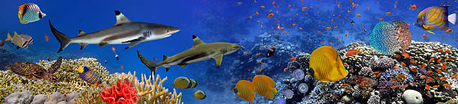

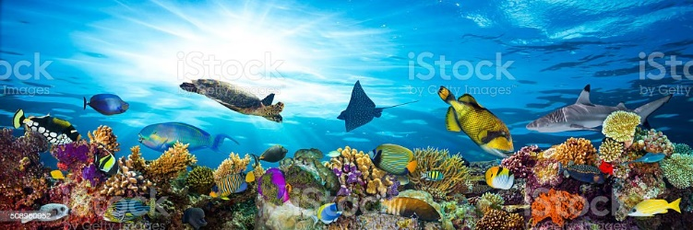

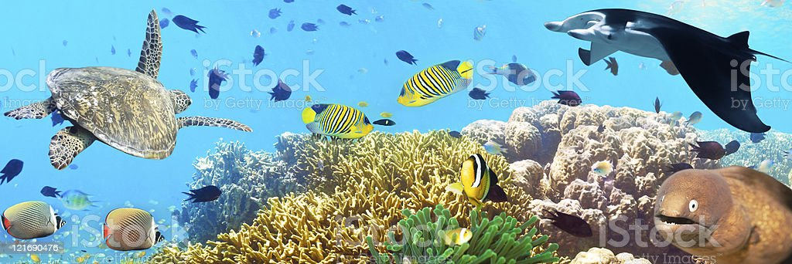

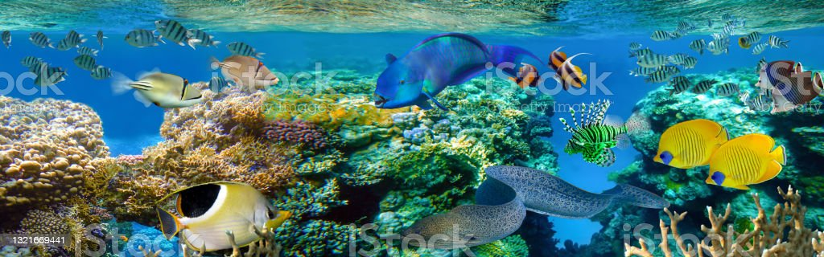

Panel 1 Left Side – Photos
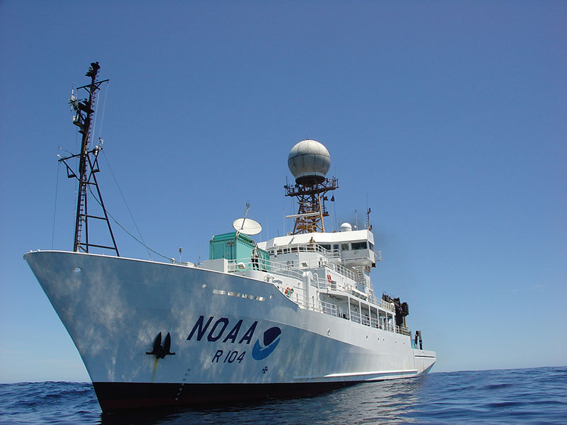

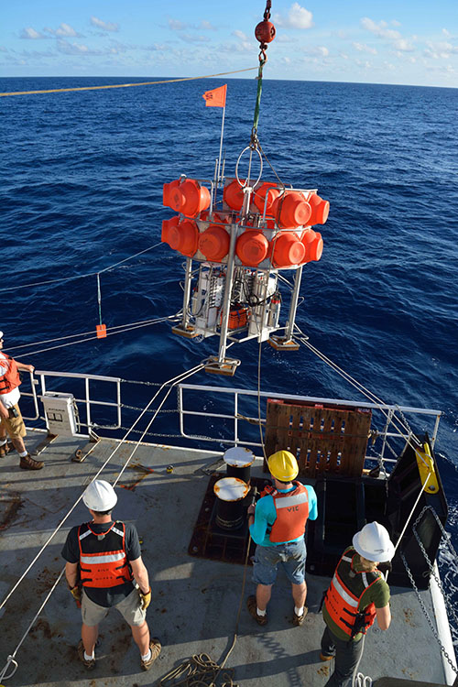

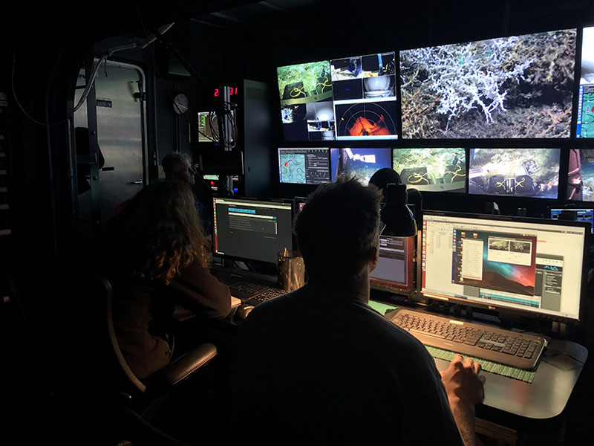

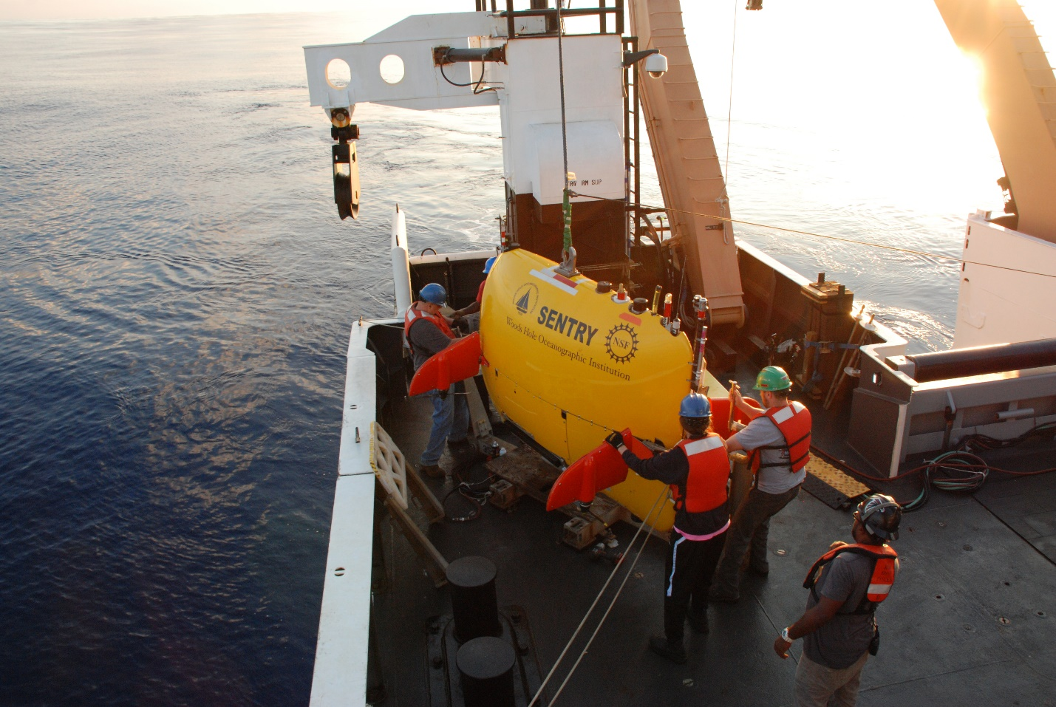
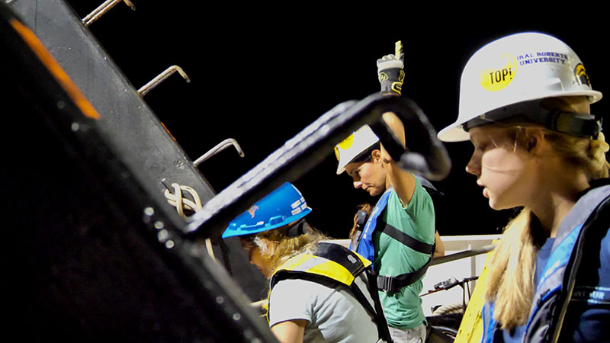

Middle 2nd Panel Photos

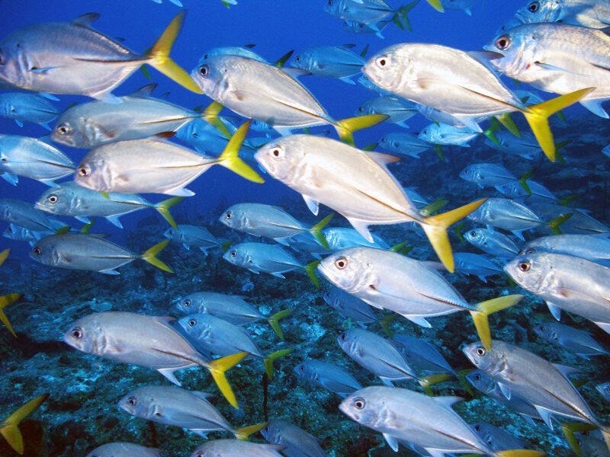

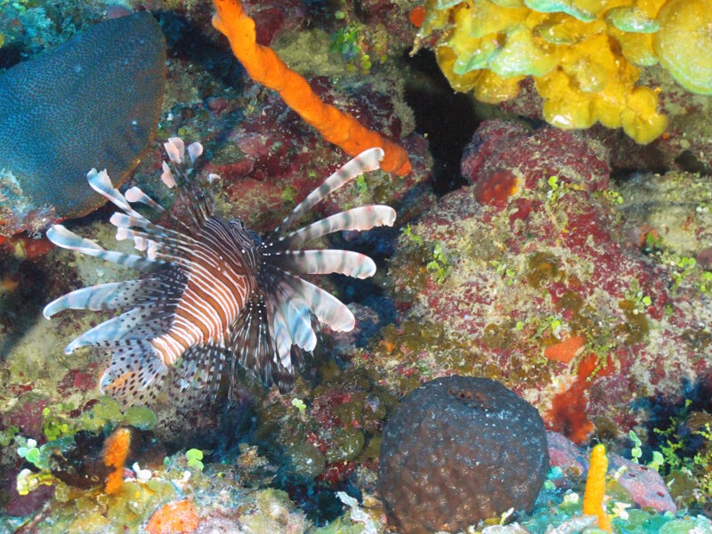

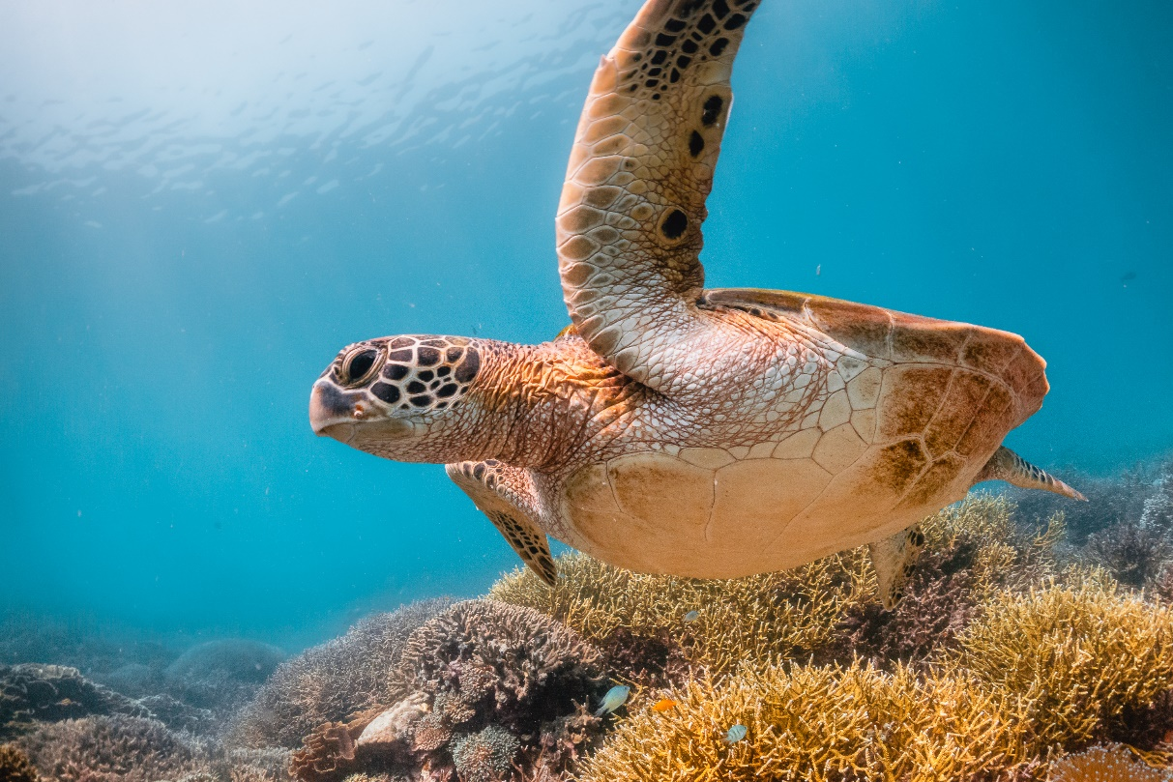

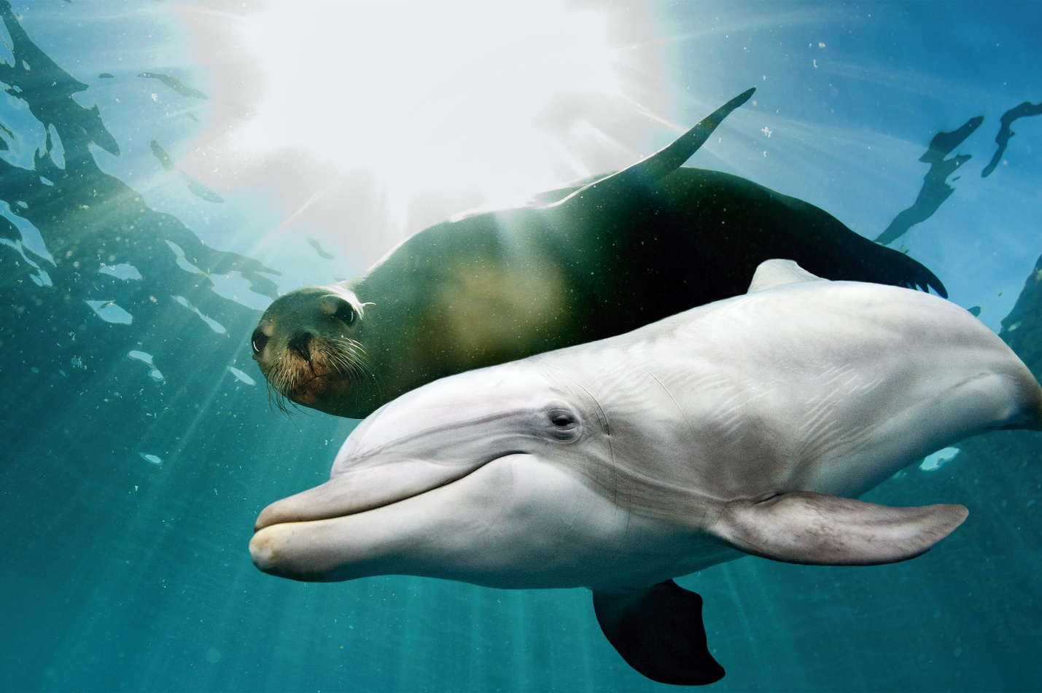

3rd Panel Photos

