Name of project: Software integration section design for a homepage of a SaaS company

Brief description:

Design a software integration section for the homepage of this website: https://ezycollect.io/

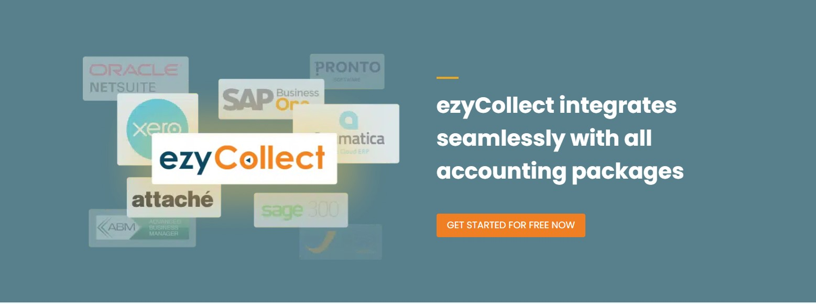

There's already an existing section, but it needs a fresh look that's professional while still coherent with the overall design of the home page.

Requirements:

- Clean look and is visually appealing.

- Match the overall design of the ezyCollect homepage and complies with brand guidelines (file uploaded)

- A logical and easy-to-follow layout

- Display the logos or icons of integrations clearly (logos uploaded)
  - Prominent logos: MYOB certified logo, Netsuite certified logo
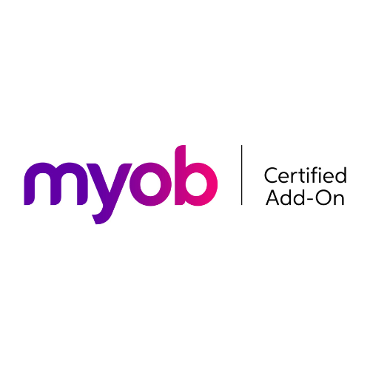

  - Followed by: Xero certified logo, Quickbooks logo, Sage certified and SAP B1-certified logo
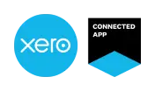

  - Other logos to display (least prominent): JCurve, MS Dynamics, MYOB Advanced, Attache, Pronto


- A header text: "ezyCollect integrates seamlessly with your accounting software"

- A paragraph text below the header

- A CTA (button or hyperlink text): View integrations

Project deliverables
- Figma file of the design
- Hi-res images used in the design

Designs we like:

- Active Campaign: "Team up with your favourite apps", https://www.activecampaign.com/pricing

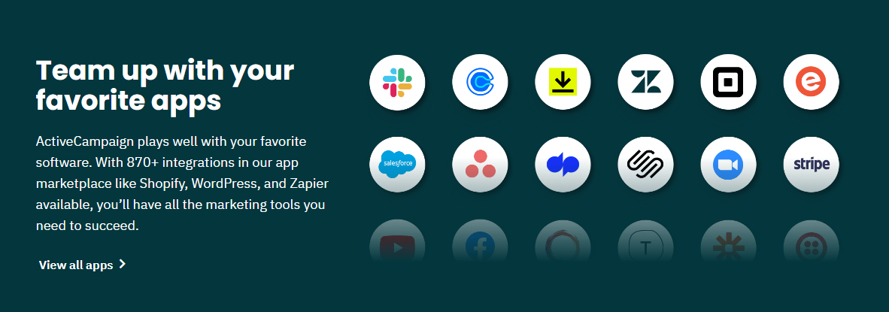

Notable competitor design:
- Chargebee: "Built to Connect" https://www.chargebee.com/

