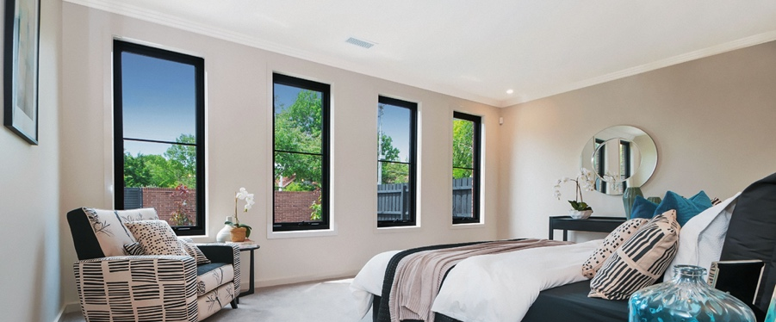
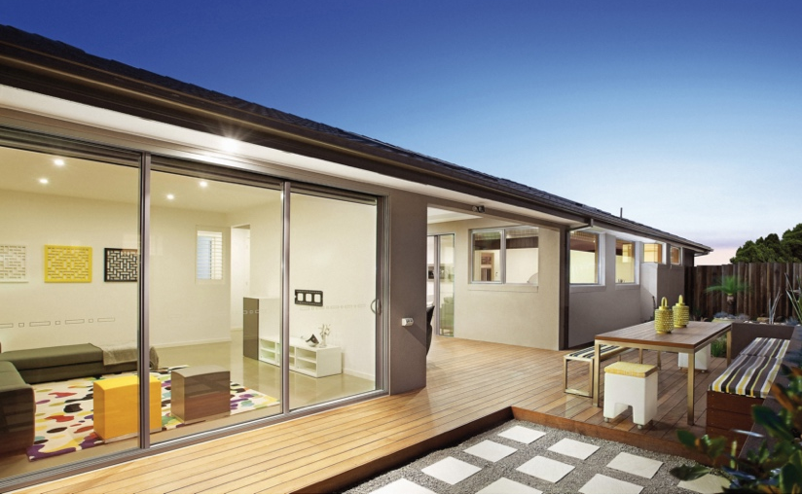
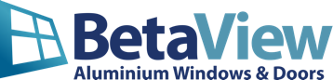
10% off with this flyer
BetaView manufactures and installs premium aluminium windows. Have your existing door and windows replaced with new ones. This will increase the comfort, appearance and value of your home. Northern Beaches residents can get a 10% discount with this flyer..

