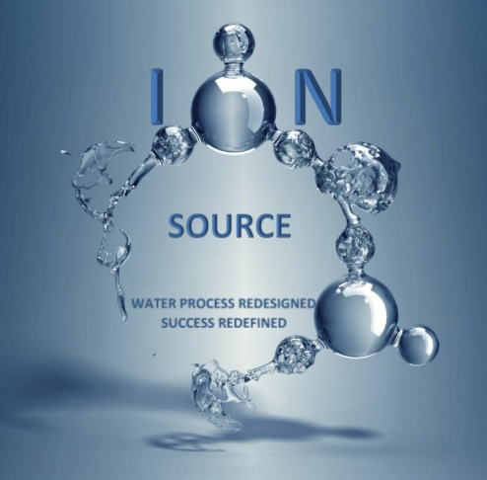

Large Scale, Advanced Oxidation, Chemical Free Water Treatment

The ION Source Molecular Cavitation ION Reactor (MCIR) Technology represents a radical innovation in chemical free water treatment. The technology has emerged from treating some of the harshest water, Produced Water from Oil & Gas Production.

The MCR technology consists of a cylindrical reaction chamber in which two to eight counter rotating elements create a massive, controlled cavitation field. Imposed through the cavitation field is an electric field driving a totality of physical and electro-chemical reactions.

Chemical Free water treatment uses the elements within the water stream to create its own Advanced Oxidation radicals through the incredible power of the cavitation bubble. The cavitation bubble creates temperatures and pressures similar to that of the sun’s surface and the nucleus of the bubble. These extreme temperatures and pressures break down complex organic molecules, water, etc., to create a rich spectrum of Advanced Oxidation radicals that continue to convert organic compounds into products of combustions. Metal ions are reduced to mineralized states, which precipitate out of solution, forming an inert solid. The inert solids are simply filtered from the effluent with common filtration techniques.

The MCIR Chemical Free water treatment is suited to a broad spectrum of applications. The first, large scale application was in the chemical free treatment of Produced Water from Oil & Gas Production.

Produced Water treated by the MCIR process uses the Total Solids within the water stream to treat itself without any additional chemicals. The treated water is free of: Hydrocarbons, Hydrogen Sulfide, active microbes, and very low in Iron. TDS levels are typically reduced 30 – 50% regardless of incoming TDS level. The polished water typically has an NTU less than 5.

Other Oil & Gas applications is the permanent viscosity reduction of heavy crude by the cracking of long chain hydrocarbons into distillates. On-the-fly hydration of drilling fluids show instantaneous high performance properties of high EC stability and viscosity.

Municipal Potable and Waste Water treatment with the MCIR enables an entirely new approach for providing low cost, high performance treatment. MCIR treatment of Potable water shows significant de-mineralization of Iron, Sulfur (Hydrogen Sulfide), Calcium, Magnesium, etc. Further the halides in the TDS will be converted to Chlorine Dioxide and Free Chlorine providing organic dis-infection. There is no generation of Tri Halomethanes in the disinfection process.

Waste Water treatment results in reduction of solids up to 80% and BOD/COD reduction of 90%. The processed is sterilized and the flocculating bacteria is destroyed, which enables significantly greater bio-reactivity. The reduction in solids also results in much lower solids for disposal and lower dewatering costs.

MCIR De-Salination is a significant technology innovation in that the process is through physical chemistry, not molecular sieving. The process works at all TDS levels. It is a low energy process conducted at low pressure. There is no concentrate stream, this eliminates the need for costly and hazardous disposal. All of the incoming water is treated. There is no need for pre-filtration or chemicals for the desalination process. The TDS is converted to inert oxidized solids.

