https://www.etsy.com/listing/1350657039/kelpie-art-print-scottish-folklore-wall?ga_order=most_relevant&ga_search_type=all&ga_view_type=gallery&ga_search_query=kelpie&ref=sr_gallery-3-3&organic_search_click=1

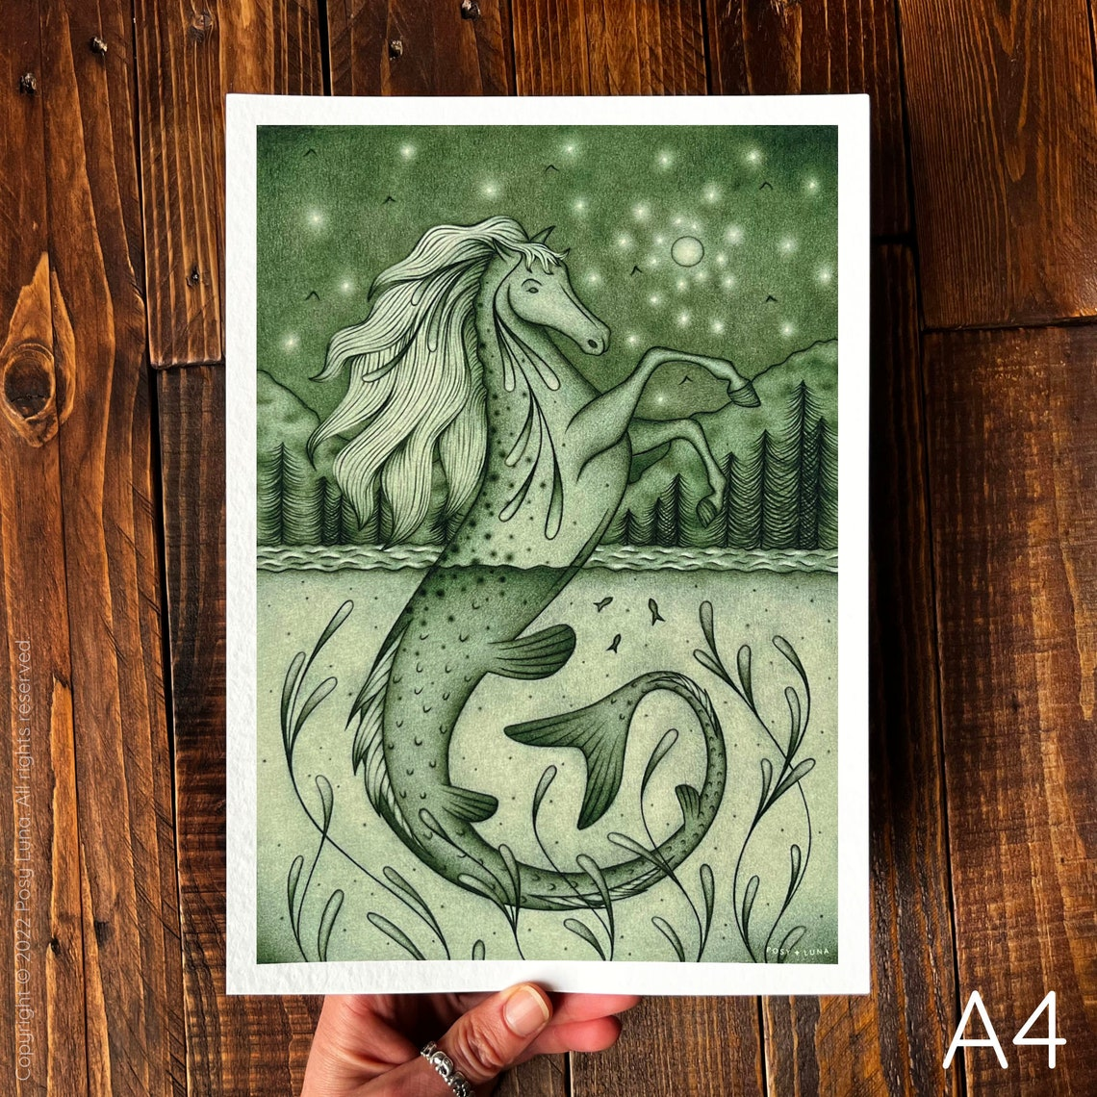

https://www.etsy.com/listing/804526837/kelpie-heraldic-badge-heraldry-cosplay?ga_order=most_relevant&ga_search_type=all&ga_view_type=gallery&ga_search_query=kelpie&ref=sr_gallery-2-48&frs=1&organic_search_click=1

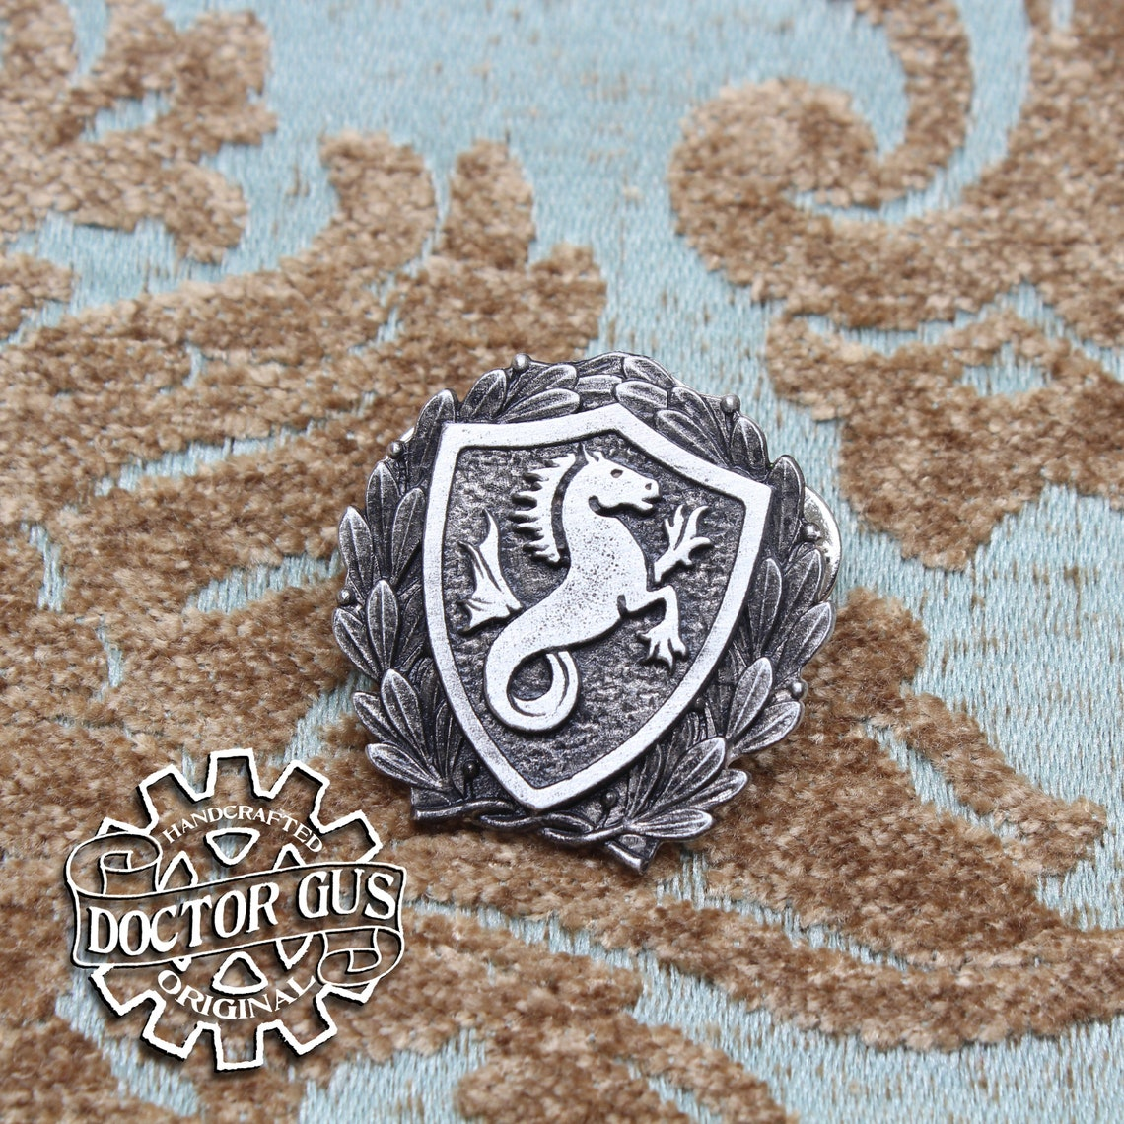

https://www.etsy.com/listing/1018213783/celtic-horse-for-rhiannon-epona-mari?ga_order=most_relevant&ga_search_type=all&ga_view_type=gallery&ga_search_query=kelpie&ref=sr_gallery-2-18&organic_search_click=1

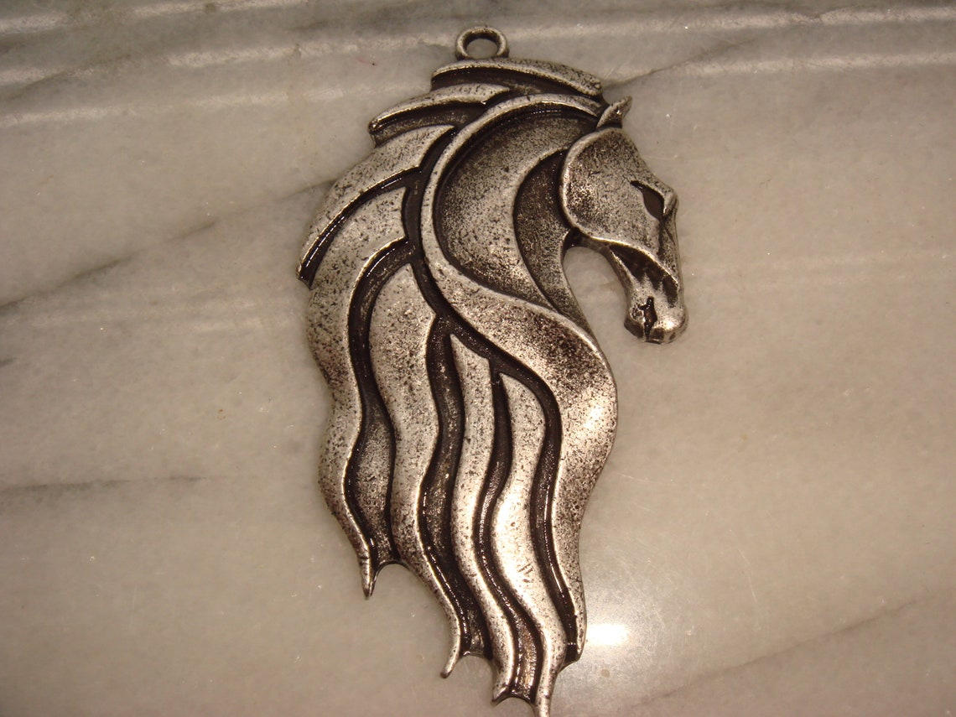

https://www.etsy.com/listing/1050136140/hippocampus-kelpie-enamel-pin-cute?ga_order=most_relevant&ga_search_type=all&ga_view_type=gallery&ga_search_query=kelpie&ref=sr_gallery-1-34&organic_search_click=1
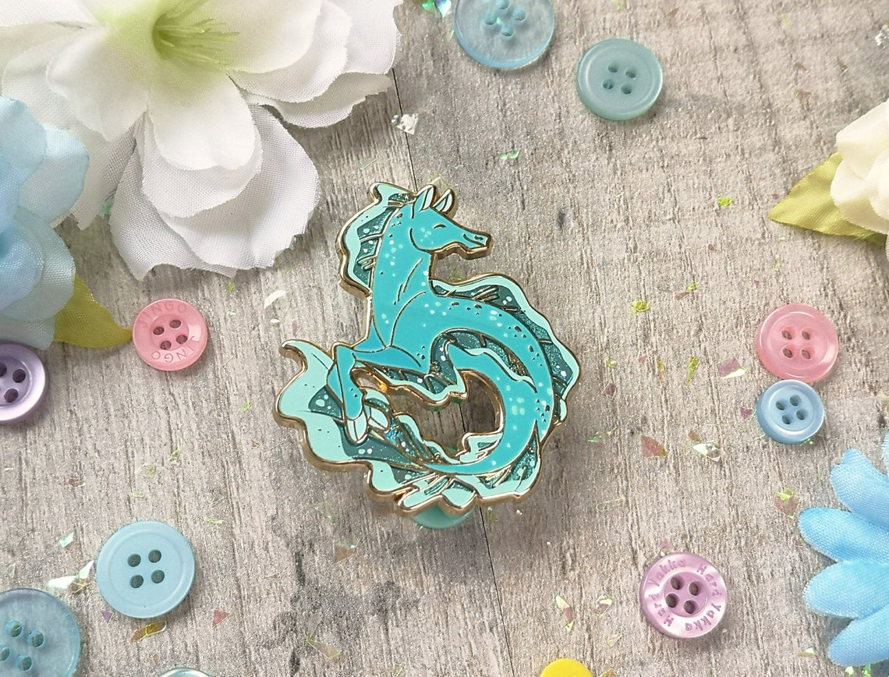

https://www.etsy.com/listing/1225464127/kelpie-wax-seal-signet-ring?ga_order=most_relevant&ga_search_type=all&ga_view_type=gallery&ga_search_query=kelpie&ref=sr_gallery-1-12&sca=1&sts=1&organic_search_click=1

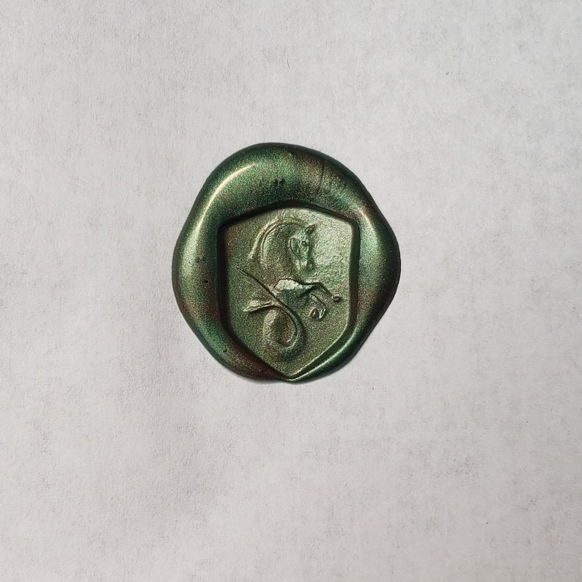

https://www.etsy.com/listing/506553284/solid-925-sterling-silver-double-sided?ga_order=most_relevant&ga_search_type=all&ga_view_type=gallery&ga_search_query=kelpie&ref=sr_gallery-1-15&frs=1&sts=1&organic_search_click=1
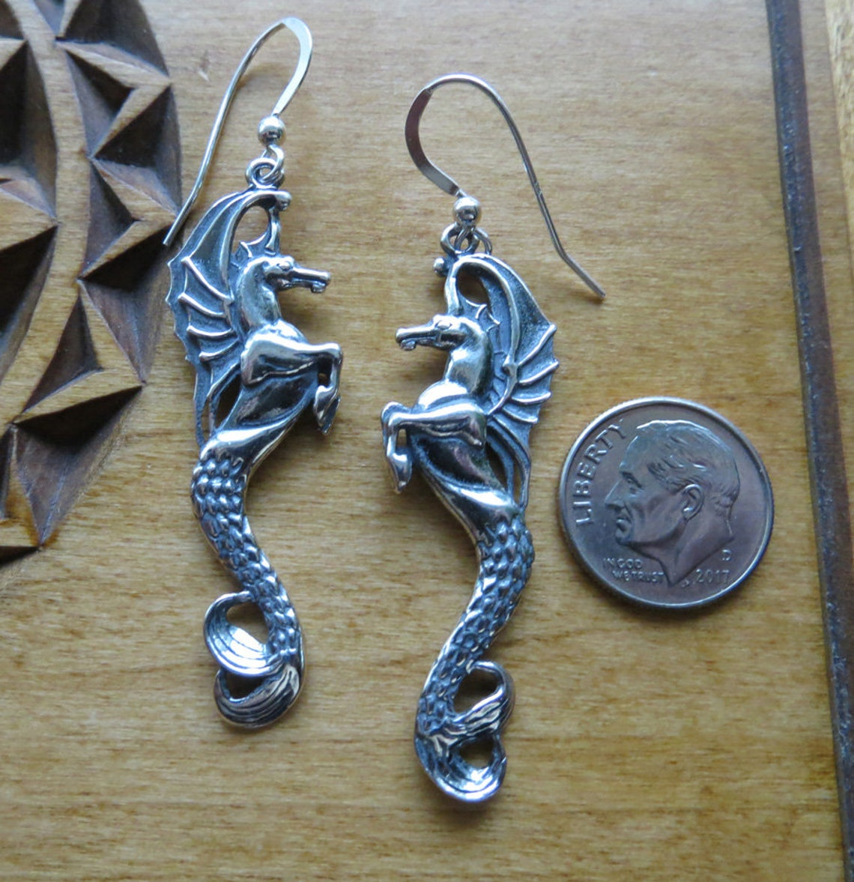

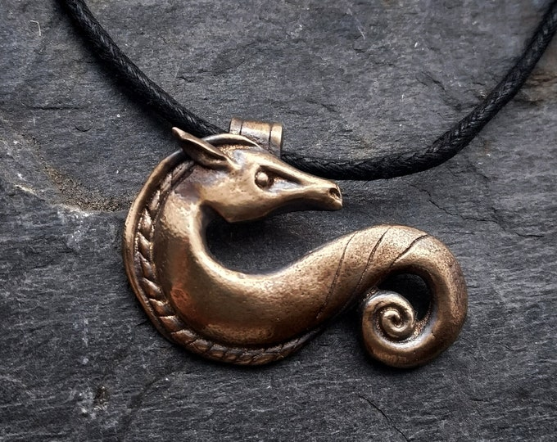

https://www.google.com/imgres?imgurl=https%3A%2F%2Fi.scdn.co%2Fimage%2Fab67616d0000b273d70da855019b7d14f7a5fd6d&tbnid=vJ0S5nWu4Iw6WM&vet=10CCoQMyh6ahcKEwj4hKf2mrb-AhUAAAAAHQAAAAAQAw..i&imgrefurl=https%3A%2F%2Fopen.spotify.com%2Ftrack%2F5y18cr0H7XGPb5RYEucqED&docid=RM3zah8lIaSIJM&w=640&h=640&itg=1&q=celtic%20water%20horse&client=firefox-b-1-d&ved=0CCoQMyh6ahcKEwj4hKf2mrb-AhUAAAAAHQAAAAAQAw
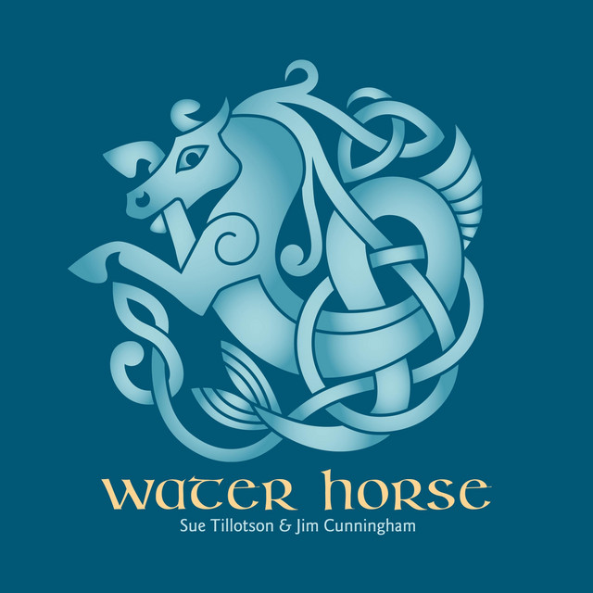

https://celticcorner.net/products/kelpie-kilt-buckle
