CHANGING THE WAY WE VIEW STRESS IN THE WORKPLACE.
Instinctive Solutions was founded in 2010 as Warren Barry became a certified Kolbe Facilitator. Founded in addition to a Myofascial Release Therapy business - Warren had a desire to help small to large companies build better teams. Through his work Warren discovered a link between chronic Myofascial pain and conative stress and began to build case studies to document cause and effect.
Stress in an organization can rob the team of energy, time, and resources. For the last 25 years, Warren has worked in the healthcare industry and as an entrepreneur studying and treating chronic pain. Over the last decade, he discovered the missing link for his patients - treating the root cause of their stress with Kolbe Wisdom. He has conducted a number of case studies on the topic and coined the term “Instinctive Ergonomics” to describe the results of counter-intuitive work placements in the development of chronic pain. Warren was awarded the Conative Professional Award in 2016 for this groundbreaking research.
Today, Instinctive Solutions is recognized for ground-breaking research and game-changing programs that empower individuals, teams, and organizations to take flight with a focus on the personal strengths of each employee, facilitating the creation of collective excellence, and by helping employers find the right-fit employees to begin with.

LETS ACTIVELY ENGAGE YOUR EMPLOYEES TOGETHER

Warren Barry

PURVEYOR OF THE POND

SPEAKER, FACILITATOR & CONSULTANT
Warren Barry is an award-winning pioneer in the field of human resources who studies the implications of counterintuitive work environments on individuals and organizations. Warren brings insights to employees, employers, and human resource professionals alike which leads to harmony, productivity, and profitability.
Warren works with organizations, human resource management, and managerial teams to reveal the internal potential of the human capital they already possess along with the risks and costs of conative stress.

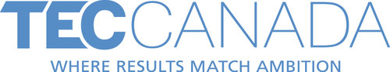

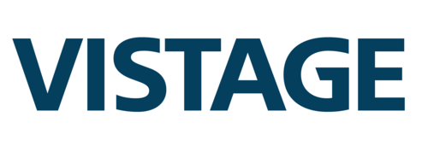
Warren is an International keynote speaker with Vistage Worldwide Inc, as well as a speaker for TEC Canada, and has conducted presentations across the country for a variety of organizations. He focuses on building healthy workplace environments by embracing one’s self and others, and explores the connection between chronic pain and working counter-intuitively.

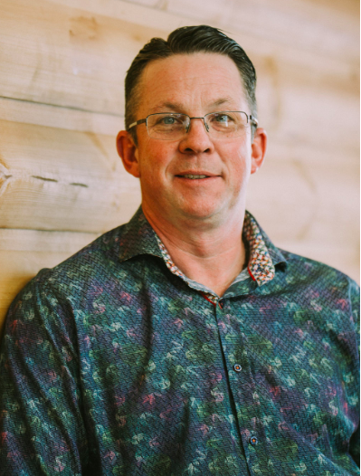

Blair Andrew

CONSULTANT
After 30 plus years as a partner in a family owned insurance brokerage firm, Blair realized that he was in need of a change. He was very successful, had years of experience, his people loved him, yet something inside didn’t match the outside. What he discovered, wasn’t at all what he thought it was. This personal experience along with his positive attitude guided him to do this for others.
Blair is certified in Kolbe and Relationship Model (RM) Governance training. These two additional qualifications add to his skill set and ability to help you hire and retain the right people, grow your teams, improve your culture and strategic direction of your organization
Blair is the Past Chair of the Insurance Brokers Association of Saskatchewan(IBAS) and also a former board member for the Insurance Brokers Association of Manitoba(IBAM). Blair has sat on numerous local community boards over the years providing valuable knowledge of NGO board structure and strategic planning.
Blairs infectious passion comes through when encouraging individuals and organizations to believe in themselves thus helping their team to fly higher, faster, and more efficiently.
Blair lives with his wife Deb in their new log house, bed and breakfast, and retreat center, all while running the second family dog lodge in Carlyle Saskatchewan. A true prairie entrepreneur.

YOU HAVE POTENTIAL ON YOUR TEAM. LET'S UNCOVER IT.
Do you feel like a misfit? The odd duck? How is that affecting you, and the people around you? Are you being your best, or holding yourself back from your true potential?
Discovering your personal potential, or the potential of the team, is crucial for success.
We have all felt like misfits at some point in our lives, some of us earlier on, some of us later in life, and some of us all the way through. Yet, what made you feel like a misfit is usually your greatest strength. What other people saw in you was something that they lacked in themselves. Therefore, based upon their perspectives, you become the odd duck.
Being the odd duck gives you an incredible advantage. You get to see an aspect of the pond that no one else sees. This allows you to unlock your true potential, and send ripples across the pond that go far beyond yourself. In turn, this provides true performance to a team. The truth is that we all need each other. We need to flock together.
Working with individuals or teams, we help you discover your strengths, what makes you unique, and how you can work better together. Whether it's working with the CEO, HR, or individuals on the team, we can sit down and discover what makes you awesome. Honk!

LETS WORK TO BUILD PEOPLE, POTENTIAL & PERFORMANCE.
BOOK A MEETING

WARREN BARRY
Warren Barry is an award-winning pioneer in the field of human resources who studies the implications of counterintuitive work environments on individuals and organizations as a whole. He brings insights to employees, employers, and human resource professionals alike which leads to harmony, productivity, and profitability.
Warren works with organizations: executive officers, human resource management, and managerial teams to reveal the internal potential of the human capital they already possess along with the risks and costs of conative stress.
Warren is a member and speaker for TEC Canada and has conducted presentations across the country for a variety of organizations. He focuses on building healthy workplace environments by embracing one’s self and others, and explores the connection between chronic pain and working counterintuitively.
Warren engages audiences about how being the odd duck can be one of your greatest assets, and helps you realize that being a misfit is one of your greatest strengths. With his case studies on how working counterintuitively in your job can create chronic pain, he provides insights and examples on how not to cook your goose. By empowering unique people, you will understand that being yourself ain’t so bad, in fact, it's pretty awesome.
How do we get our teams engaged, happy, and productive? We get our ducks in a row, that’s how. Not every flock needs the same geese. There are 135 varieties of geese in the world, and the world needs all of them - just as the world needs the talents of everyone to be successful. We must understand, respect and appreciate what each person brings to the flock in order to be truly successful. Together we Better The Pond. Let’s discuss.

I'LL HELP YOU EMPOWER

UNIQUE PEOPLE

FEELING LIKE A MISFIT?

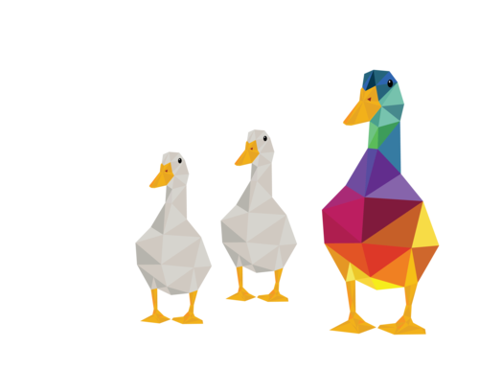

Do you ever feel like you’re dancing to the beat of a different drum? A goose in the midst of a pond full of ducks? The reality is that we all feel like we don’t belong from time to time - and we are all uniquely different. There can be incredible success when we are allowed to function in our unique skill sets for our personal lives, and also for the organizations we serve. It’s time to give yourself permission to be you - flaws and all.

IT’S THAT SIMPLE.

YOU MATTER.

YOU MAKE A DIFFERENCE.

YOU’RE AWESOME.
“When you can just be yourself, things come freely and easily, just like you are in the jet stream.”
When you can just be yourself, things come freely and easily, just like you are in the jet stream. When you align yourself with the tasks that are natural to you, you have the capability to do amazing things. You actually get energy from the task, and a true sense of joy when you are doing it.
In order for a flock of geese to be efficient and productive in flight, they fly in a V. They do it for a reason. During flight, the lead goose never stays the lead goose. They trade off, they take turns, they help each other. Each goose in flight counts on the goose in front of him / her to create a draft behind them to make it easier for the goose behind. Just as in business, depending on the direction of the organization, there are times when leadership needs to change. Do we need innovation and change, or do we need stability and security? Sometimes a new flight plan is required, or new materials need to be discovered and used. We can count on the talents of each individual to help us get to where we want to go.

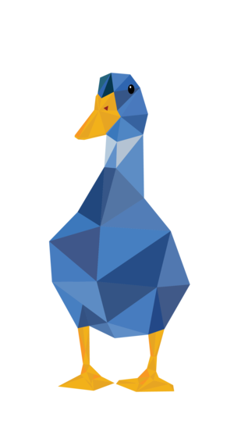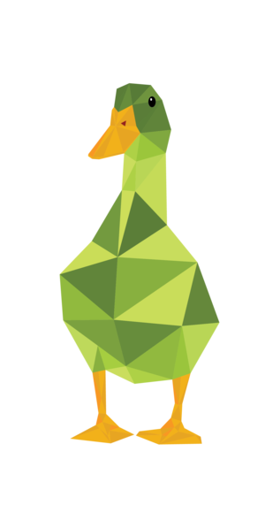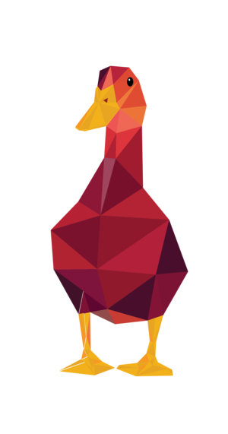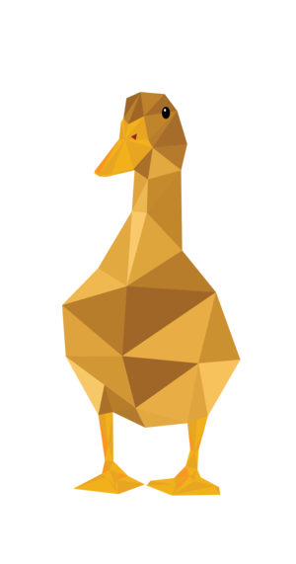
Try as it might a duck can never be a goose. Imagine a goose trying to live as a duck. It may walk like a duck and quack like a duck - but it is still a goose.
People are the same. Each individual has natural strengths and challenges in the workplace. When employees work against their natural innate patterns to meet job demands, physical pain and stress can result. This increases employee turnover, stress leave, and insurance claims.

How many people on your team suffer from stress and chronic pain? Are they exchanging meetings and productive work time for appointments or restricting duties because of pain? No matter how much training, support, and/or benefits are provided - something is disconnected. We can help. Take Flight with Instinctive Solutions.

ARE YOU SET UP FOR SUCCESS?
As the CEO or business owner, you see things very differently from everyone else. You have the responsible for the entire operation. Leading everyone in the same direction. You need to make sure that everyone is flying in a V behind you. How do you make that happen?
A key factor in business' success is it's people. The capacity to which those people are actively engaged will have a bottom line impact on the productivity, efficiency, retention, and profitability of your company.


STATISTICS CANADA SHOWS THAT:
- 60% OF EMPLOYEES ARE DISENGAGED
- 15% ARE ACTIVELY DISENGAGED
- 25% ARE ACTIVELY ENGAGED AT WORK
This results in 350 million dollars in lost productivity in North America alone!

the world is your pond.
Welcome to the Pond - your sphere of influence. It reaches well beyond those in front of you and carries ripples - touching lives globally. We believe we are better together.
#BetterThePond is a movement designed to encourage taking the time to appreciate and truly see those around us. Our team at Instinctive Solutions makes the time to notice and celebrate people, and the joy of giving. From buying a coffee, paying appreciation to a stranger, to supporting a little league team - we believe each action has a reaction. What ripple effect will your actions cause?
“When we take the time to really see and appreciate the people around us, we take the time to better the pond.”
— WARREN BARRY

