Wow!! These all look SO good! I should have picked specific letters - so here they are below:
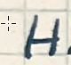 H
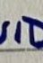 I

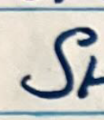 S
W
T – this should be slightly higher than the other letters like this - 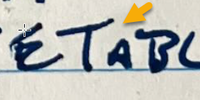
I
E

Cadence and heights should be similar to the below. Note the first capital is always a bit larger.
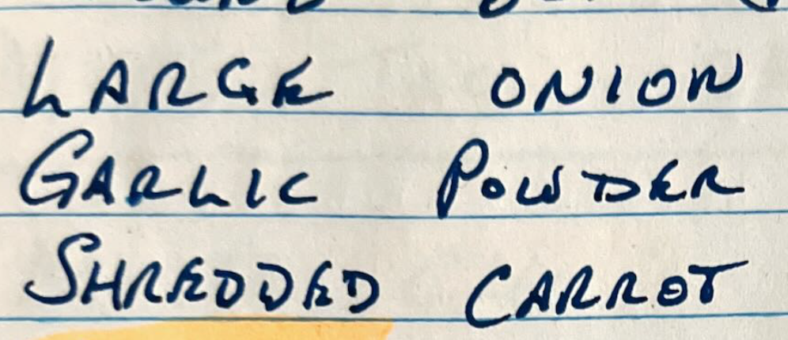

I would love it all in black and no extra embellishments– like hearts or swirls or “fading brushstrokes”, please . For line thickness, please make them all similar, like a nice gel pen (not too think or too thin).

Thank you so much!!

