MOJO & MELO DESIGN BRIEF BACKGROUND INFORMATION

Colours we like

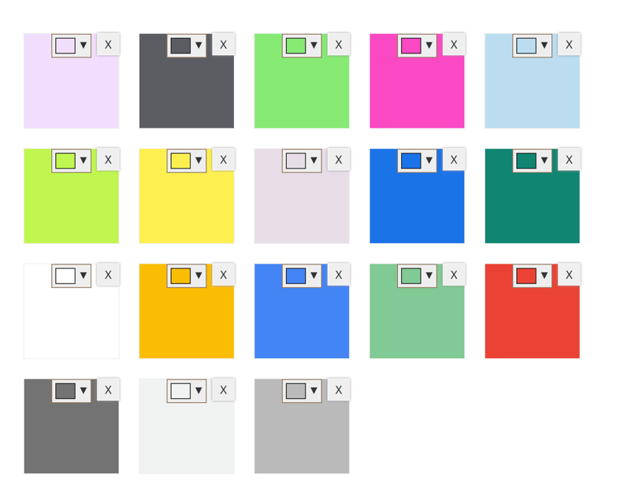

Concepts we like

One brand colour at top of box like Selfridges

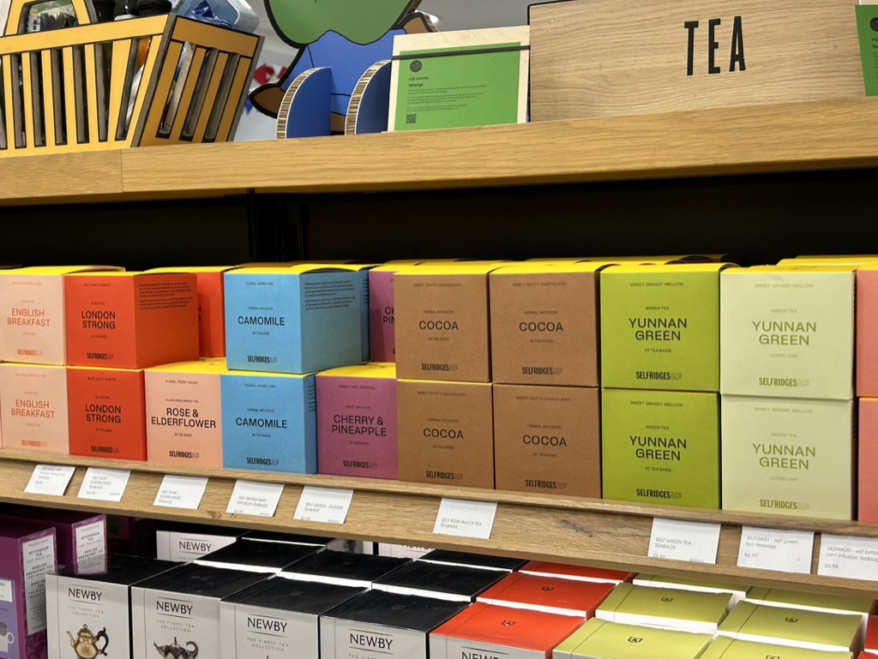

Brands we like:

Good and proper: https://www.goodandpropertea.com/
https://uk.yourtea.com/collections/1-week-programs
https://drinkolipop.com/
https://www.drunkelephant.co.uk/gb/en/

Competitors/relevant brands
Nutratea
Pukka
Teapigs
Stuarts
https://numitea.com/pure-ingredients/
sama tea https://www.samatea.com/
joyo tea https://joyotea.com/
prince and son
https://omgteas.co.uk/
https://www.goldenmoontea.com/
https://www.teasetea.com/
(https://www.teaplusdrinks.com/collections/programmes )
(https://solarisbotanicals.com/pages/the-different-types-of-tea) t2 https://www.t2tea.com/

Others to look at
https://fix8.com/ gut health drinks
https://www.innocentdrinks.co.uk/things-we-make/super-smoothies
https://jpsoriginals.com/collections/speciality-tea
https://bighearttea.com/collections/plastic-free-tea-bags/products/signature-tea-bundle
https://www.theteamakers.co.uk/products/peppermint-teabag-envelopes?variant=40380337946823

