Centurion Concepts – we can’t use these as we do not own them but something similar is fine. These are here for inspiration.

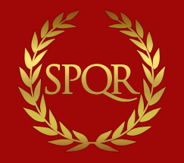
(SPQR) Flag of Ancient Rome – maybe the yellow grain motif here could replace the yellow circle below with new face inside. Tough is is a bit thick and should maybe be narrower.
Redskin Face and execution on old Helmet. The Native American face must be replaced by the Centurion face. We will keep the red background color for the helmet.

