Graphic Design Brief

Design Tasks:
- Logo
- Design theme for website
- Stationary templates – letter, business card, email signature
- Design for external signage
- Design for aluminium fencing (1.0 m high, maximum space between vertical elements 10 cm) & laser cut screen (approx. 2 .6 m x 4 m)

Background
A 1970’s beachside motel is undergoing a fill refit with an art deco theme.
The graphic design should reflect this theme.
An art deco style fabric has been selected for the soft furnishings as the dominant design element for the renovation. The fabric has a geometric pattern and dark teal & silver colours:
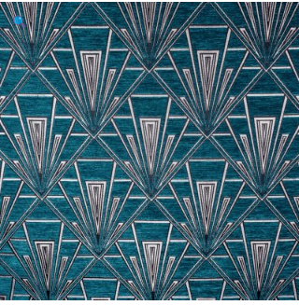
Motel name begins with ‘M’ so ‘MM’ could be worked into the design elements as a signature element reflecting the name of the motel.

