BACKGROUND
What is the product?
- Stu’ffy Puffs are lightly caramelized flavored corn puffs.
- The origin of the snack - the snack was created as part of an organic science lab to teach organic chemistry. The recipe was simple; yet, everyone who tried it said it was addicting and loved it.
  - The brand was originally called Classroom Crunch. The name was changed to Stu’ffy Puffs in part as a tribute to a family member that’s last name starts with Stu. That family member was lost to ALS and is a cause that Stu’ffy Puffs is aligned with.

What is the core problem that Stu’ffy Puffs is solving for?
- The snacking category (in particular popcorn like snacks) lacks options that look and feel “gourmet.” In particular, high quality ingredients with unique flavors.

What space is Stuffy Puffs disrupting and reimagining?
- Party Snacks is the main focus to start.

Are there specific cultural or industry trends that inspired you?
- Not specific to the industry of snacks pers se.
- However, there is an angle where the brand could be more closely aligned with schools and education. There hasn’t been much of any innovation in fundraising at the school level.
  - Thinking about new ways to get students involved in commerce in digital ways instead of old school tabling and door to door tactics.

What do you feel is the biggest challenge for Stu’ffy Puffs?
- The product has a lot of local interest at the start but the brand is still very early in its development. There’s good interest in local stores carrying the brand but they want the brand to look more polished. Additionally, there are few online resources in place as the brand was still under development and the operations were not yet in place to support any unexpected uptake in demand.

Could you provide additional background on the audience demographics / segmentation, who are you primarily targeting?
- Millennials and Gen Z: This is likely the most promising demo at the start. It plays well with the brand origin story and students love it. It is where initial word of mouth is likely to originate.
  - Additionally, this demo is considered more adventurous with food choices and enjoy trying new flavors and creative combinations.
- Foodies and culinary enthusiasts
- Gift-givers
- Families

Brand Vibes
- Experimental
- Makes you think - that’s not what i would have expected
- Doesn’t take itself too serious
- Underdog / Humble / Hard Working
- Educational
- Philanthropic / Mission oriented

What are short-term and long-term success measures? Beyond growth and/or sales, what impact do we want to see on category and culture?

- Short term - leverage the brand assets to:
  - Establishing initial distribution in local stores
  - Completing the build of an online presence
  - Develop social channels
- Long term
  - Build a broadly distributed product that is true to its roots and origin story
  - Expansion of flavors and use cases (e.g. ice cream topping)
  - Be a huge asset to the ALS cause and support a potential cure being brought to market

COMPETITORS
- Some examples of competitors are:
  - Mainstream corn puffs
    - Pirate’s booty, Snyders, and utz are some of the larger brands in the space.
  - Smaller and emerging corn puff brands:
    - CrackCorn, Buc-ee's Nuggets (SEE APPENDIX)
- Adjacent popcorn brands that are positioning as high quality
  - Garrett’s, Popcornopolis, Moose Munch, G.H. Cretors, Poppy Handcrafted Popcorn.

How will your brand differentiate from competitors?
- From a product standpoint, brands tend to use popcorn as the base more often than corn puffs because puffs are more expensive. There’s an opportunity to speak to the quality and taste of the puff being differentiated from most competitors.
  - Being less common as a base, there’s an opportunity to be first or early to market with new flavors.
- The product is multifaceted in that it works in a stand alone fashion as a snack but also has been tested as a topping for different bases (like ice cream). In particular, the crumbs are popular as a topping.
- Not only are we offering an alternative to flavored popcorn and mainstream options; we are a mission driven brand that also has an organic affiliation to ALS as part of the brand’s origin story.

What threat will your brand pose to the competitors? How will you push the category forward?
- This is a brand that was created as an experiment. It’s a brand that is willing to take some chances and push the boundaries. We hope to bring some fun and excitement to a category mostly dominated by larger brands that aren’t very exciting or smaller brands that are resource constrained.

What is your biggest challenge in creating differentiation for Stuffy Puffs?
- Raising awareness in the crowded snack category is a challenge; having a brand that looks legit yet speaks to the unique origin story will help it stand out.
  - Early discussions around distribution have been promising as people can relate to the product and story.

DELIVERABLES

Designing a container label

What is the way your audience will be discovering your brand? What touchpoints need to have brand infused?
- In store will be a big initial touchpoint.
- Beyond that, there is a large opportunity for e-commerce that has not been pursued yet as the brand and offering were under development. Social media will be a big part of the initial push to intro consumers to the brand.

CURRENT PRODUCT, LABEL & PACKAGING INFO

Current Flavors
- Original, Cinnamon, Cheddar, Peanut Butter (Pending), Mildly Spicy (Under Review)

Current Label
- The front label is 5 x 4.
- The label on the back is 3 x 3. It contains nutritional information and a small story of how we started the product.
- The labels are currently Black and White as they are expensive to print. The more colors we add the cost obviously increases. That said, we can explore new options as long as they are airtight and heat sealed for safety.

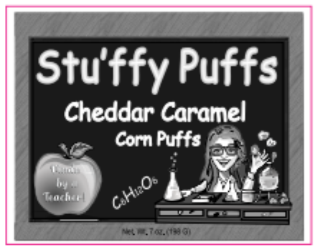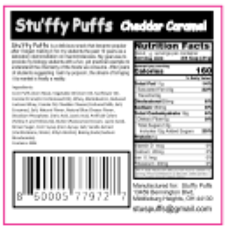
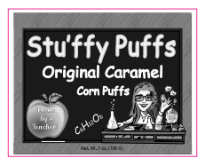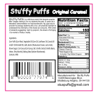

Current Packaging Details
- 1 size, 7 oz bags.
- The bags are 8 inches across and 10 inches in height.
- The plastic is thick and completely impermeable to air. The shelf life of a bag is 12 months.

Bag should state:
- Manufactured in a facility that also processes tree nuts.
- To order more online go to visit the stuffypuffs website (will share)
- Gluten Free

No dieline exists

APPENDIX - COMPETITIVE ENVIRONMENT
https://www.crackcorn.com/
https://www.instagram.com/crackcornofficial/?hl=en

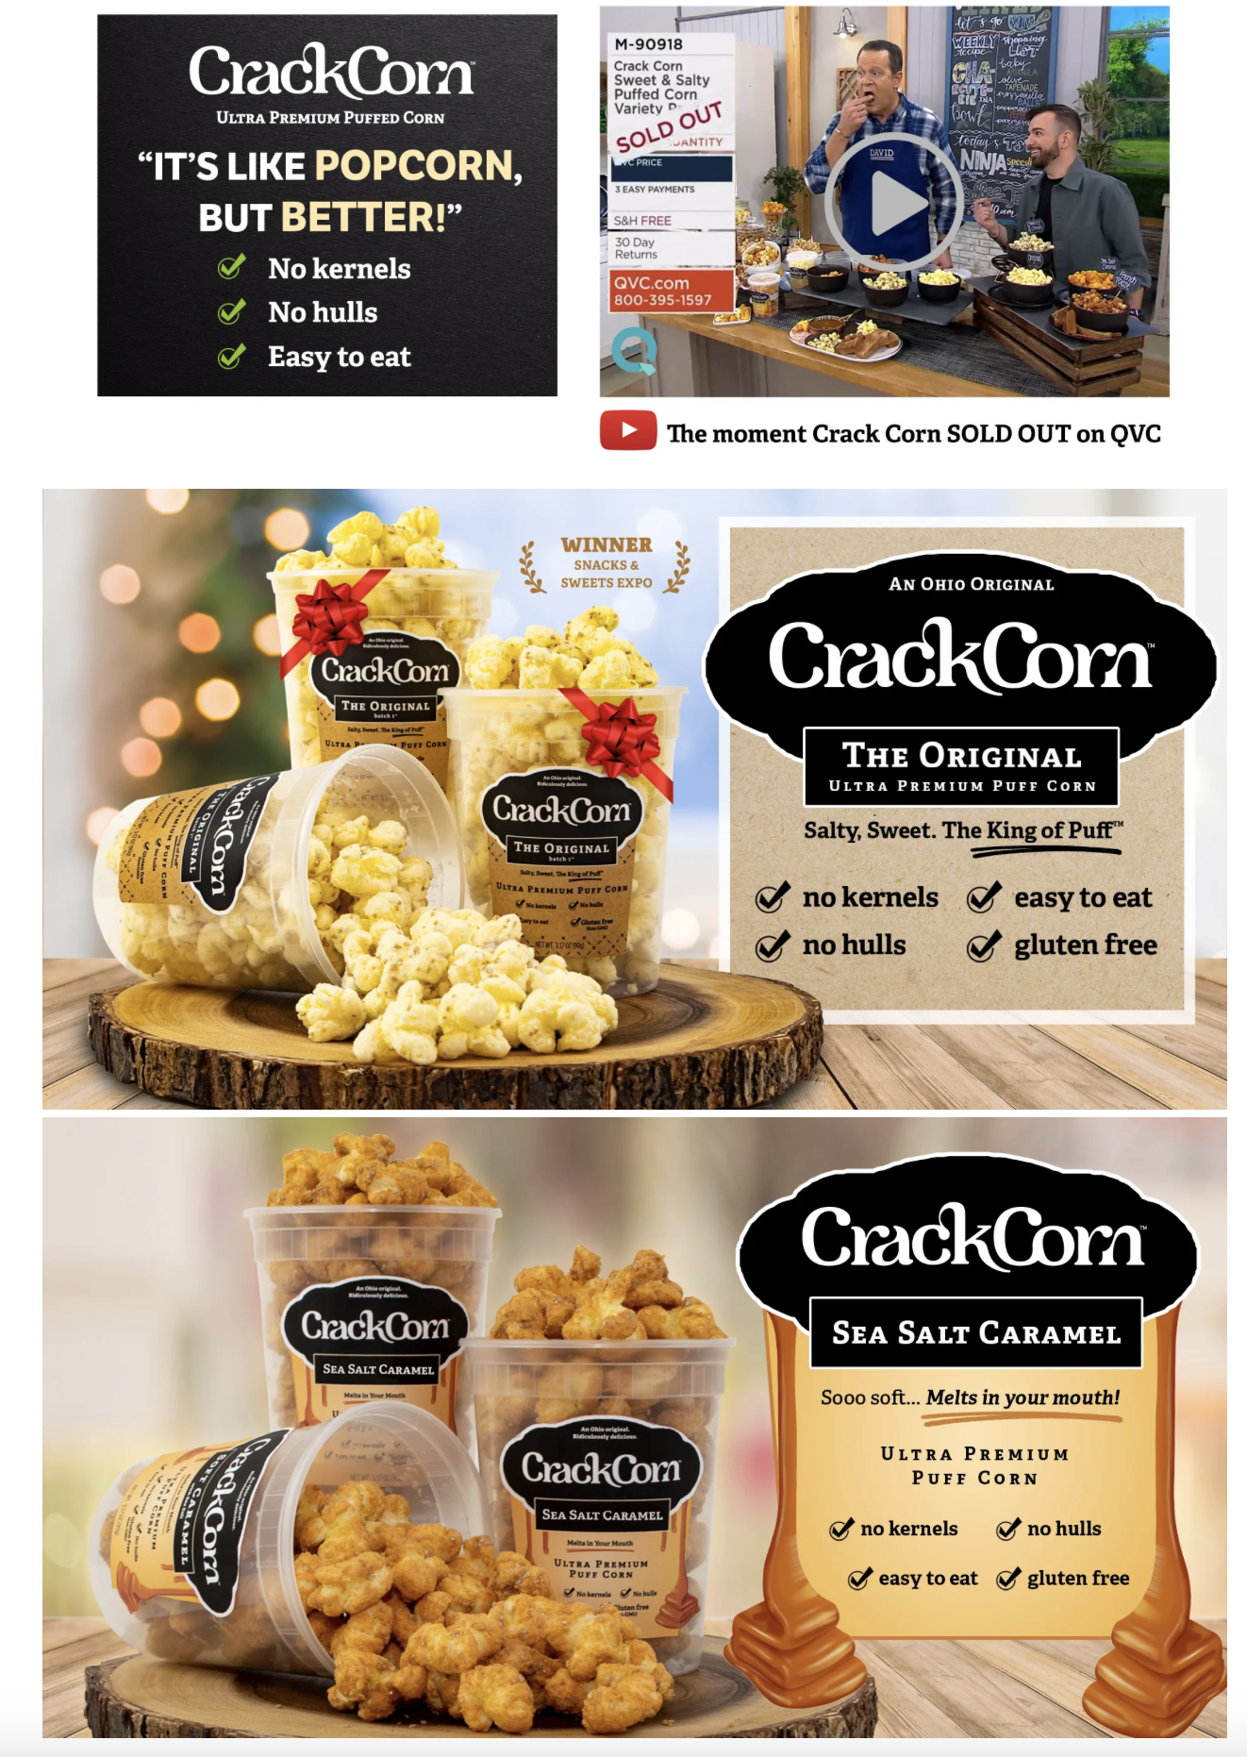
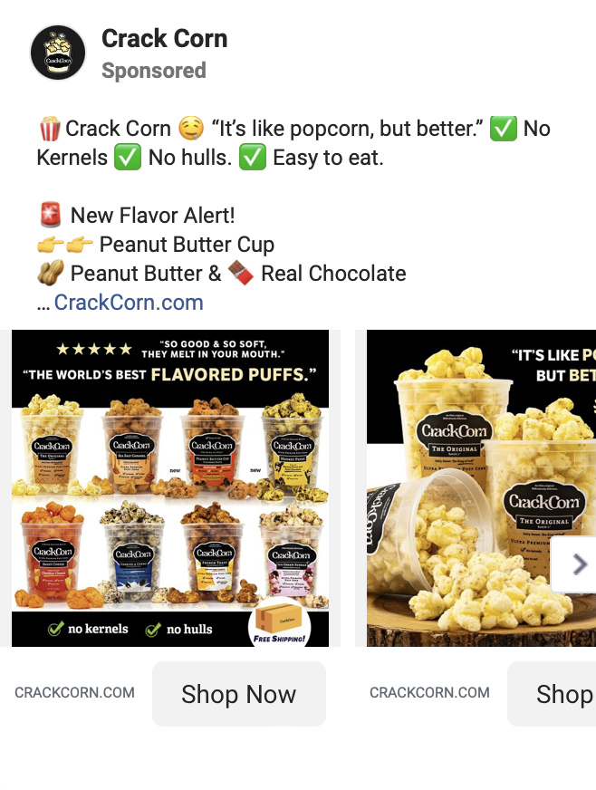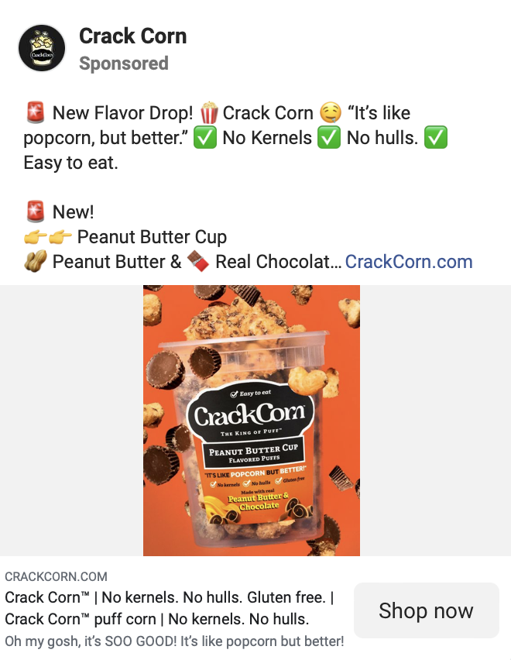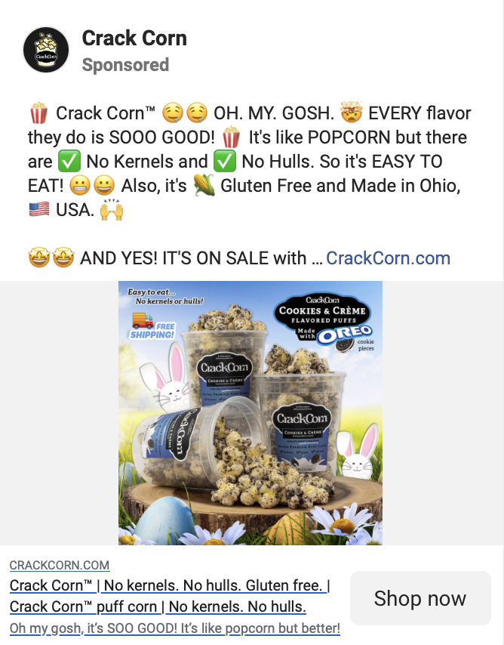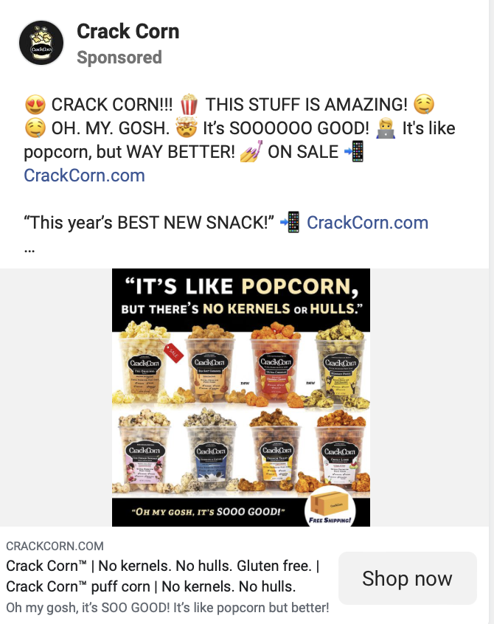

https://texassnax.com/
https://www.instagram.com/texassnax/?hl=en

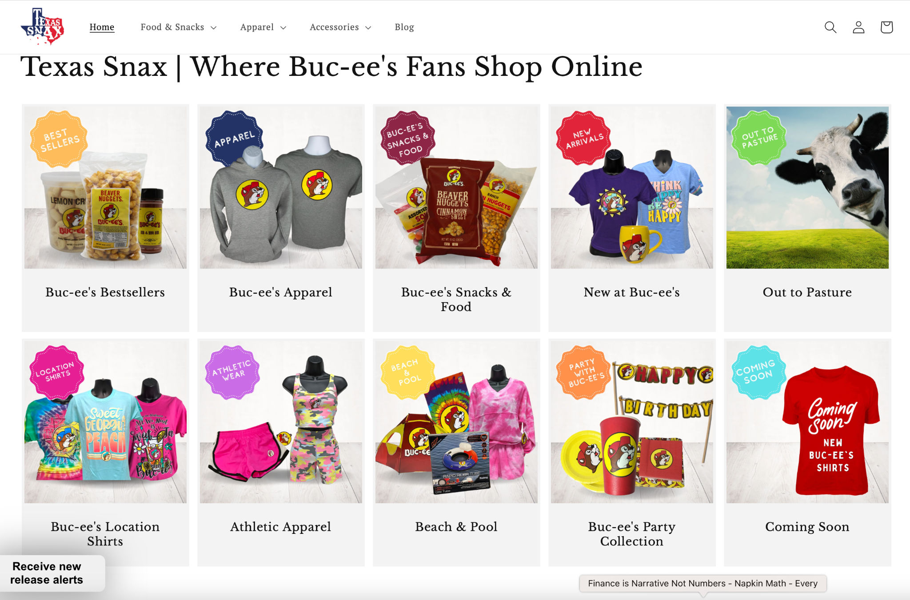
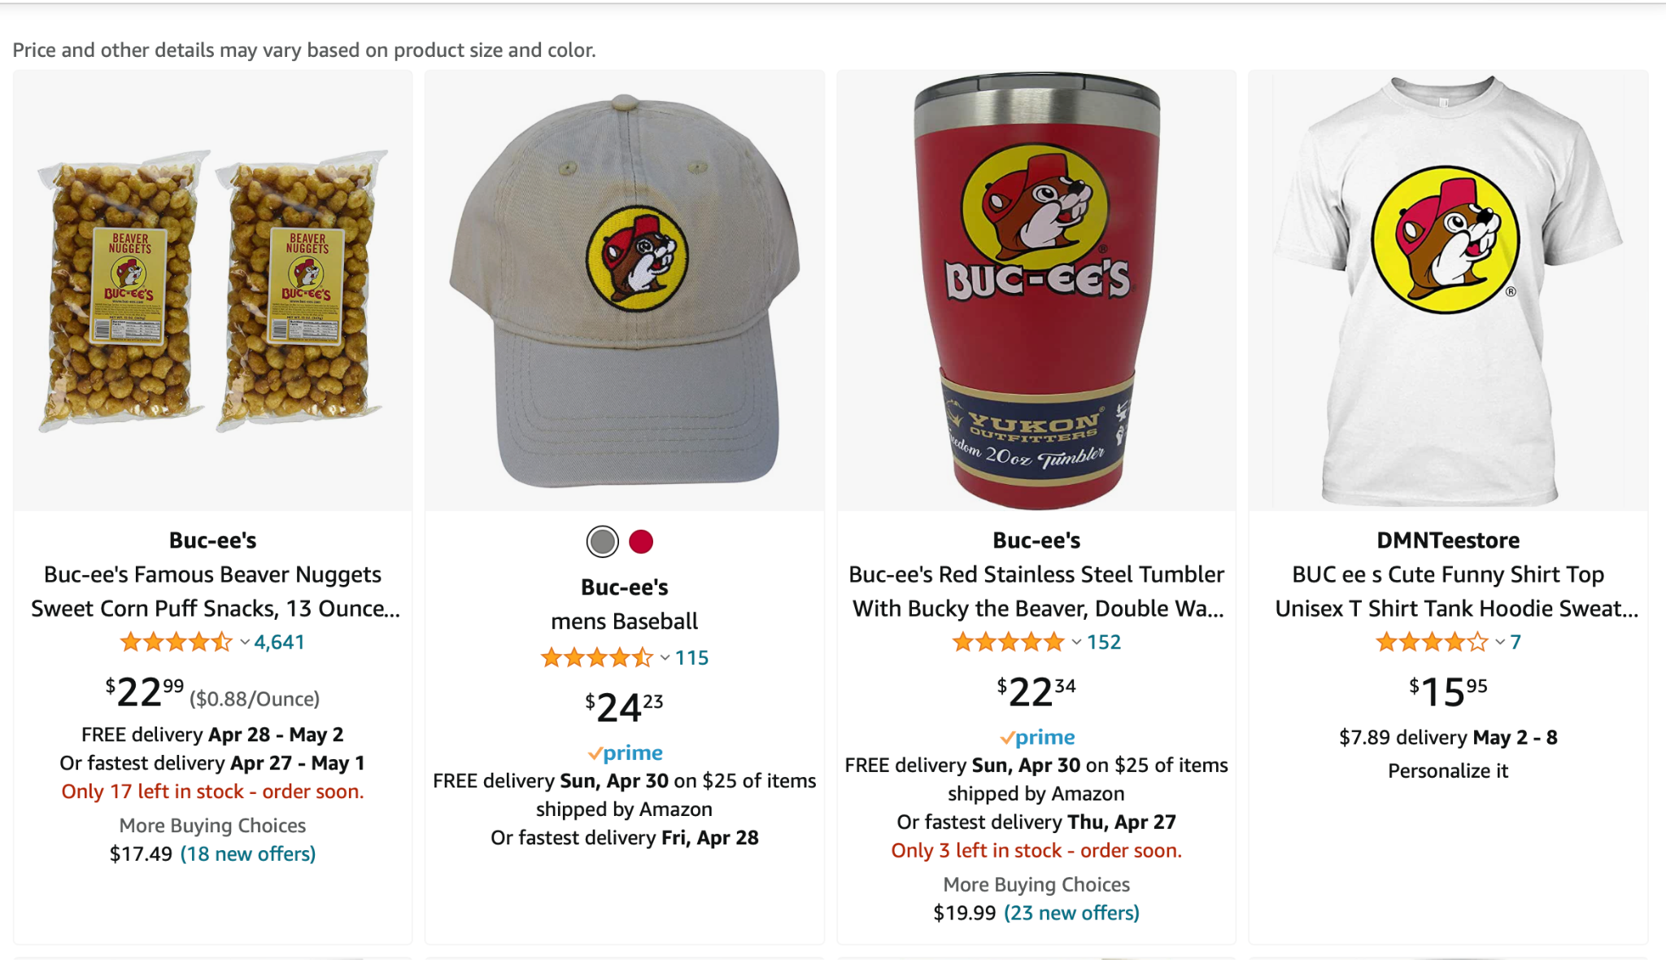
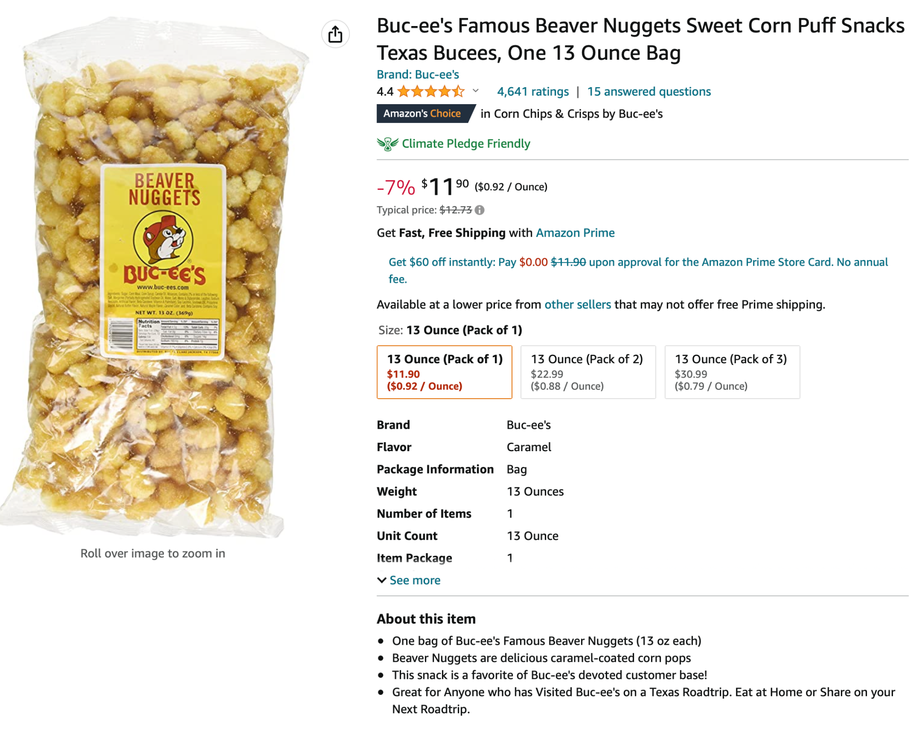

Brands of interest from a design / aesthetic perspective
cpgd.xyz
Muddy Bites — CPGD.XYZ
The best part of a sundae cone, now available as a bite-sized snack – Muddy Bites is filed under Food in the Consumer Packaged Goods Directory. (286 kB)
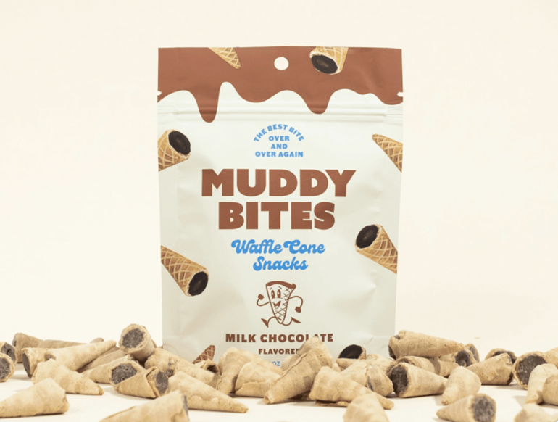

https://www.cpgd.xyz/brands/muddy-bites
cpgd.xyz
Effin' Good Snacks — CPGD.XYZ
Effin' Good Snacks is set to reinvent the most popular late night snacks into better, healthier, and more sleep-friendly. – Effin' Good Snacks is filed under Food in the Consumer Packaged Goods Directory. (391 kB)

