





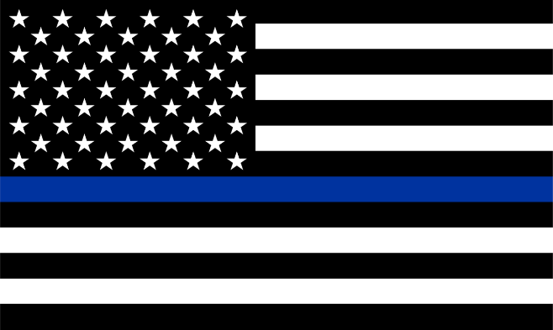
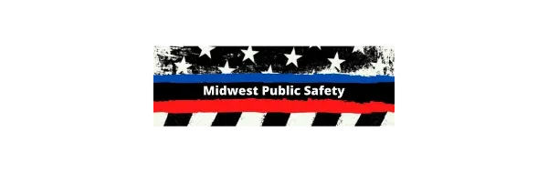
All State, County, Local, and Tribal law enforcement / public safety members are cordially invited for FREE LUNCH. The Brick House food truck will be in the Printek parking lot offering up burgers and apps for lunch.
Tuesday, June 20th, from 11:30am to 2:00pm
Printek parking lot
3515 Lakeshore Drive
St. Joseph, MI 49085

Stop by for lunch or grab it to go… The Brick House looks forward to serving up a great lunch for all officers. This lunch is FREE courtesy of PrintekMobile, Emergency Vehicle Conversions (EVC), B.E.R Refrigeration, Heating, Cooling & Plumbing inc., IMS Insurance, TG3 Electronics, and Midwest Public Safety Group.
LAW ENFORCEMENT
APPRECIATION LUNCH
FREE LUNCH FOR ALL PUBLIC SAFETY

