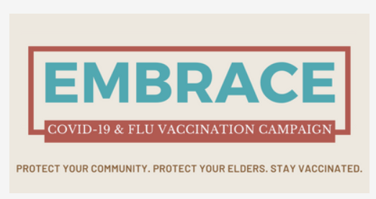


(Note to designer, for the final end product there will be 3 with just this this logo updated – logos have been provided COVID-19, flu, COVID-19&flu)
Clean Hands for a Healthier Community
Viruses, like the flu and COIVD-19, can spread when hands touch people or surfaces.
Regular handwashing with soap and water can help prevent you and others from getting sick.

When to wash your hands:

- After coughing, sneezing, or blowing your nose
- When caring for someone who is sick
- Before, during and after you prepare food
- Before eating
- After toilet use, or changing diapers
- When hands are visibly dirty
- After handling animals or animal waste
- Returning home after being in public

How to wash your hands properly:

(Mimic the blue graphic, use icons like those shown in blue image with the writing below)
- Wet your hands.
- Apply soap.
- Rub hands, wrists, and between fingers rapidly, and scrub under fingernails.
- Scrub for at least 20 seconds, or sing “Happy Birthday!” twice.
- Rinse your hands.
- Dry with air or a paper towel. Turn off the tap with a towel.

Skin protects the body again viruses. Take care of the skin on your hands by,
- Applying water-based hand cream
- Use gloves during daily tasks, like when washing dishes, cooking, gardening, working on cars, or house repairs.
- Contact your doctor if your skin becomes irritated or infected

Additional ways to prevent viruses from spreading:

- When you cough or sneeze, cover your mouth and nose with your elbow or a tissue.
- Don’t touch your eyes, nose, or mouth.
- Avoid close contact with those who are sick.
- Wear a mask.
- Use hand sanitizer if you are unable to wash your hands.
- Get yearly vaccinations and stay up to date with vaccination boosters.
FIND A VACCINATION SITE TODAY!
To find out more about the available vaccines near you, contact your local:
- Indian Health Services, tribal, or urban health clinics, and doctor’s offices (even if you don’t have a regular doctor or nurse)
- Community Health Representative or Community Health Aide
- Visiting mobile and community-based immunization clinics, or
- Pharmacies, or grocery stores.

For more information on handwashing, visit: https://www.cdc.gov/handwashing/index.html
This project is supported by the Centers for Disease Control and Prevention of the U.S. Department of Health and Human Services (HHS) as part of a financial assistance award totaling $20,007,444 with 100 percent funded by CDC/HHS. The contents are those of the author(s) and do not necessarily represent the official views of, nor an endorsement, by CDC/HHS, or the U.S. Government.

