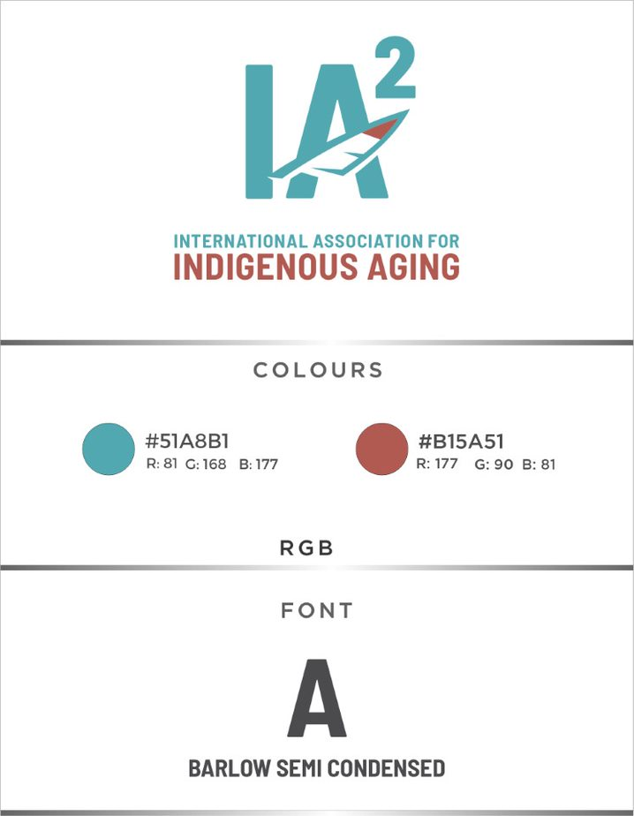
Install new font: https://support.microsoft.com/en-us/office/add-a-font-b7c5f17c-4426-4b53-967f-455339c564c1
Download Barlow Semi Condensed: https://fonts.google.com/specimen/Barlow+Semi+Condensed/about

