Creative Brief

ILiAD Messaging

Core Message
ILiAD is a one-of-a-kind technological breakthrough that is revolutionizing how lithium is produced across the world. At a time when EV demand is primed to skyrocket, there has never been a better time to deploy the world’s cleanest, most efficient and sustainable lithium production technique that will supply the materials needed to produce EV batteries. Better yet, the dynamic technology can be used for brine resources across the world, with the potential to massively reduce emissions, water use and land use at lithium production operations worldwide.

Sub Messages

1.) Innovative

ILiAD is the first-of-its kind, innovative technology that is changing the way lithium is produced around the world. This patented technology revolutionizes the way lithium is produced by filtering it out from brine before the brine is returned to the earth. No one in the world is producing lithium like this, but that won’t be the case for long.

2.) Clean

ILiAD is cleanest lithium production technology in the world. The carbon emissions and water use of ILiAD are a fraction of other production operations and methods. A production operation using ILiAD can be reduced to 1% of the physical footprint compared to other operations. The 90% recovery rate of lithium from the brine is also industry leading, as it is twice as efficient as some production methods like evaporation ponds.

3.) Efficient

The clean, efficient technology will pave the way to meet the skyrocketing demand for lithium in the most sustainable way possible. Lithium demand around the world is expected to increase 20Xs by 2050 to support the rapidly expanding demand for Electric Vehicles. This technology will support this expanded demand efficiently and with the smallest impact to our environment.

3.) Flexible

A flexible, dynamic design allows the technology to be used all brine types. Whether it be the highly mineralized, extremely hot geothermal brine in California, or the cold brine in the Great Salt Like in Utah, or brines in South American, ILiAD is designed to work on virtually all brines making it a viable technology solution for lithium producers across the world.

4.) Proven

ILiAD is a battle-tested and proven technology. The technology was tested, and retested over 6 years, which included testing by eventual customers who are utilizing the licensed technology for their operations. The process was proven time and again on some of the world’s most difficult brines to process.

Branding Concepts

1. Build on ES Minerals Logo. Utilizing the blue, grey and green shades, and the circular shape, develop a branding for ILiAD that matches the look and feel of ESM.



2. Play into Greek Mythology of the Name. Using a play on “Illiad” utilize Greek shapes, look or feel as a nod towards their reputation for innovation and ingenuity. Perhaps a logo with a look and feel of the aqueduct system.

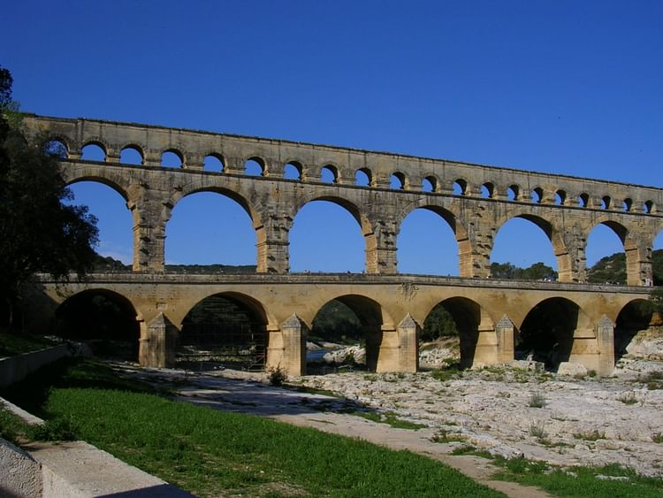

3. Anatomical/Chemical. Subtle nod to complex chemical process of ILiAD.

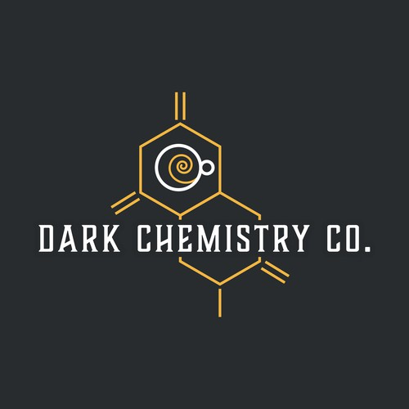

4. “Black Box.” Lean into the mystique and “magic” of ILiAD by emphasizing darker colors with a black box type feel.

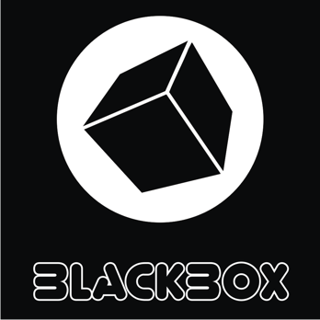

Tag-Lines

Creating the energy of tomorrow, today
Lithium Reimagined
Making the energy of tomorrow, today

