Overview
We are seeking an illustrator and designer for a spiritual book about the enlightenment of women and are requesting 7 illustrations, one for each chapter title, in simple blank line or brush art (such as an Asian or Chinese minimalist design).

For the illustrations, there are two themes we’d like to explore:
- A journey
- Naturally feminine

Broader themes:
- Clean
- Feminine
- Natural
- Diverse
- Joyous

Book Cover
Title:
Women in Enlightenment
Stories of Awakening
by Dharma Sisters

Chapter Illustrations
The illustrations must print in black and white and also render in kindle. The cover has a butterfly, so it would be wonderful, but not required, if there could be a subtle butterfly integrated into each design.

Walking The Path
A sketch of a journey home, one that is not straightforward.
Tones:
- Adventurous
- Unexpected
- Magical
- Crooked (not straightforward)

Example


Initial Liberation
A sketch of a woman carrying chopped wood and a bucket of water.
There is a Buddhist saying, “Before enlightenment, chop wood carry water, after enlightenment, chop wood carry water.”

Tones:
- Business as usual
- A sense of movement - purposefulness - not drudgery

Example (we’d really like something like this, but more professionally rendered):
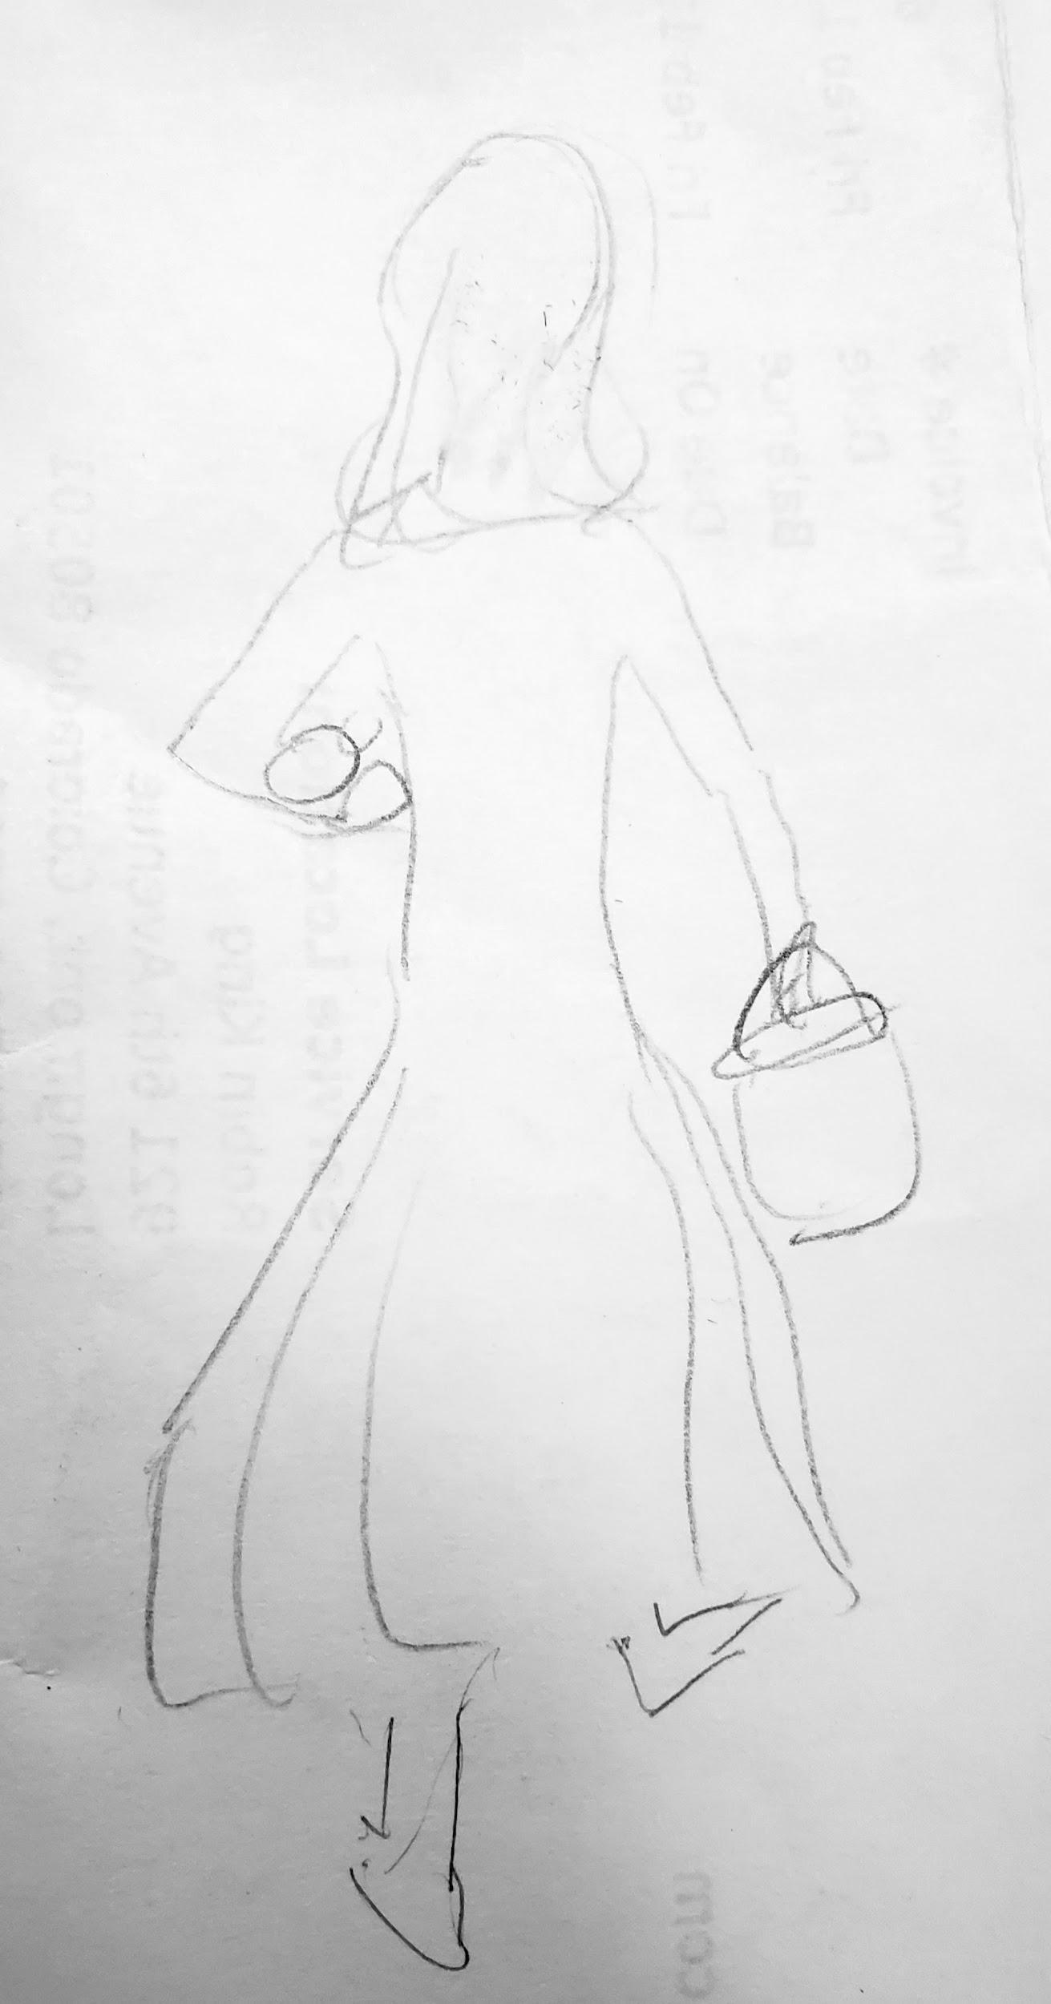

Deepening into Enlightenment
Tones:
- Continuous
- Unfolding
- Diving
- Soaring
- Endless
- Multi-faceted
- Deepening
- Unknown

A passageway into the unknown
(unable to find example)

Deep diving (but simpler, less ornamented, than the image below)
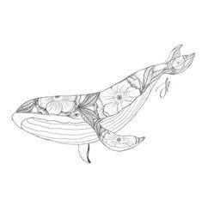

Lotuses growing (but, again, much simpler, less heavy, design)
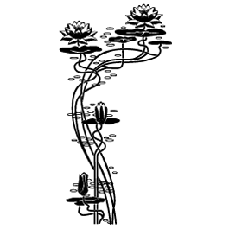

A rose, or many roses, with many petals, unfolding. Example:


Enlightenment

Tones:
- Autonomous
- Strong
- Silent
- Rooted
- Whole
- Happy

A mighty radiant tree (with roots) standing in light. Something more like the bare lines drawing a bonzai-shaped tree would also be wonderful.

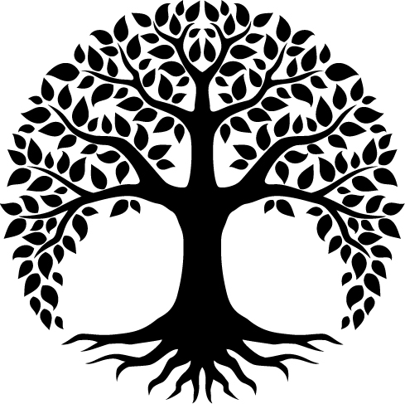

Obstacles
A bump in the road (this image isn’t quite right)

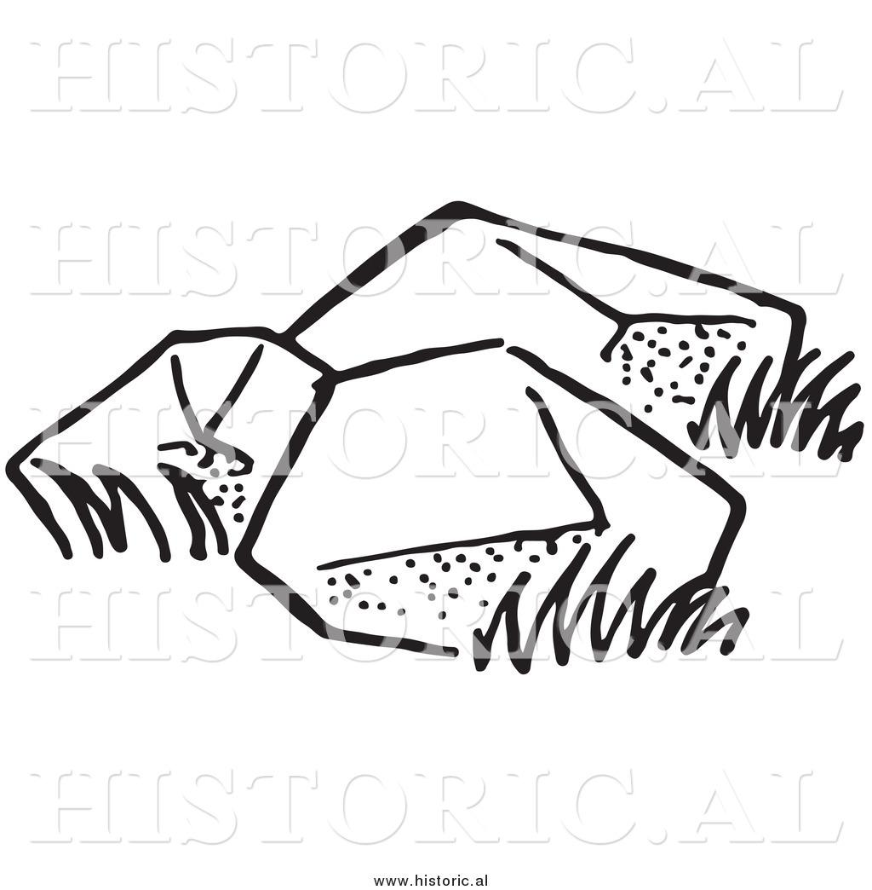

Practice
Upward spiral

Sacred labyrinth

Tending the garden

Grace
Tones:
- Divine feminine
- Freely flowing
- Carries all

Flowing stream


A divine vessel pouring blessings (such as Kwan Yin)
