Home Research Team Publications Join Contact
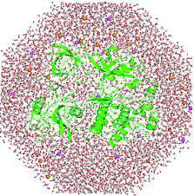 James Bardwell Lab

RESEARCH
Proteins start life as linear amino acid sequences and end up as beautifully folded, active structures. Dr. Bardwell’s laboratory focuses on recently discovered machinery that drives protein folding in the cell. Powerful genetic, structural, and biophysical tools are being used to generate a detailed picture of how these folding machines work. Members of the Bardwell lab also use directed evolution to improve protein folding. They do this by asking organisms themselves to solve difficult protein-folding problems. By examining the solutions to these problems, they are better able to understand folding in the cell.
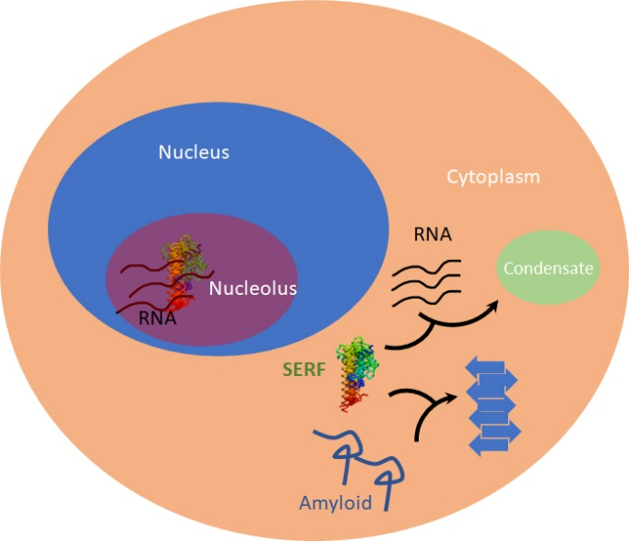
Studying the Physiological Function of Human SERF2
Our lab has successfully discovered the development of amyloid aggregation biosensors in yeast. SERF has been shown to accelerate amyloid aggregation both in vitro and in vivo. It can modulate the disease progression of Alzheimer’s and Parkinson’s Disease in animal models. By determining the physiological functions of SERF, we aim to provide more perspectives on diseases interventions.
Our studies include using techniques such as cell biology, microscopy, RNA-seq, RNAi, CRISPR knockout and knockin as well as Cross-linking immunoprecipitation. https://pubs.acs.org/doi/10.1021/acschembio.0c00083
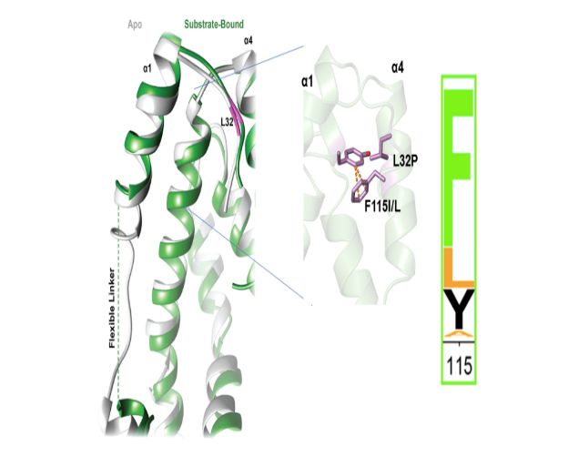
Studying The ATP-Chaperone Spy
Our lab is interested in exploring the functional dynamics in proteins. One area of focus is on the Spy structure. Specifically, how it both allows client folding-while-bound and how it prevents aggregation.

Mitra R, Gadkari VV, Meinen BA, van Mierlo CPM, Ruotolo BT, Bardwell JCA. Mechanism of the small ATP-independent chaperone Spy is substrate specific. Nat Commun. 2021 Feb 8;12(1):851. doi: 10.1038/s41467-021-21120-8

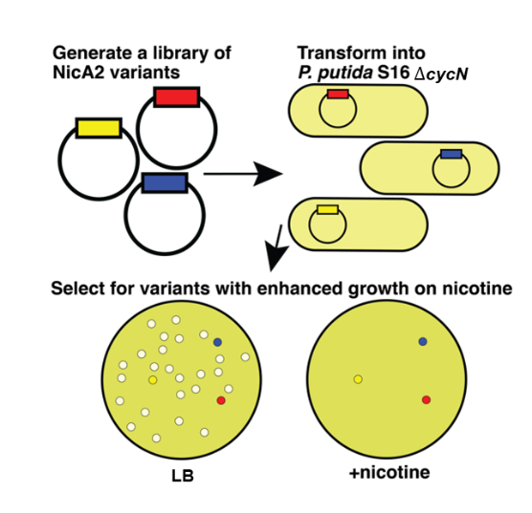

Treating nicotine addiction through directed evolution

Addiction to tobacco is the leading cause of preventable death in the world. We are studying an enzyme NicA2 that degrades nicotine and has been shown to have therapeutic potential when injected into nicotine addicted rats. We find that contrary to the assumption that this enzyme uses oxygen as its electron acceptor, it instead uses a newly discovered cytochrome c, CycN. CycN serves as the natural electron acceptor of NicA2. The inability of CycN mutants to metabolize nicotine in the presence of oxygen opens up the opportunity to select for NicA2 mutants of increased therapeutic potential that can use oxygen directly as an electron acceptor. So far, we have uncovered variants with up to a 200-fold increase in their oxygen-dependent catalytic rate.

Dulchavsky M, Clark CT, Bardwell JCA, Stull F. (2021) A cytochrome c is the natural electron acceptor for nicotine oxidoreductase. Nature Chemical Biology. 2021 January 11. https://doi.org/10.1038/s41589-020-00712-3 PubMed

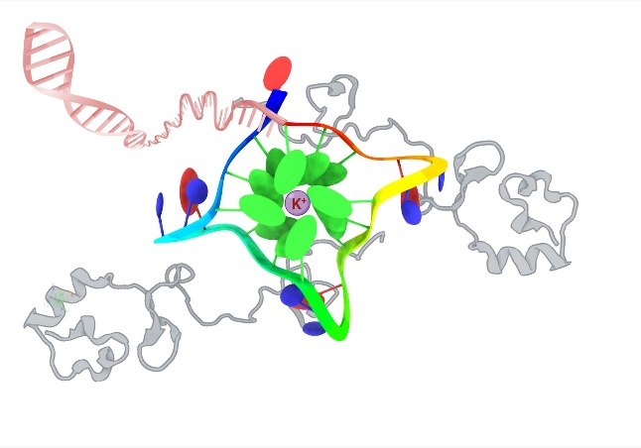
How Proteins Regulate Gene Function By Acting on G-quadruplexes
Our research focuses on elucidating the structural basis of G-quadruplex recognition by two small highly charged and partially disordered proteins. The studied proteins are amenable to solution NMR and preferentially bind to G-quadraplex structures in vitro and in vivo. By understanding how this recognition process occurs we hope to help develop a G-quadruplex binding protein-based platform for gene regulation by manipulating the structure. We approach our studies using biophysical, computational and cellular biology techniques.

Sahoo BR, Bardwell JCA. SERF, a family of tiny highly conserved, highly charged proteins with enigmatic functions. FEBS J. 2022, doi: 10.1111/febs.16555.

Team

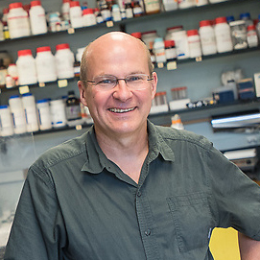
James C. Bardwell, Ph.D.

Rowena G. Matthews Collegiate Professor,

MCDBHHMI Investigator
jbardwel@umich.edu
- Howard Hughes Medical Investigator
- Department of Molecular Cellular Developmental Biology
- Program in Cellular Molecular Biology
- Department of Biophysics

Jim received his PhD from the University of Wisconsin in Molecular Biology. He then continued his studies in mRNA Stability at NCI, Bacterial Genetics at Harvard Medical School and Protein Folding at University of Regensburg in Germany. He has been working as a researcher for 24 years and has been affiliated with HHMI and the University of Michigan since 2005. In Jim’s spare time he enjoys biking, kayaking, and giving tours to Natural History Museum visitors of the coral reek and octopus tanks in his office.

Xiexiong Deng

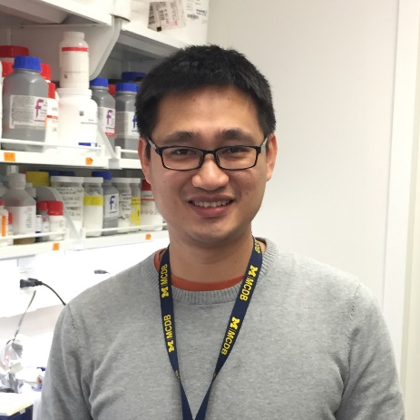
Postdoctoral Fellow
dengx@umich.edu
Xiexiong attained his PhD at Michigan State University in 2018, where he studied the mitotic function of histone H3 in budding yeast. Afterwards, he joined Bardwell lab and studies amyloidogenic protein folding using budding yeast. Outside the lab, he loves watching soccer and playing badminton.


Bikash Sahoo

Postdoctoral Fellow
bsahoo@umich.edu
Bikash received his Ph.D. in Chemistry from Osaka University, Japan, and then joined University of Michigan Biophysics program as a postdoc. Currently, in Bardwell's lab, he works as a research specialist and his research focuses on the structural biophysics of G-quadruplex binding proteins that regulate genome function and many critical biological processes at high-resolution. Outside the lab, Bikash enjoys designing websites, 3D illustrations, and browsing international affairs.

Rashad Mitra
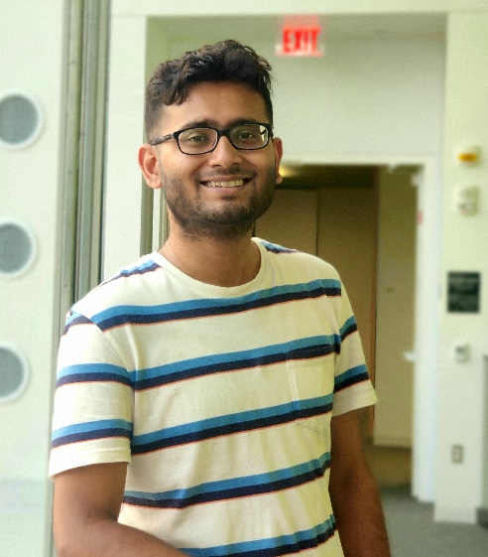

Graduate Student
Rishav received his master’s degree in biotechnology from St. Xavier’s College (Autonomous) Kolkata affiliated to the University of Calcutta, India. He joined the Bardwell Lab in 2018. Currently, he is focussing on finding a biophysically amenable chaperone-substrate pair to understand mechanisms of chaperone- assisted protein folding. Outside of lab, Rishav enjoys listening to classical music and watching movies.

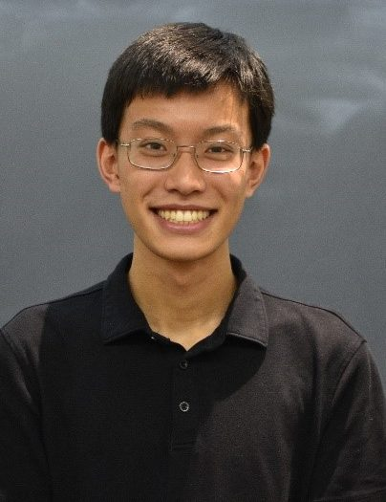
Harry Yang

Undergraduate
Harry joined the lab in Summer 2021, working with Dr. Xiexiong Deng to understand the physiological function of SERF. He is majoring in Biochemistry and minoring in Computer Science. Outside of lab, he enjoys playing the flute, taking walks, and performing with Revolution Chinese Yoyo.

Sania Mancer
Visiting Master’s Student
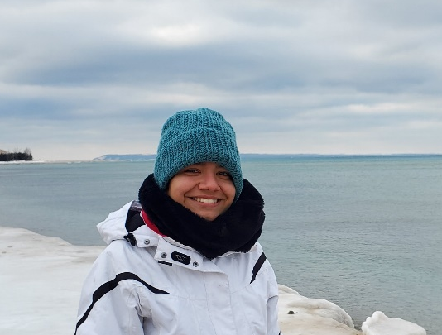
Sania acquired a B.S. in Biochemistry and is currently a second-year Masters student in Quantitative Biology at the University of Montpellier, France. She joined the lab to work for 7 months to complete her master’s thesis. Currently she is trying to characterize the binding of G-quadruplex with SERF related proteins. Outside of lab she loves going outdoors, swimming, traveling and most importantly drinking coffee.

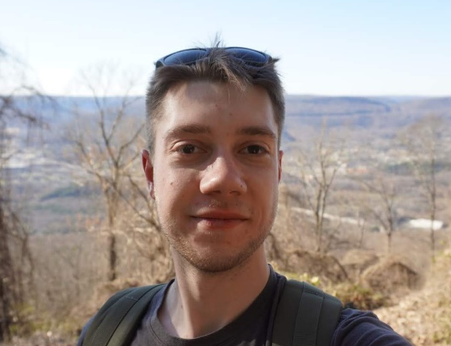
Nathan Clark

Undergraduate
Nathan joined the lab in Winter 2022. He is majoring in Biophysics and minoring in Physics. He currently works with Postdoctoral Fellow Bikash Sahoo to better understand the function of a SERF protein. Nathan is from Hudsonville, Michigan and enjoys hiking, kayaking, reading, and watching movies.

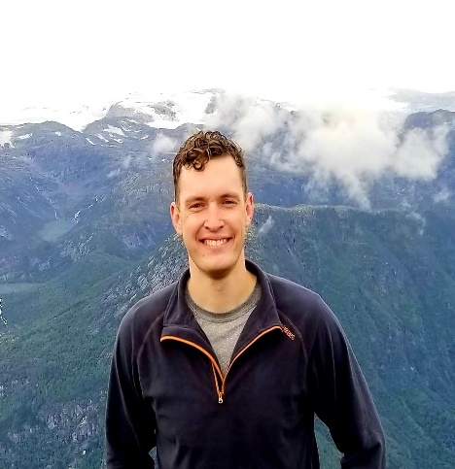

Matt Crotteau

Undergraduate
Matt joined the lab as a senior in Fall 2022. He is majoring in Molecular, Cellular, and Developmental Biology. He plans to attend graduate school for either Molecular Biology or Bioinformatics after graduation. Matt is from Rice Lake, Wisconsin and enjoys outdoor activities, cooking, and going to the gym. He currently works with graduate student Rishav Mitra on exploring the mechanism of complex coacervation of an intrinsically disordered protein SERF and its interacting RNA along with the mechanistic details of these interactions at a structural level.

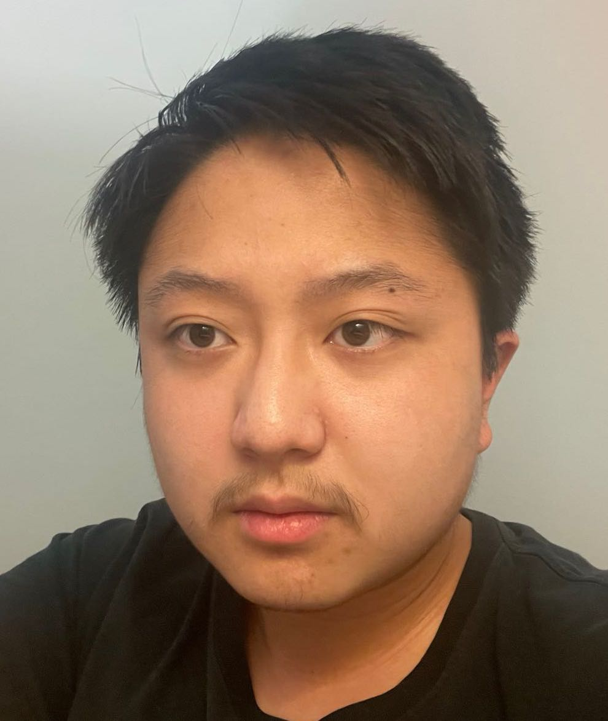
Steve Liu
Undergraduate

Steve joined the lab as a sophomore in Fall 2021. He is majoring in Biochemistry and plans to attend graduate school to pursue a PhD. He began his lab work studying under a former graduate student, Mark Dulchavsky, on the Directed Evolution of Flavin-Dependent Nicotine-degradative enzyme (NicA2). Currently, he is working independently on the directed evolution of the other Flavoenzymes. Steve is from Chengdu, China. Outside of the lab, he enjoys cooking, traveling, reading, and painting.

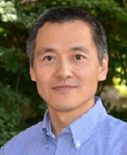

Ken Wan

Senior Laboratory Technician
kewan@umich.edu
Ken has worked as a lab technician at U-M for nearly ten years. He joined the Bardwell lab from an HHMI lab in June 2013. Ken’s work is mainly on protein expression and purification. His work consists of making all kinds of constructs for E. coli, Baculovirus insect cell and yeast systems as well as purifying proteins with or without tags using the AKTA system. He enjoys screening and optimizing the protein crystals as well. Ken likes traveling, swimming, and fishing.

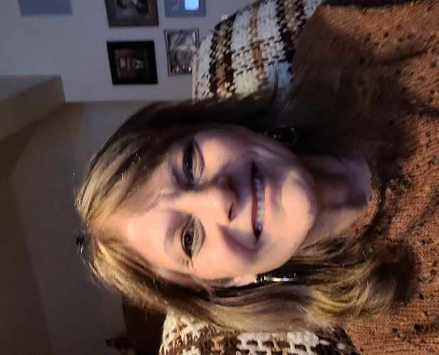

Traci Banjanin

Lab Manager & Research Technician II
banjanin@umich.edu
Traci earned a BS in biochemistry from MSU and a M.Ed. in educational leadership from WSU. After a 30 year career as a chemistry teacher, Traci retired and joined the Bardwell lab in February 2021. She is enjoying supporting the research and administrative needs of all in both the Bardwell and Jakob lab. Outside of work, Traci likes to kayak and boat, bike, read, and cook.

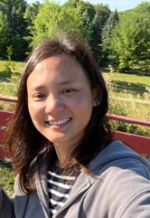

Sylvia Widjaja

Laboratory Technician
Sylvia earned her bachelor’s degree of chemical engineering from the University of Melbourne, Australia. She joined the Bardwell-Jakob lab recently as a lab technician to support the research team. She loves spending time with family, traveling and doing outdoor activities.

2022-2019 Recent Publications

2022 Publications
Wu K, Minshull TC, Radford SE, Calabrese AN, Bardwell JCA. Trigger factor both holds and folds its client proteins. Nat Commun. 2022 Jul 15;13(1):4126. doi: 10.1038/s41467-022-31767-6. PubMed

Choudhary V, Wu K, Zhang Z, Dulchavsky M, Barkman T, Bardwell JCA, Stull F. The Enzyme Pseudooxynicotine Amine Oxidase From Pseudomonas Putida S16 Is Not An Oxidase, Bua A Dehydrogenase. Journal of Biological Chemistry. 2022 Jul 11. doi: 10.1016/j.jbc.2022.102251 PubMed

Sahoo BR, Bardwell JCA. SERF, A Family Of Tiny Highly Conserved, Highly Charged Proteins With Enigmatic Functions. The FEBS Journal. 2022 Jun 13doi: 10.0000/febs,16555. PubMed

Rishav Mitra, Kevin Wu, Changhan Lee, and James C.A. Bardwell ATP-Independent Chaperones. Annual Reviews of Biophysics 2022 Feb 15. PubMed

2021 Publications
Beaufay F, Amemiya HM, Guan J, Basalla J, Meinen BA, Chen Z, Mitra R, Bardwell JCA, Biteen JS, Vecchiarelli AG, Freddolino PL, Jakob U. Polyphosphate drives bacterial heterochromatin formation. Science Advances. 2021 Dec 24;7(52):eabk0233. doi: 10.1126/sciadv.abk0233. Epub 2021 Dec 22. PMID: 34936433. PubMed

Mitra R, Gadkari VV, Meinen BA, van Mierlo CPM, Ruotolo BT, Bardwell JCA. Mechanism of the small ATP-independent chaperone Spy is substrate specific. Nat Commun. 2021 Feb 8;12(1):851. doi: 10.1038/s41467-021-21120-8. PubMed

Dulchavsky M, Clark CT, Bardwell JCA, Stull F. A cytochrome c is the natural electron acceptor for nicotine oxidoreductase. Nature Chemical Biology. 2021 January 11. https://doi.org/10.1038/s41589-020-00712-3 PubMed

2020 Publications
He W, Zhang J, Sachsenhauser V, Wang L, Bardwell JCA, Quan S. Increased surface charge in the protein chaperone Spy enhances its anti-aggregation activity. J Biol Chem. 2020 Aug 17:jbc.RA119.012300. doi: 10.1074/jbc.RA119.012300. Online ahead of print. PubMed

Lee C, Betschinger P, Wu K, Zyla DS, Glockshuber R, Bardwell JCA. A metabolite binding protein moonlights as a bile-responsive chaperone. EMBO J. 2020 Sep 3;e104231. doi: 10.15252/embj.2019104231. Online ahead of print. PubMed

Sachsenhauser V, Deng X, Kim HH, Jankovic M, Bardwell JCA. Yeast Tripartite Biosensors Sensitive to Protein Stability and Aggregation Propensity. ACS Chem Biol. 2020 Apr 17;15(4):1078-1088. doi:10.1021/acschembio.0c00083. Epub 2020 Mar 10. PubMed

2019 Publications
Rocchio S, Duman R, Omari KE, Mykhalylyk V, Orr C, Yan Z, Salmon L, Wagner A, Bardwell JCA, Horowitz S. Identifying dynamic ,partially occupied residues using anomalous scattering. Acta Crys 2019. D75, 1084-1095.

Meinen BA, Gadkari VV, Stull F, Ruotolo BT, Bardwell JCA. SERF engages in a fuzzy complex that accelerates primary nucleation of amyloid proteins. Proc Natl Acad Sci USA 2019 Oct 28. pii: 201913316. doi: 10.1073/pnas.1913316116. PubMed [FACULTY OPINIONS]

Wu K, Stull F, Lee C, Bardwell JCA. Protein folding while chaperone bound is dependent on weak interactions. Nat Commun 2019 Oct 23;10(1):4833. doi: 10.1038/s41467-019-12774-6. PubMed

Yan Z, Hussain S, Xu W, Bernstein HD, Bardwell JCA. Chaperone OsmY facilitates the biogenesis of a major family of autotransporters. Mol Microbiol 2019 Aug 1 doi: 10.1111/mmi.14358. PubMed

Teixeira F, Tse E, Castro H, Makepeace KAT, Meinen BA, Borchers CH, Poole LB, Bardwell JC, Tomás AM, Southworth DR, Jakob U. Chaperone activation and client binding of a 2-cysteine peroxiredoxin. Nat Commun. 2019 Feb 8;10(1):659. doi: 10.1038/s41467-019-08565-8. PubMed

Join Our Lab
If you are interested in joining a well-funded, collaborative team working in the areas of protein structure, function and genetic engineering, send Jim your CV via email to: Jbardwel@umich.edul. We consider applications on a rolling basis. We are recruiting for postdocs and graduate students.
Contact Us
Principal Investigator: James Bardwell , jbardwel@umich.edu
1-734-764-8028

Location: HHMI @ The University of Michigan
Biological Sciences Building
1105 N University , Room 5022
Ann Arbor, Michigan 48109
