Replacment photos for 2023 Website
Steven ( Xiaomeng Liu)
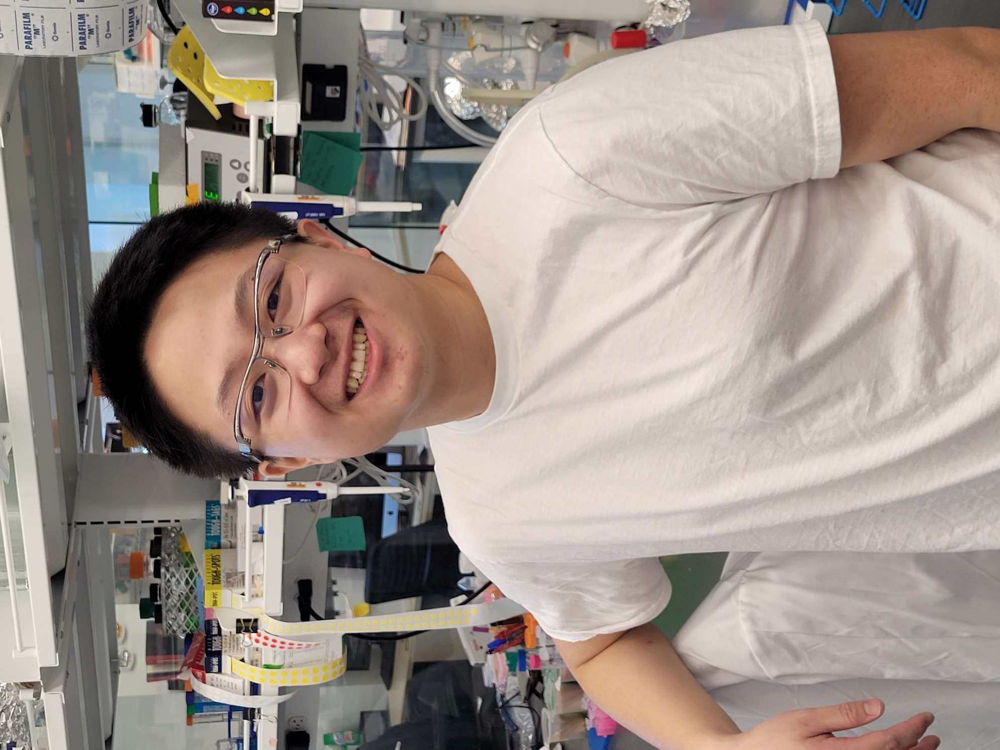

Bikash Sahoo
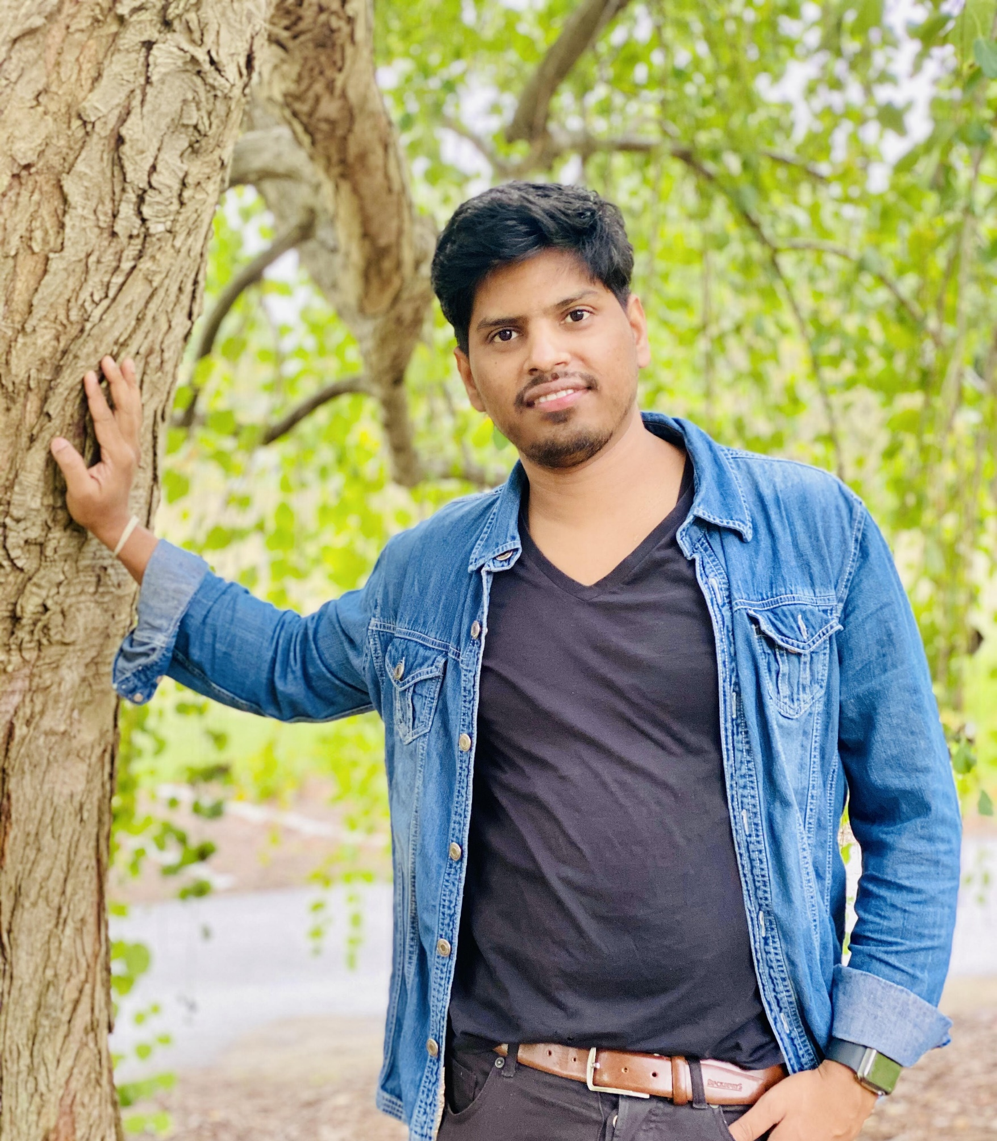

Overall Image of our Lab
