
Insurance Quotation Brief

Date (today’s date)
Strata Management Group (Name)
Strata Manager (Name – Email)
Please find information relative to the insurance renewal application for:
Building Name & Address

Then all this information from the Building Info page including the new fields listed on the spreadsheet under Item 163
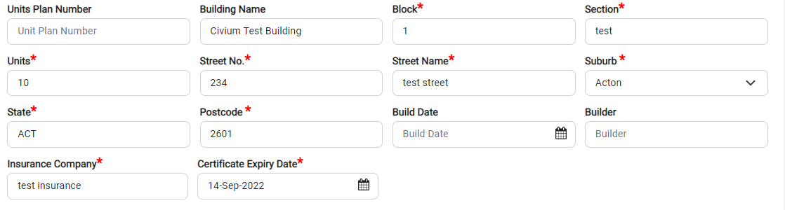



Insurance claims history for past 24 months:
Claims made? Yes No (user ticks in word doc)
Details: free text area

Routine, Safety & Compliance Inspections Register:
Basically shows exactly the Upcoming Periodic Inspections Page

Building Activity Summary for past 24 months:
Shows the Management Summary, but better presented:
Date | Area | Item | Comment Category | Company | Cost
19/5/2022 | Basement | Garage Door Motors | Defect | Jims Industries | $4500
Vsghgsvvhgvahgvgvdshgavsagsdhavhsvdsgvgsavgvagvgavavsvagvhasavagsavgvshs
19/5/2022 | Basement | Garage Door Motors | Defect | Jims Industries | $4500
Vsghgsvvhgvahgvgvdshgavsagsdhavhsvdsgvgsavgvagvgavavsvagvhasavagsavgvshs
19/5/2022 | Basement | Garage Door Motors | Defect | Jims Industries | $4500
Vsghgsvvhgvahgvgvdshgavsagsdhavhsvdsgvgsavgvagvgavavsvagvhasavagsavgvshs
19/5/2022 | Basement | Garage Door Motors | Defect | Jims Industries | $4500
Vsghgsvvhgvahgvgvdshgavsagsdhavhsvdsgvgsavgvagvgavavsvagvhasavagsavgvshs
19/5/2022 | Basement | Garage Door Motors | Defect | Jims Industries | $4500
Vsghgsvvhgvahgvgvdshgavsagsdhavhsvdsgvgsavgvagvgavavsvagvhasavagsavgvshs
19/5/2022 | Basement | Garage Door Motors | Defect | Jims Industries | $4500
Vsghgsvvhgvahgvgvdshgavsagsdhavhsvdsgvgsavgvagvgavavsvagvhasavagsavgvshs
19/5/2022 | Basement | Garage Door Motors | Defect | Jims Industries | $4500
Vsghgsvvhgvahgvgvdshgavsagsdhavhsvdsgvgsavgvagvgavavsvagvhasavagsavgvshs
19/5/2022 | Basement | Garage Door Motors | Defect | Jims Industries | $4500
Vsghgsvvhgvahgvgvdshgavsagsdhavhsvdsgvgsavgvagvgavavsvagvhasavagsavgvshs
19/5/2022 | Basement | Garage Door Motors | Defect | Jims Industries | $4500
Vsghgsvvhgvahgvgvdshgavsagsdhavhsvdsgvgsavgvagvgavavsvagvhasavagsavgvshs
19/5/2022 | Basement | Garage Door Motors | Defect | Jims Industries | $4500
Vsghgsvvhgvahgvgvdshgavsagsdhavhsvdsgvgsavgvagvgavavsvagvhasavagsavgvshs

