Non-alcoholic Wines
Product names:
- Sangria
- Prosecco
- Rose
Descriptor: Non-alcoholic mocktail / Boisson non-alcoolisée
Volume: 275ml
Bottle: Wrap around label, paper substrate
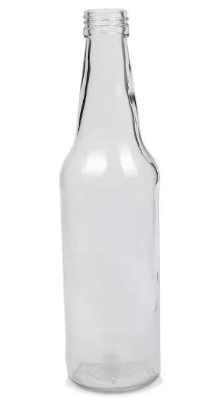
Colour of product in bottle:
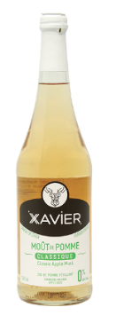
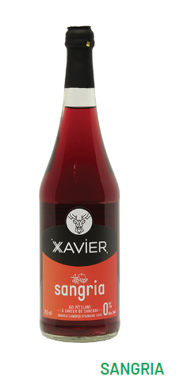 Prosecco 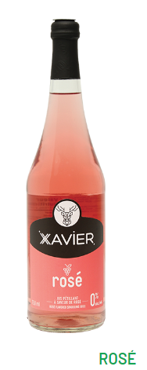
Looking for a design that is full of bright, bold colours.
A couple ideas of the colours were looking for:
